**BIOELECTROCHEMICAL MEASUREMENT SYSTEM OF A BIOMICROSYSTEM BASED ON ANTIBODIES**

# OBJECTIVE

To demonstrate the procedure to follow in order to carry out the impedance analysis of the biomicrosystem using the AGILENT 4294A impedance analyzer with a precision of 40 Hz - 110 MHz and the AGILENT 16089A Kelvin clip leads accessory, which are located in the cleanroom laboratory of the Electrical and Electronics Engineering department.

# SCOPE

To provide a protocol for the Uniandes community with the aim of performing the measurement and respective analysis of impedances in a biomicrosystem.

# DESIGN SPECIFICATIONS AND RESTRICTIONS

The AGILENT 4294A impedance analyzer is an effective equipment for impedance measurement and component and circuit analysis. It has a frequency range of 40Hz to 110MHz with a basic impedance of +/- 0.08%. It has an interface in Microsoft Excel that will acquire the data for subsequent analysis.

The AGILENT 16089A Kelvin clip leads accessory is connected to this equipment, which allows direct impedance measurements for the characterization of the biomicrosystem. Since this device has different factors that can alter the measurement, it is necessary to perform the calibration procedure that involves a short circuit and an open circuit to minimize the alteration.

# EQUIPMENT & DEVICE HANDLING

## AGILENT 4294A IMPEDANCE ANALYZER

### Sample Preparation

The sample contact points must be properly cleaned and prepared for the connection of the metal clamps to the electrodes.

### Initial Configuration

1. Connect the AGILENT 16089A Kelvin clip leads.

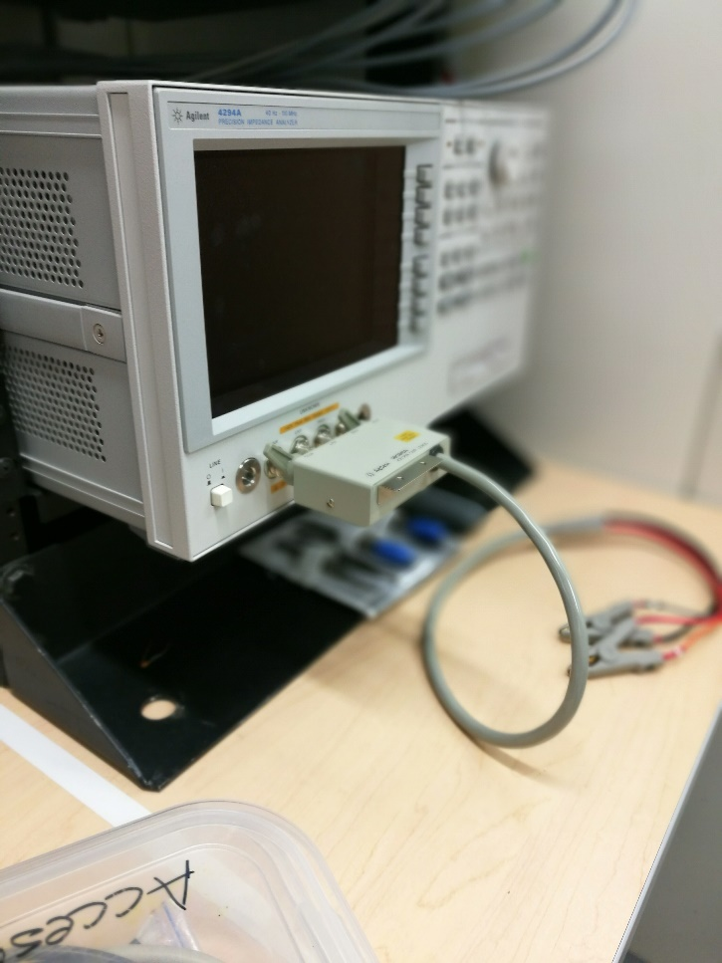

Figure 1: Connection of AGILENT 16089A Kelvin clip leads.

1. Turn on the equipment with the line I/O button.
2. Turn on the impedance analyzer control computer with the button located on the left side of the equipment.
3. Press the Format button located on the Measurement panel to select the |Z|-θ measurement model.

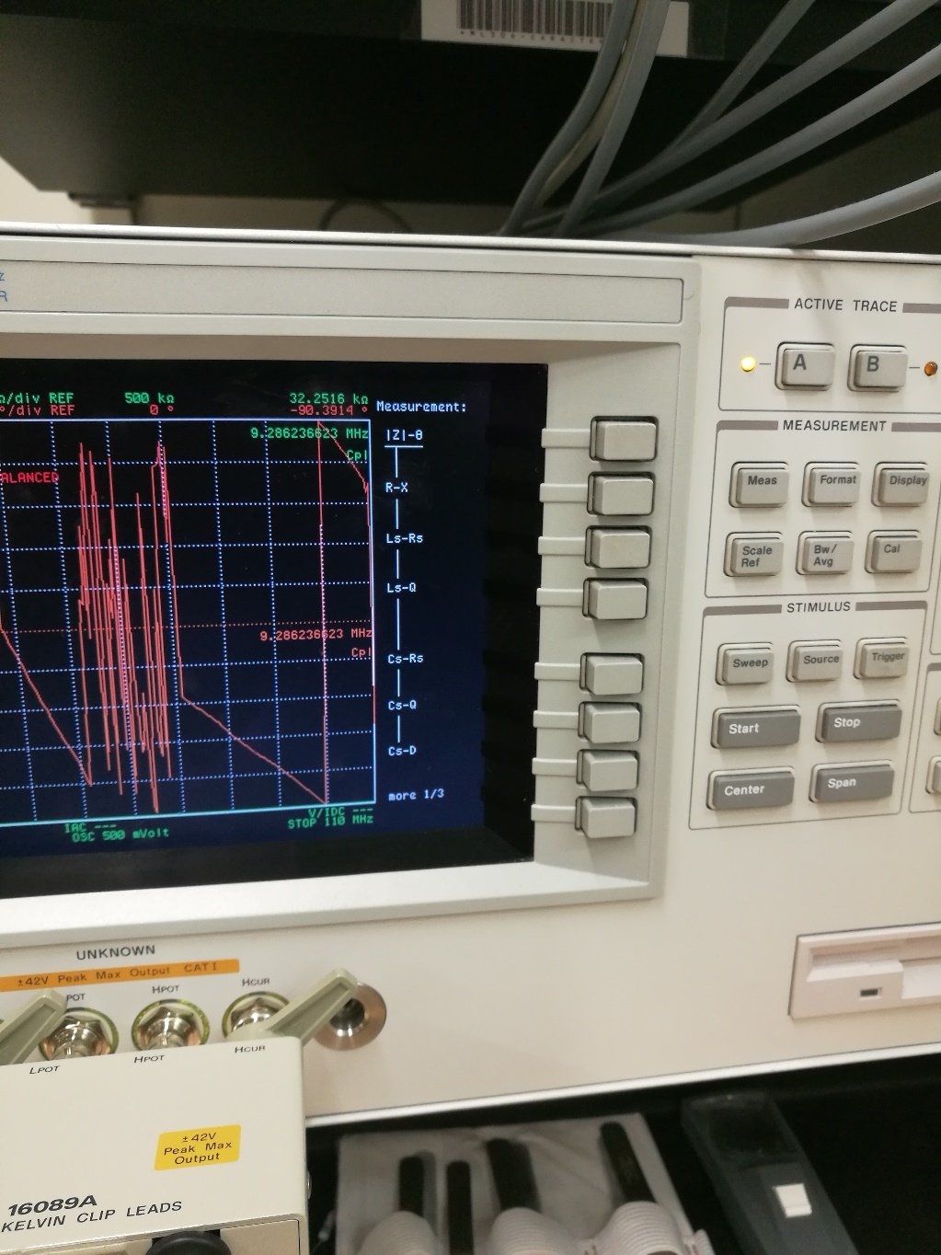

Figure 2: Equipment configuration panel.

1. Press the Start button located on the Stimulus panel and select the minimum measurement value. Note that for the biomicrosystem, three different minimum values are used: 40Hz, 120Hz, and 200Hz.
2. Press the Stop button located on the Stimulus panel and select the maximum measurement value. Note that for the biomicrosystem, three different maximum values are used: 120Hz, 200Hz, and 280Hz.
3. Press the Cal button located on the Measurement panel.
4. Select the Calibration button which appears in the menu provided by the screen.
5. Perform the short circuit connection in the adapter and press the Short button located on the screen and wait for the respective calibration to take place.

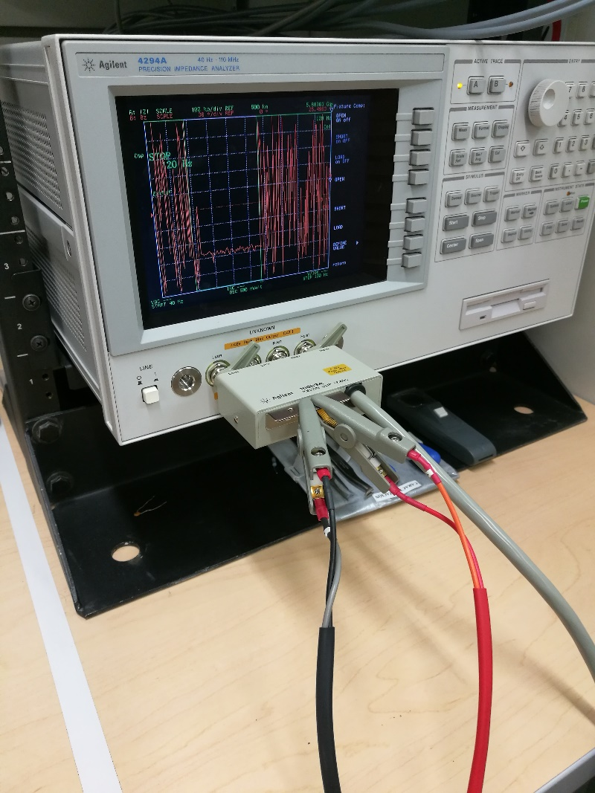

Figure 3: Open circuit connection in the adapter.

1. Perform the open circuit connection in the adapter and press the Open button located on the screen and wait for the respective calibration to take place.

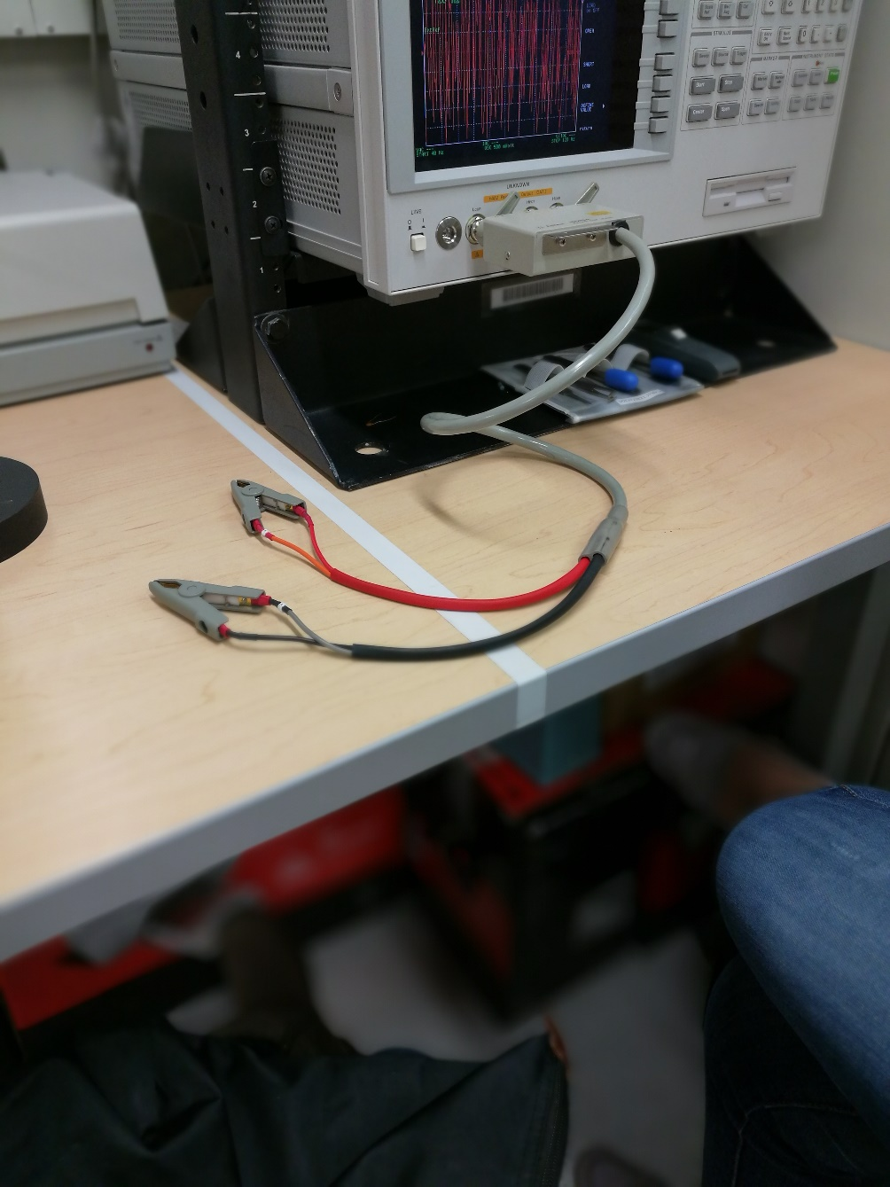

### Measurement and Results Acquisition

1. Place the biomicrosystem in the Kelvin clip Leads AGILENT 16089A.

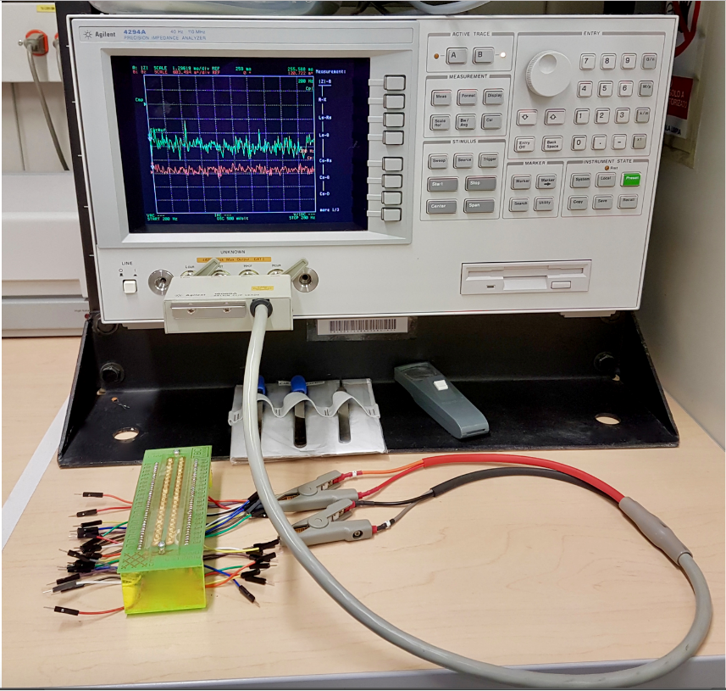

Figure 4: Adaptation of the biomicrosystem in the Kelvin clip Leads AGILENT 16089A.

1. Wait for the analyzer to complete a full sweep to be able to see the measurement on the screen.
2. Copy the file located in the Acquisition folder on the desktop, which is on the control computer, and rename it. This file is a Microsoft Excel interface that will acquire the data for later analysis.

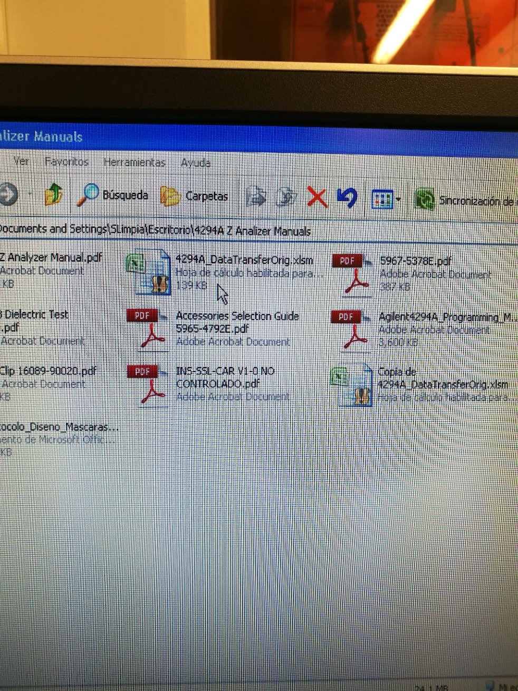

Figure 5: Selection of executable file.

1. Execute the file and enable the Microsoft Excel macros to obtain the data from the equipment.
2. Click the Get Data button located in the Microsoft Excel file.

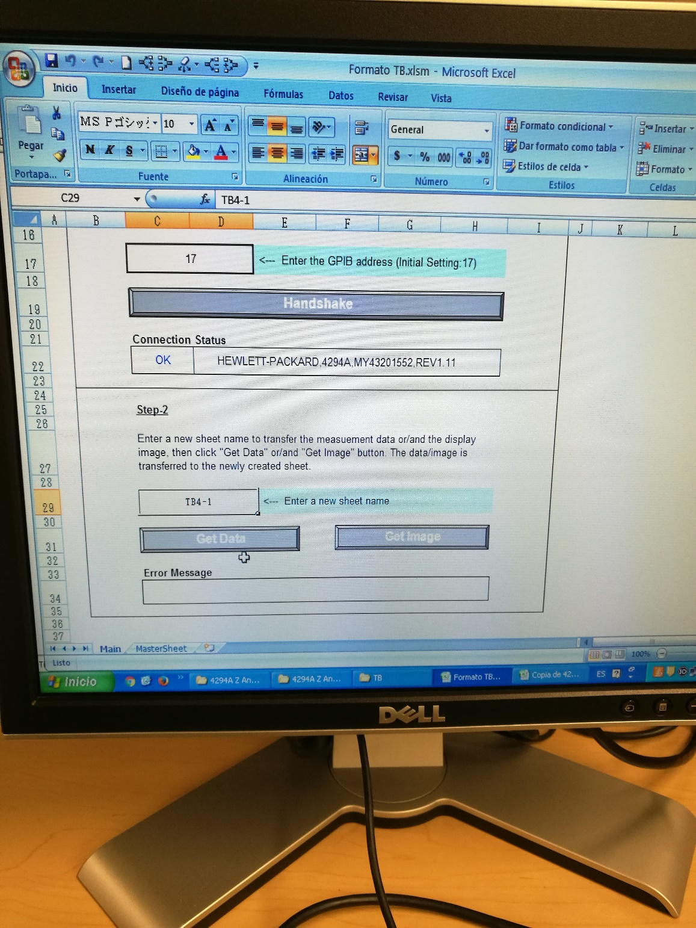

Figure 6: Program interface.

1. Repeat the procedure from step 5 in section 4.1.2 for each of the ranges to be studied.
2. Save the file with the obtained data and close the program.
3. Remove the biomicrosystem from the Kelvin clip Leads AGILENT 16089A.
4. Kelvin clip Leads AGILENT 16089A.

### Inspection and environmental considerations

Check that the material is in perfect physical condition. The Kelvin clip must operate in an ambient temperature range of 0°C - 55°C and a relative humidity of up to 95% at 40°C without condensation. To store it, the ambient temperature should be within the range of -40°C – 70°C and a relative humidity of up to 95% at 40°C.

### Operation

1. Adjust the cable length to 1 meter.
2. Connect the Kelvin clip Leads AGILENT 16089A with the diagonal jaws towards the left side to the terminals of the impedance analyzer AGILENT 4294A.
3. Adjust the jaws of the Kelvin clip Leads AGILENT 16089A in a diagonal right direction.
4. Perform steps 9 and 10 in section 4.1.2 to perform device compensation.
5. Connect the biomicrosystem to the device.

# CHANGE CONTROL

|  |  |  |  |
| --- | --- | --- | --- |
| CHANGE DESCRIPTION | DATE | VERSION | APPROVED BY |
|  |  |  |  |