**PROTOCOL FOR PRINTED CIRCUIT BOARD DESIGN FROM ADOBE ILLUSTRATOR**

***Version 1.0***

**Produced by: María Camila Guachetá Buendía**

# OBJECTIVE

To show the Uniandes community the procedure that must be followed in the design and generation of files for the manufacture of electronic schematics using various programs.

# SCOPE

To inform the Uniandes community of the procedure to be followed for the design of prints in Adobe Illustrator, generation of necessary files for the manufacture of the design in Design, and confirmation of the correct generation of Gerber files in Gerbmagic. In this way, to achieve the appropriation of the use of these programs in order to have more tools that facilitate the design and generation of prints.

# SOFTWARE REQUIREMENTS

* Adobe Illustrator CC6
* Design 8.0
* Gerbmagic

# STEP Y STEP

## FIRST PART

1. Open Adobe Illustrator CC.

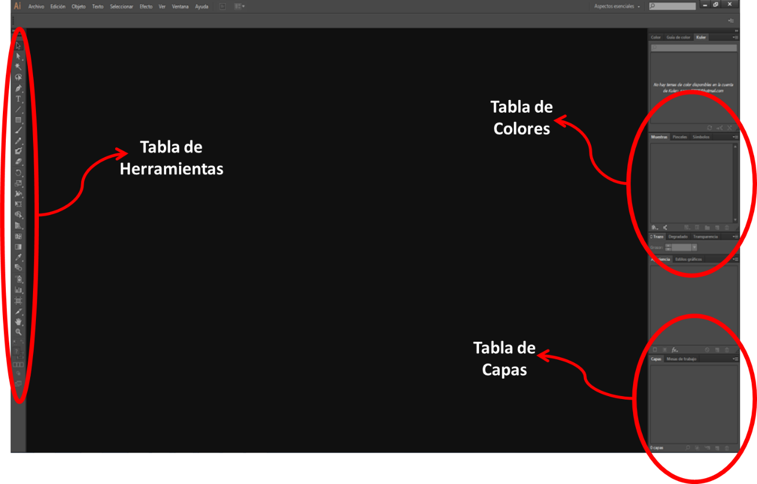

Image 1: Adobe Illustrator Window.

1. Click on the File tab and then on New. Now a new window will appear in which you enter the project name, select the crop area, and then click OK. (Note: to print one (1) mask to work on the Karl Sussligner equipment, it is advisable to set the crop area to A4).

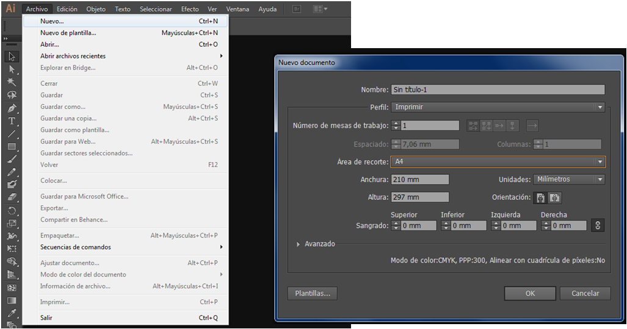

Image 2: How to create a new file.

1. If you want to work with layers, you can add new layers by clicking on the icon 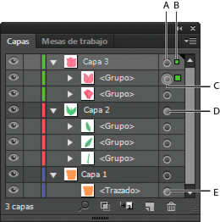, and the layers that the project has will be listed at the bottom right of the Adobe Illustrator window. The list of layers is sorted from the top layer of the project to the bottom layer, if you have a perpendicular view of the print being made.

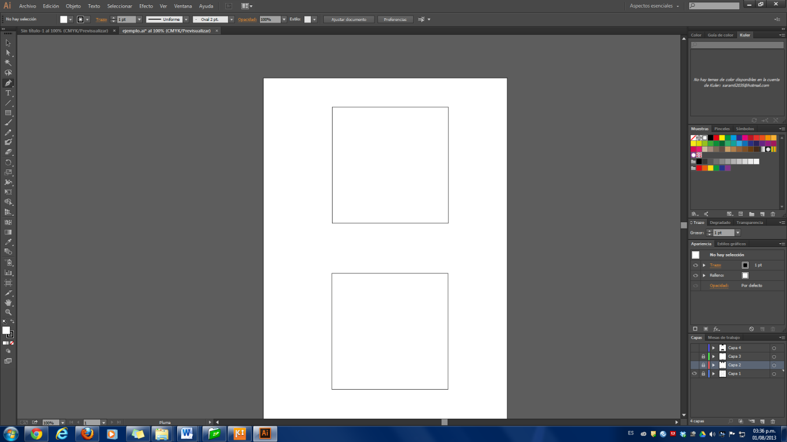

Image 3: Layer Creation.

1. Below are some of the most useful tools for creating prints in Adobe Illustrator:

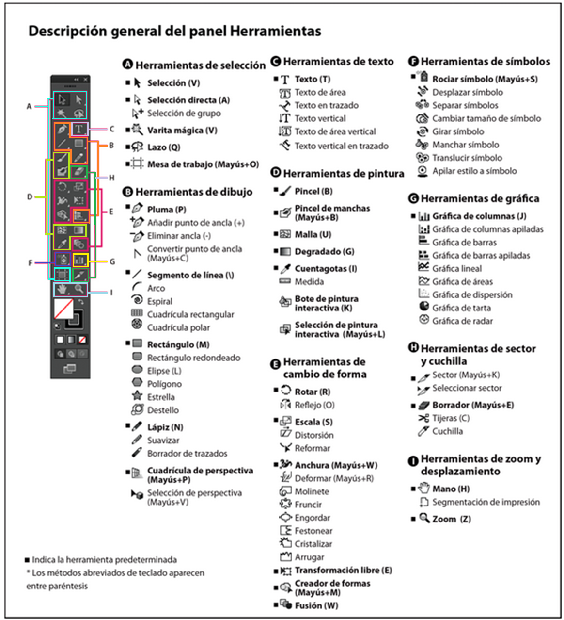

Image 4: Tool Table [1].

Note: Another command that can help is copy: while holding down ALT, drag the figure you want to copy with the mouse. Also, 3 icons that are very helpful in the layer table are:

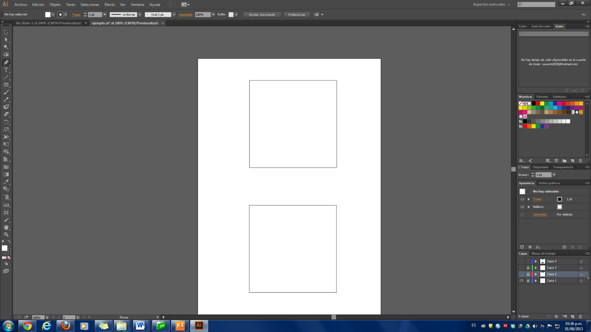 Allows you to view or hide the layer.

 Allows you to lock the layer to prevent changes to it.

 Allows you to add layers.

After learning about the tools, you can now create the design you want to print.

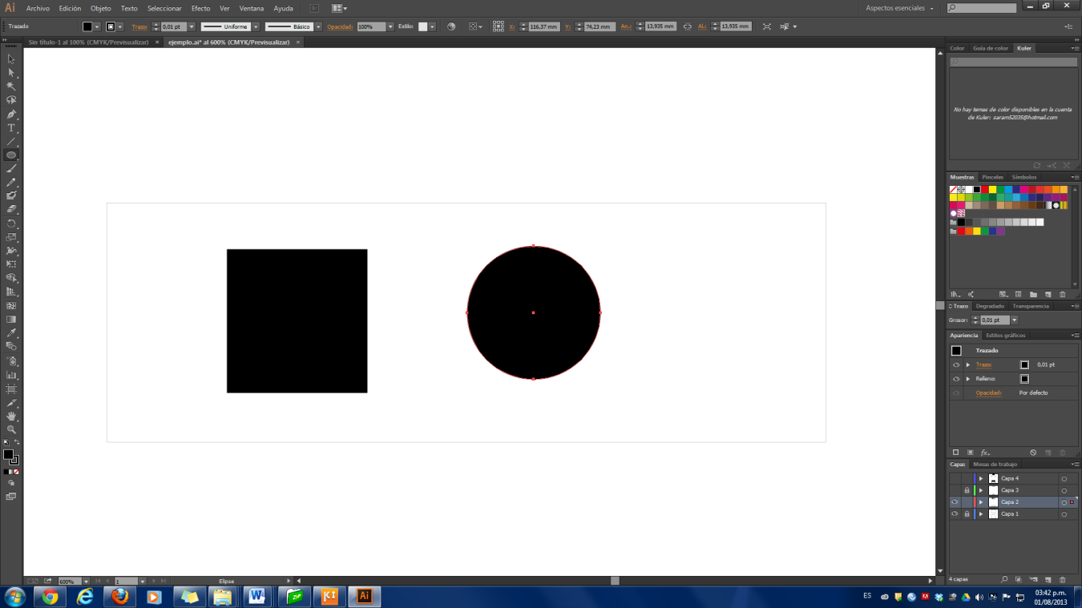

Image 5: Design in Adobe Illustrator.

1. After creating the design you want to have on the print, click on File and then on Export. At this point, a window will appear in which you export the print with the name you choose, but you must save it as an AutoCAD file. This is done by selecting the DXF (AutoCAD Exchange File) or DWG (AutoCAD Drawing) option in the Type box.

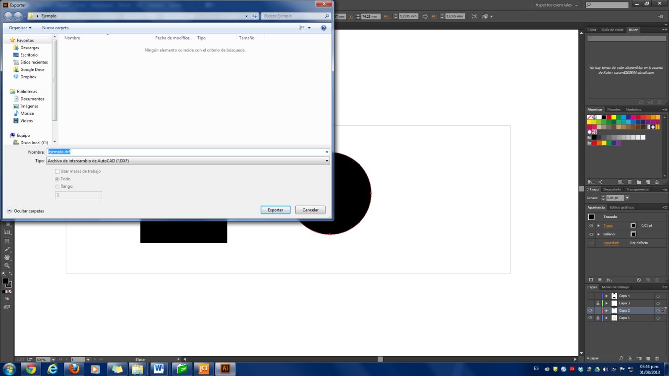

Image 6: Saving an AutoCAD file.

***Note:*** The procedure in point five (5) is performed when you want to export the entire print, but if you only want to export certain parts, such as just the electrodes, then select all these parts and perform the same procedure as in point five (5), taking into account that when the export window appears, the "Export only selected area" option should be chosen.

## SEGUNDA PARTE

1. Open Design.

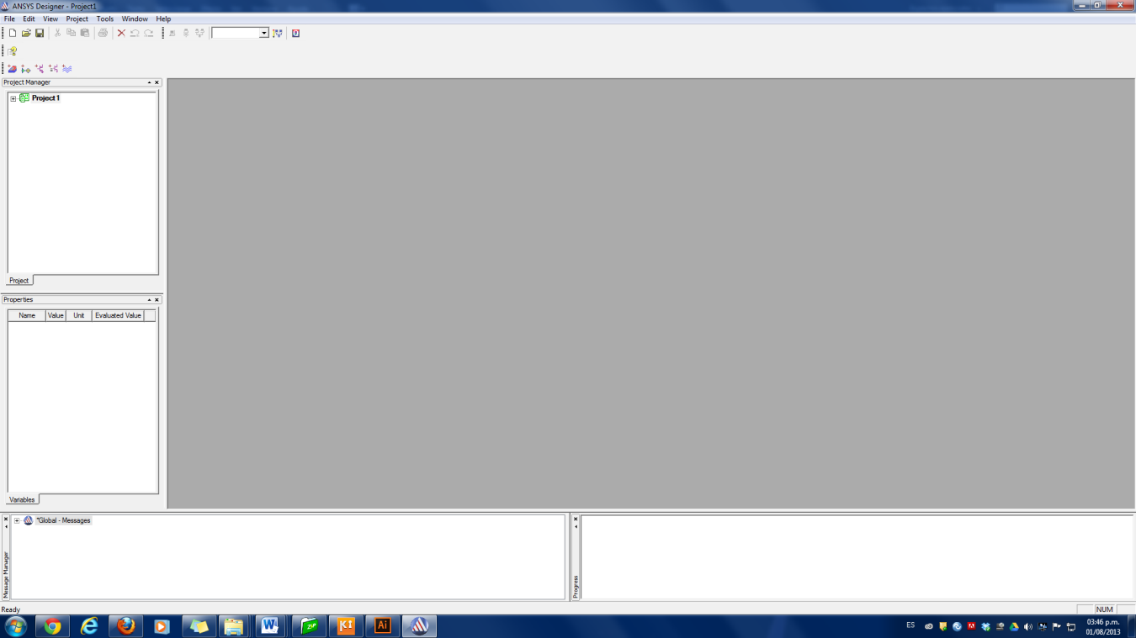

Image 7: Design Window.

1. Click on the Insert EM File icon. Then a window with the name Choose Technology will open, select the substrate suitable for the work to be done, in case only printing is desired, it is advisable to select FR4 which is the substrate used in the printed circuit laboratory and place it Open.

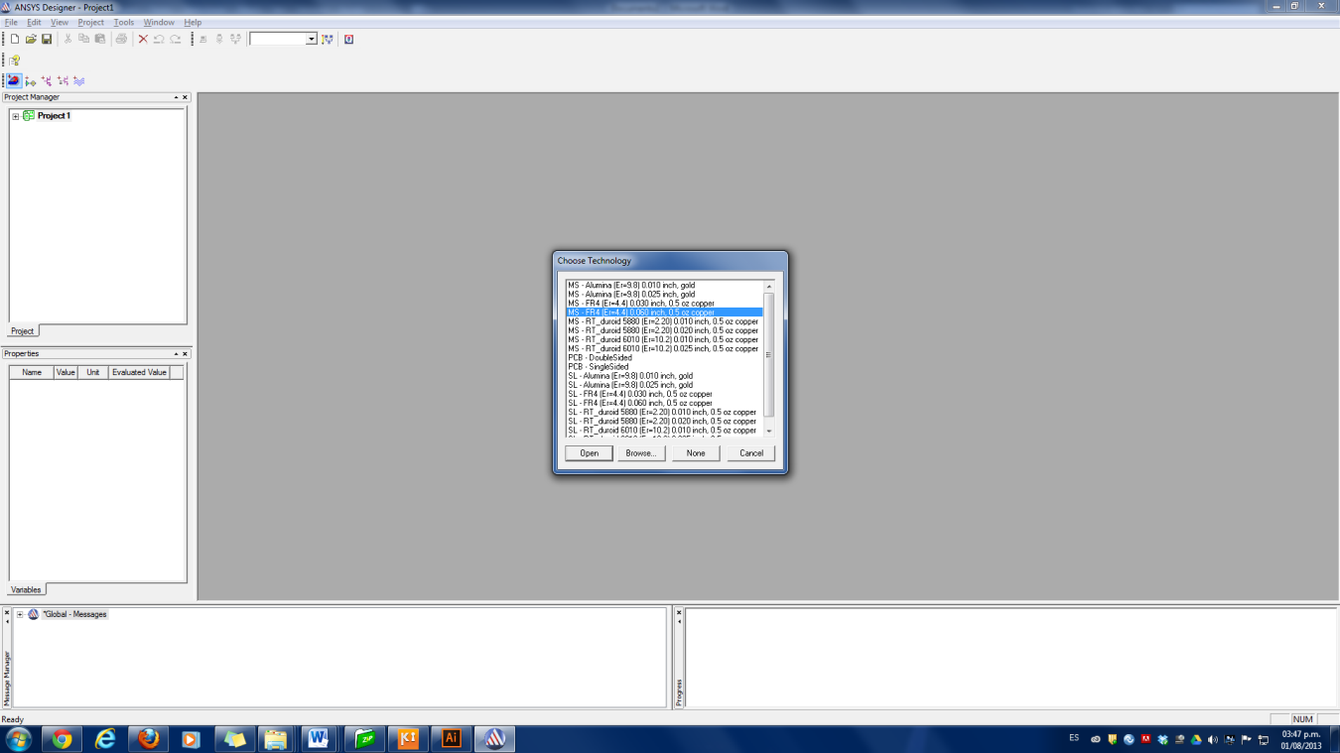

Image 8: Choose Technology Window.

1. Now click on File, choose the Import option, and then the AutoCAD option. Finally, what should be done is to look for the file that was made in Adobe Illustrator.

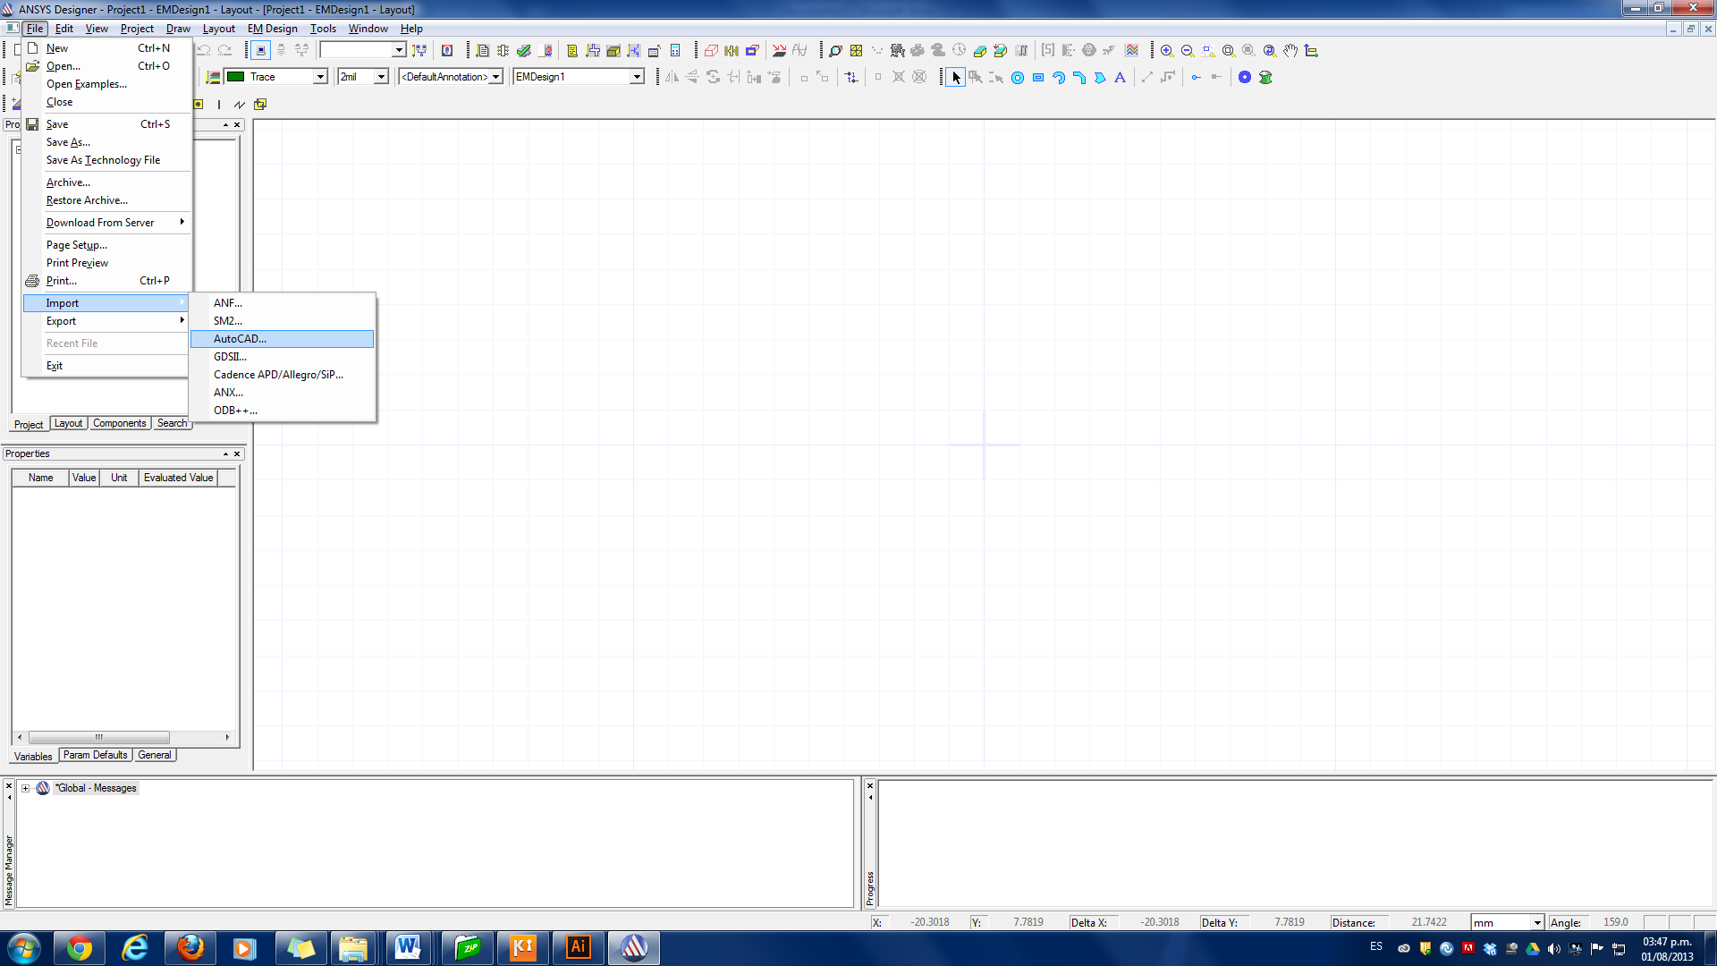

Image 9: Open a file in Design.

1. Then select the layer(s) that you want to send for printing.

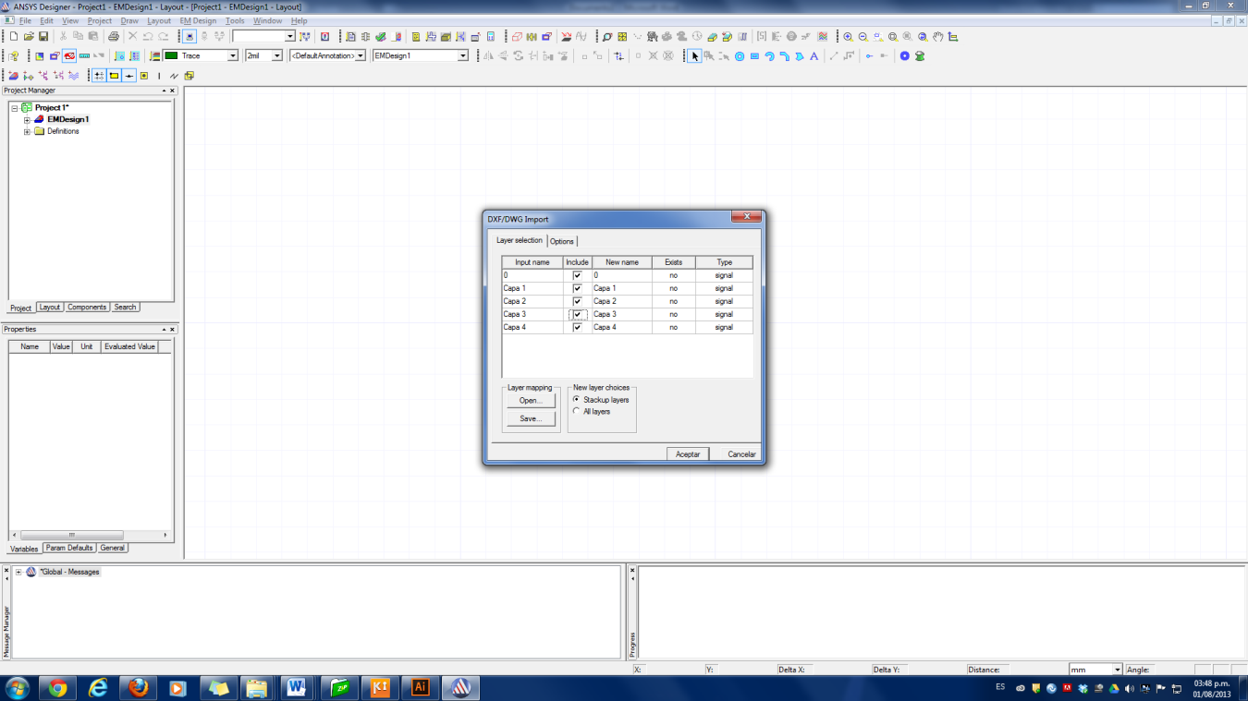

Image 10: Layer Selector Window.

1.  At this point, you only need to use the tool with which you must make a polygon that borders the circuit design made in Adobe Illustrator to be printed. When you have already made the polygon bordering the circuit and you want to finish using the polygon tool, double-click on the final vertex of the polygon stroke.

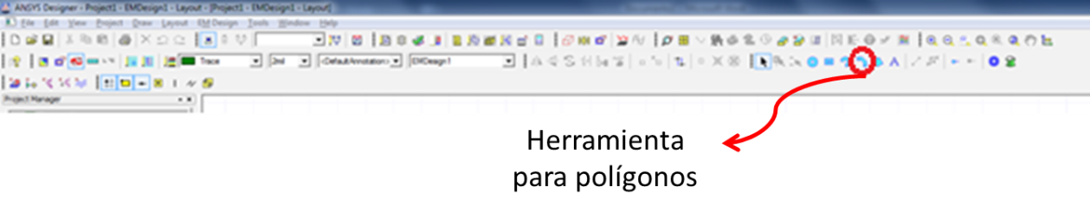

Image 11: Polygon stroke icon location.

Given the printing technology of the printed circuit laboratory, it is necessary to invert the colors of the mask to create a negative.

7. After this procedure, all that remains is to export the finished circuit. Then, go to File and select the Export option. Subsequently, select the Gerber option. Now, a window will appear where you put the name you want to save the file with. At that time, a window will appear in which certain parameters are selected to make the Gerber file. Therefore, the first thing to do is to delete all the layers that are selected by default, this can be done by clicking on the Delete button. Then click on the New button and select the layers that were used in the making of the circuit and that you want to print. You must also select the Trace option. Finally, click OK.



Image 12: Creating a Gerber File.

## THIRD PART

1. Open Gerbmagic. This tool is used to check that the Gerber file that has just been generated is in good condition to be printed.
2. Go to the File tab, then select the Open option and finally search for the Gerber file and open it. If the file opens, this means that it is in good condition and that file can be sent for printing.



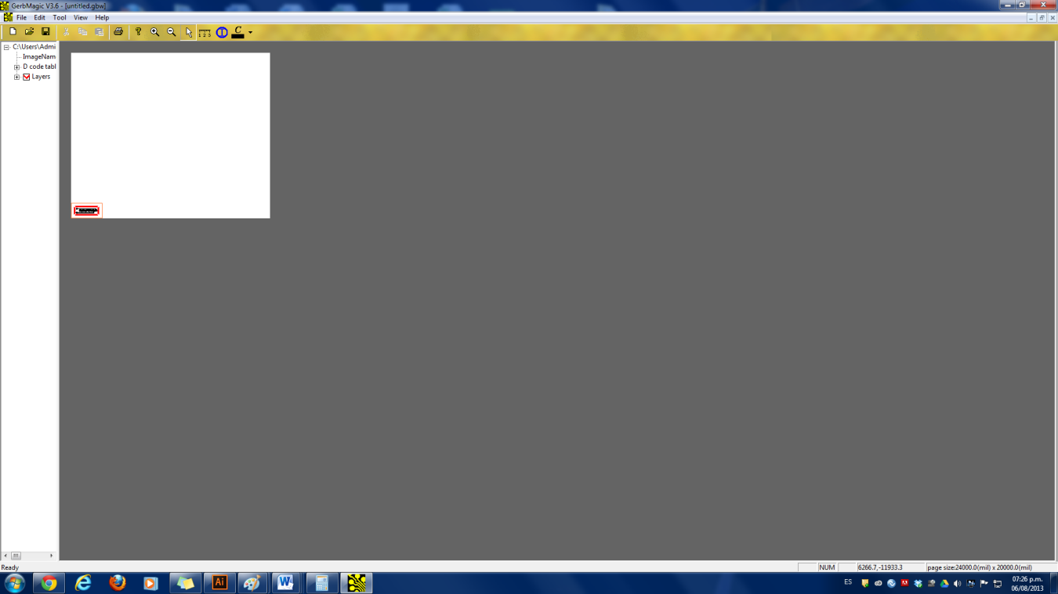

Image 14: Opening files in Gerbmagic.

# BIBLIOGRAPHY

Adobe. (2012). *Adobe*. Recuperado el 2 de Agosto de 2013, de Illustrator/Herramientas: http://help.adobe.com/es_ES/illustrator/cs/using/WS714a382cdf7d304e7e07d0100196cbc5f-6337a.html

# CHANGE CONTROL

|  |  |  |  |
| --- | --- | --- | --- |
| **CHANGE DESCRIPTION** | **DATE** | **VERSION** | **APPROVED BY** |
|  |  |  |  |