**PROTOCOL FOR THE DESIGN OF MASKS FOR THE MANUFACTURE OF ARTIFICIAL ARTERIES WITH SF-100.**

***Version 1.0***

**Produced by: Zahira Itzel González Cleves**

1. **O**BJECTIVE

To show the Uniandes community the procedure that must be followed in designing masks to manufacture microchannels with SF-100 in the cleanroom laboratory of the Electrical and Electronic Engineering department.

# SCOPE

To inform the Uniandes community about the preparation required for the use of SF-100 in the cleanroom laboratory.

# DESIGN SPECIFICATIONS AND RESTRICTIONS

## FORMAT

In the cleanroom laboratory of the University of Los Andes, the equipment used to produce prototypes of micro-patterns on different layers of photoresist is called SF-100 (Micro Patterning). This equipment receives monochromatic .bmp files and it is understood that the maximum exposure area of the SF-100 is 1024 pixels x 768 pixels.

The SF-100 uses two different exposure technologies: one with an approximate pixel size of 15µm x 15µm and the other with an approximate pixel size of 5µm x 5µm. (For this protocol, the 15µm technology will be used).

To align successive masks, alignment patterns must be included in the designs.

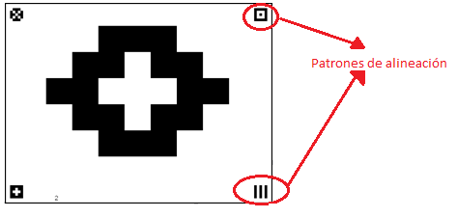

Figure 1: Example of a mask with alignment patterns.

For device identification, the first mask should have information about the project, designer, version, and date, and each subsequent mask should indicate the corresponding mask number. The font size for the labels should be 11. Information that needs to be easily visible should have a font size of 36 or larger.

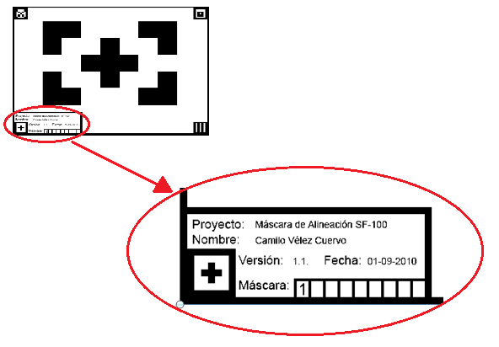

Figure 2: Example of a label for mask identification.

## BONDING PAD

The minimum size for bonding pads for soldering with Ball Wire solder is 12x12 pixels.

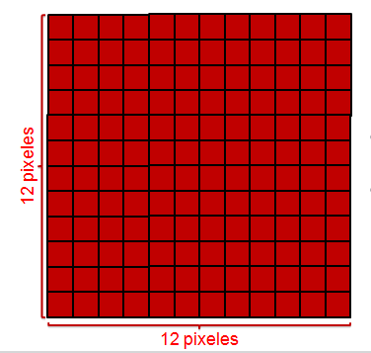

Figure 3: Minimum size of bonding pads

## SPACING

It is recommended to maintain a minimum distance of 4 pixels between microchannel lines that are located next to each other.

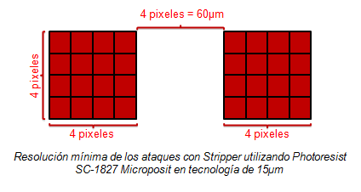

Figure 4: Recommended minimum resolution.

## TOOLS

Although it is quite feasible to design the .bmp file for the masks using Microsoft Paint, it is recommended to use a more advanced drawing program that allows control over the sizes of geometric shapes in terms of pixels and that preferably handles layers. Adobe Illustrator CS5 is recommended for this task.

## REMEMBER

The final design is the superposition of layers made with different matching masks.

The design should consider margin shifting of the masks.

# STEP BY STEP WITH PAINT

1. If the mask design is done with Paint, open the window and select the Paint Menu located in the upper left part of the window. Then select the Properties option.
2. When selecting Properties, a window will open where the file size can be adjusted, in this case a size of 1024 pixels x 768 pixels is desired.



Figure 5: Steps to access file properties.

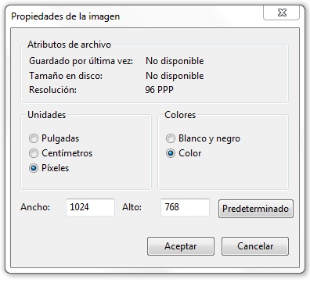

Figure 6: Window to change and verify file size.

1. In the top toolbar, select the View tab and activate the grid. To visualize the amount of pixels in the microchannel design, a zoom of 500% or higher is recommended.

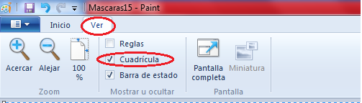

Figure 7: Steps to make the grid visible in the file.

1. It is possible to know the amount of pixels that correspond to a distance through a simple rule of three:

**Remember that this equation only applies if the technology used is the one in which 1 pixel equals 15µm x 15µm

In this case, artificial arteries of 1cm in length are required, therefore, the required number of pixels can be found using the rule of three:

The length is rounded to 667 pixels. A line of this length is drawn as centered as possible, leaving as much space as possible to the right and left of the image, as that space will be needed later. For this purpose, it is suggested that the left end of the line be at coordinates (177, y).

In the same way, the number of pixels for the width of the line is calculated. For the purposes of this protocol, the line will be 15µm wide, which is equivalent to 1 pixel.

1. Thin tubes similar to infusion tubes used in hospitals are used for fluid injection into the microchannels. In this case, the diameter of these tubes is approximately 2mm, so it is necessary to make the corresponding hole in the mask.

Therefore, a circle with a diameter of approximately 130 pixels is drawn at the left and right ends of the image so that the previously drawn line is aligned with the middle of the circumference. Remember to leave a minimum of 4 pixels between the circumference and the edge of the image for safety.

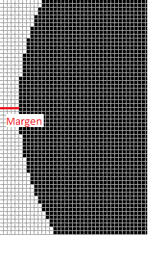

Figure 8: Margin between the device figure and the image border.

Note that in this case, the margin was 5 pixels.

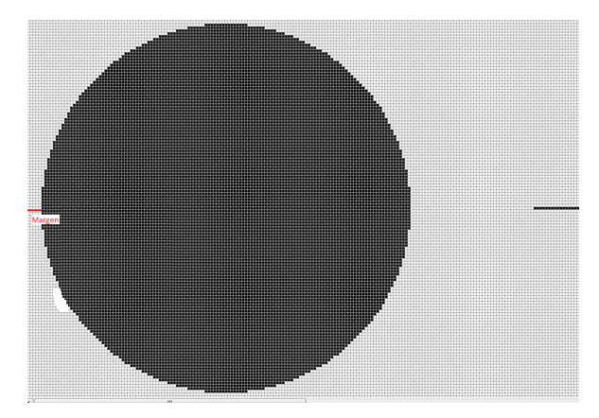

Figure 9: Progress of the mask seen with a 500% magnification.

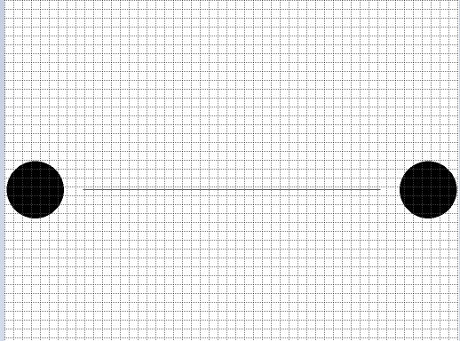

Figure 10: Progress of the mask seen with a 50% magnification.

It is not necessary for the circles to be centered vertically but they should be opposite each other.

1. In the free space between the left end of the line and the left-side circle, a triangle should be located such that one of its vertices intersects with the end of the line and the other two intersect with the circumference. This triangle will provide a smooth entry for the fluid.

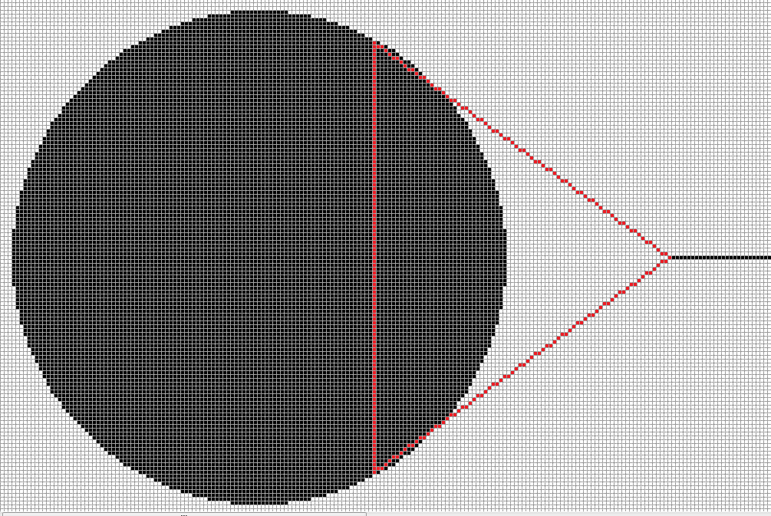

Figure 11: Scheme of the union between the microchannel and one of the device terminals.

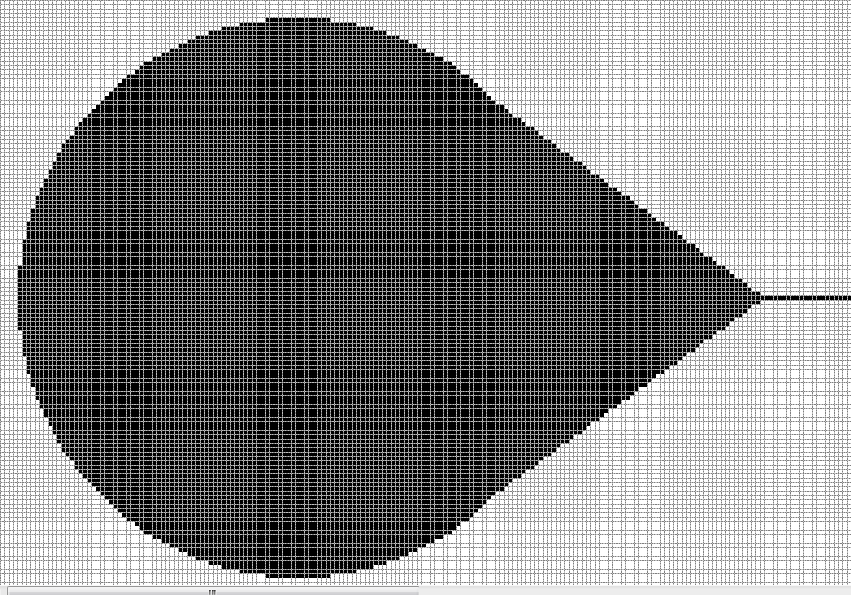

Figure 12: Union between the microchannel and one of the device terminals.

Now a triangle is made in the same way at the other end of the microchannel.

The result will be similar to:

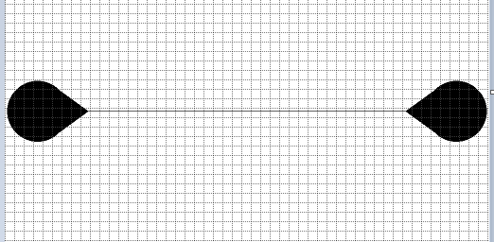

Figure 13: View of the device mask with a 50% magnification.

1. The alignment patterns are now drawn and the label with information about the project, mask, and student's name is created. A good pattern size is 25x25 pixels, and it is recommended to leave a 2-pixel margin between the patterns and the image's edges.

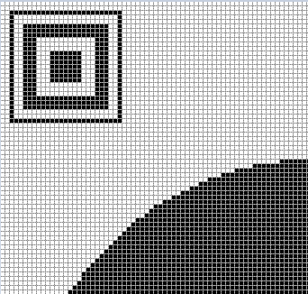

Figure 14: Alignment pattern viewed with a 600% magnification.

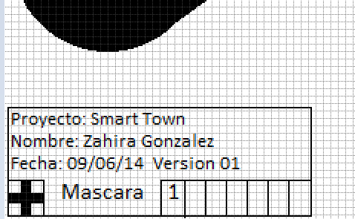

Figure 15: Label marking the first microchannel.

1. The channel's width is information that should be visible at a glance; therefore, it will have a font size of 36 or larger.
2. The system's inputs should be marked with a downward arrow and a number, while the system's outputs should be marked with an upward arrow and a number. The numbering of inputs and outputs should be sequential.
3. The image's margin should be 3 pixels wide. It can be a complete margin or divided to not interfere with the design.

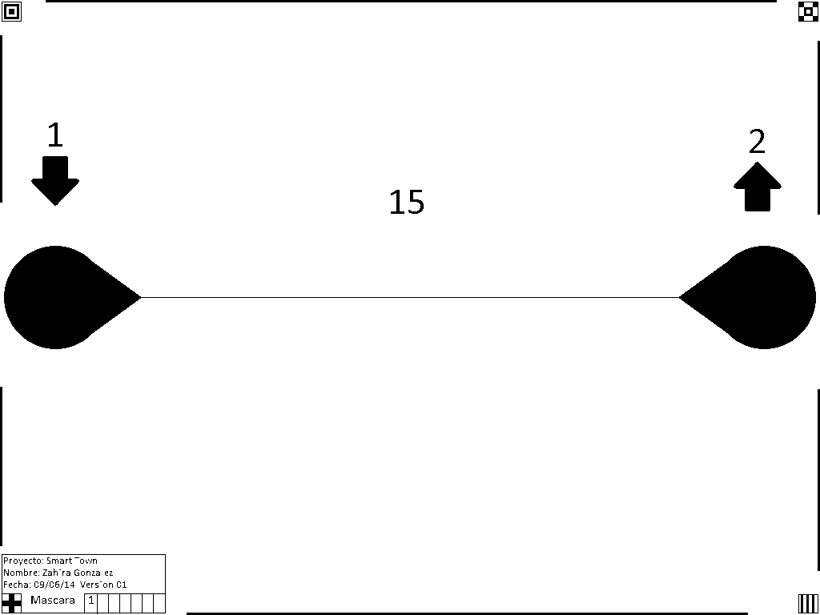

Figure 16: Final result of the mask.

Note that in this case, the margin is divided. The device has a numbered input 1 because it is terminal 1 and a numbered output 2 because it is terminal 2. The channel width is observed to be 15µm.

1. The file should be saved as a monochrome bitmap like this:

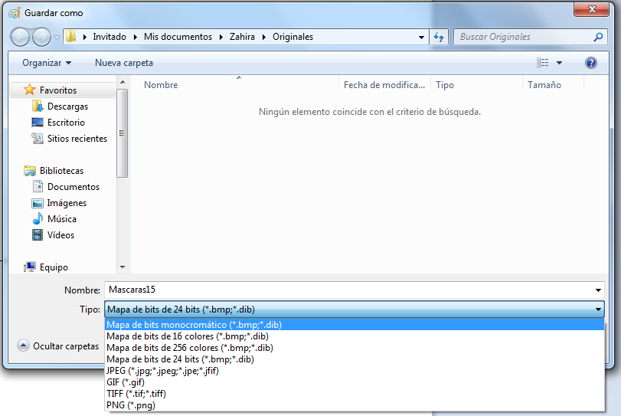

Figure 17: Description of steps to save the file.

And select "accept" when prompted:

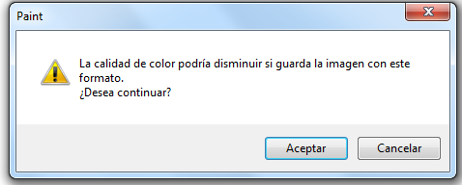

Figure 18: Description of steps to save the file.

# STEP BY STEP WITH ADOBE ILLUSTRATOR

1. The following is an example of a two-layer manufacturing process where the masks were drawn using black for the first layer and red for the second layer.

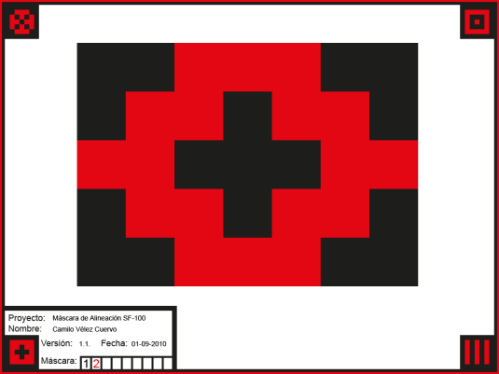

Figure 19: Example for two layers.

1. The SF-100 must receive two separate files for each of the layers. The file must be monochrome as shown below. The alignment patterns of the masks corresponding to different layers must be complementary as shown below:

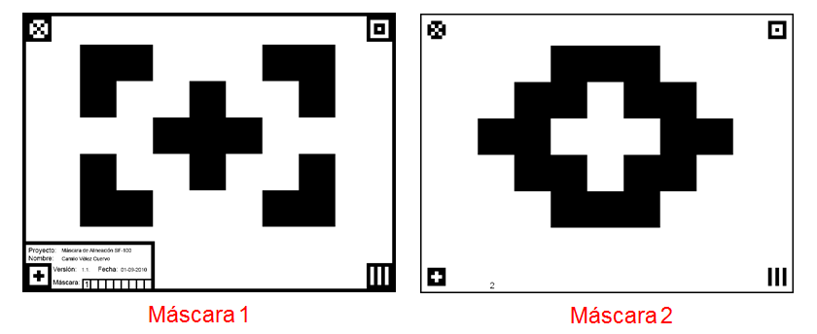

Figure 20: Example for two layer.

1. Once the masks are designed using Adobe Illustrator's layers function, keeping in mind that colors can be used to facilitate layer visualization in this program, export the files layer by layer.
2. With only the first layer (layer) turned on, click on File/Export*.*

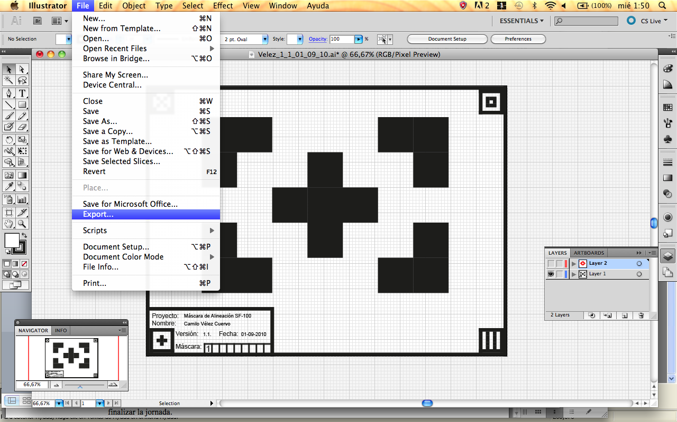

Figure 21: Steps to export.

1. Write the name and select BMP (bmp) format, then click Export.

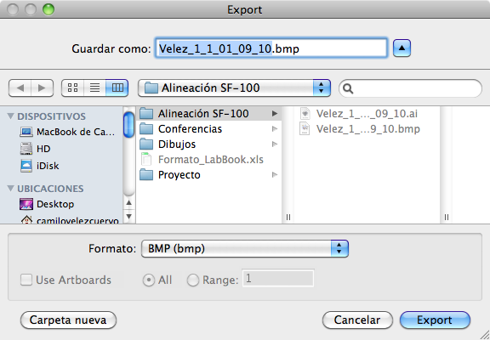

Figura 22: Pasos para exportar.

1. To manufacture in the cleanroom, students must submit a .zip file with the masks properly marked and identified. The .zip file should be marked with the first last names of the group members, and the name of each .bmp file should have the structure: last name1_last name2_mask_version_date(mm_dd_yy).bmp.

*Example:*

*The file Bolivar_Nariño.zip contains the files: Bolivar_Nariño_1_1_08_04_10.bmp*

*Bolivar_Nariño_2_1_08_04_10.bmp*

*Bolivar_Nariño_3_1_08_04_10.bmp.*

1. Select and click OK:

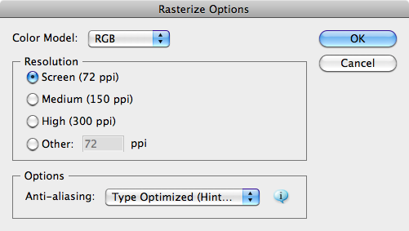

Figure 23: Steps to export.

1. Select and click OK:

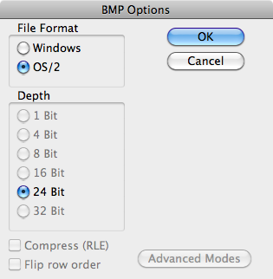

Fig24. Pasos para exportar

1. Once the .bmp file is exported, open it using Microsoft Paint and save it as a monochrome file:



Figure 24: Steps to save.

1. Overwrite the file as a "Monochrome Bitmap (*.bmp, *.dib)" type, click Save, and confirm the action of overwriting the file.

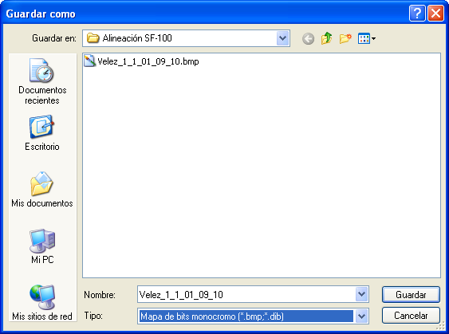

Figure 25: Steps to save.

1. In front of the following pop-up message, you must indicate YES:

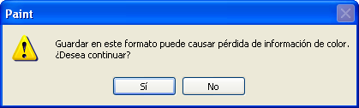

Figure 26: Steps to save.

1. It is important to confirm that the file has been created and saved with the dimensions allowed by SF-100. To do this, right-click on the file icon in the explorer and observe the Summary tab.

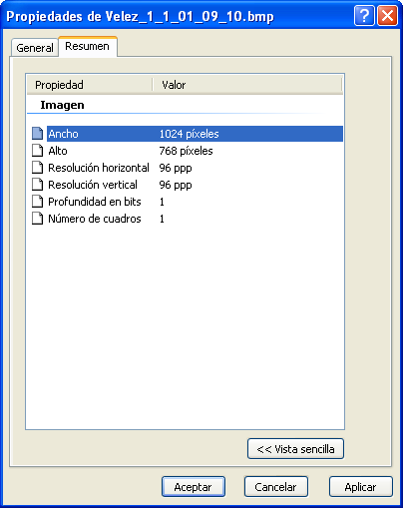

Figure 27: Steps to verify the size.

1. Finally, open Adobe Illustrator and turn off the current layer and turn on the next one that you want to export and repeat all the mentioned steps, taking care to change the file names.

The process must be repeated for all the layers that require the use of micro etchings on photoresist.

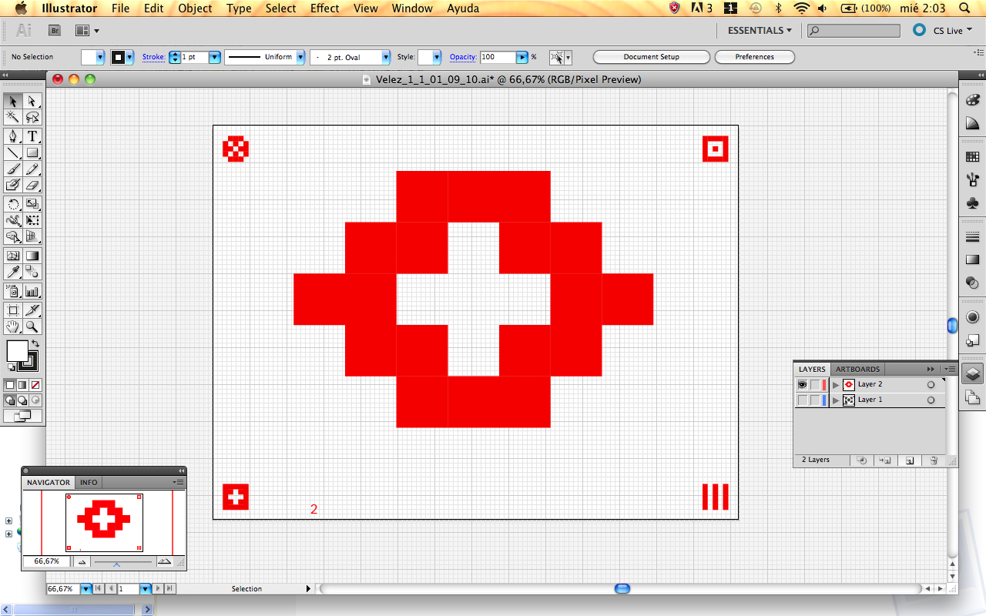

Figure 28: Steps to change active layers.

# CHANGE CONTROL

|  |  |  |  |
| --- | --- | --- | --- |
| **CHANGE DESCRIPTION** | **DATE** | **VERSION** | **APPROVED BY** |
|  |  |  |  |