**PROTOCOL FOR OBSERVATION, HANDLING, AND INJECTION OF FLUIDS IN FLUIDIC MICROSYSTEMS**

***Version 1.0***

**Produced by: Zahira Itzel González Cleves**

# OBJECTIVE

To show the Uniandina community the procedure that must be followed when using the microscope and microinjector to work with fluidic microsystems in the cleanroom laboratory of the electrical and electronic engineering department.

# SCOPE

To inform the Uniandina community of the procedure to be followed for the observation and injection of liquid into microfluidic systems in the cleanroom laboratory.

# MICROSCOPE USE CONDITIONS

Parts of a microscope:

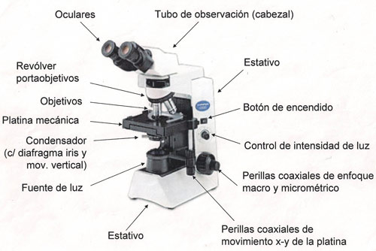

Figure 1: Parts of an optical microscope http://www.asturnatura.com/articulos/estructura-funcion-celular/metodos-estudio-celula.php.

The microscope must be supported on a firm and flat surface, as well as the microinjection system.

## TURN ON THE MICROSCOPE:

1. Identify the parts of the microscope (See Figure 1)
2. Remove the protective cover
3. Turn on the camera(s). If it is required to incorporate/withdraw any memory or battery, do it and then reposition the camera (see section: "Reposition the camera")
4. Turn on the microscope using the switch located on the right side of it.
5. Increase the light intensity using the knob that controls the lighting located on the right side of the microscope.
6. If you want to connect fluidic microsystems, refer to the section "Microsystem connections." Otherwise, refer to the "Sample observation" section.

## CAMERA REPOSITIONING

1. In case the camera support is not placed on the microscope, it is necessary to put it. To do this, first, adjust the camera to the support using the screw at the bottom of it that fits into the bottom of the camera. It is necessary that the camera lens is in the center of the support hole to operate it and zoom correctly.
2. Once the camera is on the support, place the support in one of the microscope eyepieces. The eyepiece fits into the support hole by exerting gentle pressure. If only one camera is going to be used, the support can be placed horizontally or vertically as needed, but if two cameras will be used, both supports (one for each camera) must be placed vertically, one in each eyepiece.
3. Now turn on the microscope using the switch located on the right side of it. And turn on the camera.
4. Increase the light to its maximum and zoom with the camera until a totally white background is seen on the camera screen.

## MICROSYSTEM CONNECTIONS

1. Take a 10ml or 5ml syringe preferably and fill it with the necessary fluid so that the syringe is well supported in the microinjector and the plunger of the syringe exceeds the microinjector push lever slightly.
2. The "microfluidic connection for syringes" hoses have two ends: one is the hose, and the other has a plastic coupling. Connect the plastic coupling to the syringe nozzle; it must fit perfectly.
3. Now push the syringe plunger to empty some of the liquid through the hose until the syringe plunger is fully supported on the microinjector push lever. The liquid should be emptied into a plastic container. Do not forget to have absorbent towels within reach in case of spills.
4. Connect the other end of the microfluidic connection hose to the microsystem inlet.
5. Continue with the "Sample observation" steps.

## SAMPLE OBSERVATION

1. Gently push back the lever on the stage to position the sample (or microsystem), and then secure it by releasing the lever. Be careful that the hose does not obstruct the observation of the sample.
2. Use the x-y stage control to position the sample over the light beam. This control is located vertically on one side of the microscope; the upper knob moves the stage back and forth, while the lower knob moves it from side to side.
3. Once the sample (or microsystem) is positioned, use the coarse focus to bring the sample or the desired section into view. The coarse focus knobs are located on the sides of the microscope and are distinguished by the larger knob; the smaller knob located above it is the fine focus.
4. Then, use the fine focus adjustment to bring the sample into sharp focus.
5. Adjust the light intensity to achieve appropriate contrast for observing the sample.
6. If a higher magnification is required, lower the stage so that the revolving nosepiece can rotate without hitting it, and then set the desired objective magnification. After this, refocus is necessary.
7. To use the microinjector, it is necessary to connect it to a computer with MatLab via a parallel port, since the program that controls the microinjection was designed in MatLab.

## TURNING OFF THE MICROSCOPE:

1. Turn off the light completely using the illumination control knob located on the right side of the microscope.
2. Adjust the stage to its lowest position using the coaxial coarse focus knob.
3. Use the lowest magnification objective, in this case 4x. Locate this by rotating the nosepiece (not the objectives) until it is in the desired position.
4. Turn off the microscope using the switch located on the right side of the microscope.
5. Turn off the camera(s). Leave the cameras and their mounts attached to the microscope. If any memory or battery needs to be removed, do so and then reposition the camera (see section: "Reposition the Camera").
6. Finally, put on the protective cover.

# CHANGE CONTROL

|  |  |  |  |
| --- | --- | --- | --- |
| CHANGE DESCRIPTION | DATE | VERSION | APPROVED BY |
|  |  |  |  |