**PROTOCOL FOR PREPARATION OF SOLUTES, MOLARITY CALCULATION, AND SOLUTION PREPARATION.**

***Version 1.0***

**Produced by: María Camila Guachetá Buendía**

# OBJECTIVE

To show the Uniandes community the procedure that must be followed when using the precision balance in the cleanroom laboratory of the Department of Electrical and Electronic Engineering.

# SCOPE

To inform the Uniandes community about the procedure to be followed when using the precision balance, and to facilitate the preparation of solutes and solutions with a high degree of accuracy in the cleanroom laboratory.

# STEP BY STEP

## PART ONE: PREPARATION OF SOLUTION AT A DETERMINED MOLARITY

### CONTEXT

For this first part, Potassium Ferricyanide and Potassium Ferrocyanide will be used as solutes. These solutes are used because they:

* Allow the study of surface phenomena.
* Are soluble in water.
* Undergo transfer of one electron, indicating that:
  + There are no secondary reactions in the process.
  + No new faces are formed in the process.
* Are glucose meters.
* React quickly at many electrodes.
* Are used in amperometric biosensors.
* Allow the study of mass transport effects.

The concentration level in liquids is measured in Moles ([M] = (mol X)/L)



Figure 1: a) Potassium Ferricyanide and b) Potassium Ferrocyanide.

### METHODS OF PREPARING SOLUTION AT A DETERMINED MOLARITY

To prepare a solution, the following parameters need to be known:

1. Desired concentration level [NC] of the solute in the solution.
2. Volume of the solution.
3. Molecular weight [PM] of the solute to be used.

***Note:*** The molecular weight of the solute can be found on the package, as shown in the following image:



Figure 2: a) PM of Potassium Ferricyanide and b) PM of Potassium Ferrocyanide.

The units in which the molecular weight is expressed are: , y.

The procedure for determining the mass of the solute needed is as follows:

**▲** *Example 1 - Potassium Ferricyanide/Potassium Ferrocyanide:*

The mass of each solute needs to be determined to create the Ferricyanide/Ferrocyanide electrolyte.

Desired concentration level:

Volume of the solution:

Molecular weight of Potassium Ferricyanide:

Desired concentration level:

Volume of the solution:

Molecular weight of Potassium Ferrocyanide:

Once the required amounts of solutes are obtained to create the Potassium Ferricyanide/Potassium Ferrocyanide solution, they can be mixed with the corresponding amount of water to obtain the solution.

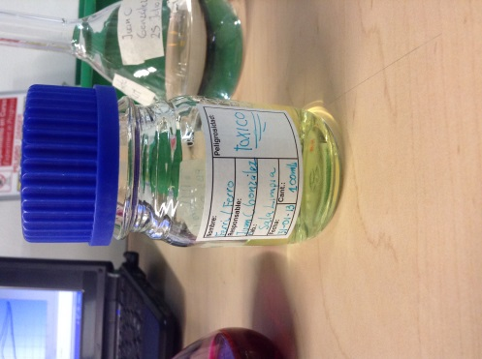

Figure 3: Potassium Ferricyanide/Potassium Ferrocyanide solution.

### PROCEDURE TO OBTAIN THE REQUIRED SOLUTE MAS

1. In order to accurately obtain the necessary mass of the solute for the preparation of the solution, it is of utmost importance to use the precision balance. The procedure for using the precision balance is as follows:
2. Prepare a piece of paper, aluminum or container to put the solute on when weighing it, but make sure that this "container" weighs less than the amount of solute to be measured.
3. Now place the "container" on the precision balance.
4. Make sure the precision balance is level.
5. Then tare the precision balance, which sets the weight to zero on the precision balance, already having the container on its balance but without counting the weight of this "container".

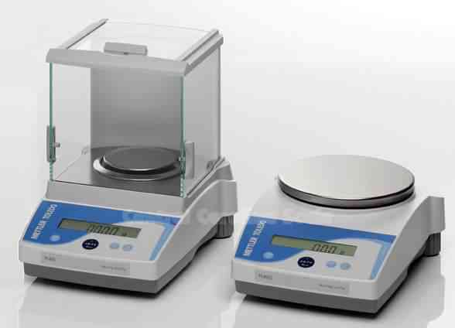

Figure 4: Precision Balance.

***Recommendations:***

* Do not lean or place anything heavy on the surface where the precision balance is located when leveling, taring and/or using it.
* Use the side that is most skilled.
* Be careful with the larger grains that the reagent may have since they may weigh more than what was needed.

If you exceed the desired mass, it is much better to start the procedure over on the precision balance.

## PART TWO: BUFFER PREPARATION BUFFER

### CONTEXT

A buffer or buffer solution is a solution that is used to maintain a constant pH, especially when working with solutions that contain biological materials that can degrade with strong pH changes. So, the buffer is really a mixture of salts that maintain the pH of the solution constant even if there are disturbances when another substance enters it.

### FORMS OF PREPARATION

To prepare a buffer, the Henderson-Hasselbach equation is needed:

[1]

Where:

, e.g. tribasic

*e.g., monobasic or hydrogen.*

The parameters necessary to create a buffer are:

1. Ionic strength level [NCI] of the buffer.
2. Acidity constant [pKa].
3. Desired pH value.

*Note:* The reagents used in the cleanroom are from Sigma, so it is recommended to enter their website to search for the acidity constant of the reagent needed. To search for this reagent on the Sigma website, the CAS number that appears on the reagent's packaging, which is the one that really identifies the reagent, should be entered.



Figure 5: a) CAS number of the reagent and b) Acidity constant.

*Example 2: Monobasic Potassium Phosphate and Tribasic Sodium Phosphate Buffer*



Figure 6: a) Monobasic Potassium Phosphate and b) Tribasic Sodium Phosphate.

Take equation [1] and solve the ratio [A^-]/[HA] to obtain:

[2]

Now the values of the desired pH and the acid pk_a are replaced. In this case, a pH of 6 is desired and there is an acidity constant of pk_a=6.82.

Thus, equation [2] becomes:

And the following relation is obtained:

[3]

It should be noted that:

[4]

For the preparation of this buffer, it is desired that NCI=0.1. Therefore, [A^- ] is isolated from equation [4], resulting in the following expression:

[5]

Now, equation [5] is substituted into equation [3], resulting in:

And [HA] is isolated:

With the previous term, the value of , can be determined,

Finally, the same procedure as in example 1▲ is followed to determine the mass of each component for the creation of the buffer.

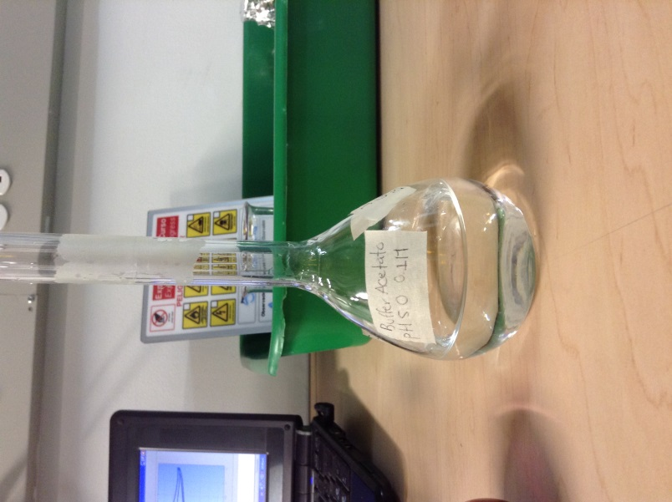

Figure 7: Monobasic potassium phosphate and tribasic sodium phosphate buffer.

# CHANGE CONTROL

|  |  |  |  |
| --- | --- | --- | --- |
| **CHANGE DESCRIPTION** | **DATE** | **VERSION** | **APPROVED BY** |
|  |  |  |  |