**ASSEMBLY OF FLUIDIC MICROSYSTEM FOR CAPSULE GENERATION**

***Version 1.0***

**Produced by: Diana Sotelo & Johann Osma**

1. **OBJECTIVE**

To show the Microsystems group community the procedure to follow for the assembly of fluidic microsystems proposed for capsule generation.

1. **SCOPE**

To inform interested parties of the steps required to correctly assemble the low-cost systems worked on in the group for the generation of small-sized capsules.

1. **MATERIALS**

* Nitrile gloves
* Glasses
* Acrylic sheet of selected thickness
* Methylene chloride (Methyl methacrylate)
* 3 or 5 mL syringe
* Glue (super glue or UHU is recommended)
* Metal connectors
* Glass sheet
* Weight (currently the one available in laboratory ML-006, weighing 2.375 kg, is used)

1. **DESIGN SPECIFICATIONS AND RESTRICTIONS**

**Format**

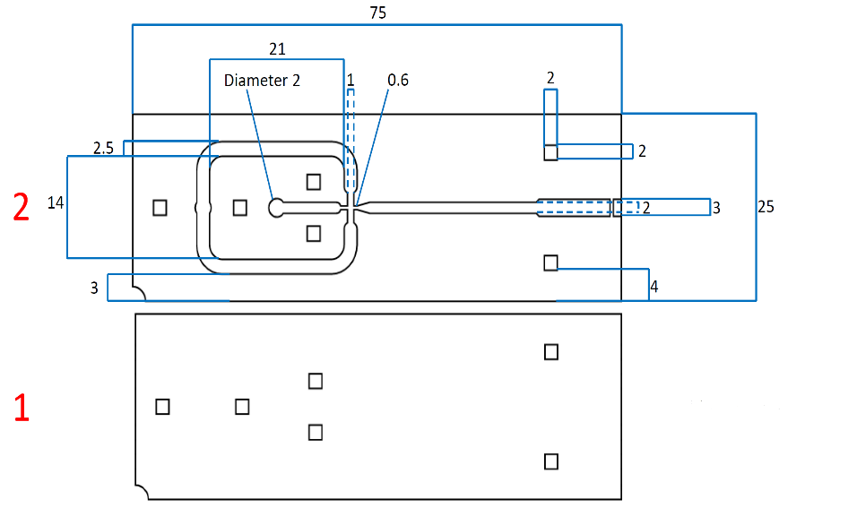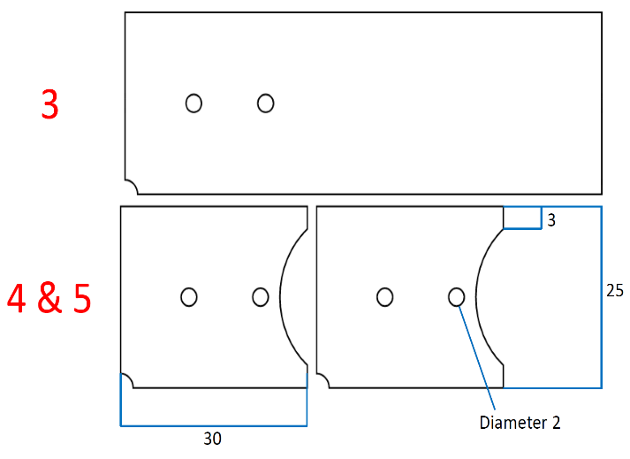

Figure 1: Proposed microsystem plans with positioning order on the left. Measurements in mm.

For the proper implementation of the above design, an acrylic plate with a thickness of 2.5 mm was obtained. Subsequently, the design in .PDF format was supplied to a laser cutting machine to obtain each sheet cut.

Additionally, the reference squares (columns) of the system were cut from a 2 mm thick sheet, so that they measure 2x5x2 mm. The length or height may vary depending on the height of the first two sheets used.

**Remember**

The final design is the superposition of the 3 layers manufactured with laser cutting and two additional ones that allow for better use or ease of positioning of the USB microscope focusing on the system output.

The design must contemplate the original dimensions, whose format is in .dxf or .PDF.

1. **STEP BY STEP**
2. Place the base sheet, marked as 1 in Figure 1, and place the columns in their respective reference squares using tweezers and surrounding the base of each square with glue. Then, place them in each hole (as vertical as possible), avoiding them getting stuck to the glass base or the table, and let them dry completely.

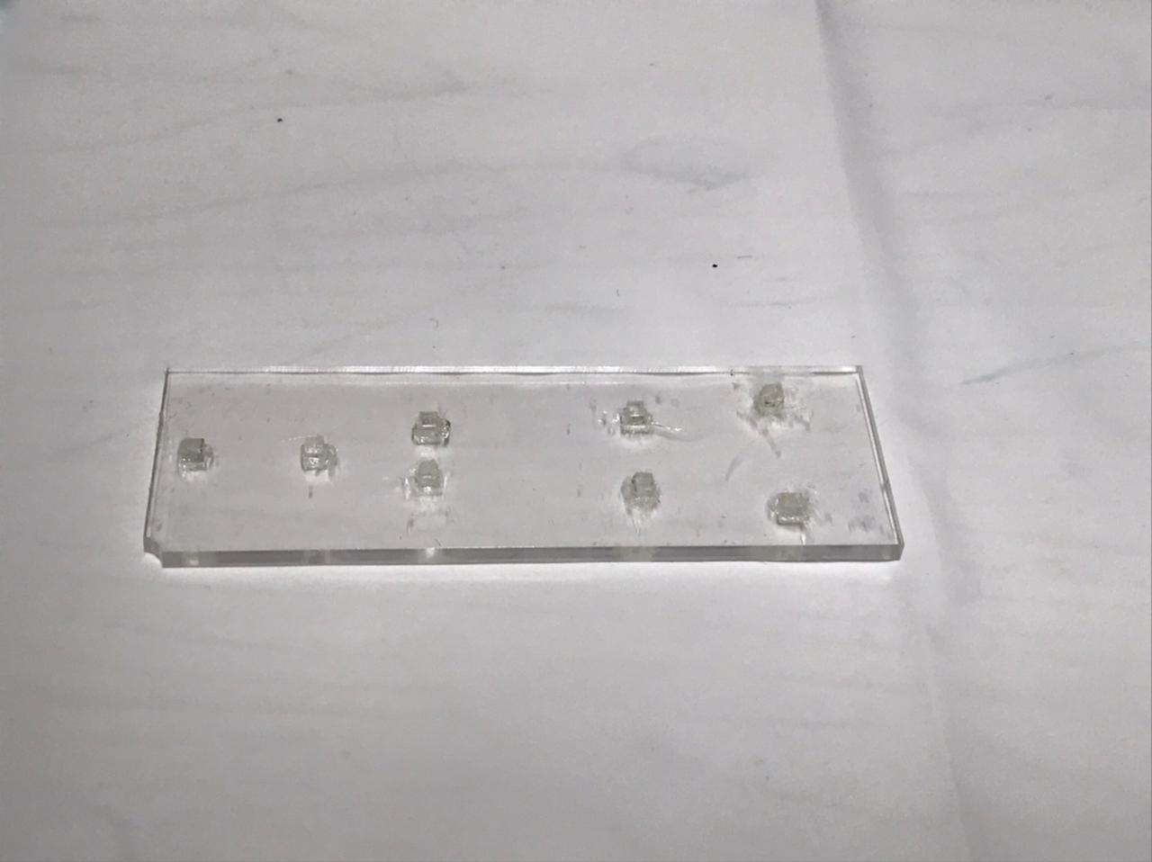

Figure 2: Base sheet with reference squares positioned.

1. Once the columns or squares are fixed on the base sheet, add the isolated part of the second level. Around the 3 corresponding squares, add the methyl methacrylate homogeneously using a syringe, and fit the section into the corresponding squares as quickly as possible. Once it is located, apply manual pressure and leave for 5 minutes with the weight on top. Remember that the methyl methacrylate starts to evaporate quickly as soon as it reacts with oxygen.

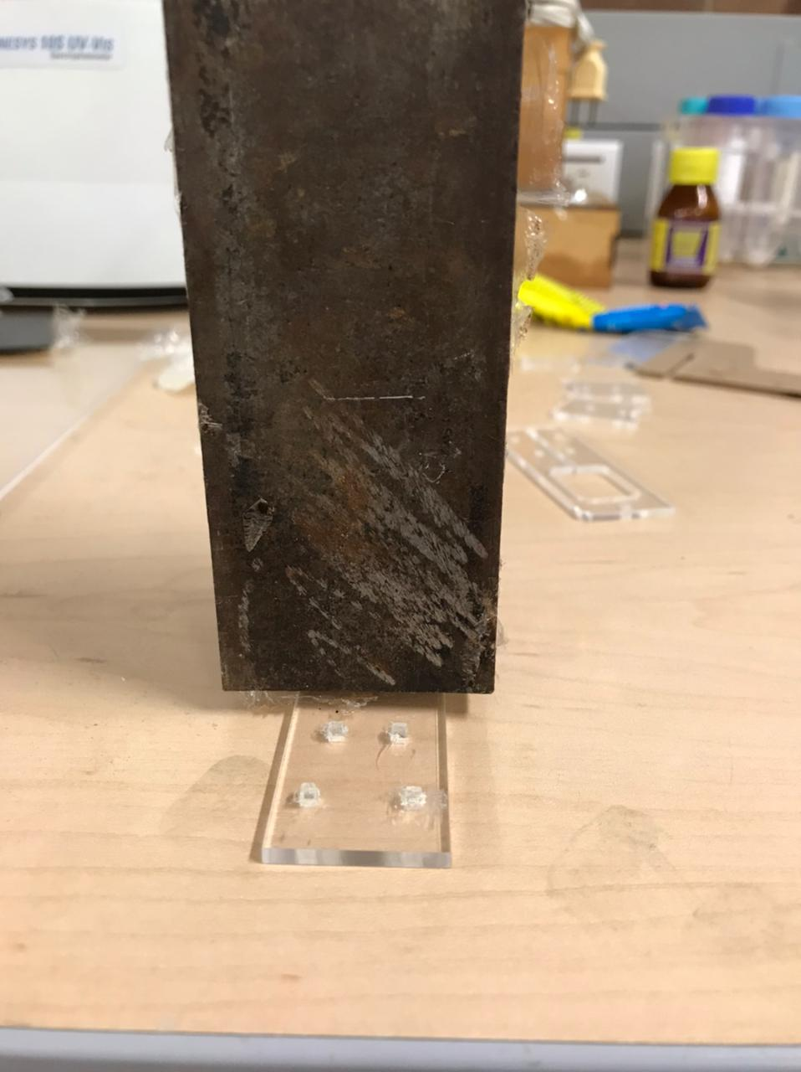

Figure 3: Front view of the weight placed on the isolated section of the second level.

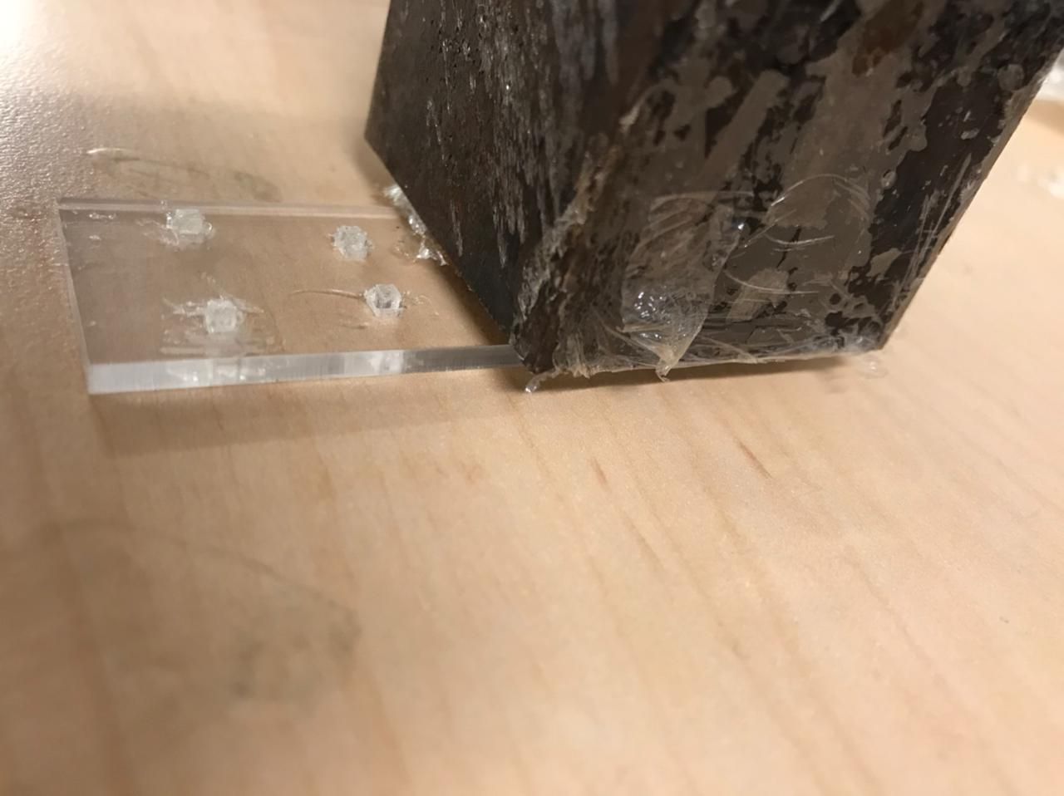

Figure 4: Side view of the weight placed on the isolated section of the second level.

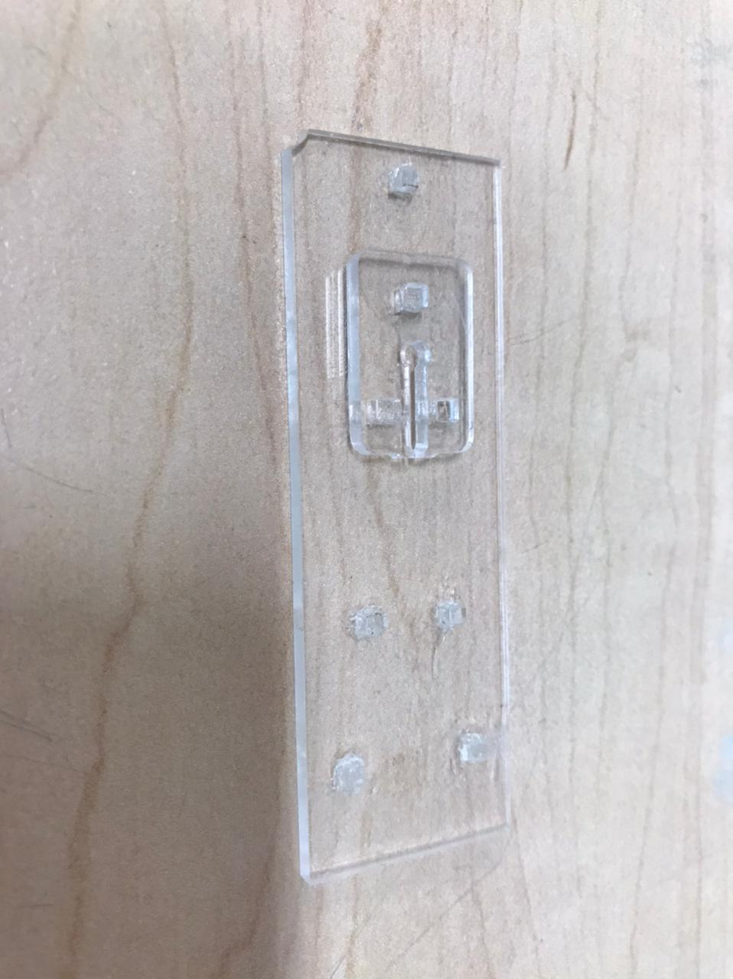

Figure 5: Isolated section of the second level located in the system.

1. Once the isolated section has been fixed, take the rest of the second level and break the end union of the channel with tweezers. Subsequently, add methyl methacrylate as uniformly as possible to the rest of the base sheet and fit the external sheet of the second level, using the reference squares. Again, apply manual pressure, place the weight, and leave for approx. 5 minutes.

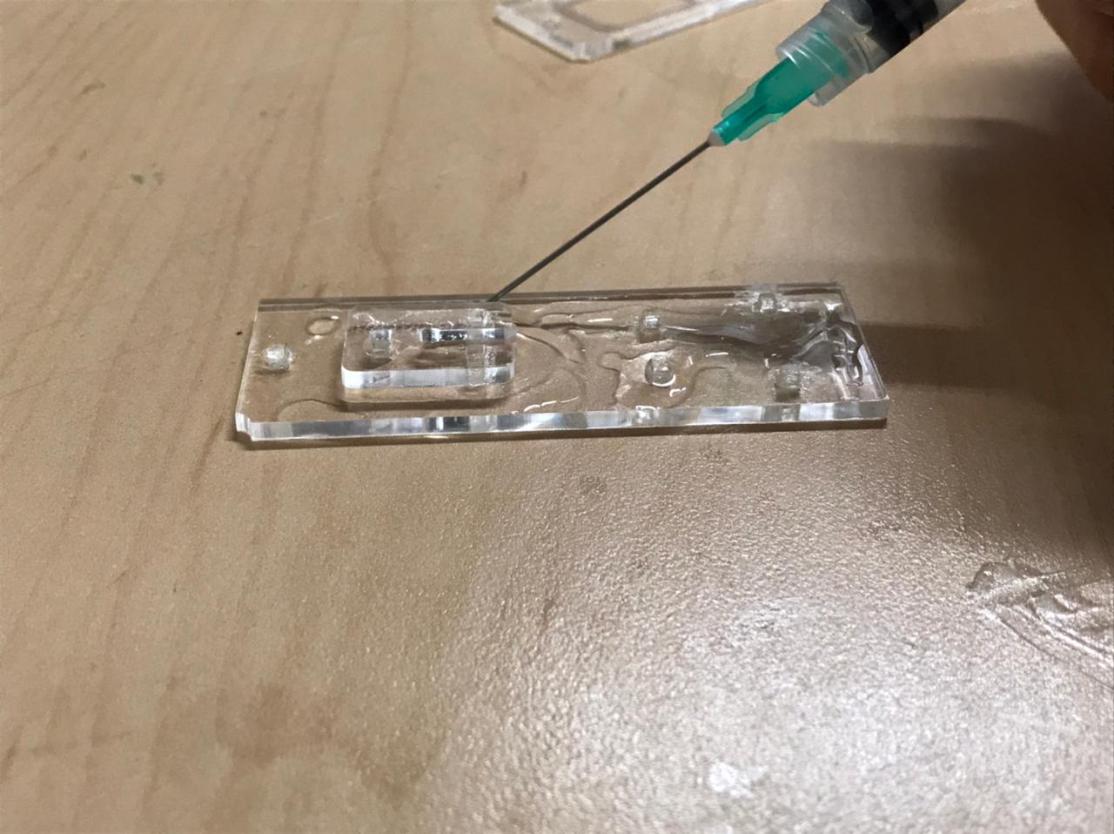

Figure 6: Addition of methyl methacrylate using the syringe.

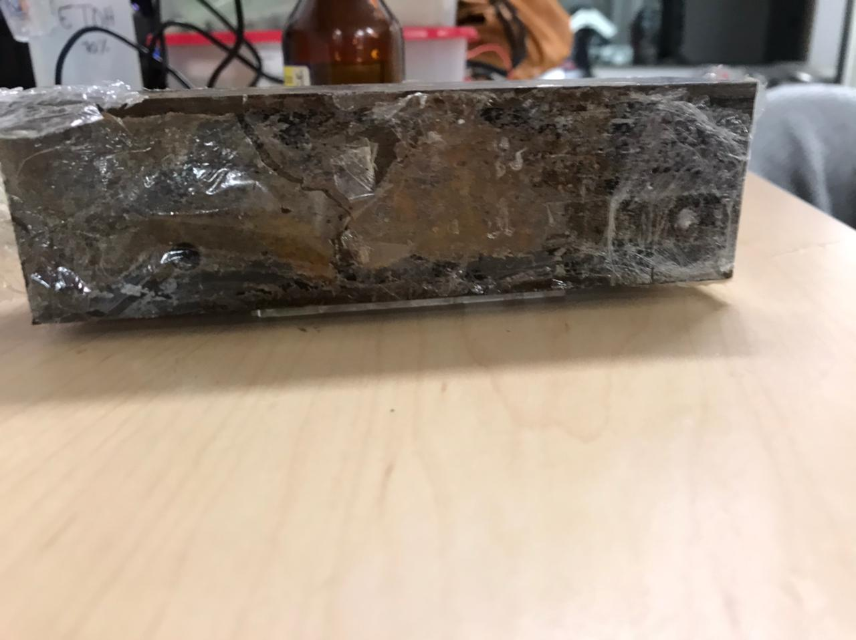

Figure 7: Weight placed on the second level.

1. Place one of the metal connectors at the channel outlet, with the longer side facing inward. Add enough glue to it, fit it, and apply pressure using tweezers. Let it dry completely.

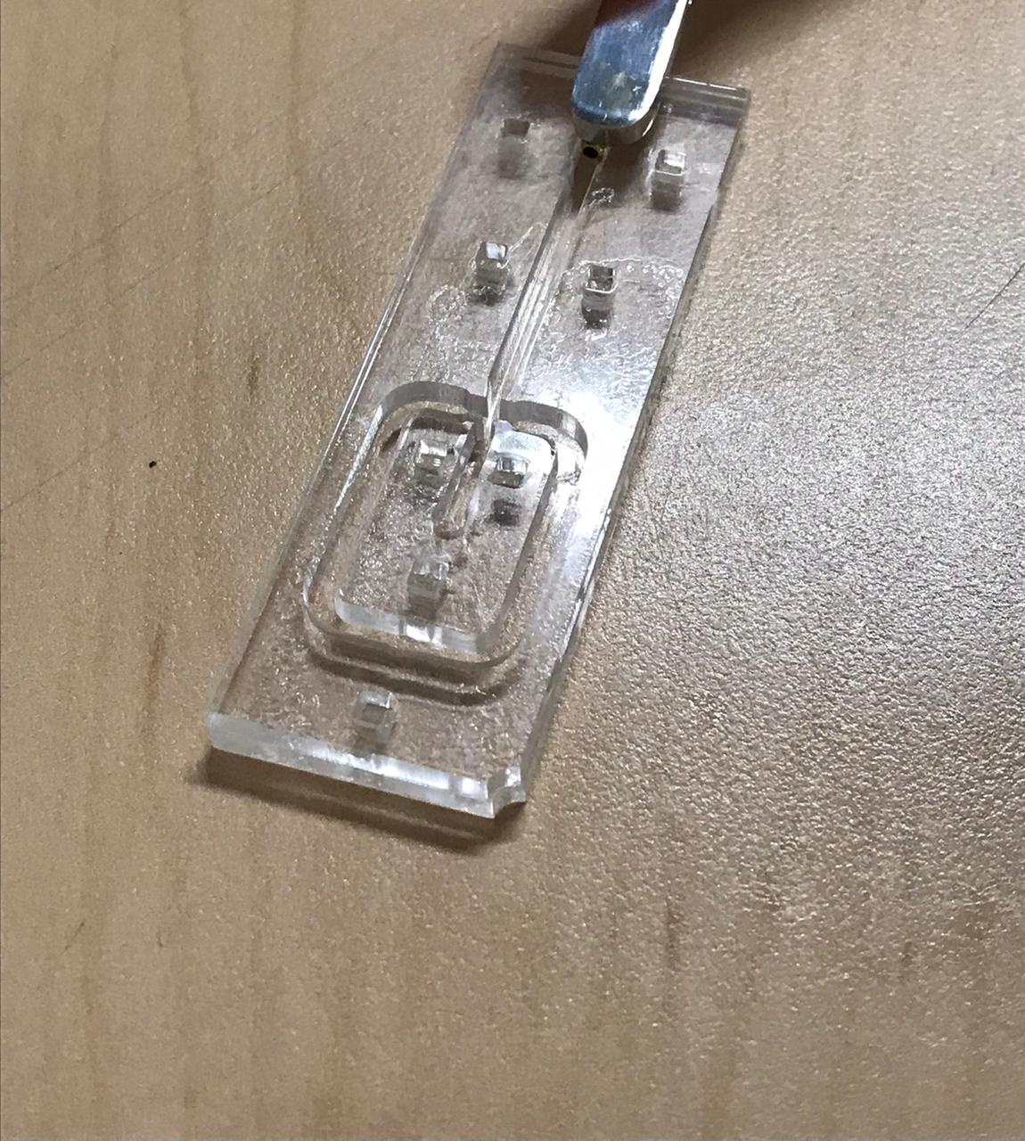

Figure 8 Location of the system output connector.

1. Once the adhesive that fixes the output connector is dry, the third level of the system is joined. Sufficient methacrylate must be added, but not in excess, so that the corresponding sheet for this level can be fixed without generating a blockage of the capsular generation section. Manual pressure is applied again, the weight is placed and left for approx. 5 min. It should be noted that a blockage in this area could render the system useless.

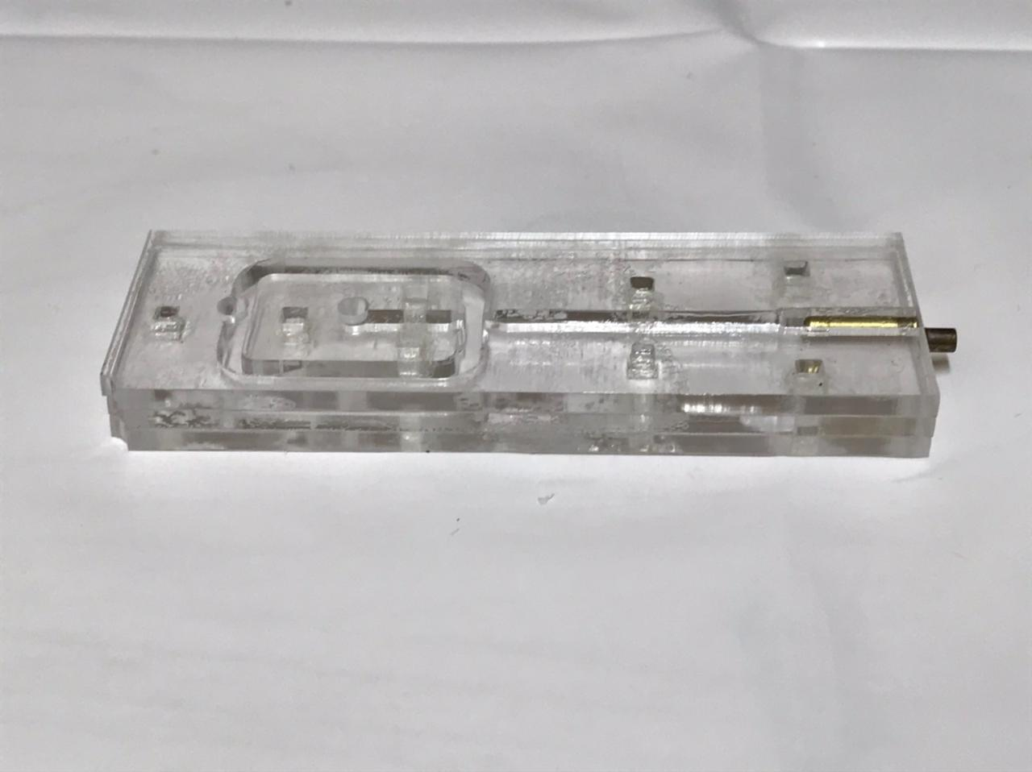

Figure 9 Microsystem assembled up to the third level.

1. A leak check of the system must be performed. For this, a syringe with a solution of tinted water is used. The syringe is placed in each of the system's inputs (blocking the other) and the tinted solution is manually injected. Subsequently, it is checked whether the colored water penetrates between the sheets or leaks out of the side of the system. If leaks are identified, the system is cured, for which the syringe previously used to add the methacrylate is used to inject the reagent slowly into the areas where the leaks were identified. On the other hand, if channel blockage occurs, it is recommended to inject a high-pressure jet of water to try to recover it.

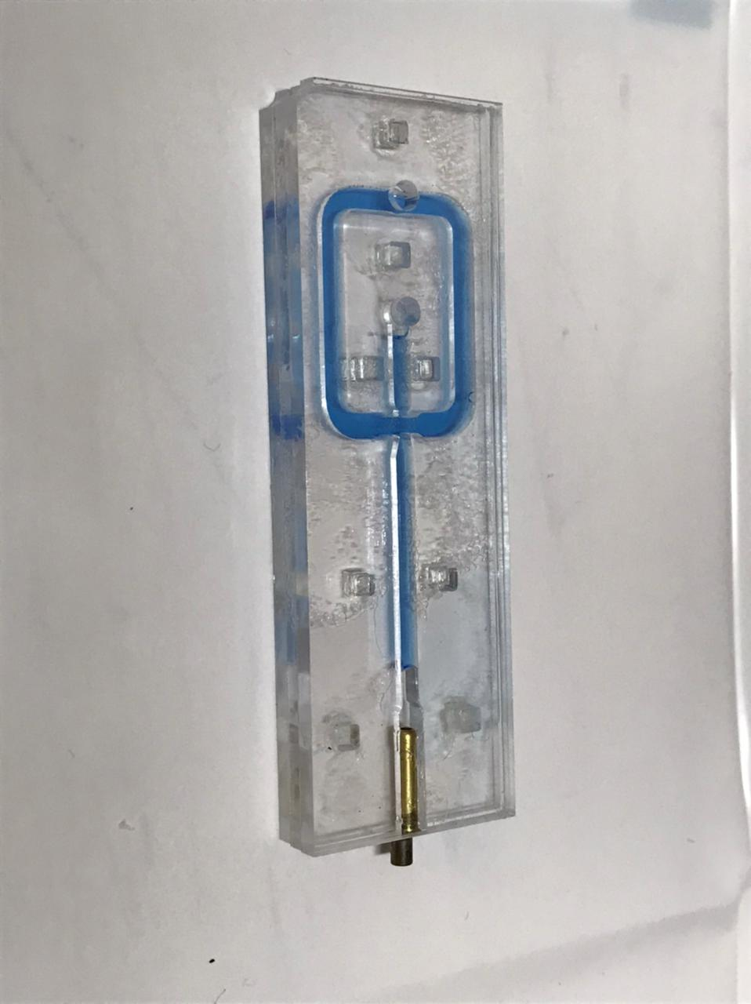

Figure 10 System leak evaluation, lateral view.

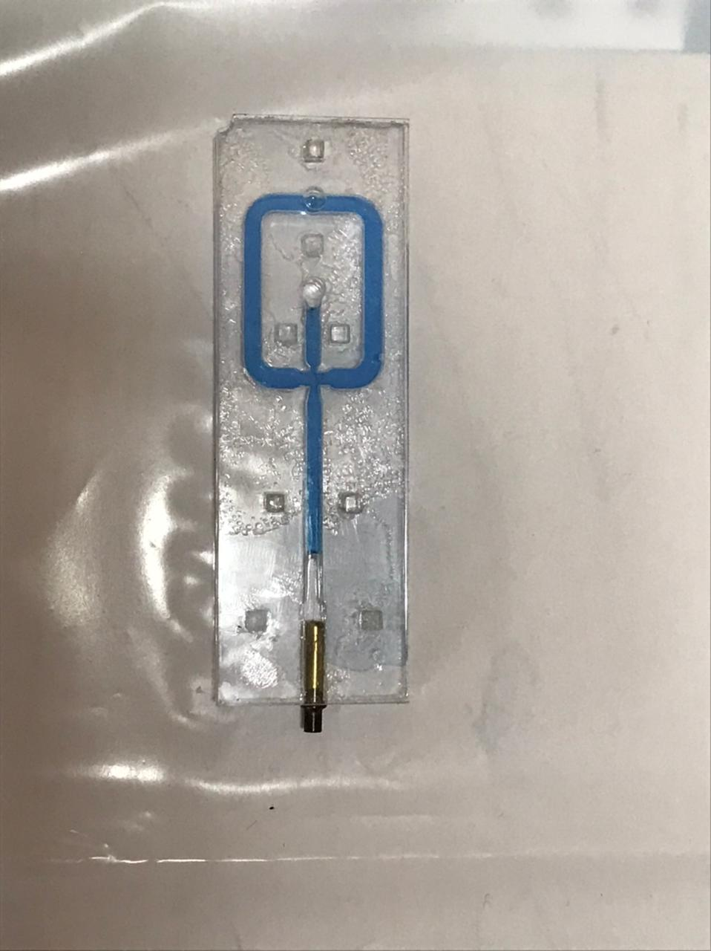

Figure 11 System leak evaluation, top view.

1. Once it is confirmed that there are no leaks in the system, the channel must be washed and dried before proceeding with the next level.
2. Next, the fourth level is added. This sheet (of different length from the others) serves to prevent the metallic input connectors from colliding with the third level, as well as to function as a reference axis to focus the system's generation zone using a USB microscope. Like the previous levels, methacrylate is added, pressure is applied uniformly, and the weight is left until the joint is dry. In this step, an additional sheet can be placed by repeating the previous procedure to create a fifth level; this will depend on the experimenter's preferences.

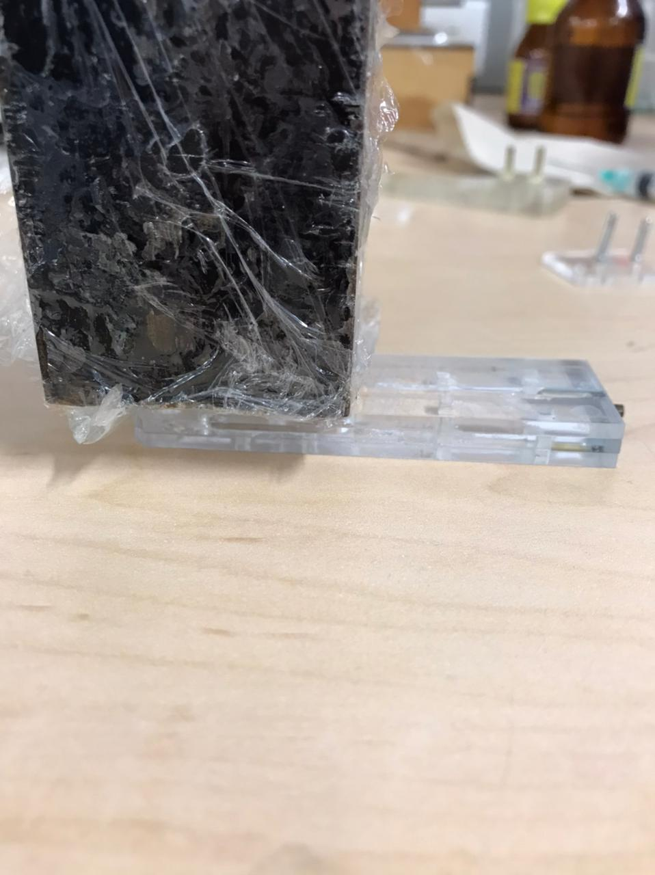

Figure 12 Weight location on the fourth level of the system.

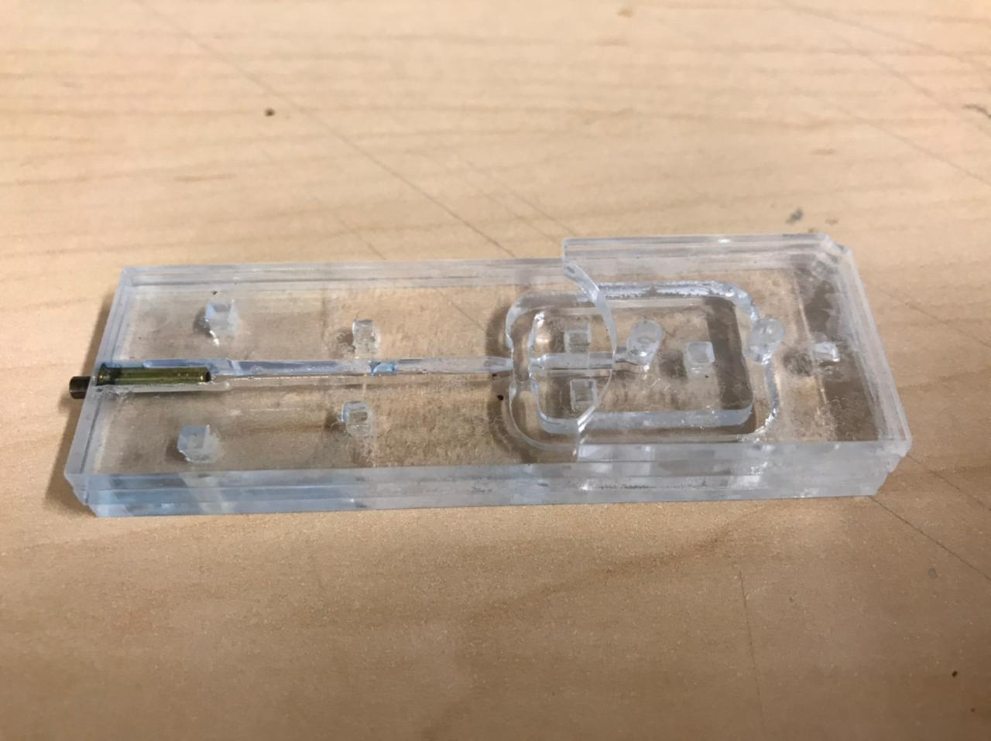

Figure 13 Fourth-level sheet located on the system.

1. Finally, the connectors are placed in the inputs, with the shorter side down, and covered with enough adhesive. They must be allowed to dry for at least 12 hours, as they are very sensitive and easily detach when removing the probes that connect the system to the injection equipment used to generate the capsules.

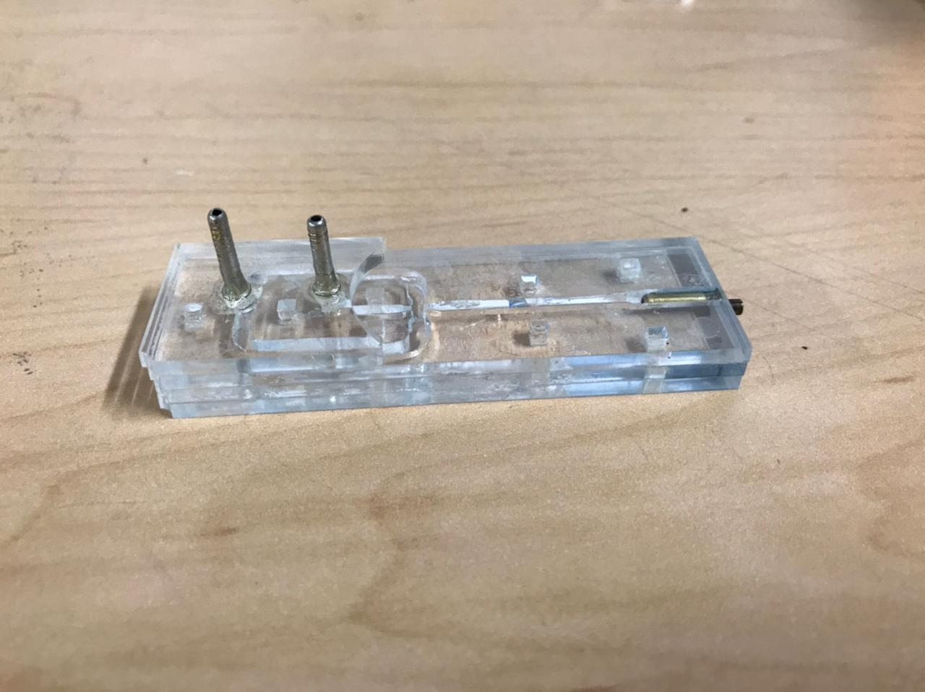

Figure 14 Assembled system, lateral view.

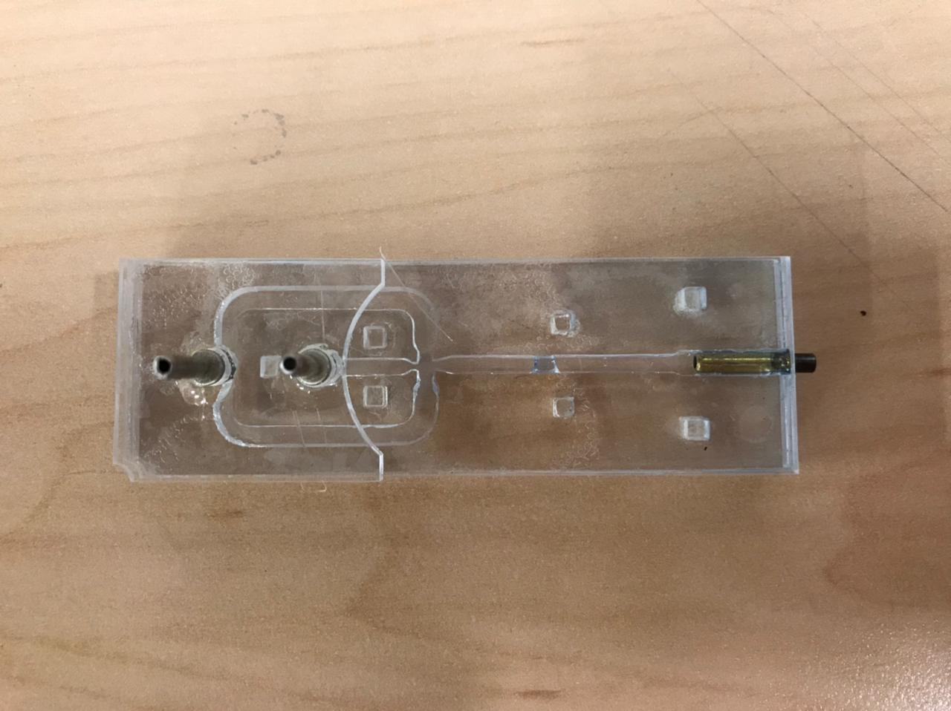

Figure 15 Assembled system, top view.

1. **CHANGE CONTROL**

|  |  |  |  |
| --- | --- | --- | --- |
| **CHANGE DESCRIPTION** | **DATE** | **VERSION** | **APPROVED BY** |
|  |  |  |  |