**PROTOCOL FOR QUANTIFYING PROTEIN/ENZYME CONCENTRATION**

***Version 1.0***

**Produced by: Diana Sotelo & Johann Osma**

1. **OBJECTIVE**

To determine the concentration of proteins or enzymes in a solution or immobilized. In this case, the enzyme lipase was used as an example, using the Genesys 10S UV-Vis spectrophotometer, Thermo Scientific, and a photography box.

1. **SCOPE**

To present three methods:

* Perform calibration curves of protein concentration using the Bradford standard.
* Perform measurements of free protein/enzyme concentration.
* Perform measurements of the presence of immobilized protein/enzyme.

1. **CALIBRATION CURVES OF PROTEIN CONCENTRATION USING THE BRADFORD STANDARD**

To carry out this task, a Genesys 10S UV-Vis spectrophotometer, 1 mL spectrophotometry cells, 200 μL and 1000 μL micropipettes and tips, Protein Assay Dye (PAD) reagent, Milli-Q type II water, Bovine Serum Albumin (10 mg/mL) or BSA are required.

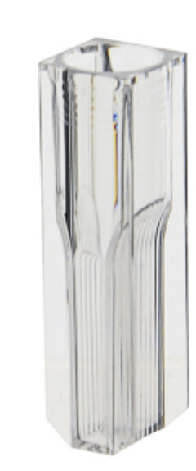

Fig. 1 Example of 1 mL spectrophotometry cells.

1. **METHODOLOGY.**
2. **Standard curve development:** for this part, a Genesys 10S UV-Vis spectrophotometer, 1 mL spectrophotometry cells, 200 μL and 1000 μL micropipettes and tips, Protein Assay Dye (PAD) reagent, Milli-Q type II water, and Bovine Serum Albumin (10 mg/mL) or BSA are required.
3. First, prepare 1 mL of a 1:10 dilution of the Albumin stock solution (10 mg/mL) by adding 900 μL of distilled water and 100 μL of the stock solution. A solution of 1 mg/mL of Albumin is obtained. A 1:10 dilution is performed again from the new Albumin stock solution (1 mg/mL). A solution of 100 μg/mL of Albumin is obtained. From this stock solution, solutions are prepared at concentrations of 75 μg/mL, 50 μg/mL, and 25 μg/mL, as shown in Figure 2**.**

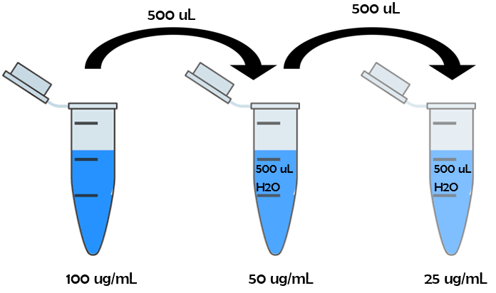  
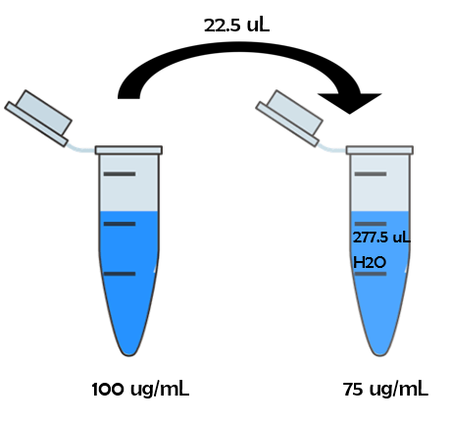

Fig. 2 Design of dilutions for standard curve.

**In a 1 mL spectrophotometry cell, 800 μL of distilled water and 200 μL of PAD are added, resuspended with a micropipette until the sample is homogenized, and agitated for 5 seconds on a vortex. Incubate for 15 minutes at 25°C and read as BLANK at 595 nm. Subsequently, to measure the samples of each prepared solution (100 μg/mL, 75 μg/mL, 50 μg/mL, and 25 μg/mL), 700 μL of Milli-Q water and 100 μL of the sample are added to a 1 mL cell. Finally, add 200 μL of PAD, resuspend until homogenized, incubate for 15 minutes at 25°C, agitate for 5 seconds on a vortex, and read at 595 nm.**

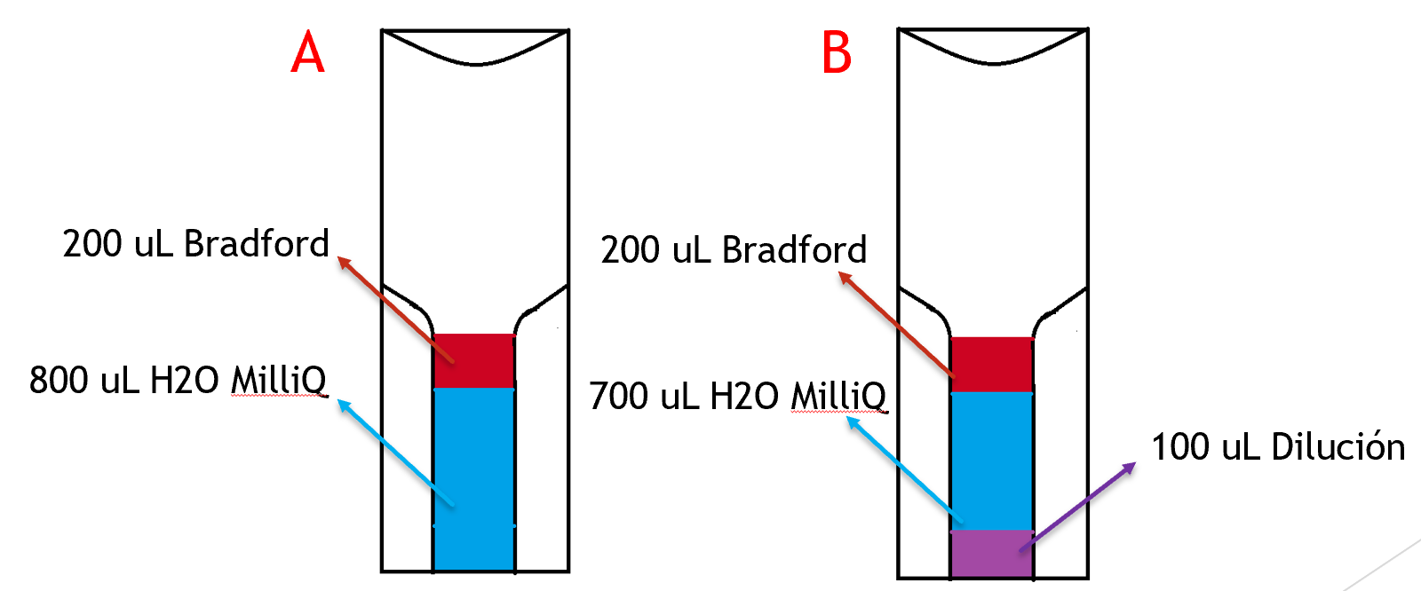

Fig. 3 Proposed schematic for the distribution of blank (A) and sample (B) cells.

**To obtain the standard curve, a linear regression is performed based on the absorption vs. concentration data obtained. A relationship between protein concentration and absorbance was established that reflects the reaction with the PAD, and an equation and an R^2 close to 1 were obtained. Once the necessary data has been taken, a photo of the cell must be taken for qualitative analysis, and these should be taken in the standard photography box so that the results are comparable**.

Fig. 4 Calibration curve obtained with different dilutions of ASB.

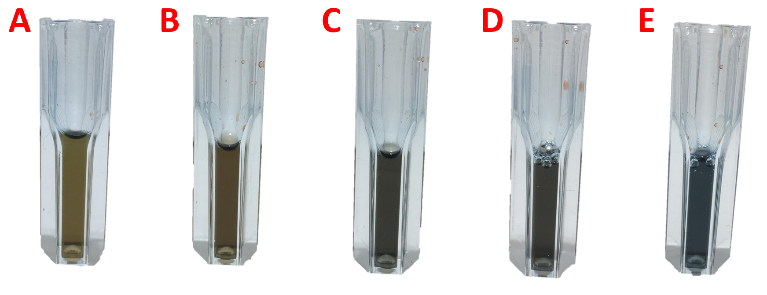

Fig. 5 Qualitative result of different dilutions of ASB. Blank (A), 25 ug/mL (B), 50 ug/mL (C), 75 ug/mL (D), 100 ug/mL (E).

Calculation equation for concentration by absorbance at 595nm:

The following equation describes the concentration of protein/enzyme from the absorbance at 595 nm.

Where **m** represents the slope generated by the function from the standard curve, which shows the concentration change per data associated to absorbance. In this case, the value was 120.21.

1. **MEASUREMENTS OF FREE PROTEIN/ENZYME CONCENTRATION**

**Enzymatic quantification of free lipase enzyme:** A Genesys 10S UV-Vis spectrophotometer, 1 mL spectrophotometry cells, 200 uL and 1000 uL micropipettes and tips for 200 and 1000 uL micropipettes, Protein Assay Dye (PAD) reagent, Milli-Q type II water, and Lipase 20 are required.

In a 1 mL spectrophotometry cell, 800 uL of distilled water and 200 uL of PAD are added, and the sample is resuspended with a micropipette until homogenized, shaken for 5 seconds on a vortex, and read as BLANK at 595nm. Subsequently, to measure the sample of the enzyme (in this case Lipase 20), 700 uL of Milli-Q water, 200 uL of PAD, and 100 uL of the sample are added to a 1 ml cell; resuspend until homogenized, incubate for 15 minutes at 25°C, shake for 5 seconds on a vortex, and read at 595 nm.

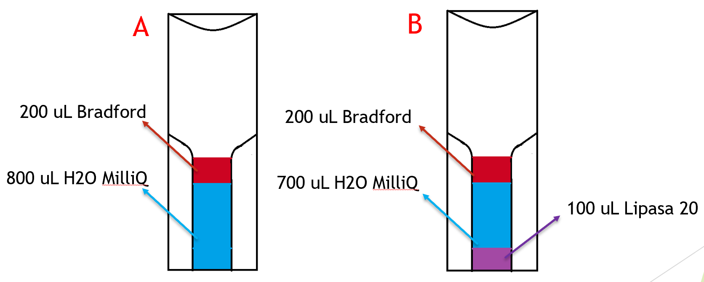

Fig. 6 Proposed schematic of the distribution of blank (A) and sample (B) cells for enzymatic concentration quantification. a.

Table 1 Result of the lipase enzyme sample measurement in the spectrophotometer.

|  |  |  |  |
| --- | --- | --- | --- |
|  | Take | Abs (nm) | Concentration (ug/mL) |
| Sample 1 | Take 1 | 0,604 | 72,607 |
| Take 2 | 0,605 | 72,727 |
| Sample 2 | Take 1 | 0,595 | 71,525 |
| Take 2 | 0,599 | 72,006 |
|  |  | Average | 72,216 |

The change must be qualitatively evident in the cell; if the color turns blue, it is assumed that the enzyme is present.

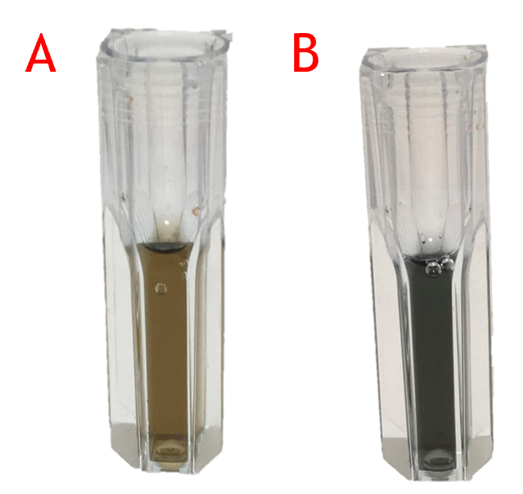

Fig. 7 Qualitative result of blank (A) and with the Lipase enzyme sample (B) cells.

Using the concentration calculation equation by absorbance at 595nm (standard curve) and the obtained sample absorbance value, the corresponding lipase concentration value is calculated. A colorimetric change close to blue was evidenced in the lipase sample after the reaction time with the Bradford reagent. The obtained absorbance was 0.601 nm, so it was concluded that the free lipase had a concentration of approximately 72.22 ug/mL.

1. **MEASUREMENTS OF IMMOBILIZED PROTEIN/ENZYME PRESENCE**

**Enzymatic quantification of immobilized particles:**

1 mL cells or Eppendorf tubes, a 200 µL and a 1000 µL micropipette, 200 µL and 1000 µL micropipette tips, filter paper, mesh or funnel, dropper, acrylic or glass sheet, small spatula, Protein Assay Dye (PAD) reagent, Milli-Q type II water, particles with immobilized lipase enzyme are required.

In a cell, add 800 µL of Milli-Q water and 200 µL of PAD, resuspend with a micropipette until the sample is homogeneous, and shake for 5 seconds on a vortex. Subsequently, to measure the sample of particles with immobilized enzyme (in this case Lipase 20), 750 µL of Milli-Q water, 200 µL of PAD, and 40 particles of the sample, weighing approximately 0.0306 g, are added to a 1 mL cell; resuspend until homogeneous, incubate for 15 minutes at 25°C, and shake for 5 seconds on a vortex**.**

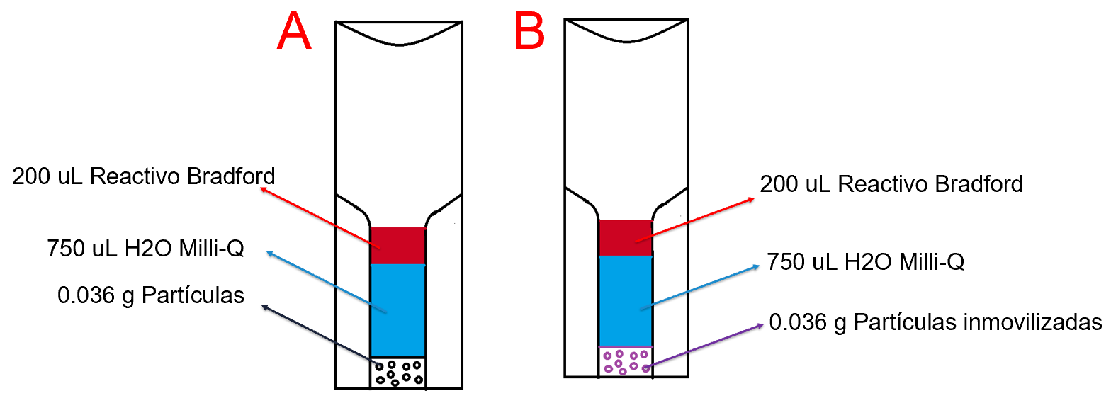

Fig. 8 Proposed schematic of the distribution of blank (A) and sample (B) cells for the identification of enzyme in immobilized particles.

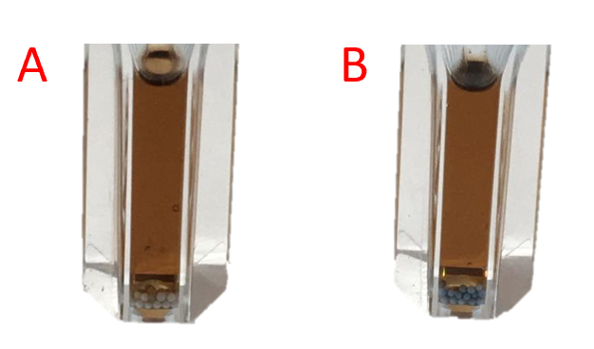

Fig. 9 Result of blank (A) and immobilized particles (B) after the incubation process.

The particles are allowed to react for a period of 15-30 minutes and filtered using mesh and filter paper. The filtered particles are separated with a spatula, and a sample of approximately 10-15 particles is placed on the sheet in the photography box. To visualize the colorimetric change, it is necessary to add a drop of water to the particles. The particles with immobilized enzyme present a blue coloration on their surface.

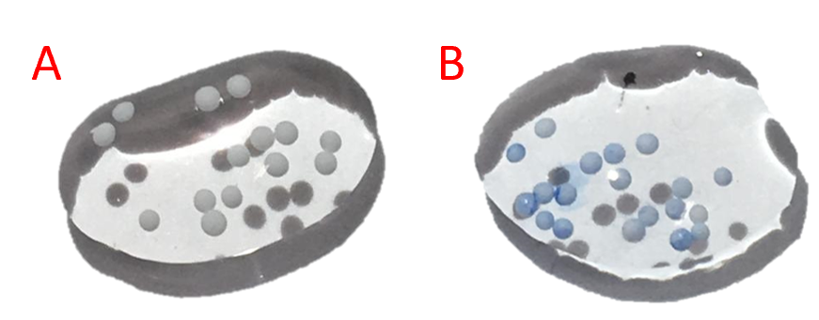

Fig. 10 Result of blank (A) and immobilized particles (B) after reacting with the Bradford reagent.

**Enzymatic and protein quantification of solids and surfaces**

A Genesys 10S UV-Vis spectrophotometer, 3 mL cells or Eppendorf tubes, a 200 µL and a 1000 µL micropipette, 200 µL and 1000 µL micropipette tips, filter paper, mesh or funnel, dropper, acrylic or glass sheet, small spatula, Protein Assay Dye (PAD) reagent, Milli-Q type II water and a surface with immobilized lipase enzyme are required.

In a 3mL spectrophotometry cell, 800 uL of distilled water and 200 uL of PAD are added, and the sample is resuspended with a micropipette until homogenized, shaken for 5 seconds on a vortex, and read as BLANK at 595nm. Subsequently, to measure the sample of the surface with the immobilized enzyme (in this case Lipase 20), 800 uL of Milli-Q water, 200 uL of PAD, and the solid plaque with the enzyme of interest are added; resuspend until homogenized, incubate for 15 minutes at 25°C, shake for 5 seconds on a vortex, and read at 595 nm, making sure of placing the plaque in a perpendicular position (frontally) respect to the ray from the device. This to avoid interferences or undesirable effects to the measurement.

*Fig. 11 Cell reference after resuspending the solution before the measurement.*

Given that the quantification is measured according to the analyzed surface of the plaque, the section 4 formula is multiplied by a conversion factor to obtain the quantification in function of the area. Considering the solution volume, the final formula is presented as: