# SYNTHESIS OF FLUORESCENT CARBON DOTS BY A THERMAL METHOD

***Version 1.0***

**Produced by: Amaimen Guillén Pacheco**

# OBJECTIVE

To synthesize fluorescent carbon dots by a thermal method.

# REQUIREMENTS

To prepare the material, prior knowledge is required in: stoichiometric calculations of reagents, weighing on precision balances, use of ovens, sonicators, centrifuges, and magnetic stirrer, as well as characterization techniques.

# SOTWARE REQUIREMENTS

None.

# SYNTHESIS METHOD

The thermal method for synthesizing carbon dots is based on subjecting a wide range of precursors, including organic and inorganic materials, to temperatures ranging from 100 to 250 °C and controlled pressures [1,2]. Conventional techniques start with a base solution where organic salts such as urea and lemon salt are mixed in deionized water and ethanol and then subjected to high temperatures and controlled pressure [3].

# PERSONAL PROTECTIVE EQUIPMENT (PPE)

* Clean room suit / fluid-resistant gown
* Hood
* Face mask
* Goggles
* Nitrile gloves
* Closed boots or shoes
* Heat-resistant gloves

# STEP BY STEP

## PREPARATION OF SOLUTIONS

1. Take a glass precipitate or beaker of at least 25mL. Verify that it is not dirty and that it cannot contaminate the procedure.
2. Deposit 4mL of deionized water or Milli-Q grade and 4mL of ethanol.
3. Weigh out 0.12 g of lemon salt on a precision balance.
4. Dilute the lemon salt in the solution described in step 2, using a stirring rod until a translucent solution is obtained.
5. Weigh out 0.12 g of crystal urea.
6. Dilute the crystal urea in the solution described in step 4, using a stirring rod until a homogeneous solution is obtained, which may have a lemon-green color.
7. Sonicate the mixture for at least 10 minutes.
8. After sonication, transfer the mixture to a clean, impurity-free ceramic container, then cover the container with aluminum foil.

**Note:** All processes are described in Figure 1.

## SYNTHESIS OF FLUORESCENT CARBON DOTS BY A THERMAL METHOD

1. Take the solution contained in the ceramic container to an oven previously heated to 250 °C for 45 minutes.

***Figure 1:*** Description of the synthesis of carbon dots using a thermal method. Image created in BioRender.com*.*

1. When the 45 minutes have elapsed and you consider it safe to remove the ceramic container from the oven, proceed to extract the ceramic container from the oven. The result should be similar to that shown in Figure 2.

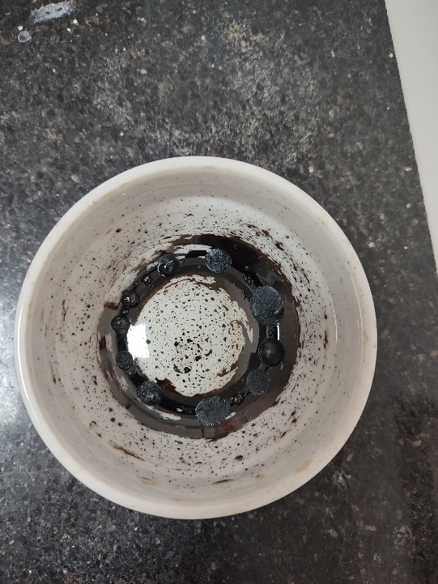

**Figure 2:** Resulting solution after being in an oven at 250 °C for 45 minutes.

1. Let it cool to room temperature until you consider it safe (approximately 20 minutes).
2. Once the ceramic cup is cool, add 20mL of deionized water or Milli-Q grade and with the help of a spatula obtain a homogeneous solution.
3. Deposit the solution in Falcon tubes of at least 15mL. Ensure that the solution level is the same in each falcon, for this, use manual or micropipettes.
4. Once you have each falcon at the same level, secure them with their respective lids and take them to a centrifuge at 8000 rpm for 20 minutes.
5. When the centrifugation time has elapsed, remove the falcon tubes one by one and, with the help of micropipettes, deposit the supernatant in sterilized glass plates as shown in Figure 3.

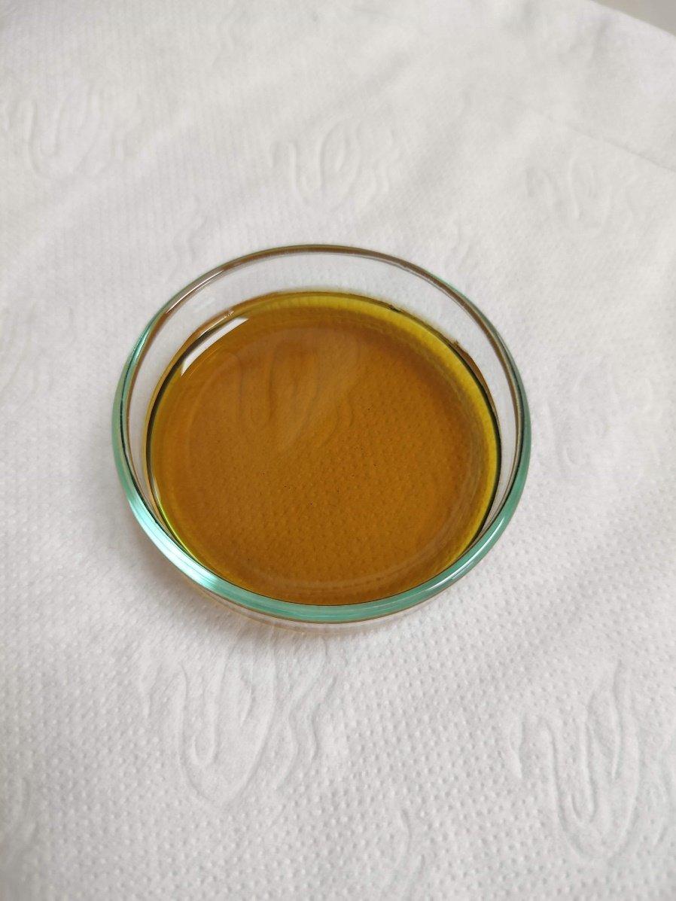

**Figure 3:** Resulting supernatant after 20-minute centrifugation process.

1. Take the glass plates containing the resulting supernatant from the centrifugation to a preheated oven at 90 or 100 °C and leave it overnight for the solution to dry.

**Note:** You can verify the presence of fluorescent carbon dots by taking a small portion of the precipitate, diluting it in deionized water, and then depositing it in a small glass bottle and bringing it to a UV lamp (365 nm) to check for fluorescent carbon dots as shown in Figure 4.

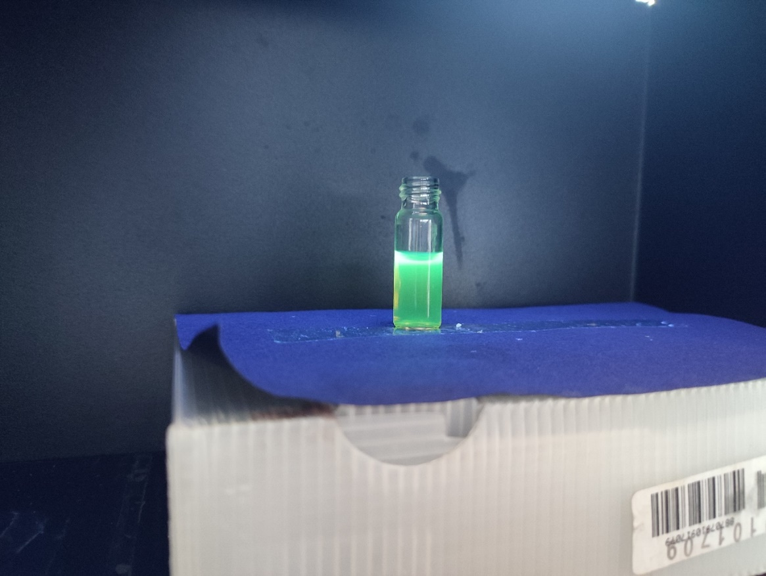

**Figure 4:** Fluorescent carbon dots under the irradiation of Analytik Jena UVP UVGL-58 UV lamp (Analytikjena, Upland, CA, USA)

1. After at least 12 hours have passed, remove the glass plates from the oven and let them cool to room temperature as shown in Figure 5.

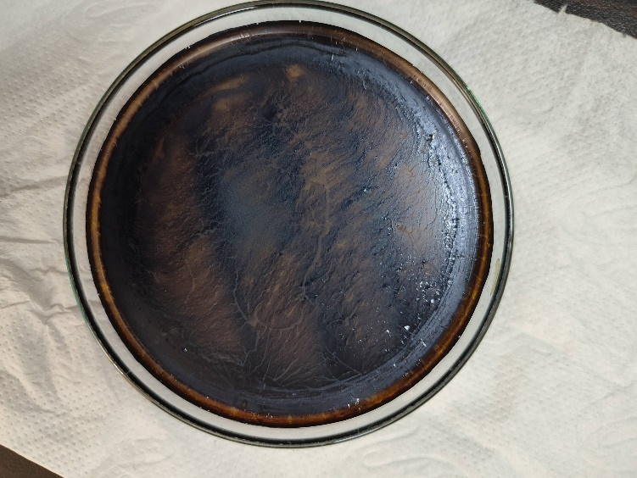

**Figure 5:** Fluorescent carbon dots after the drying process.

1. Once it is safe to work, meaning the glass plates containing the dried product are safe to handle, proceed to remove the particles using spatulas and deposit them in glass jars with lids and store them for further analysis.

# BIBLIOGRAPHY

[1] Mkhari, O.; Ntuli, T.D.; Coville, N.J.; Nxumalo, E.N.; Maubane-Nkadimeng, M.S. Supported carbon-dots: A review. *J. Lumin.* **2023**, 255, 119552. https://doi.org/10.1016/j.jlumin.2022.119552

[2] Alas, M.O.; Alkas, F.B.; Aktas Sukuroglu, A.; Genc Alturk, R.; Battal, D. Fluorescent carbon dots are the new quantum dots: an overview of their potential in emerging technologies and nanosafety. *J. Mater. Sci.* **2020**, 55, 15074-15105. https://doi.org/10.1007/s10853-020-05054-y

[3] Çalhan, S.D.; Alaş, M.Ö.; Aşık, M.; Kaya, F.N.D.; Genç, R. One-pot synthesis of hydrophilic and hydrophobic fluorescent carbon dots using deep eutectic solvents as designer reaction media. *J. Mater. Sci.* **2018**, 53, 15362 – 15375. https://doi.org/10.1007/s10853-018-2723-4

# CHANGE CONTROL

|  |  |  |  |
| --- | --- | --- | --- |
| **CHANGE DESCRIPTION** | **DATE** | **VERSION** | **APPROVED BY** |
|  |  |  |  |