# SYNTHESIS OF MAGNETITE / CARBON DOTS NANOHYBRIDS USING A MAGNETIC STIRRING COPRECIPITATION METHOD

***Version 1.0***

**Produced by: Amaimen Guillén Pacheco**

# OBJECTIVE

To synthesize magnetite/carbon dots (MNPs@CDs) nanohybrids using a coprecipitation method with magnetic stirring.

# REQUIREMENTS

To prepare the material, prior knowledge is required in: stoichiometric calculations of reagents, weighing on precision balances, use of ovens, sonicators, centrifuges, and magnetic stirrer, as well as characterization techniques.

# SOFTWARE REQUIREMENTS

None.

# SYNTHESIS METHOD

Generally, synthesis methods to obtain nanohybrids are based on the synthesis of precursor materials independently and then these are joined by different techniques that seek to couple the materials [1,2]. Among the most common methods used to obtain magnetite/carbon dots nanohybrids are solvothermal or hydrothermal [3], ultrasonication [1] and suspension or coprecipitation using magnetic stirring [2].

# PERSONAL PROTECTIVE EQUIPMENT (PPE)

* Cleanroom suit / fluid-resistant gown
* Hood
* Mask
* Goggles
* Nitrile gloves
* Closed boots or shoes
* Heat resistant gloves or gauntlets.

# STEP BY STEP

## SYNTHESIS OF MAGNETIC NANOPARTICLES (MNPs)

1. Take two glass beakers or precipitation vessels of at least 100mL. Verify that they do not have any dirt that may contaminate the procedure.
2. Weigh 1.98 g of FeCl2 - 4H2O and 3.24 g of FeCl3 on a precision balance.
3. Deposit 50 mL of deionized water or Milli-Q grade in each of the beakers.
4. In one of the beakers, add the FeCl2 - 4H2O and in the other add FeCl3.
5. Vigorously agitate both solutions until they appear homogeneous.
6. Take both solutions and deposit them into a beaker of at least 250mL and mix them with the help of a glass stirrer.
7. Place the previous mixture on a magnetic stirring hot plate. Only use the stirring function of the plate and leave it stirring for approximately 5 minutes using a magnetic stirrer.
8. While waiting for the 5 minutes of stirring, weigh 0.1 g of Hyperbranched bis-MPA polyester-64-hydroxyl (bis-MPA) (97%) on a precision balance and add it to the mixture that is still being stirred.
9. Take a solution of ammonium hydroxide (NH4OH - 25%) and with the help of a dropper, add drop by drop. You will see that small black dots are formed, which means that the magnetite is being formed. Perform the addition of ammonium hydroxide until the mixture has reached a pH of 10, which must be measured using equipment or pH strips.
10. Once the solution has reached a pH of 10, raise the temperature to 80°C and leave it stirring for 5 hours.
11. Let the solution cool to room temperature, and in 15mL falcon tubes add the magnetite solution. You can check its magnetism using a magnet.
12. Take the Falcons to a centrifuge for 30 minutes at 8000 revolutions per minute (rpm) previously covered, and make sure they all have the same level (10mL) of solution. Repeat the procedure until all the solution has been centrifuged.
13. Collect the supernatant of each Falcon in a clean beaker of at least 200mL.
14. Wash this supernatant by centrifugation at 8000 rpm for 5 minutes using deionized water, acetone, and ethanol in a ratio of 8:4:4 mL, respectively. Perform the washing procedure for the entire mixture 3 times. Each time the nanoparticles will precipitate, and the supernatant must be discarded.
15. Place the previously washed nanoparticles on a glass plate and take them to the oven at 90 °C and let them dry overnight or at least 12 hours.
16. Once the nanoparticles are dry, let them cool to room temperature. Collect the nanoparticles using a spatula and deposit them in a glass jar with a lid for further analysis.

**Note:** All processes are described in Figure 1.

***Figure 1:*** *Description of the synthesis of magnetite nanoparticles (MNPs) using a chemical co-precipitation method. Image created in BioRender.com.*

## SYNTHESIS OF CARBON FLUORESCENT DOTS (CDs) BY A THERMAL METHOD

1. Take a precipitation glass or glass beaker of at least 25mL. Verify that it does not have any dirt that could contaminate the procedure.
2. Deposit 4mL of Milli-Q grade water or deionized water and 4mL of ethanol.
3. Weigh 0.12 g of lemon salt on a precision balance.
4. Dilute the lemon salt in the solution described in point 2, for this use a stirring rod until obtaining a translucent solution.
5. Weigh 0.12 g of crystal urea on a precision balance.
6. Dilute the crystal urea in the solution described in point 4, for this use a stirring rod until obtaining a homogeneous solution that can present a lemon green color.
7. Take the mixture to sonicate for at least 10 minutes.
8. After sonication, deposit the mixture into a clean and impurity-free ceramic container, then cover the container with aluminum foil.

**Note:** All processes are described in Figure 2.

1. Take the solution contained in the ceramic container to a preheated oven at 250 °C for 45 minutes.

***Figure 2:*** Description of the synthesis of carbon dots using a thermal method. Image created in BioRender.com*.*

1. When the 45 minutes have passed, and you consider it safe to remove the ceramic container from the oven, proceed to extract the ceramic container from the oven. The result should be similar to that observed in Figure 3.

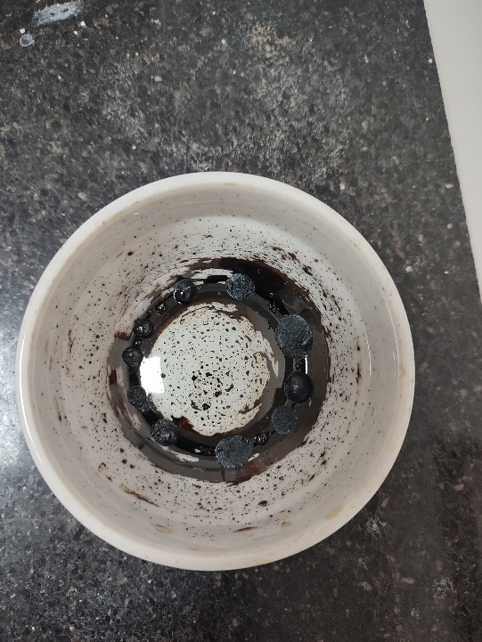

**Figure 3:** Resulting solution after being in an oven at 250 °C for 45 minutes.

1. Let it cool to room temperature until it is safe (approximately 20 minutes).
2. Once the ceramic cup is cool, add 20 mL of deionized or Milli-Q grade water and use a spatula to obtain a homogeneous solution.
3. Deposit the solution into Falcon tubes of at least 15 mL. Make sure the level of solution is the same in each Falcon. Use manual pipettes or micropipettes to achieve this.
4. Once each Falcon is at the same level, secure them with their respective lids and centrifuge at 8000 rpm for 20 minutes.
5. After the centrifugation time has passed, remove the Falcons one by one and use micropipettes to transfer the supernatant to sterilized glass plates as shown in Figure 4.

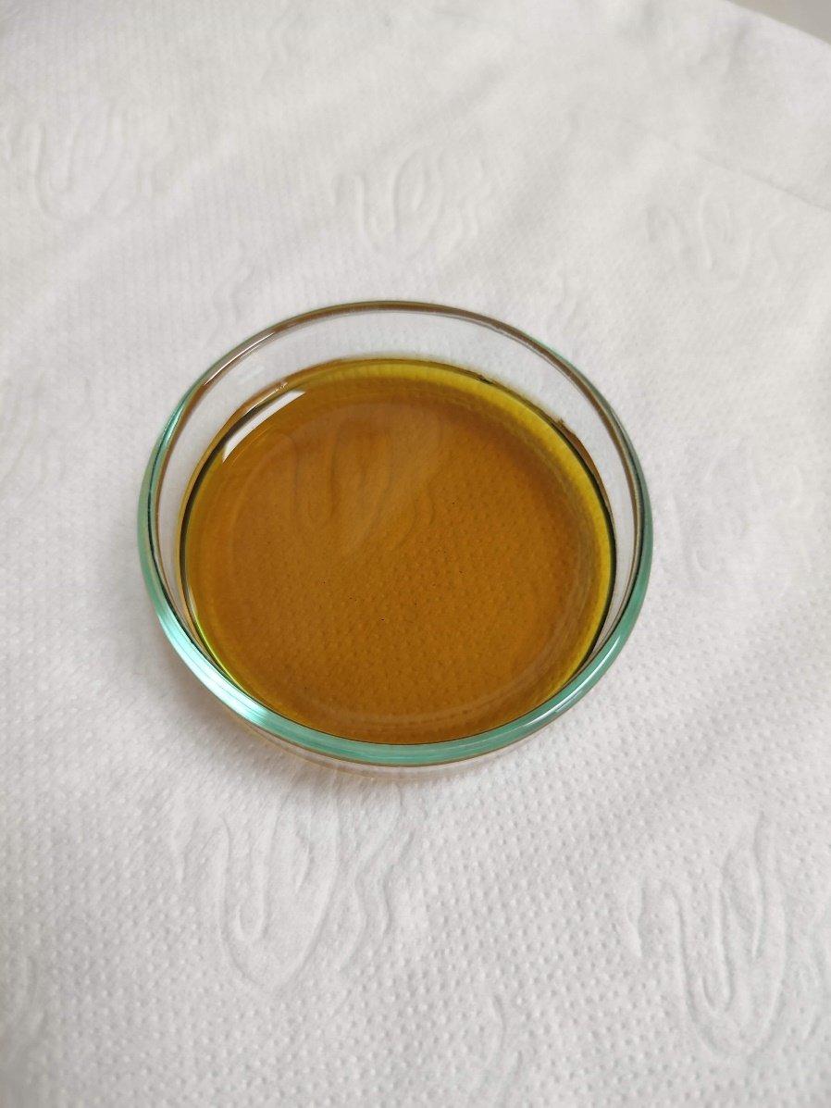

**Figure 4:** Supernatant resulting from the centrifugation process for 20 minutes.

1. Take the glass plates containing the supernatant resulting from the centrifugation to a preheated oven at 90 or 100 °C and leave it overnight for the solution to dry.

**Note:** You can check for fluorescent carbon dots by taking a small portion of the precipitate and diluting it in deionized or Milli-Q grade water. Then, transfer it to a small glass bottle and bring it to a UV lamp (365 nm) and check for fluorescent carbon dots as shown in Figure 5.

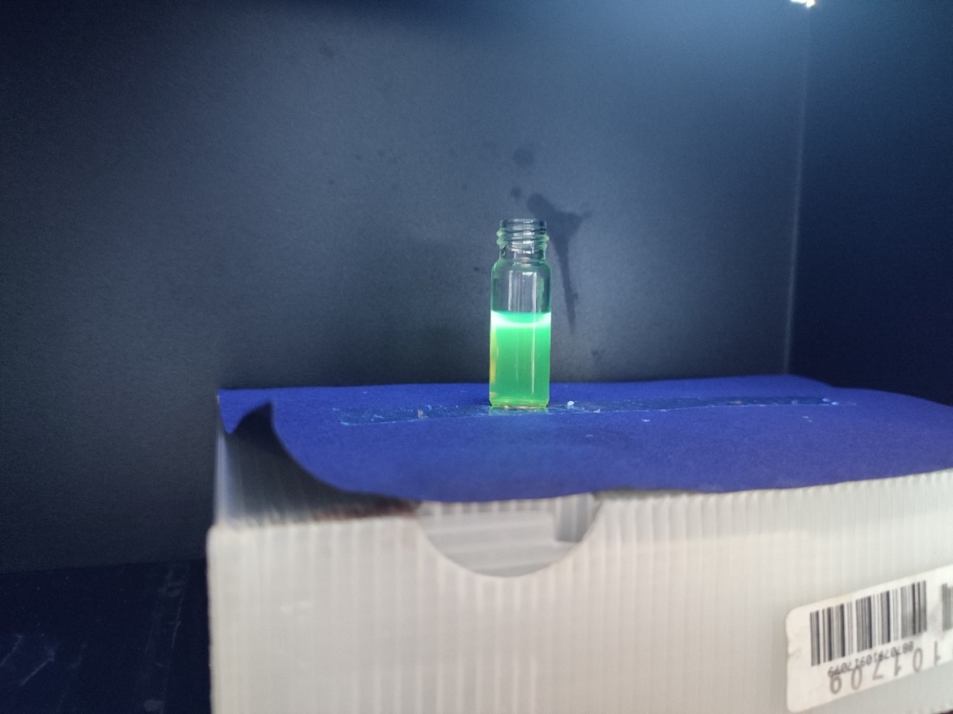

**Figure 5**: Fluorescent carbon dots under the irradiation of Analytik Jena UVP UVGL-58 UV lamp (Analytikjena, Upland, CA, USA)

1. After at least 12 hours, remove the glass plates from the oven and let them cool to room temperature as shown in Figure 6.

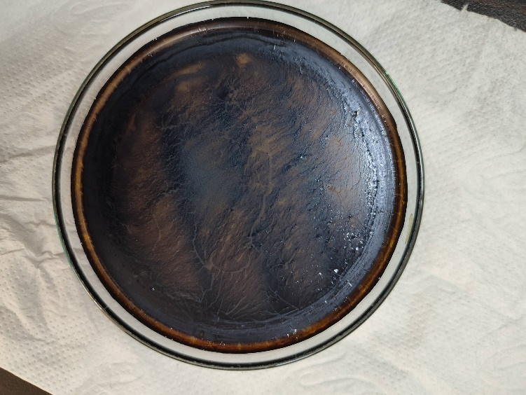

**Figure 6**: Fluorescent carbon dots after the drying process.

1. Once it is safe to work, i.e., the glass plates containing the dry product are cool, proceed to remove the particles using spatulas and transfer them to glass jars with lids and store them for further analysis.

*.*

## SYNTHESIS OF MAGNETITE / CARBON DOTS NANOHYBRIDS (MNPs@CDs)

1. Weigh 0.5 mg of MNPs and 10 mg of CDs on a precision scale.
2. In a beaker of at least 25 mL, add 10 mL of deionized water and add the 10 mg of CDs.
3. Take the solution to a magnetic stir plate and add the 0.5 mg of MNPs. Let it stir overnight or at least 12 hours.
4. Take the solution and transfer it to a Falcon with a lid of at least 15 mL. Then, centrifuge at 8000 rpm for 5 minutes.
5. After the centrifugation time has passed, remove the Falcon and use micropipettes to transfer the supernatant to sterilized glass plates as shown in Figure 7.

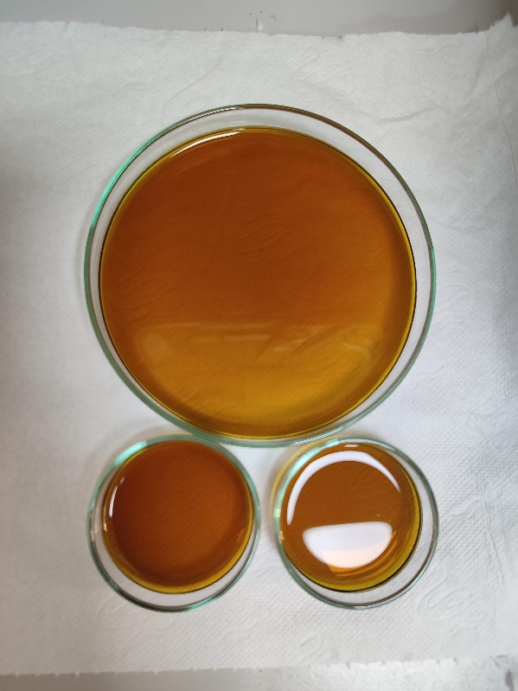

**Figure 7:** Supernatant resulting from the centrifugation process for 5 minutes.

1. Take the glass plates containing the supernatant resulting from the centrifugation to a preheated oven at 90 or 100 °C and leave it overnight for the solution to dry.
2. After at least 12 hours, remove the glass plates from the oven and let them cool to room temperature as shown in Figure 8**.**

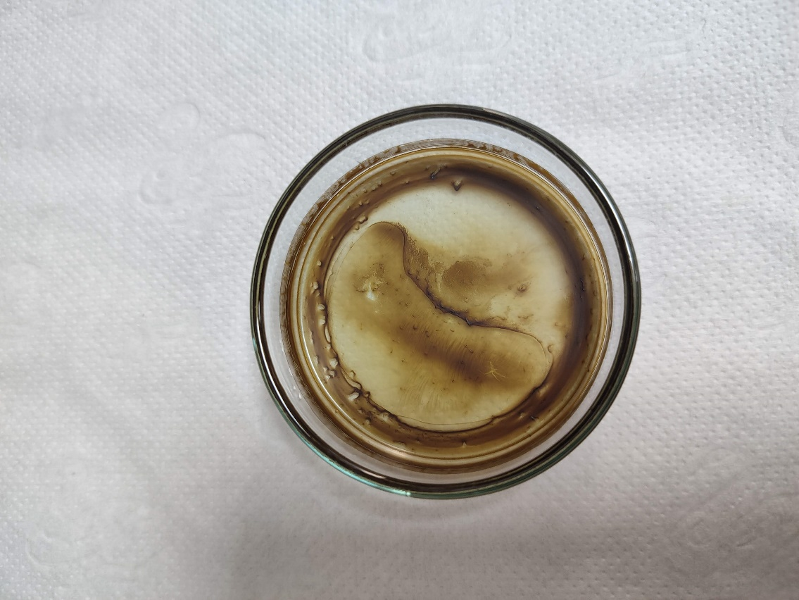

**Figure 8**: Magnetite / carbon dots nanohybrids (MNPs@CDs) after the drying process.

1. Once it is safe to work, meaning that the glass dishes containing the dried product are cool, proceed to remove the particles using spatulas and deposit them into glass jars with lids and store them for further analysis as shown in Figure 9.

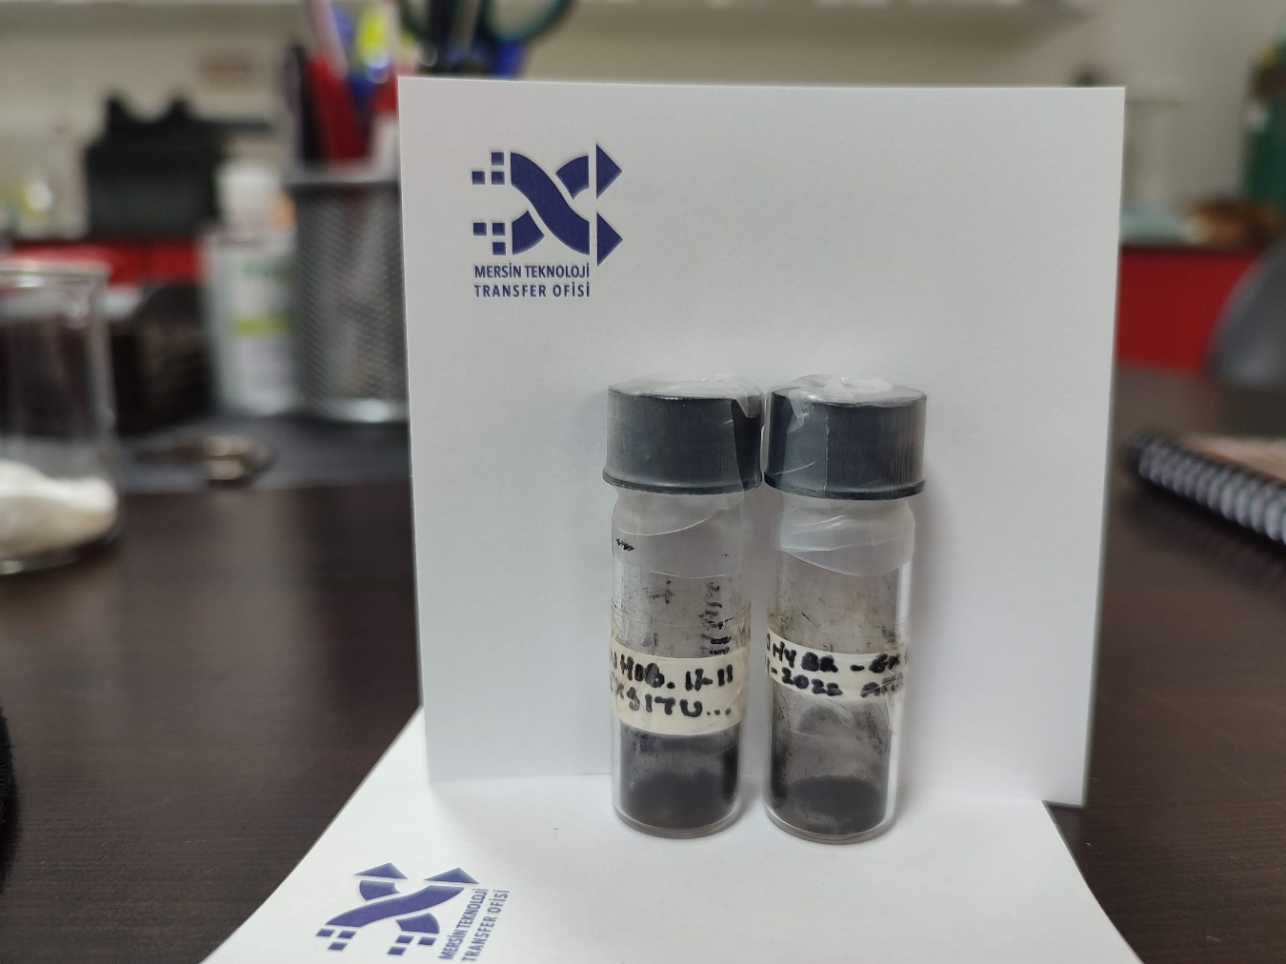

**Figure 9**: Magnetite/carbon dot nanohybrids (MNPs@CDs).

Note: All processes are described in Figure 10.

**Figure 10**: *Description of the synthesis of magnetite/carbon dot nanohybrids (MNPs@CDs). Image created in BioRender.com.*

# BIBLIOGRAPHY

[1] Guo, Y.; Qian, J.; Iqbal, A.; Zhang, L.; Liu, W.; Qin, W. Pd nanoparticles immobilized on magnetic carbon dots@Fe3O4 nanocubes as a synergistic catalyst for hydrogen generation. *Int. J. Hydrog. Energy*, **2017**, 42, 15167-15177. https://doi.org/10.1016/j.ijhydene.2017.04.253

[2] Abbas, M.W.; Soomro, R.A.; Kalwar, N.H.; Zahoor, M.; Avci, A.; Pehlivan, E.; Hallam, K.R.; Willander, M. Carbon quantum dot coated Fe3O4 hybrid composites for sensitive electrochemical detection of uric acid. *Microchem. J.* **2019**, 146, 517-524. https://doi.org/10.1016/j.microc.2019.01.034

[3] Shirke, Y.M.; Abou-Elanwar, A.M.; Kwon, S.J.; Choi, W-K.; Hong, S.U.; Lee, H.K.; Jeon, J-D. Development of nanocomposite membranes based on sulfated β-cyclodextrin/glutaraldehyde with magnetically recoverable magnetite-carbon dot hybrid nanoparticles for water vapor dehumidification. *J. Environ. Chem. Eng.* **2022**, 10, 107042, https://doi.org/10.1016/j.jece.2021.107042

# CHANGE CONTROL

|  |  |  |  |
| --- | --- | --- | --- |
| **CHANGE DESCRIPTION** | **DATE** | **VERSION** | **APPROVED BY** |
|  |  |  |  |