**MANUFACTURING AND FUNCTIONALIZATION OF MICRO ROBOTS FOR ARSENIC REMOVAL**

***Version 1.0***

**Produced by: Juan José Carrera Luna**

**Catalina de la Torre Acuña**

**Andrés Santiago Martínez Hernández**

**David Halal**

# OBJECTIVE

To document the manufacturing and functionalization of two groups of micro robots designed for the treatment of water contaminated with heavy metals and dyes.

# REQUIREMENTS

To follow this tutorial, it is necessary to have knowledge in the preparation of solutions (v/v preparations).

Handling of micropipettes and MiliQ.

# EQUIPTMENT REQUIREMENTS

Sonicator: (model reference), Vortex agitator: (model reference), present in a clean room.

# STEP BY STEP

## MICRO ROBOT MANUFACTURING

To manufacture the micro robots, the following materials are needed:

* 1 mm x 1 mm square magnetic sheets of strontium ferrite with a thickness of 0.3 mm
* 1 mm x 2 mm rectangular nickel sheets with a thickness of 0.3 mm.

Note: 2 sheets of each type are required for each robot, as illustrated in Figure 1.

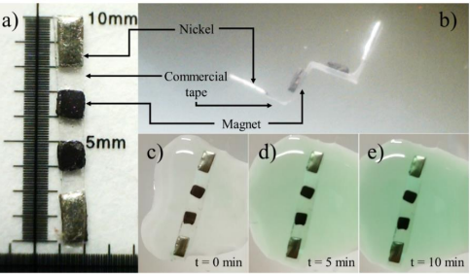

Figure 1: Optical images of a) assembled microrobot on a microscopic ruler b) bent microrobot, and a lacase activity test using ABTS at different time intervals c) 0 minutes d) 5 minutes and e) 10 minutes. Taken from [1]

To ensure the correct manufacturing process, it is recommended to use a scalpel, plastic tweezers, millimeter sheet, transparent tape, and a Transparent Self-adhesive PVC sheet (contact paper).

Procedure:

1. Protect the millimeter sheet with a PVC self-adhesive coating.
2. Place a piece of tape on the millimeter sheet so that the markings on it are visible. The adhesive side of the tape should face the user if he or she looks at the millimeter sheet.
3. Use the markings on the millimeter sheet to place the magnetic and nickel sheets: with 1 mm spacings, place a nickel sheet first, followed by the two magnetic sheets, and finally the second nickel sheet as indicated in Figure 1a.
4. Cut out the contour of the sequence of sheets. This produces 1 robot of 1mm x 10mm. You can use adjacent markings to produce other robots.

## GROUP 1: FUNCTIONALIZATION WITH LACASE FOR PHENOLIC DYE DEGRADATION

For this part, the following materials are required beforehan:

* (3-aminopropyl) triethoxysilane (APTES) concentrated at 2% volume/volume.
* Concentrated glutaraldehyde at 2% volume/volume.
* Lacase enzyme with known concentration.

If the expected concentrations are not available, solutions should be diluted or concentrated so that the expected concentration is obtained.

The following laboratory equipment is required to perform the following procedure:

* Vortex agitator
* Sonicator

Procedure:

1. Deposit a considerable amount of micro robots in test tubes.
2. Add water to the test tube to cover the micro robots.
3. Add 50 μL of APTES (2%) to the test tube.
4. Place the test tubes in the sonicator and turn it on for 20 minutes (2 cycles of 10 minutes each) to ensure immobilization of all parts.
5. Wash the test tubes with the micro robots using MilliQ water.
6. Add 50 μL of glutaraldehyde (2%) for 30 minutes as a crosslinking agent.
7. Vortex for 2 minutes per test tube.
8. Wash the test tubes with the micro robots using MilliQ water.
9. Let it stand for 40 minutes.
10. Add 50 μL of lacase with 15051 U/I to the test tube. Let it stand for 12 hours (overnight) to immobilize the enzyme on the surface of the micro robots. If unable to do so in the stipulated time, leave the test tubes in the refrigerator.

## GROUP 2: FUNCTIONALIZATION BY XILANIZATION OF MICROROBOTS FOR HEAVY METAL TREATMENT

For this part, the following materials are required beforehand:

* (3-aminopropyl) triethoxysilane (APTES) concentrated at 2% volume/volume.

If expected concentrations are not available, solutions should be diluted or concentrated so that the expected concentration is obtained.

The following laboratory equipment is required to perform the following procedure:

* Sonicator
* Vortex agitator

Procedure:

1. Deposit a considerable amount of micro robots in test tubes.
2. Add water to the test tube to cover the micro robots.
3. Add 50 μL of APTES (2%) to the test tube.
4. Place the test tubes in the sonicator and turn it on for 20 minutes (2 cycles of 10 minutes each) to ensure immobilization of all parts.
5. Wash the test tubes with the micro robots using MilliQ water.