Installing NOVA and PSTrace

***Version 1.0***

**Produced by: Oscar Andres Nontoa Navarrete**

# OBJECTIVE

To install the software for the use of the Metrohm’s potentiostat and the Palmsens’ potentiostat.

# REQUIREMENTS

Computer requirements:

* 1 GHz or faster
* 32-bit (x86) or 64-bit (x64) processor
* USB port
* 2 GB of RAM
* 20 GB free hard disk
* Windows 7 or later

# STEP BY STEP

* 1. **METROHM’S POTENTIOSTAT**

1. Go to the archive named “*link.txt*” by following the path “*Documentation/DIY Book/Potenciostat*”. This link will take you to a folder named “*Software_potentiostat*” (*note: you need an Uniandes account to have access to this folder*).
2. Download the .zip folder “*nova-setup-2.1.6*”. In this folder, you will find two archives: 1) One user manual, and 2) a .exe file named “*nova-setup.exe*” as it is shown in the figure below.

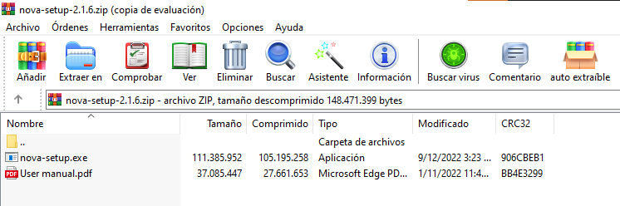

Fig. 1. User manual and .exe file.

*Note: You can find the files on the Metrohm’s website: <https://www.metrohm.com/en_us/service/software-center/nova.html>*

1. Execute the NOVA’s installer (“*nova-setup-2.1.6*”). A window will pop up asking you in which directory you want to setup the program (see the figure below). Choose the directory, click the check box to agree with the terms and conditions, and click the green button “INSTALL”.

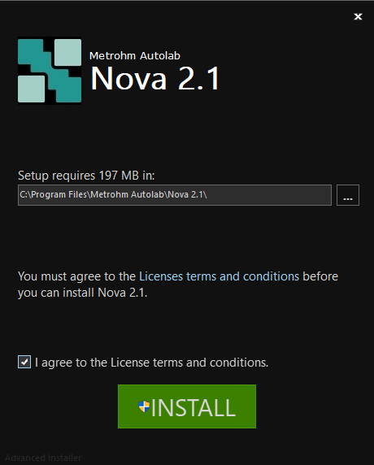

Fig. 2. Directory, terms, and conditions window.

1. The setup process will take a while.
2. Then, two pop up windows will appear asking you if you want to install two different software. Click “*install*” in both cases.

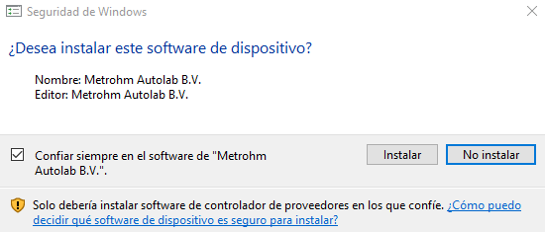

Fig. 3. Pop up window for Metrohm Autolab B.V. software.

Fig. 4. Pop up window for Avantes software.

1. When the software is already installed, click “Finish”, and you will find the icon of the software on your desktop.

Fig. . NOVA's software installed.

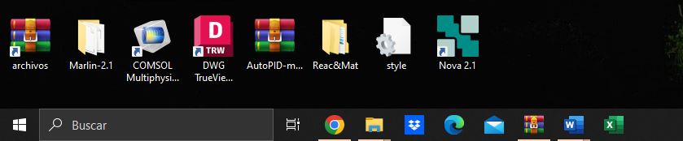

Fig. 6. NOVA's icon on desktop.

* 1. **PALMSENS’ POTENTIOSTAT**

1. Go to the archive named “*link.txt*” by following the path “*Documentation/DIY Book/Potenciostat*”. This link will take you to a folder named “*Software_potentiostat*” (*note: you need an Uniandes account to have access to this folder*).
2. Download the .zip folder “*pstrace-5.9.2317*”. You will find a .exe file named “*PSTrace-5.9.2317 Setup.exe*” in the folder which is the installer.

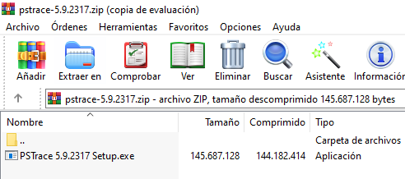

Fig. 7. “PSTrace-5.9.2317 Setup.exe” file in folder “pstrace-5.9.2317”

1. Execute the Palmsens’ installer. Choose the directory where you are going to set up the program, click the check box to agree with the terms and conditions, and click “Next” (see figure below).

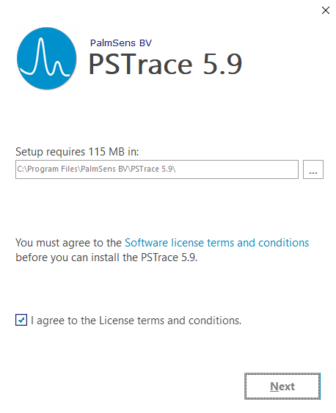

Fig. 8. Directory, terms, and conditions window.

1. Then, another window will appear asking if you want to send feedback. Whether you allow it or not, you can install the software. Click “Install”.

Fig. . Feedback window.

1. The installer will install some drivers for the use of the potentiostat. The figures below will guide you in this process. First, extract the driver’s package clicking “Extract” (figure 10). In the next window click “Next”. Then, you must accept the licence agreement, and click “Next”. Finally, another window will show you the drivers that were correctly installed (figure 11). Click “Finish”.

Fig. . Extracting the drivers.

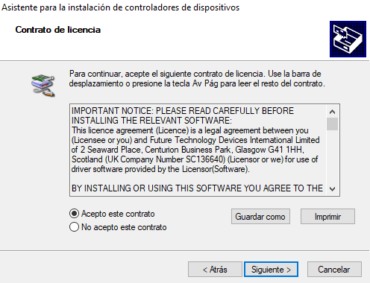

Fig. . Driver's licence agreement.

Fig. . Drivers installed correctly.

1. Some minutes later, you will see the next window (figure below). You can choose either launching the app or not by clicking the checkbox. Click “Finish” to finish the installation. You can now see the app’s icon on your desktop.

Fig. . Finishing the installation.

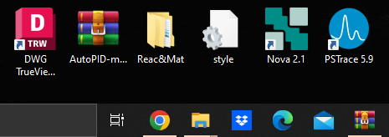

Fig. 14. PSTrace 5.9 on your desktop.