Programming the Crhistian´s potentiostat

***Version 1.0***

**Produced by: Oscar Andres Nontoa Navarrete**

# OBJECTIVE

To program the Crhistian´s potentiostat.

# REQUIREMENTS

* Download Code Composer Studio (the development environment for Texas embedded processors) using the link: <https://www.ti.com/tool/CCSTUDIO#downloads>
* Texas Instruments MSP4030 LaunchPad.
* MSP4030

# STEP BY STEP

1. Go to the archive named “*Potentiostat_class.zip*” by following the path “Documentation/DIY Book/Potenciostat/Codigo fuente microcontrolador MSP” and download it.
2. Execute the Code Composer Studio´s launcher (fig. 1).



Fig. . Code Composer Studio's launcher

1. Select a directory for your workplace (fig. 2) and click “*Launch*”. Be careful with the directory you choose because you will need it later.

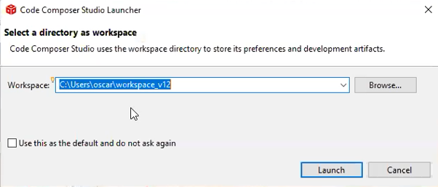

Fig. 2. Selecting the directory's workspace.

1. Unzip the file “*Potentiostat_class.zip*” and copy it into the workspace you chose (fig. 3).

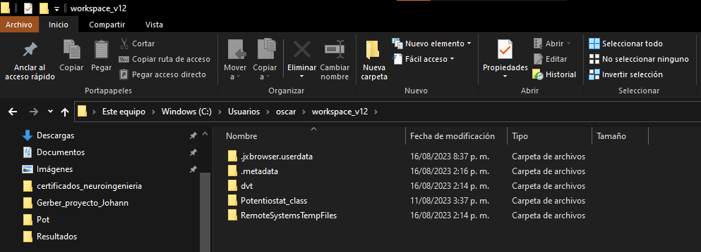

Fig. 3. Copy "Potentiostat_class" in your workspace.

1. In “*Getting started*” choose the option “*Import Project*” (fig. 4), import the file “*Potentiostat_class*” (fig. 5) and click “*Finish*”.

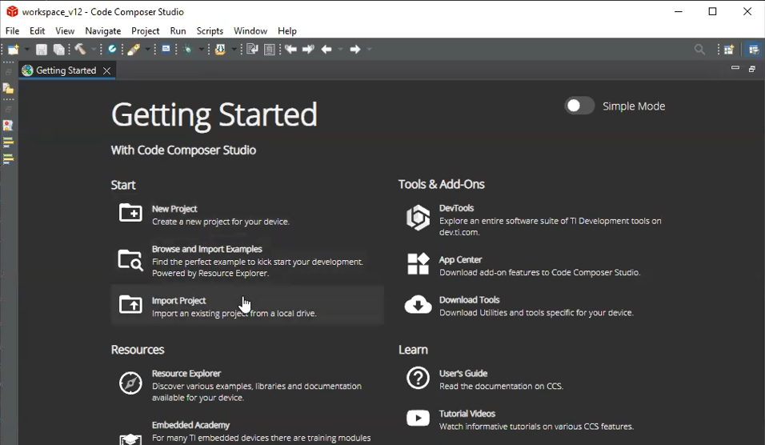

Fig. 4. In "Getting Started" choose "Import Project".

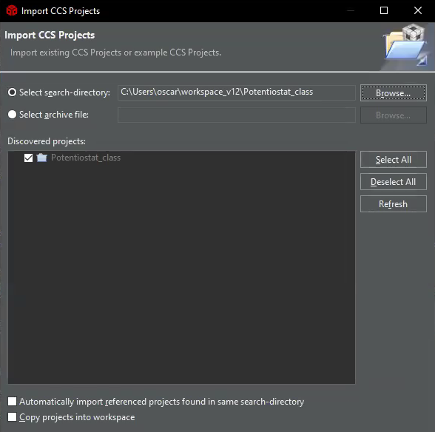

Fig. . Import "Potentiostat_class"

1. You will see the project on the left side of the IDE (fig. 6). Double click on the project and all the files of the project will be displayed.

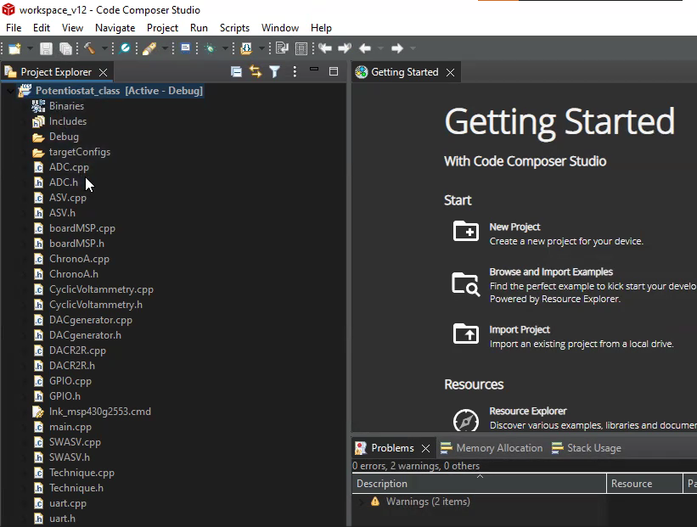

Fig. . Potentiostat project' files.

1. Click on “*main.cpp*” and, to validate that all the files are there, click on the icon 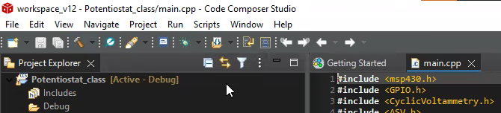 (fig. 7) to compile the program.



Fig. 7. Compile the main code.

1. Mount the MSP430G2553 on the Texas Instruments MSP4030 LaunchPad as shown in the figure below. *Note: consider the orientation of the microprocessor*.

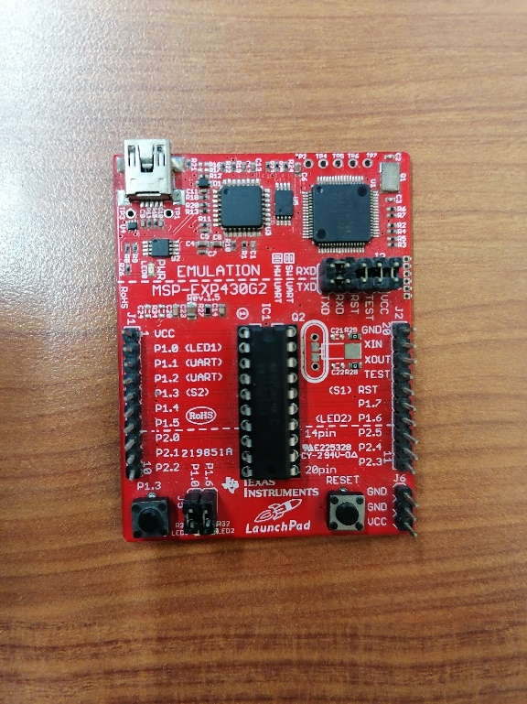

Fig. 8. How to mount the MSP430G2553 on the LaunchPad.

1. Click on the icon  to compile and upload the code to the MSP430G2553 (fig. 9).

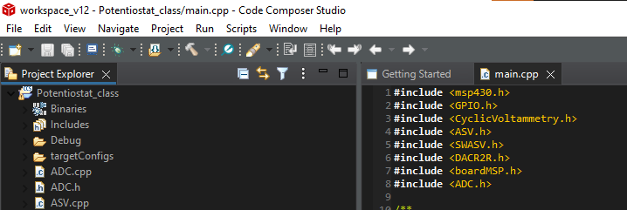

Fig. . Upload the code.

1. On the ULP Advisor’s window click on “Proceed” (figure below).

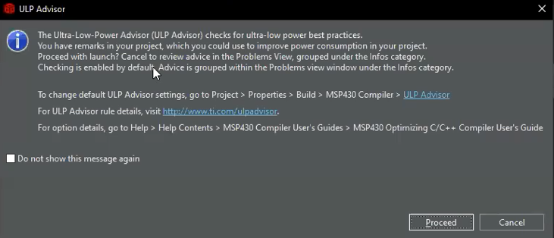

Fig. . ULP Advisor’s window.

1. Another window will show up and the line 43 will be highlighted in blue. Click on the icon  and then, clink on the icon .

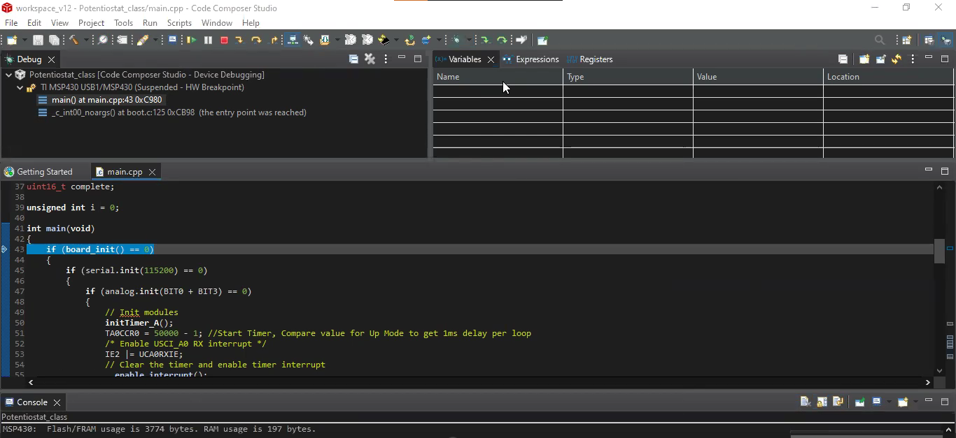

Fig. . Debugging the code.

1. Now your MSP430G2553 is programmed! Place the microcontroller on the potentiostat and enjoy it!

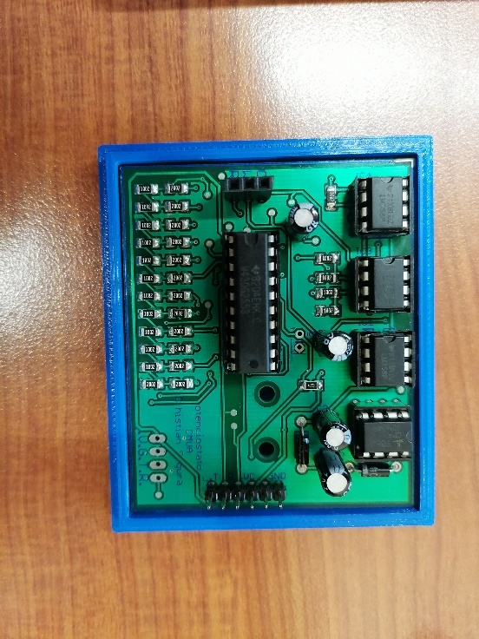

Fig. 12. MSP430G2553 mounted on the potentiostat.