Cleaning and Set for EEG recording using the Micromed System
Version 1.0
Produced by: Daniel Augusto Yepes Gutierrez

OBJECTIVE
To clean and set up the Micromed system to record EEG.

REQUIREMENTS
- Ensure that there is installed the SystemPlus Evolution software on the PC. Please note that the program will not launch if a Micromed system is not connected.
- Micromed SD LTM64 Express.
- Amount of electrodes needed for the montage.
- Cotton wool.
- Cotton sticks.
- Clip.
- Steel laboratory spatula.
- Flexible metric tape measure ruler.
- Ethylic alcohol 70%.
- NuPrep EEG & ECG skin preparation gel.
- Ten20 EEG conductive paste.

STEP BY STEP
  - Electrodes cleaning

- Apply ethylic alcohol 70% on a cotton pad.
- Clean the electrodes removing any residual paste and dirt, with the cotton piece.
- Should any residual conductive paste be present on the electrode hole, it should be removed using a clip. Kindly insert it through the rear of the electrode.
- Clean again using the cotton piece.
- Dry the electrode with a cotton stick.

  - Software and Micromed set up

- Execute the SystemPlus Evolution software (fig. 1).


Fig. 1. SystemPlus Evolution launcher
- Create a new participant by clicking the icon (Fig. 2.) or pressing F2.
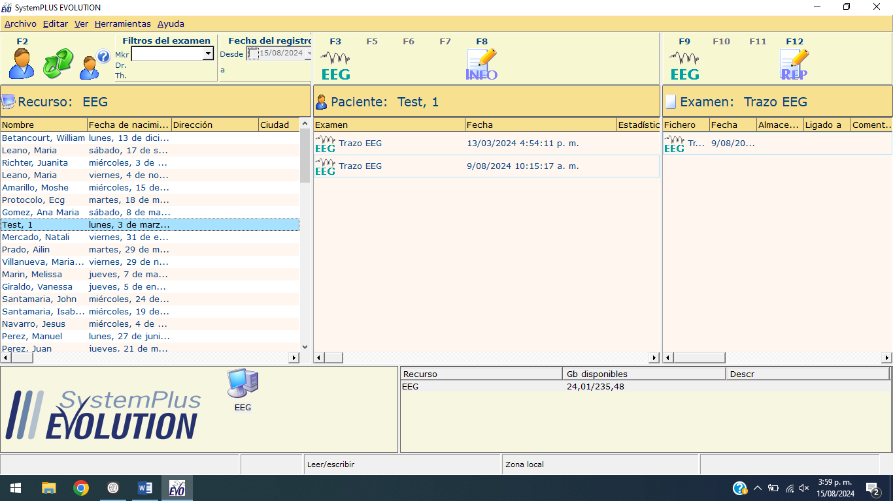
Fig. 2. Creating a new participant.
- Fill the participant information. Add an ID as a tag for your experiment (fig. 3). Click on “New” to add a nonexistent participant. Mandatory information is First Name, Last Name and Birth date. If needed, information of each participant can be modify using the “Open” option.

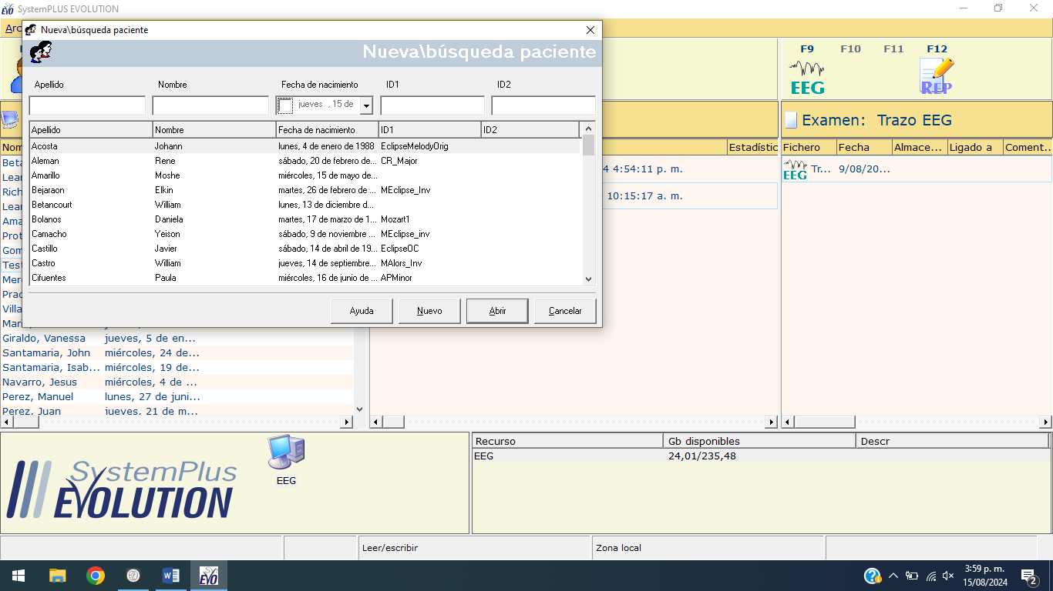 Fig. 3. Filling participant information
- Start the EEG UI by clicking the icon or pressing the key F3 (fig. 4), please verify the current montage setting on the UI (Fig. 5). If necessary, you may change the setting or create a new one for the experiment (fig. 6.).
Fig. 4. Opening EEG recording UI

Fig. 5. Checking Montage
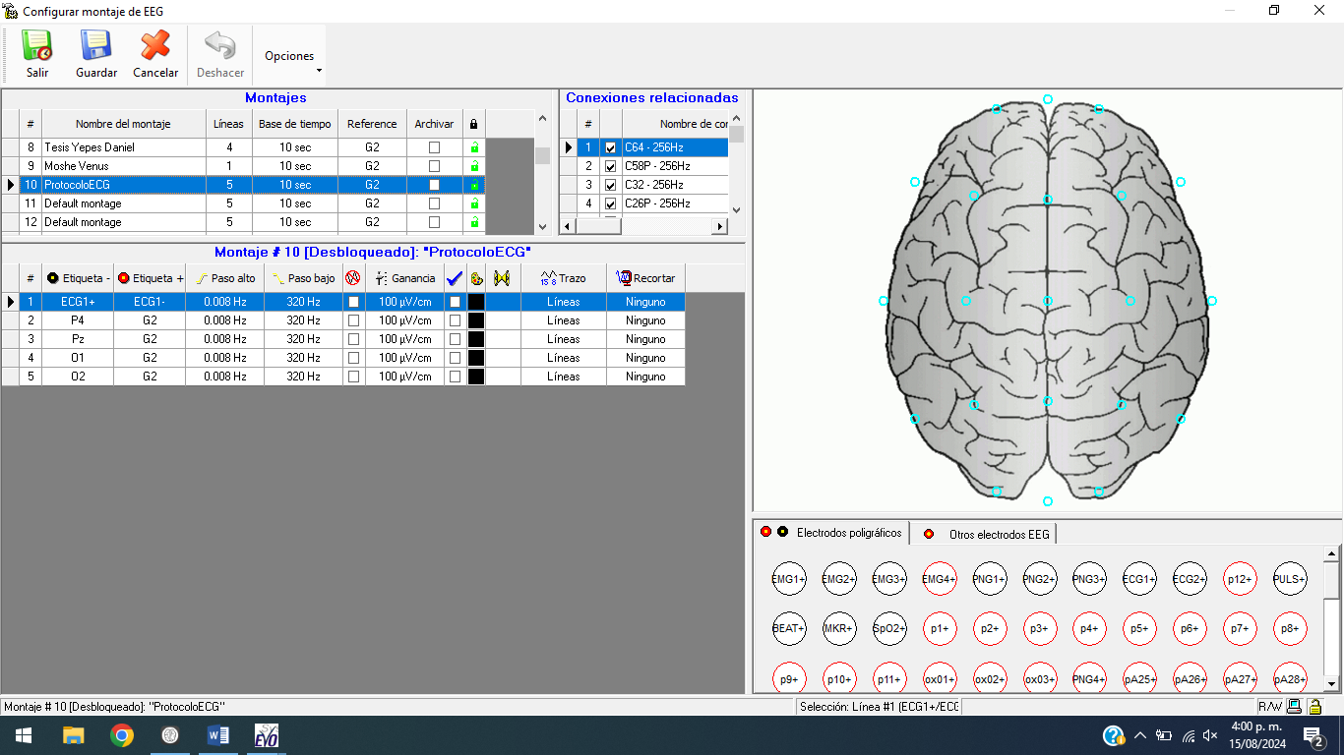
Fig. 6. Montage creator/editor.

- EEG channels are fixed to the number displayed on the matrix from the impedance checking interface (fig. 7). Connect the electrodes to the designated pins for the selected montage (Fig. 8).
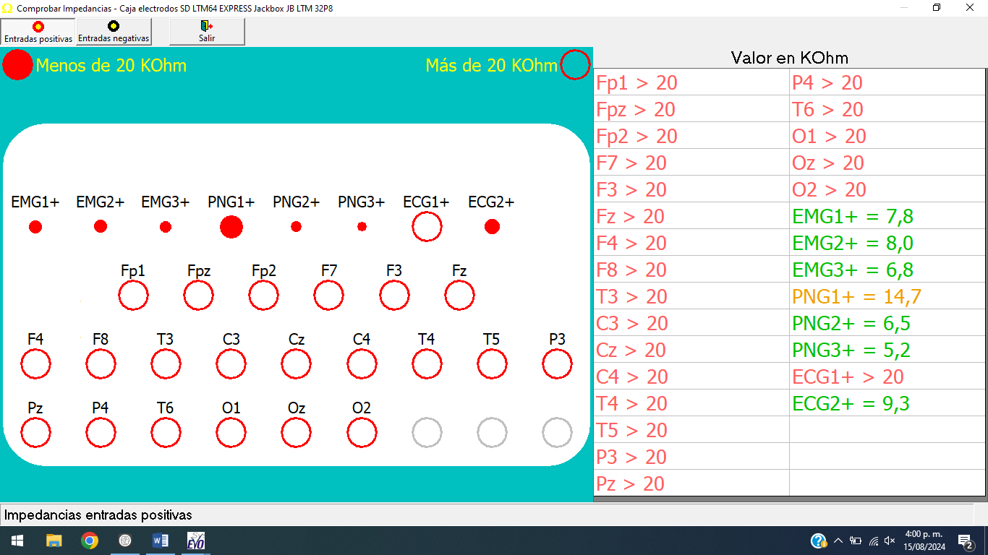
Fig. 7. Matrix of impedances for each channel. The number where is needed to connect the electrode corresponds with the number counting from top to bottom and for each column. I.e. Channel18 will be Pz, and 22 will be Oz. It’s open by clicking the Ω button on the EEG UI.
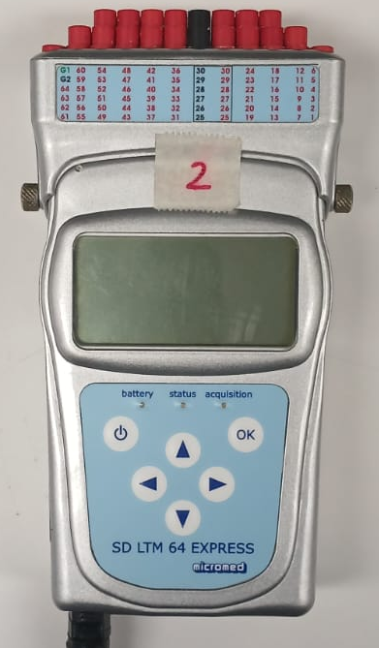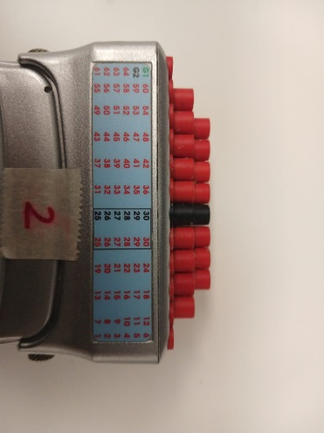
Fig. 8. Channels to connect the electrodes depending on the montage selected.

  - Participant preparation and set up
- Measure participant head from the nasion to the inion (Fig. 9).

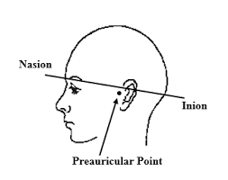
Fig. 9. Nasion and Inion locations
- Determine the spots for the channels you will use using the 10-20 system (Fig. 10). Considering that:

  - Marks for the Z electrodes are made through the midline from nasion to inion, at intervals of 10%, 20%, 20%, 20%, 20% and 10% (Fig.10).

  - The T3, C3, C4, and T4 electrodes are placed at marks made at intervals of 10% for the C electrode from Cz and the T at intervals of 20% from the C3 or C4 electrode, respectively (Fig. 10).

  - The Fp2, F8, T4, T6, and O2 electrodes are placed at intervals of 5%, 10%, 10%, 10%, 10%, and 5%, respectively, measured above the right ear, from front (Fpz) to back (Oz). The same is done for the odd-numbered electrodes on the left side, to complete the full circumference. O1 and O2 are placed a 10% (Fig. 10).
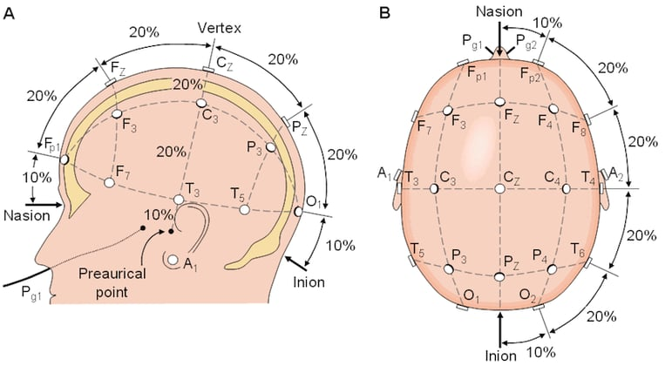
Fig. 10. Nasion and Inion locations
- Clean marked spots for the electrodes with a cotton swap moistened with ethylic alcohol 70%.
- Clean marked spots using NuPrep skin preparation gel.
- Use the steel laboratory spatula to cover the electrode surface with Ten20 conductive, ensuring a flat layer is left on the top.
- Place the electrode on the marked spot for each electrode and press until the strip of conductive paste comes out of the electrode hole. If the subject has a lot of hair, use your hands to separate the hair to ensure maximum skin contact.
- Repeat the aforementioned steps for the ground electrode. The ground electrodes will be connected to the Gs pin of the micromed (Fig. 8.).
  - EEG recording
- Ensure that the impedances for the EEG channels that will be recorded are within the 8 to 15 range (Fig. 11). Same for the ground electrode (s) (Fig. 11).
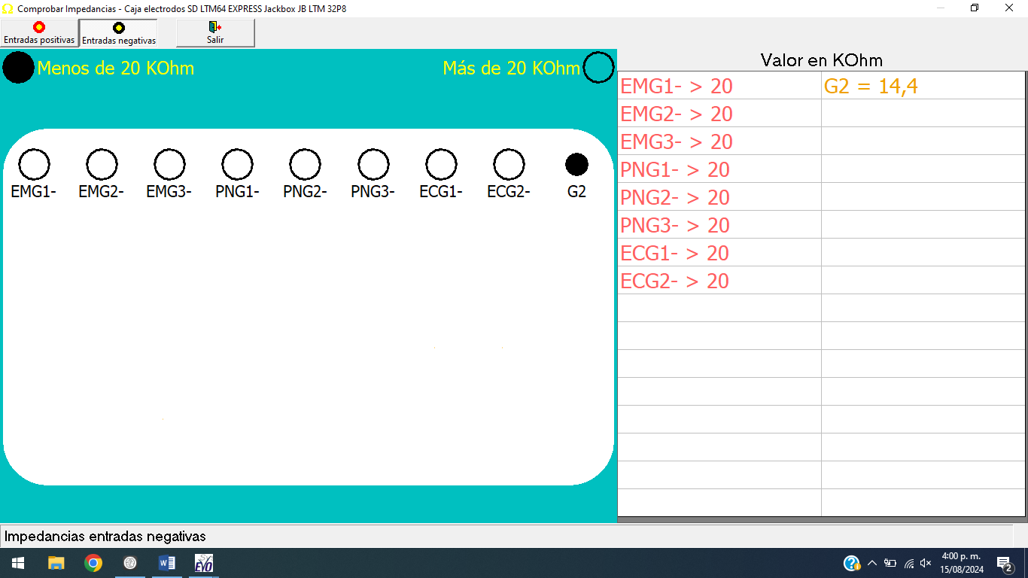
Fig.11. Checking impedances for EEG channels and Ground (G2)

- Click the play button at the EEG UI and wait until the recording stabilizes (Fig. 15). Once the capture is stable, click the record button to start the EEG recording.
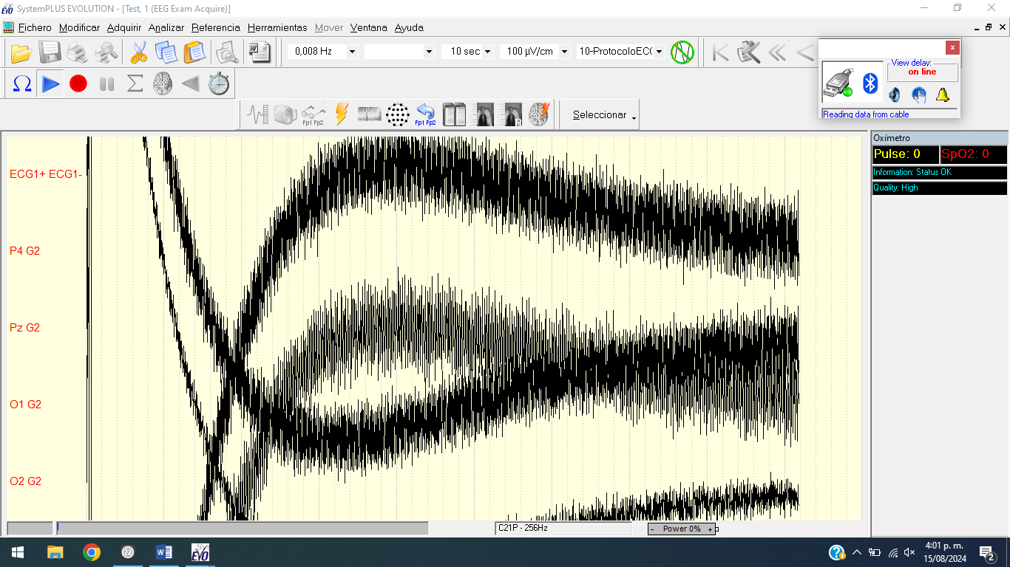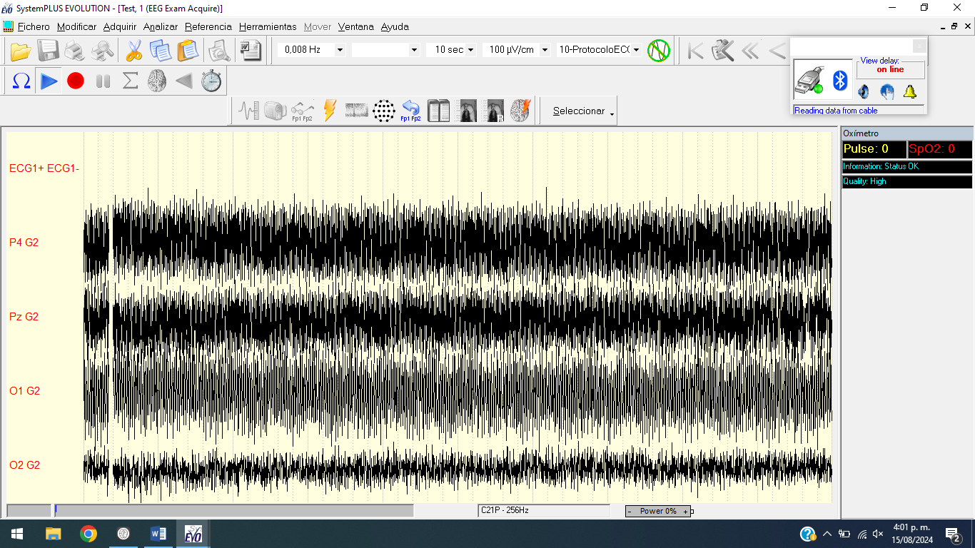
Fig.12. EEG reading unstable and stable
- Once the experiment or recording is complete, click the record button again to finish the EEG recording.
- In order to close the EEG UI or the software, stop the reading by clicking the play button.

