OPERATIONAL PROCEDURE FOR SIZE AND ZETA POTENTIAL ANALYSIS - ZETASIZER NANO
Version 1.0
Produced by: Ingrid Nathaly Rangel M.

OBJECTIVE
To describe the procedure to be adopted for particle size and zeta potential analysis using the Malvern Zetasizer Nano ZS90 equipment.

REQUIREMENTS
Prior training by the laboratory staff in charge of the equipment's location is recommended to handle the Malvern Zetasizer Nano ZS90 equipment, about its basic principles and care. The manual and accessories guide can be found at the following links:
- MALVERN. Zetasizer Nano Series User Manual. MAN0485: https://www.chem.uci.edu/~dmitryf/manuals/Malvern%20Zetasizer%20ZS%20DLS%20user%20manual.pdf
- MALVERN. Zetasizer Nano Series Accessories Guide. MAN0487: https://www.cif.iastate.edu/sites/default/files/uploads/Other_Inst/Particle%20Size/Accessories%20and%20Cells%20Guide.pdf

SOFTWARE REQUIREMENTS
Zetasizer Nano software v3.30 or avaliable version.

PERSONAL PROTECTIVE EQUIPMENT (PPE)
- Goggles
- Lab coat
- Nitrile gloves

GENERAL DESCRIPTION AND CONDITIONS
Before starting the measurement procedure, turn on the instrument and computer. Wait 30 minutes to perform analysis so that the laser stabilizes. It is normal for the equipment to make some noise when starting up. Consider Figure 1 as a guide to the main parts of the equipment. The power button is located on the back panel of the equipment.

Figure 1: Main parts. 1) Equipment; 2) Computer with the equipment software; 3) Cells; 4) Area of the equipment cell; 5) Access button to the cell area and status indicator.
  - SAMPLE PREPARATION
Refer to chapter 5 of the equipment user manual for details on concentration for each type of measurement and necessary precautions in sample preparation.

CHOICE AND FILLING OF THE CELL
Refer to the equipment accessories manual for the complete list of cells and their specifications. For the procedures described in this operational procedure, the following cells can be used:

Table 1: Working Cell Determination.
Cell | Parameter | Especification
Glass - square aperture with 4 polished faces (PCS115) | Measurement Type | Size, Molar mass
 | Typical Solvents | Water, most organic and inorganic solvents
 | Optical Quality | Excellent
 | Minimum Sample Volume | 1 mL
Polycarbonate - Be/Cu plated gold electrodes (DTS1060) | Measurement Type | Size, Zeta potential
 | Typical Solvents | Water, water/ethanol  Not resistant to organic solvents
 | Optical Quality | Very good
 | Minimum Sample Volume | 0,75 mL

Observations: There is also a polycarbonate cell with a square aperture with 4 faces. This cell, due to its material, is not resistant to organic solvents.

Filling the glass cell should be done by tilting it and slowly draining the solution down the wall to avoid bubbles. Ensure that the cell is dry and clean on the outside after inserting the sample to prevent damage to the equipment's cell holder electrodes. To do this, dry it with soft paper before inserting it into the equipment.
The filling of the polycarbonate cuvette must be carried out according to the following steps. Make sure that the cuvette and its electrodes are dry and clean on the outside after inserting the sample to avoid damage to the electrodes of the cuvette holder. To do this, dry it with soft paper before inserting it into the equipment. Attention: cuvette not resistant to organic solvents.
- Attach a syringe containing the sample to one of the cuvette inlets. Invert the cuvette. Then slowly insert the sample halfway into the inner U-tube.
- Rotate the cuvette with the inlets facing upwards and continue slowly inserting the sample until the limit illustrated above is reached.
- Remove the syringe. Check for bubbles by gently shaking the cuvette. Place the caps on each outlet. Make sure that one of the caps is tightly closed and the other is loosely closed to avoid pressure on the cuvette.
- Press the button 5 indicated in Figure 1 to open the equipment compartment where the cuvette will be placed.
In the case of the polycarbonate cuvette, there is a preferred side for the cuvette. On this side there is a line on the top of the cuvette, as indicated in the following figure. This side should be oriented towards the user when the cuvette is inserted into the instrument cuvette holder.

METHODOLOGY

SOFTWARE INITIALIZATION AND BASIC FUNCTIONS RECOGNITION
- Connect the equipment before starting the software.
- On the desktop, double-click the computer icon.
- The software startup window will appear. If any user has previously used the software and has not closed their results, this user's results window will appear.

- Create a file to save all measurements. Go to File → New → Measurement File.
- If it does not already exist, create a folder with the project name, and within this folder, create another one with your name. Name the file. Remember that this is the file that will save all your analyses that will be done on the equipment, and not just one of them. It is recommended to include your own name in the file.

- The measurement file window will appear on the screen. Each new measurement you perform will appear as a line in this window.

MANUAL MEASUREMENTS
In this type of measurement, all parameters are specified before each measurement.
- Go to Measure → Manual

- In the window that appears, select the type of measurement you want to perform in Measurement type. For example, size for particle size or zeta potential for zeta potential.
- Type the name of your sample in Sample name. If necessary, provide relevant information in Notes.

- On the left menu, select Dispersant.
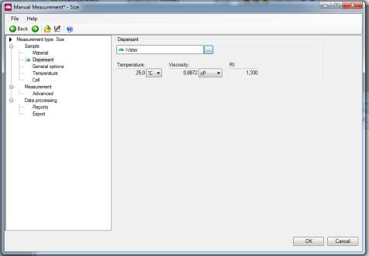

- Click on the button with three dots and select the dispersant in the window that appears. Attention: Check the compatibility of your dispersant with the cuvette to avoid damaging it.
- Select Temperature on the left menu to select the analysis temperature and how long the device will wait for thermal equilibrium before measurement.
- Select Cell to choose the cuvette that will be used. Attention: The appearance of this window may vary depending on the type of measurement (size or zeta potential). However, the principle is the same, to select the cuvette that will be used in the experiment.

- In Measurement, modify the measurement parameters. For a first analysis, where many characteristics of the sample are not known, it is recommended to start with a measurement containing 10 runs of 10 seconds each. Change these values as you get more information about your sample. Attention: The appearance of this window may vary depending on the type of measurement (size or zeta potential). However, the usual values are the same.
- Select Export to create a file that will receive the information of your measurement in a format that can be imported later into software such as Excel and Origin. Click on the folder icon to select your folder and give a name to the file.
- After clicking OK, the measurement window will appear. Click Start to start the measurement.
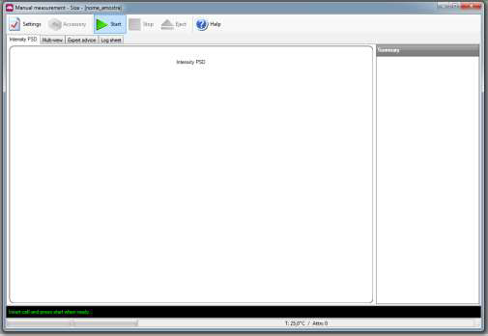
- After each run, the graph on the screen will be updated.

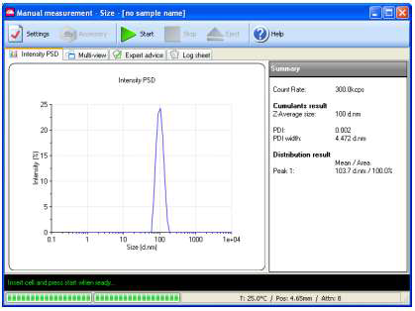
- After finishing, return to the measurement file window. Click on the name of your sample. Several tabs will appear at the top of the window. Select the one that contains the information you want to see. Check the status of the Result Quality item. If it is not marked as Good, follow the instructions that appear on the screen to see the software suggestions to improve the quality of your analysis.
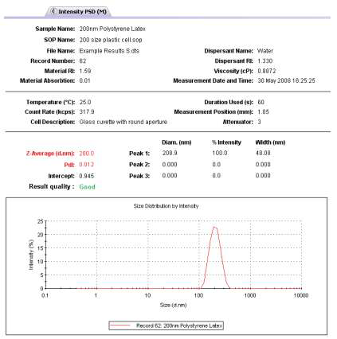

MEASUREMENTS USING A STANDARD OPERATING PROCEDURE (SOP)
In this type of measurement, parameters are saved in a file previously created by the user. Once the file is loaded, the measurement requires less user intervention. It is a useful type of measurement for those who have already discovered the optimal analysis condition for their samples using the previous measurement type and plan to analyze various samples under the same conditions.
Refer to chapter 8 of the equipment user manual for details on creating and using SOPs.

ANALYSIS TERMINATION
After completing the measurement, remove the cuvette by slowly pulling it out from the sample compartment. Dispose of the solution in an appropriate container. Wash the cuvette thoroughly with distilled water. Dry it well on the outside with a soft paper. If a new measurement is going to be performed immediately after, wash the cuvette with the new measurement solution a few times to avoid dilution effects.
If no new measurement is going to be performed, close the sample compartment, make sure it is clean and dry. Close the equipment software. Go to the folder specified in Export to copy the files generated by the software, which can be opened in software such as Excel and Origin for graph generation. For security reasons, it is advisable to go to the folder with the original data files of your measurements and make a copy for backup. To do this, locate the folder C:\Users\Usuario\Documents\Malvern Instruments\Zetasizer\Measurement Data, open it and copy the file. Do not delete or cut the file, just make a copy. Copies can be extracted from the computer through USB devices or CD/DVDs. The computer does not have internet access to send email messages.
Turn off the computer and the equipment. Disconnect the stabilizer and remove its plug from the wall socket, leaving the adapter connected to the stabilizer socket. Record the use of the equipment in the control notebook next to it. Clean the workspace, taking care to store the materials properly and not damage neighboring equipment with water or solvent. Cover the equipment, monitor, and keyboard/mouse set with protective bubble wrap, if necessary.

CHANGE CONTROL

CHANGE DESCRIPTION | DATE | VERSION | APPROVED BY

