ARDUINO CONTROL PROTOCOL FROM LABVIEW
Version 1.0
Produced by: Logan Linamaría Mejía Suárez

OBJECTIVE
To show the Uniandes community the procedure that must be followed to control an Arduino board from Labview software.

SCOPE
To inform the Uniandes community about the procedure to be followed for using an Arduino board from Labview software.

SOFTWARE INSTALLATION
- It is assumed that the computer has Labview installed.
- Install JKI VI Package Manager: http://www.ni.com/gate/gb/GB_EVALTLKTVIPM/US
- In case the link is broken, search for it on Google as "Download National Instruments VI Package manager."
- After clicking Download, you will be prompted to log in to National Instruments. If you do not have an account, you need to register.
- JKI VI Package Manager can be seen as a store of additional Labview tools. In it, we will find the Labview interface for Arduino.
- Once downloaded, it should look like this:
- Search for the Labview Interface for Arduino tool, double-click it, and wait for the following window to load:
- The package information will appear, and in the left menu, you will see the current version of Labview on the computer (2013 in my case) and the option to install. Since I already have it, the option that appears is to uninstall the package. Next, Next, Next. Labview is now configured. Now we need to configure Arduino.

ARDUINO INSTALLATION.
- Go to Arduino.cc
Figure 4: Arduino software download menu.
- Install Arduino. Now Arduino needs to understand what Labview is sending it.
- Download the LIFA_BASE_2012_Build_79 file from any of the following links:
- http://www.mediafire.com/download/o2yr35x3e528nlb/LIFA_Base_2012_Build_79.zip
- https://www.dropbox.com/s/vlrgnnvv2nic17f/LIFA_Base_2012_Build_79.zip?dl=0
- Extract it wherever you want and check that the files look like the ones shown below.
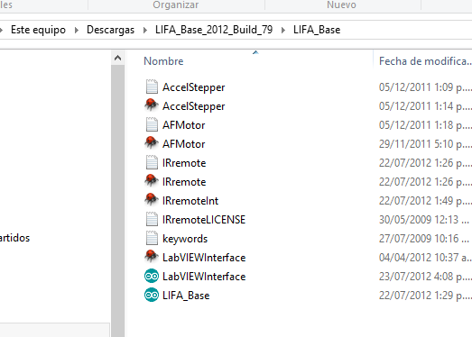
Figure 5: LIFA_Base location.
- LIFA_Base is the file we are interested in.
- Open Arduino.
- Open the LIFA_BASE file.
- Look for LIFA BASE, where it was saved. If necessary, remember that the extension is .ino
- Once the file is opened,
- Connect the board.
- Verify in tools -> board -> (the board we are using, in my case Mega2560) as shown below:
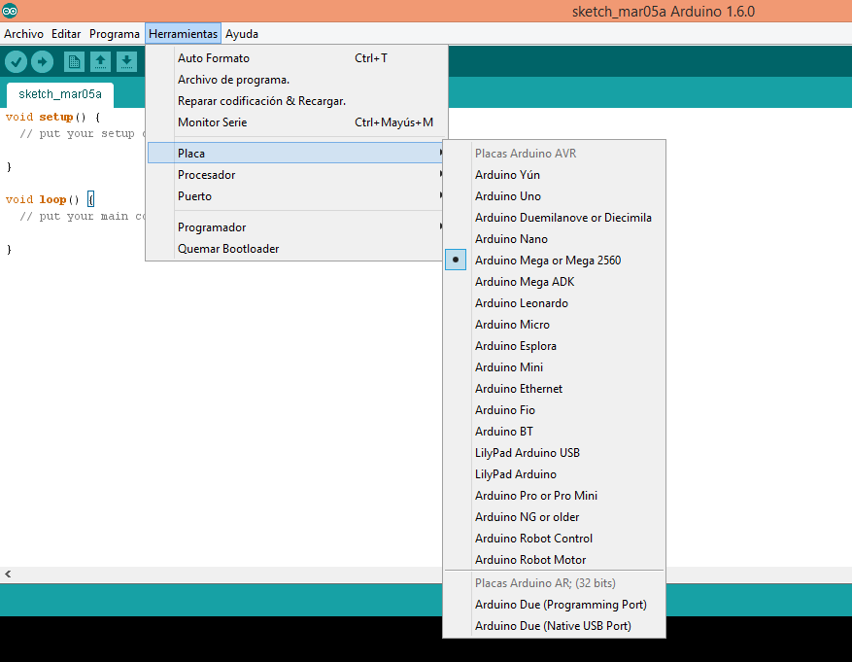
- Click on "Upload" where the arrow is. The process should start, and you can see the progress in the bottom green bar.
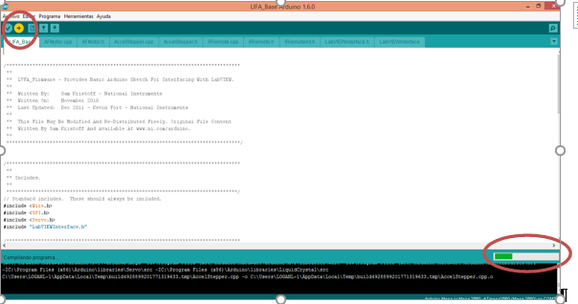
- Confirm that the word "Uploaded" appears as shown below:
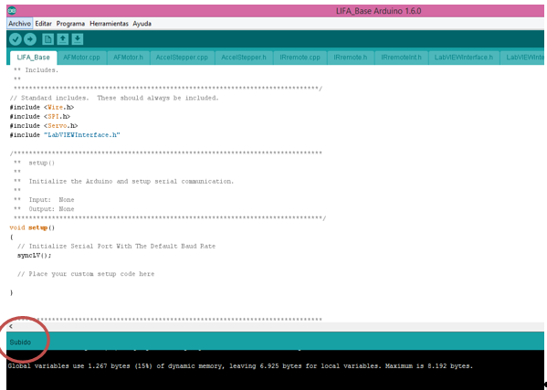
- You can now limit yourself to placing blocks in Labview and save the step of programming in C. Let's confirm it: Open Labview:
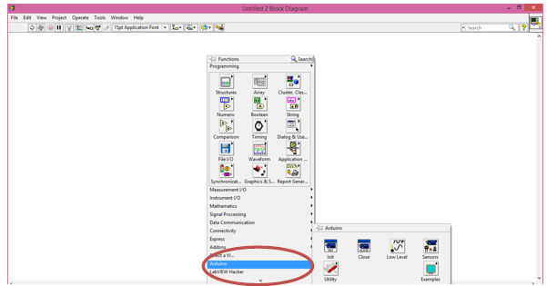

EXAMPLE 1: LET'S READ A VOLTAGE
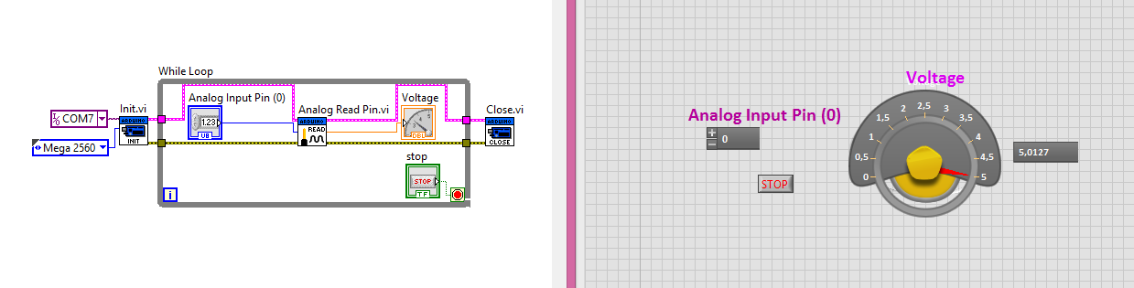
Note:
- The COM7 constant is connected to the VISA resource input.
- The Mega 2560 constant is connected to the Type Board input.
- The error in the Arduino blocks is connected between them (yellow cable), as well as the Arduino resources (pink cable).
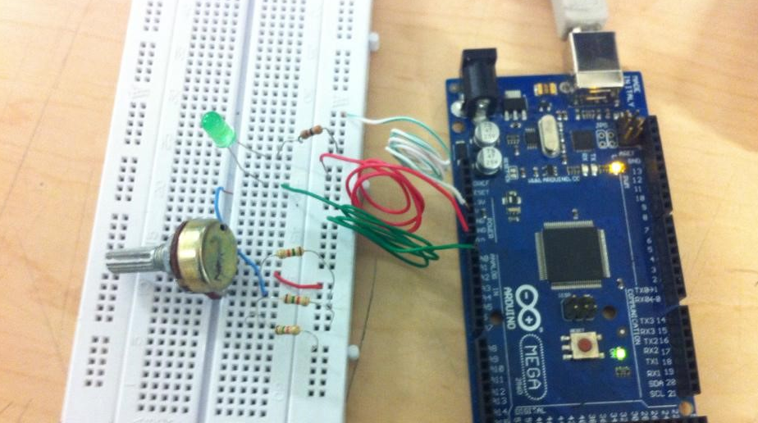
Remember: Connect the board via USB port to the computer and power it with 5V to the Vin pin. Connect the ground. Read input from pin0.
Possible errors:
- Error -1073807343
- Disconnect the card, close labview completely, connect the card and open labview. If the error persists, disconnect the card -> go to device manager in Windows -> COM and LPT Ports -> Arduino, right click to uninstall the driver (just uninstall, do not delete) -> connect the card and Windows will install it automatically -> open labview.

EXAMPLE 2: TURNING ON AN LED WITH PWM.
The following program is performed in Labview:
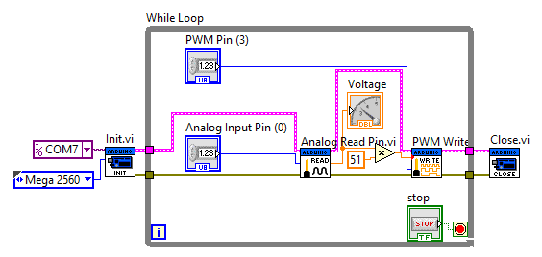
The output of the Analog Read Pin block is multiplied by 51 because the range of this output is between 0 and 5V. Whereas the PWM Write block has an input in duty cycle from 0 to 255. A simple rule of three is performed in which the maximum voltage received (5V) equals 255 (a duty cycle of 100%).
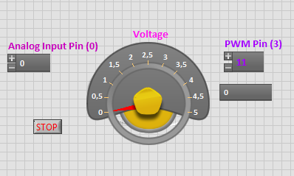
The PWM output pin to turn on the LED was pin 11.

CHANGE CONTROL
CHANGE DESCRIPTION | DATE | VERSION | APPROVED BY

