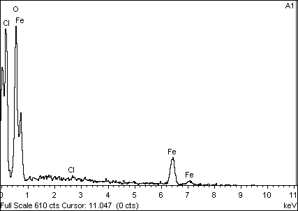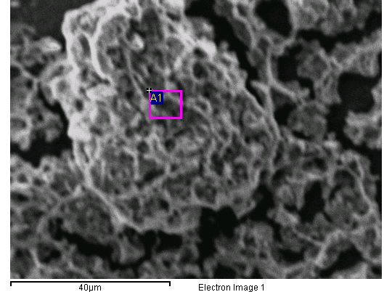

Spectrum processing :

No peaks omitted

Processing option : All elements analyzed (Normalised)

Number of iterations = 1

Standard :

O SiO2 1-Jun-1999 12:00 AM

Cl KCl 1-Jun-1999 12:00 AM

Fe Fe 1-Jun-1999 12:00 AM

|  |  |  |  |  |  |  |
| --- | --- | --- | --- | --- | --- | --- |
| Element | App | Intensity | Weight% | Weight% | Atomic% |  |
|  | Conc. | Corrn. |  | Sigma |  |  |
| O K | 0.09 | 2.4913 | 30.42 | 1.95 | 60.34 |  |
| Cl K | 0.00 | 0.9214 | 0.41 | 0.61 | 0.36 |  |
| Fe L | 0.05 | 0.6437 | 69.17 | 2.01 | 39.30 |  |
|  |  |  |  |  |  |  |
| Totals |  |  | 100.00 |  |  |  |

Comment:

22/08/2018 09:25:25

UNIVERSIDAD DE LOS ANDES

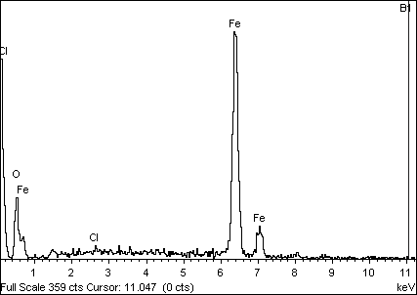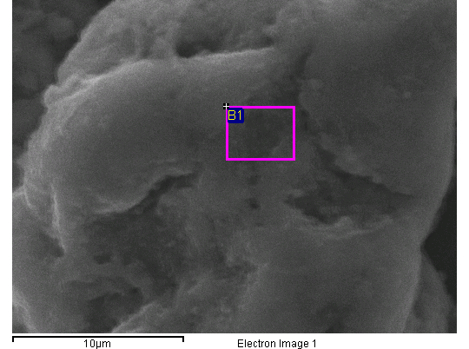

Spectrum processing :

No peaks omitted

Processing option : All elements analyzed (Normalised)

Number of iterations = 2

Standard :

O SiO2 1-Jun-1999 12:00 AM

Cl KCl 1-Jun-1999 12:00 AM

Fe Fe 1-Jun-1999 12:00 AM

|  |  |  |  |  |  |  |
| --- | --- | --- | --- | --- | --- | --- |
| Element | App | Intensity | Weight% | Weight% | Atomic% |  |
|  | Conc. | Corrn. |  | Sigma |  |  |
| O K | 0.71 | 1.5299 | 14.23 | 1.23 | 36.61 |  |
| Cl K | 0.01 | 0.8048 | 0.36 | 0.39 | 0.42 |  |
| Fe K | 2.68 | 0.9670 | 85.41 | 1.27 | 62.97 |  |
|  |  |  |  |  |  |  |
| Totals |  |  | 100.00 |  |  |  |

Comment:

22/08/2018 09:54:31

UNIVERSIDAD DE LOS ANDES

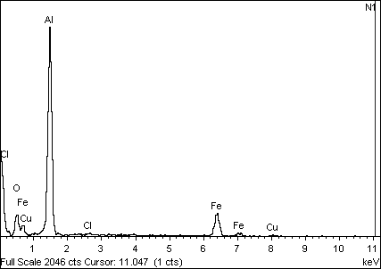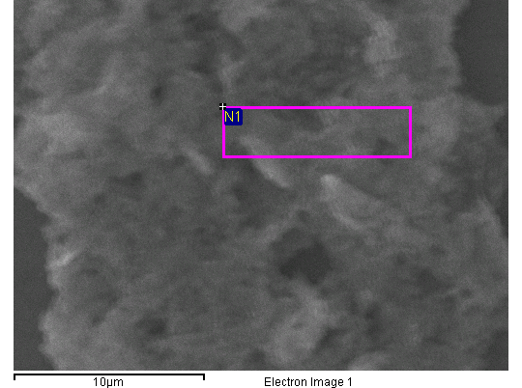

Spectrum processing :

No peaks omitted

Processing option : All elements analyzed (Normalised)

Number of iterations = 3

Standard :

O SiO2 1-Jun-1999 12:00 AM

Al Al2O3 1-Jun-1999 12:00 AM

Cl KCl 1-Jun-1999 12:00 AM

Fe Fe 1-Jun-1999 12:00 AM

Cu Cu 1-Jun-1999 12:00 AM

|  |  |  |  |  |  |  |
| --- | --- | --- | --- | --- | --- | --- |
| Element | App | Intensity | Weight% | Weight% | Atomic% |  |
|  | Conc. | Corrn. |  | Sigma |  |  |
| O K | 1.66 | 0.9726 | 21.11 | 1.10 | 35.02 |  |
| Al K | 3.68 | 0.8415 | 53.97 | 1.04 | 53.08 |  |
| Cl K | 0.04 | 0.6880 | 0.71 | 0.24 | 0.53 |  |
| Fe K | 1.56 | 0.8864 | 21.81 | 0.83 | 10.37 |  |
| Cu K | 0.16 | 0.8315 | 2.39 | 0.60 | 1.00 |  |
|  |  |  |  |  |  |  |
| Totals |  |  | 100.00 |  |  |  |

Comment:

22/08/2018 10:06:38

UNIVERSIDAD DE LOS ANDES

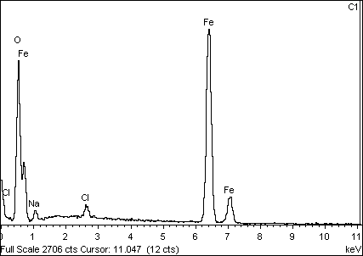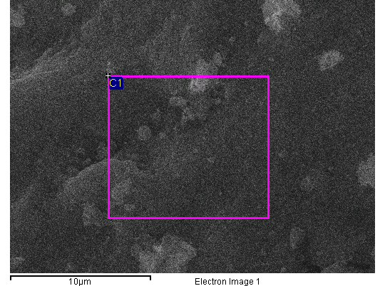

Spectrum processing :

No peaks omitted

Processing option : All elements analyzed (Normalised)

Number of iterations = 2

Standard :

O SiO2 1-Jun-1999 12:00 AM

Na Albite 1-Jun-1999 12:00 AM

Cl KCl 1-Jun-1999 12:00 AM

Fe Fe 1-Jun-1999 12:00 AM

|  |  |  |  |  |  |  |
| --- | --- | --- | --- | --- | --- | --- |
| Element | App | Intensity | Weight% | Weight% | Atomic% |  |
|  | Conc. | Corrn. |  | Sigma |  |  |
| O K | 18.37 | 1.6170 | 31.37 | 0.47 | 59.67 |  |
| Na K | 0.47 | 0.4113 | 3.19 | 0.31 | 4.22 |  |
| Cl K | 0.42 | 0.8032 | 1.44 | 0.13 | 1.23 |  |
| Fe K | 21.41 | 0.9248 | 64.01 | 0.50 | 34.88 |  |
|  |  |  |  |  |  |  |
| Totals |  |  | 100.00 |  |  |  |

Comment:

22/08/2018 10:42:35

UNIVERSIDAD DE LOS ANDES