|  |  |
| --- | --- |
| **LD3000R Specifications** | |
| Output Current | 0.02 - 2.5 A |
| Operating Mode | Constant Current |
| Internal Current Control | 12-Turn On-Board Potentiometer |
| External Current Control | 0 - 5 V Analog Input Voltage (J1 Pin 4) |
| Bandwidth | 1.1 kHz |
| Operating Voltage | ±8 to 12 V |

|  |  |
| --- | --- |
| **J1 Pin Configuration** | |
| Pin # | Function |
| 1 | +V (5 to 12 VDC, 50 mA) |
| 2 | Ground |
| 3 | **-V (-8 to -12 VDC, 2.5 A)** |
| 4 | External Current Control (0 to 5 VDC) |
| 5 | No Contact (Polarization Key) |
| 6 | Laser Diode Anode (Internally Connected to Pin 2 Ground) |
| 7 | Laser Diode Cathode |
| ~~8~~ | ~~Monitor Photodiode Anode (from Laser)~~ |
| ~~9~~ | ~~Photo Diode Monitor Output (-1 V/mA)~~ |
| 10 | Laser Current Monitor Output (1 V/A) Referenced to -V |

|  |  |
| --- | --- |
| **J2 Pin Configuration** | |
| Pin # | Function |
| **Jump 2 to 3** | **Mode 1: COMMON Referenced External Current Control** |
| Jump 4 to 5 | Mode 2: Disable External Current Control |
| 1 | No Connection (Leave Floating) |
| 5 | -V (May Also Be Used for Monitoring Signals) |

**Steps:**

1. Connect cables to LED cathode (black) and anode (red) pads.

The LED PCBA takes long to heat up (~ 30 sec). Be patient. Helpful to use high temperature and bigger soldering tips.

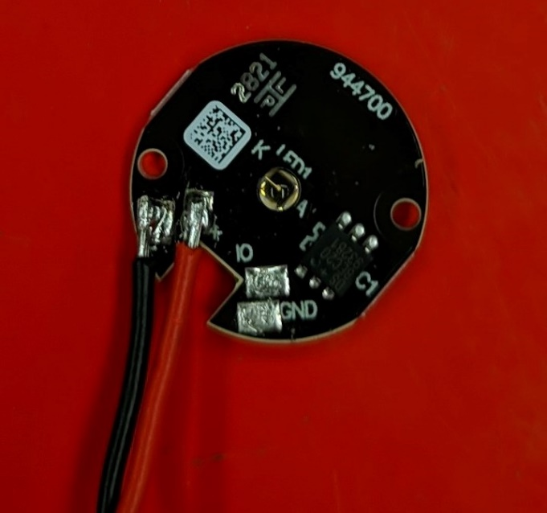

1. Connect the LED to driver.
2. Solder Power supply cables to the driver.

Use shrinkage to cover the exposed connections.

Repeat step 1 to 3 for all LEDs. Mark the drivers to avoid mixing up the LEDs.

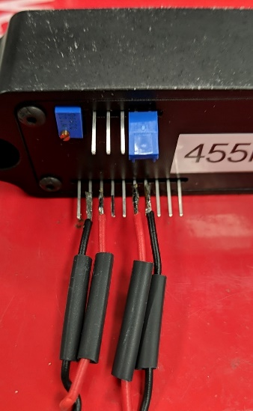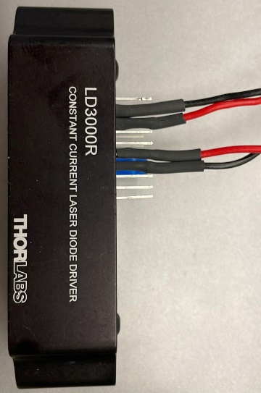

1. Screw the LED PCBs to the costume-made holders.

Use heat conducting paste behind the LED for heat conductivity.

1. Mount the dichroic filters in cage cubes.

Take into consideration the small arrow on the filter. Handle with care. Mount so the longer wavelength passes through.

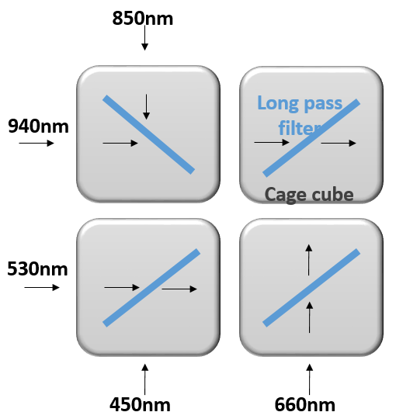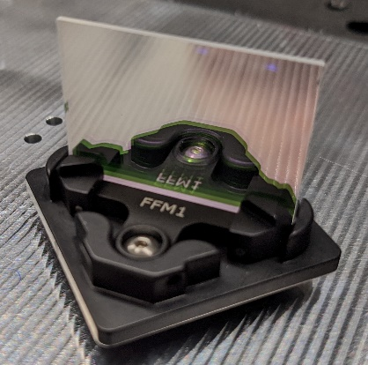

1. Mount the lenses after the LEDs to focus beam.
2. Connect the cage cubes using the custom made connecters.

At this stage all the opto-mech should be mounted on the metal plate.

