OBSERVATION OF A
TOROIDAL LUMINOUS PHENOMENON
OVER THE SEGRE RIVER

Prince of Viana Bridge · Lleida · 18 September 2022

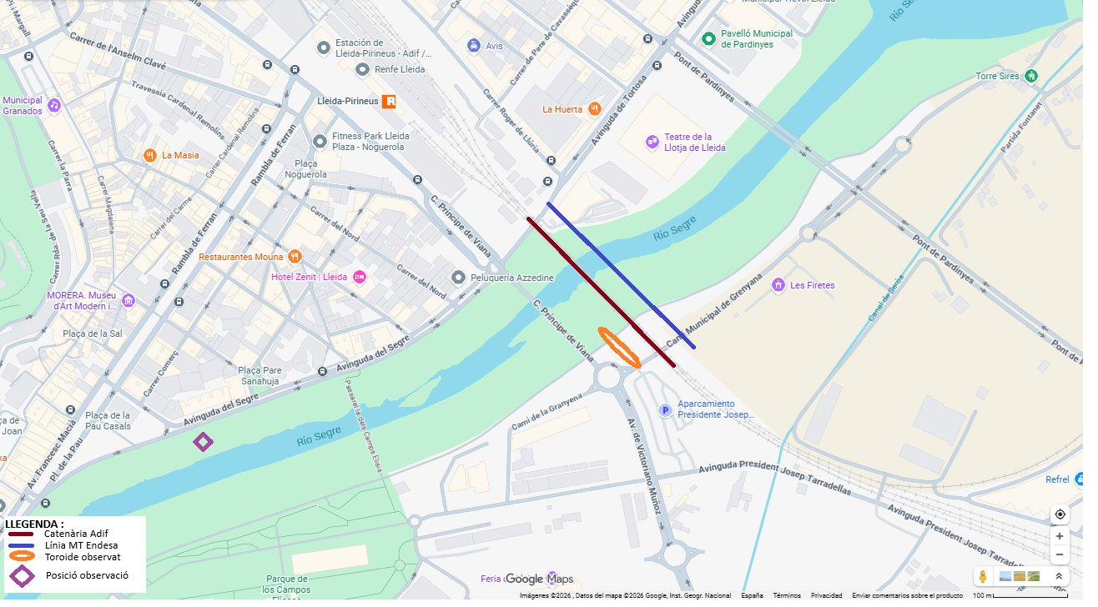
Figure 1. Map of the Prince of Viana Bridge area over the Segre River (Lleida). GPS coordinates: 41.6142° N, 0.6222° E.

PRELIMINARY NOTE
This document describes only directly observed facts. It contains no theoretical interpretations or hypotheses about the nature of the phenomenon. Data is presented exactly as perceived by the witness at the time of observation.

First-hand witness account · Written: May 2026 · Factual document · Free distribution with attribution

1. THE LOCATION AND TIME

The observation took place on Sunday 18 September 2022, in daylight hours around 18:00 h, from the Prince of Viana Bridge in Lleida, over the Segre River.

The Prince of Viana Bridge is a double-deck cable-stayed structure spanning the Segre River in Lleida, in the Cappont district. The area is frequented by vehicles and pedestrians, and offers direct views over the river section between the Vell Bridge and the University Bridge.

September 2022 was extraordinary from a meteorological perspective: it was the hottest September on record in Catalonia since reliable records began. The Segre River was at its lowest flow in 25 years, with an exceptionally low water level and a largely exposed riverbed. The sky was completely clear.

1.1 Observation point coordinates
Reference system | Coordinates
GPS (WGS84) – degrees, minutes, seconds | 41° 36′ 51″ N / 0° 37′ 20″ E
GPS (WGS84) – decimal degrees | 41.6142° N / 0.6222° E
UTM ETRS89 – Zone 31N | X = 298,780 m E / Y = 4,609,780 m N
Approximate altitude | 155 m a.s.l.

1.2 Environmental conditions
Condition | Observed value | Context
Date | 18 September 2022 | Sunday
Time | ~18:00 h (daytime) | Direct sunlight
Ambient temperature | ~35 °C | Hottest September on record in Catalonia
Wind | Light breeze ~3 km/h | Variable direction, no gusts
Segre River flow | 25-year historical minimum | Riverbed largely exposed
Visibility | Excellent | Completely clear sky

2. LOCAL INFRASTRUCTURE

Along the bridge and in the observed river section, the following electrical and railway infrastructure is visible, forming part of the normal local landscape:

• A Medium Voltage power line from Endesa running parallel to the bridge, at approximately 18 metres above river level.
• The ADIF high-speed railway catenary, running parallel to the river section, at approximately 11 metres above the river and about 24 metres horizontal separation from the MV line.
• Both lines carry alternating current at 25,000 volts and 50 Hz frequency.
• The Segre River at that point has an approximate channel width of 30 metres.

The vertical separation between the MV line and the catenary is 3 metres. Both run parallel on the same side of the river's airspace, a few metres apart in height.

3. DESCRIPTION OF THE OBSERVED PHENOMENON

The witness observed the phenomenon suddenly, without prior warning. Attention was drawn by an intense orange light above the river that initially appeared to be a solar reflection off some object. Upon direct inspection, it became clear it was an autonomous luminous floating object.

3.1 Shape and dimensions
The phenomenon had the shape of a perfectly circular ring, similar to a donut or a torus. Its approximate dimensions, estimated by comparison with the visible infrastructure (the bridge, the power lines), were:

Parameter | Estimated value
Outer ring diameter | ~25 m
Central hole diameter | ~22 m (≈ 90% of total diameter)
Ring tube thickness | ~3 m
Height above river level | ~20–30 m (above the power lines)

3.2 Colour and luminosity
L'anell era de color taronja intens i brillant, comparable al color d'una flama de gas natural o d'una làmpada de sodi de baixa pressió. La lluminositat era suficient per ser visible en ple dia amb llum solar directa.

The central hole of the ring showed a slightly blue tint different from the surrounding sky. It was not a dark or intense blue, but a subtle difference in tone that made the central hole visually distinguishable from the background sky. The witness describes this effect as: «the sky appeared a different shade of blue inside the hole».

3.3 Spatial orientation
The ring was oriented vertically — its plane was perpendicular to the ground. The central hole pointed in the direction of the river's course, so that an observer at hole level and inside it would have seen the river in perspective. From the bridge, the ring appeared face-on, as a perfect circle.

3.4 The four orbital nodes
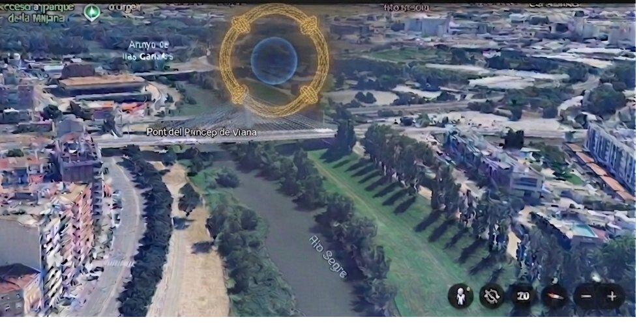
Figure 2. Sketch of the phenomenon made by the witness shortly after the observation. The orange ring, the blue central hole and the four equidistant luminous nodes are clearly visible.
Along the ring perimeter, four luminous points of greater intensity moved slowly along the ring's contour in an anticlockwise direction, as seen from the witness's perspective. Their characteristics were:

• Four points in total, evenly distributed: one at top, one at bottom, one left, one right.
• Each point was notably brighter than the rest of the ring.
• The movement was slow and uniform, with no perceptible accelerations or speed changes.
• Apparent speed: approximately one full revolution every 7 seconds (~0.14 Hz).
• Direction of rotation: anticlockwise as seen from the witness's position.
• The four points maintained their equidistant spacing throughout.

3.5 Dynamic behaviour
During the approximately three minutes the phenomenon lasted, the ring drifted slowly in the direction of the breeze, maintaining its perfect shape and geometry throughout. The movement was smooth and inertial, comparable to a balloon drifting with the wind.

The ring did not vibrate, oscillate or show any perceptible deformation. Its circular shape was constant.

4. THE EXTINCTION

L'extinció no va ser sobtada. Va ser un procés gradual d'uns 20 a 30 segons de durada, durant el qual l'anell es va anar fent cada vegada menys lluminós fins a fondre's amb el cel.

The witness describes the overall sensation as «orderly and controlled», in the sense that there was no explosion, no loud noise, no sound, and no visible disturbance in the environment immediately after disappearance.

5. WITNESS IMPRESSIONS

The witness describes the phenomenon as completely unexpected and impossible to classify in any known category at the time. Immediate impressions were:

• The geometric perfection of the ring drew attention from the first instant. Such a regular ring can hardly be accidental.
• The persistence: the phenomenon lasted long enough (three minutes) to be observed carefully and to rule out an optical illusion or momentary reflection.
• The coherence of movement: the ring drifted with the wind maintaining its shape, as if it were a solid physical object.
• The extinction sequence: the manner in which it disappeared, with the gradual fading, seemed a deliberate process rather than a random disintegration.

The witness heard no sound associated with the phenomenon, nor any particular smell. Ambient temperature and wind did not perceptibly change during or immediately after the phenomenon.

The witness was the only person who, at that moment, was in position to see the phenomenon from the correct angle. It cannot be confirmed whether others observed it from other locations.

6. GRAPHIC DOCUMENTATION

No photograph or video of the phenomenon could be obtained at the time. The witness made a freehand sketch shortly after returning home, while details were still vivid in memory.

The sketch (Figure 2, previous page) shows the general shape of the ring, the blue central hole, and the position of the four orbital nodes. The witness describes the sketch as «very approximate in terms of proportions, but faithful to the main elements: the ring, the hole and the four points».

Figure 1 on the cover is a map of the Prince of Viana Bridge area with the coordinates of the observation point.

7. OBJECTIVE CONTEXTUAL DATA

The following data corresponds to verifiable information independent of the observation, gathered afterwards to place the phenomenon in its real context:

Element | Objective data
September 2022 temperature | Hottest September on record in Catalonia (source: SMC)
Segre River flow September 2022 | 25-year historical minimum (source: CHEbro)
Endesa MV Line (Lleida) | 25 kV AC · 50 Hz · height above river: ~18 m (Prince of Viana Bridge section)
ADIF Catenary (AVE Lleida) | 25 kV AC · 50 Hz · height above river: ~11 m
Horizontal separation MV–Cat. | ~24 m (perpendicular to river)
River channel width at the point | ~30 m (at 2022 minimum level)
Bridge height above river | ~5 m (deck level)

These data are not presented as an explanation of the phenomenon, but as objective context for any subsequent study wishing to investigate the site conditions at the time of observation.

FINAL NOTE
This document has the sole objective of documenting as precisely as possible what was observed. The witness has no background in physics or science and makes no claim to explain the phenomenon.

Anyone who knows of similar documented phenomena, or who has technical knowledge enabling identification of what has been described, is invited to make contact. The description is detailed enough to allow rigorous analysis.

Alongside this factual document, there is a separate technical study (Self-Sustaining Atmospheric Plasma Toroid, Preprint May 2026) that proposes a physical model to explain the phenomenon based on a combination of acoustic and electromagnetic confinement. This model is a working hypothesis, not a confirmed explanation.

Lleida, May 2026

Factual document · Free distribution with attribution · Not subject to copyright

