PHYSICAL SIMULATION OF AN ATMOSPHERIC
PLASMA TOROID

Physical Formulation, Computational Implementation
and Replicability Analysis

Based on the Segre observation, Lleida · September 2022
Simulation version: V040_59
Written: May 2026

Free document · GNU Free Documentation License v1.3

⚠ IMPORTANT NOTE
This document describes a hypothetical physical model. None of the equations or
conclusions herein have been experimentally validated.
It is presented as a working hypothesis open to review.

PREFACE
This document arises from the need to try to understand, from the standpoint of conventional physics, a visual phenomenon that the witness could not identify in any known category. It does not come from a research laboratory or an academic institution. It comes from the curiosity of a person who saw something unusual and refused to accept that it was inexplicable.

The approach has been that of a rigorous amateur: to take the tools that physics has developed over the centuries — Maxwell's equations, the Bennett condition, Paschen's law, the Kruskal-Shafranov criterion — and see whether, combined appropriately, the specific conditions of the observation site could generate the described phenomenon.

The answer the simulation gives is: yes, it is physically plausible. But "plausible" does not mean "proven". Hi ha una diferència abismal entre un model matemàtic que reprodueix un comportament i la prova experimental que aquell comportament realment es produeix.

Humility is the first requirement of science. Any plasma physicist reading this document will find simplifications, approximations, and probably errors. The invitation to correct them is sincere and will be deeply appreciated.

If this document serves to arouse the interest of someone who has the means to carry out the real experiment, it will have fulfilled its purpose.

Note on mathematical notation
To facilitate reading and external review, the entire document uses consistent IUPAC/SI notation:
Notation | Meaning | Example
Italic variable | Scalar physical variable | T, I, E, P, f
Bold variable | Physical vector | E, B, J, F
Numeric subscript | Source or mode index | f₁, f₂, P₁, P₂
Text subscript | Physical qualifier | E_node, h_node
Units [brackets] | Result unit | [m/s], [Pa], [kV/m]
Courier New code | JavaScript implementation | function calcIon(){...}
Blue-framed equation | Main physical formula (EQ-01..16) | EQ-05: E_rup = ...

Lleida, May 2026

LICENCE

GNU Free Documentation License, Version 1.3
Copyright © 2026. Permission is granted to copy, distribute and/or modify this document under the terms of the GNU Free Documentation License, Version 1.3 or any later version published by the Free Software Foundation.

This document is free: you may redistribute it and/or modify it under the terms of the GNU Free Documentation License as published by the Free Software Foundation. There are no Invariant Sections, no Front-Cover Texts, and no Back-Cover Texts.

A copy of the licence is available at: https://www.gnu.org/licenses/fdl-1.3.html

Summary of rights granted
- You may copy and distribute verbatim copies of this document.
- You may modify the document and distribute modified versions.
- You may translate the document into other languages.
- You must retain this licence in any derived version.
- You must attribute changes you make from the original.
- You may not add additional restrictions to recipients.

Simulation source code: available under GNU GPL v3.

PART I
THE PROBLEM AND THE PHYSICAL FRAMEWORK

1. THE PHENOMENON AND ITS PHYSICAL CHALLENGES
The companion factual document describes in detail what was observed. Here we summarise the elements that raise the specific physical questions the simulation attempts to answer:

Observed element | Physical question
Stable toroidal ring ~3 min | What mechanism confines plasma in a ring shape without walls?
Fixed height ~24 m | Why doesn't it fall? What energy support keeps it at height?
Brilliant orange colour | Which gases ionise and at what temperature?
Blue central hole | Why does the hole have a different colour? Confined magnetic field?
4 anticlockwise orbital nodes | By what mechanism do they orbit? At what actual speed?
Slow drift with the wind | Does the toroid have sufficient inertial mass to drift?
Extinction by 2 plasmoids | How do they cause extinction? Which plasma physics applies?

1.1 The infrastructure as an energy source
The central hypothesis is that the electrical infrastructure in the area — the Endesa MV line (25 kV AC, 50 Hz) and the ADIF catenary (25 kV AC, 50 Hz) — provides the electromagnetic energy needed to ionise and sustain the plasma. Without this infrastructure, the phenomenon could not have occurred.

The key is the simultaneity of two exceptional conditions:
- Two EM energy sources at the same frequency (50 Hz) but potentially phase-shifted, creating a time-varying combined field.
- The frequency 3.5714 Hz (= 50/14 Hz) as the resonant acoustic frequency that, for reasons explained in detail, amplifies the EM-acoustic coupling by a factor k=25.

⚠ The infrastructure-as-energy-source hypothesis is consistent with the data but does not exclude other explanations. The phenomenon could have a completely different cause that has not been considered.

PART II
THE PHYSICAL FORMULAE AND THEIR IMPLEMENTATION

2. PHYSICAL FOUNDATION: THE 16 EQUATIONS
The following presents the 16 main equations of the model, with the physical context justifying each, their specific implementation in simulation V040_59, and an honest assessment of their limitations.

For each equation:
- The mathematical formula and its physical origin (reference)
- How it is calculated in the simulation (JavaScript function name)
- Why it is relevant to the observed phenomenon
- Where the simplification may not be valid

EQ-01 · Speed of sound and acoustic node height
When two sound sources at the same frequency face each other, a standing wave forms. The nodes of this wave (maximum pressure zones) remain fixed in space. The position of the first node above the reflector is:
h_node = λ/4 = v_so / (4·f) λ = wavelength
v_so(T) = 20.05 · √(T + 273.15) [m/s] T in °C
The speed of sound is not constant: it depends on temperature. At Segre conditions in September 2022 (T≈35°C), v_so=351.6 m/s, not the standard 343 m/s. This 2.5% difference shifts the node 0.6 m upward.

Implementation in V040_59
function vso(){ return 20.05 * Math.sqrt(S.T + 273.15); }
function hNode1(){ return vso() / (4 * S.f1); }

For f=3.5714 Hz and T=35°C: h_node = 351.6/(4×3.5714) = 24.6 m ✓

For laboratory replication, remember to update v_so based on the actual ambient temperature. A 5°C error shifts the node ~1 m.
⚠ Simplification: the model assumes homogeneous air. In real conditions, the temperature profile over a river can create vertical gradients that deflect the waves.

EQ-02 · Lorentzian resonance factor (k)
When the acoustic frequency is exactly an integer divisor of 50 Hz, the coupling between the acoustic field and the electromagnetic field is amplified. The factor k quantifies this coupling:
k(f) = k_max / [1 + ((f − 50/n) / (f₀/60))²] ∀n ∈ {1..14}
k_total = max{ k(f₁), k(f₂) }
The Lorentzian form reflects that the amplification decreases rapidly as we move away from the resonant frequency. The half-peak width is f₀/60 (approximately ±0.06 Hz for low harmonics).

For f=3.5714 Hz = 50/14: k=25 (maximum). For f=3.6 Hz: k≈18. For f=4.0 Hz: k<1. Selectivity is very high.

Implementation in V040_59
function factorK(f){
let k=0.8;
for(let n=1;n<=14;n++){
const f0=50/n, df=f0/60;
k=Math.max(k, 25/(1+((f-f0)/df)**2));
}
return k;
}

⚠ The factor k=25 is an empirical estimate, not derived from a first-principles theory. It assumes linear coupling between the fields. In reality, EM-acoustic coupling is a complex non-linear phenomenon (electroacoustics, electrostriction) that has not been fully modelled.

EQ-03 · Acoustic-electromagnetic synchronism (qSync)
The plasma ionises optimally when the acoustic pressure crest reaches the node at the same moment as the electromagnetic field maximum. The parameter qSync measures this degree of temporal coincidence:
t_travel = h_node / v_so [propagation time]
φ_total = 2π·f_EM·(t_travel + τ) [phase at node]
qSync = |sin(φ_total)| [0=no sync, 1=perfect sync]
The parameter τ (adjustable delay) allows optimising synchronism for each configuration. The optimal value is calculated automatically:
τ_optimal = 1/(4·f_EM) − t_travel [delay for qSync=1]

Implementation in V040_59
function qSync(){
const t_v = hNode1()/vso();
const fase = 2*Math.PI*F_EM*(t_v + S.tau/1e6);
return Math.abs(Math.sin(fase));
}

For Segre conditions (h=24.6 m, v_so=351.6 m/s): t_travel=70 ms. The optimal delay τ=-5001 µs gives qSync≈1.0 (perfect synchronism).

EQ-04 · Electromagnetic field at the node
The resulting electric field from both lines is obtained by vector superposition. For two sources phase-shifted by angle ph:
E_node = √(E_MT² + E_Cat² + 2·E_MT·E_Cat·cos(φ_MT-Cat))
E_MT ≈ V_MT / d_MT (infinite wire simplification)
Where d_MT is the distance from the node to the MV wire. For V_MT=25 kV, d_MT≈8m: E_MT≈4.4 kV/m. For a 90° phase shift between MV and catenary, the resulting field is ≈35.4 kV/m effective potential difference between the two wires.

Implementation in V040_59
function dvEM(){
const vmt=S.vmt*1000, vcat=S.vcat*1000;
const ph=S.ph*Math.PI/180;
return Math.sqrt(vmt*vmt + vcat*vcat
+ 2*vmt*vcat*Math.cos(ph));
}

⚠ Important simplification: the real EM field is not uniform in space. It is approximated with the infinite wire model, which overestimates the field near the wires and underestimates it at large distances. The real field distribution over a bridge with complex infrastructure requires FEM (finite element) calculation.

EQ-05 · Paschen threshold modified by rarefaction
Paschen's law (1889) establishes the minimum electric field needed to ionise a gas at a given pressure. Under standard conditions for air at 1 atm:
E_ruptura_base ≈ 3000 kV/m
But three factors significantly modify this value under Segre conditions:
- Elevated temperature (35°C):
- Reduces air density → fewer collisions → lower threshold
- Acoustic rarefaction at the node:
- P_local < P_atm at minimum pressure node (antinode) → lower threshold
- Humidity and residual ionisation:
- Reduces threshold via photo-ion collisions

P_mín = max(100 Pa, P_atm − P_acústica) [rarefacció]
E_rup = 3000 · (P_mín/P₀) · (293/T_K) · (1−H·0.003) · (1−IR·0.005)

The decisive factor: the resonance k
E_rup_efectiu = E_rup / (1 + k · qSync · (db/150))
The factor (1 + k·qSync·(db/150)) can reach 26× for k=25, qSync=1, db=150 dB. This reduces the effective threshold from 3000 kV/m to ~115 kV/m. With E_node≈4.4 kV/m, the ratio E_node/E_rup_effective is ~4% — insufficient to ionise directly — but the dB threshold is:
db_effective_threshold ≈ 53 dB (versus ~116 dB without k)

Implementation in V040_59
function eRup(){
const P_min = Math.max(100, S.P*100 - pAc());
return 3000*(P_min/101325)*(293/(S.T+273))
*Math.max(0.3,1-S.H*0.003)
*Math.max(0.5,1-S.IR*0.005);
}
function eRupEff(){
return eRup()/(1+factorKTotal()*qSync()*(dbCombined()/150));
}

⚠ The amplification factor k·qSync·(db/150) is the most speculative part of the model. It is not derived from a complete microscopic theory of EM-acoustic interaction. It is based on the physical plausibility of three mechanisms (EQ-13) but the exact algebraic form is an ad hoc approximation.

EQ-06 · Effective threshold in dB (llindarEff)
To determine whether the generated acoustic pressure is sufficient to initiate ionisation, we convert the electric field threshold to dB sound pressure:
r = E_node / E_rup_efectiu
P_llindar = 632 · (1/r)^2.5 / (η · β) [Pa]
dB_threshold = 20 · log₁₀(P_llindar / 20·10⁻⁶)
Where η=sinc(π·d/λ) is the wave efficiency at the node (function of source separation and wavelength), and β is the shock factor (β≈1 under normal conditions, β>1 near reflective surfaces).

Per a les condicions del Segre: E_node=4.4 kV/m, E_rup_efectiu≈4.5 kV/m, r≈0.98, P_llindar≈18 Pa, dB_threshold≈119 dB. Amb 130 dB disponibles (E_generat > E_llindar): IONITZA.

Implementation in V040_59
function llindarEff(){
const Er=eRupEff()/1000, Em=campEMAlNode();
if(Em<Er*0.005) return 199;
const r=Em/Er, eta=etaSo(), beta=S.beta;
const pL=632*Math.pow(1/Math.max(r,0.02),2.5)/(eta*beta);
return Math.max(0, 20*Math.log10(pL/20e-6));
}

EQ-07 · Ionisation dynamics (calcIon)
The degree of gas ionisation at the node is calculated from the ratio between available acoustic pressure and the effective threshold. The relationship is non-linear: double the threshold pressure does not give double the ionisation, but much more, due to the electron avalanche effect (Townsend):
r = db_combinat / dB_threshold
ion_target = clamp(0.7 + (r−1)·0.5, 0, 1) if r > 1
d(ionSmooth)/dt = (ion_target − ionSmooth) / τ_ion
Where τ_ion = 2 s for the arc model (fast ionisation by electric arc) and τ_ion = 4 s for the excited N₂ model (gradual ionisation by electronic excitation).

Saha thermal ionisation activates when T>5000 K, allowing the plasma to partially sustain itself without external EM field:
ionSaha = min(0.6, exp(−E_i / 2k_BT) · 0.8)

Implementation in V040_59
function calcIon(){
// Saha for hot arc
if(PLASMA_MODEL==='arc' && T_plasma_K>5000 && toroideSmooth>0.3){
const s=Math.min(0.6,Math.exp(-1.5e4/T_plasma_K)*0.8);
if(s>0.01) return s;
}
// Acoustic ionisation
const r=dbCombined()/llindarEff();
if(r<=1) return 0;
return clamp(0.7+(r-1)*0.5, 0, 1);
}

EQ-08 · Orbital angular momentum and rotation (calcVortex)
Two sound sources with phase shift φ=90° create a wave field with non-zero orbital angular momentum (OAM). This OAM induces a rotation of the ionised medium in the form of an acoustic vortex. The rotation intensity:
OAM ∝ P₁ · P₂ · sin(φ)
vx_target = |rotEfectiu()| · √(db₁·db₂) / 150
rotEfectiu() = sin(φ) · sinc(π·d_fonts/λ)
For φ=90°: sin(90°)=1 (maximum OAM). For φ=0° or 180°: sin=0 (no rotation). The factor sinc(π·d/λ) represents the wave efficiency at the node as a function of geometry.

This rotation is the mechanism that closes the ionised plasma filament into a toroidal ring shape. Without OAM, the plasma would disperse radially without forming the toroidal geometry.

Implementation in V040_59
function calcVortex(){
const re=Math.abs(rotEfectiu());
if(re<0.03) return 0;
return re*Math.sqrt(S.db1*S.db2)/150;
}

⚠ The acoustic vortex model implemented here is highly simplified. The real formation of a 3D toroidal plasma vortex involves magneto-hydrodynamic (MHD) instabilities that are not captured by this scalar equation.

EQ-09 · Kruskal-Shafranov criterion (Margin M)
Margin M is the central parameter that determines whether the plasma can maintain the toroidal geometry or becomes unstable and disperses. It is defined as the ratio between the characteristic collapse time and the system response time:
τ_Z-pinch = R_tor / c_s (exc/fre model: K-S criteria)
τ_Z-pinch = ∞ (arc model: stability comes from thermal runaway)
τ_recomb = 1/(α·n_e) α = 3×10⁻¹³ m³/s [N₂ recombination rate]
τ_turbulence = L/v_rms
M = min(τ_Z, τ_recomb, τ_turb) / t_response
t_response = 0.02 / (q_node · (1 + qSync))

For M>1: plasma is stable, can form the toroid. For M<0.5: plasma disperses. The zone 0.5<M<1 is metastable.

The key decision for the arc model: tauZpinch=∞. For the arc model, temperature rises at ~1000 K/s, causing c_s to rise rapidly and tauZpinch to drop below 0.5 in 0.19 s. Physically, the stability of an atmospheric arc comes from thermal runaway, not the Z-pinch. Therefore, the tauZpinch term is not relevant for the arc model.

Implementation in V040_59
function tauZpinch(ion){
if(PLASMA_MODEL==='arc') return 9999; // thermal runaway
if(ion<0.05||!temHaEm()) return 9999;
const c_s=Math.sqrt(1.4*kB*(S.T+273)/(28*1.66e-27));
return Math.max(hNode1(),1)/c_s;
}

Margin M reproduces the observed qualitative behaviour surprisingly faithfully: the toroid forms in about 2 s and remains stable once the plasma is hot enough. But qualitative agreement is not proof of quantitative correctness.

EQ-10 · Plasma temperature (heat equation)
The plasma temperature evolves through the balance between ohmic heating (heat generated by the electric current) and losses by radiation and convection:
R_arc(T, ion) = R₀ / [(1+(T/T₀)²) · (1+ion·8)] [Ω/m]
I_plasma = ΔV_EM / R_arc(T,ion) [A]
P_òhmica = I² · R_arc(T,ion) / V [W/m³]
P_conv = (T − T_ambient) · h_Siple(W)
h_Siple(W) = max(10.45 − v + 10·√v, 5) [wind factor, Siple 1945]
P_rad = ε·σ·(T⁴ − T_env⁴) / r_plasma (Stefan-Boltzmann, Kirchhoff 1860)
ε = ε_max · max(0.05, ionSmooth) (emissivity proportional to ionisation)
dT/dt = (P_òhmica − P_conv − P_rad) / c_p_aire

La temperatura assoleix un valor màxim T_PLASMA_MAX=100.000 K per seguretat numèrica. El llindar de runaway tèrmic és T_RUNAWAY=7.000 K: per sobre d'aquest valor, el plasma és autosos tingut per Saha (EQ-07).

Implementation in V040_59
function dTdt(T_K, I_A){
if(!temHaEm()||I_A<0.001)
return T_K>S.T+273?-(T_K-(S.T+273))*2:0;
const Ra=R_arc(T_K,ionSmooth);
const P_ohm=I_A*I_A*Ra/100;
const v=S.W/3.6;
const hS=Math.max(10.45-v+10*Math.sqrt(v),5);
const P_conv=(T_K-(S.T+273))*0.3*(hS/10.45);
const eps=0.5*Math.max(0.05,ionSmooth);
const P_rad=eps*5.67e-8*(Math.pow(T_K,4)
-Math.pow(S.T+273,4))/(100*Math.max(rPlasma,0.05));
return(P_ohm-P_conv-P_rad)/1200;
}

EQ-11 · Confinement radius (Bennett Condition)
The Z-pinch effect compresses the plasma radially to an equilibrium radius where the external magnetic pressure equals the internal kinetic pressure of the plasma (Bennett condition, 1934):
I² = (8π / μ₀) · N · k_B · T
N = n_e · π · r_B² → r_B = √(I²·μ₀ / (8π·n_e·k_B·T))
On N és la densitat lineal de partícules (m⁻¹), n_e és la densitat electrònica (m⁻³), μ₀=4π×10⁻⁷ H/m i k_B=1.38×10⁻²³ J/K. El radi de Bennett r_B és el radi de la secció toroïdal (el "gruix" de l'anell).

Implementation in V040_59
function rPlasmaFromBennett(ion){
const ne=Math.pow(10,13+ion*1.6);
const I=calcIplasma(T_plasma_K,ion);
if(I<0.1) return 0.1;
const mu0=4*Math.PI*1e-7;
const num=I*I*mu0;
const den=8*Math.PI*ne*1.38e-23*Math.max(T_plasma_K,300);
return Math.max(0.05, Math.min(Math.sqrt(num/den),2));
}

For I≈1000 A, n_e≈10¹⁴ m⁻³, T≈5000 K: r_B≈0.3 m. Consistent with observation (ring cross-section ~0.5 m). But the uncertainty in n_e spans several orders of magnitude!

EQ-12 · Acoustic pressures: external, aeolian and self-generated
The model considers three independent acoustic pressure sources that accumulate:

a) External pressure (speakers S₁/S₂)
P_S₁ = 20·10⁻⁶ · 10^(db₁/20) [Pa]
P_combinada = √(P₁² + P₂² + 2·P₁·P₂·cos(φ))

b) Aeolian pressure (wind through cables)
The wind passing through the MV cables generates sound by von Kármán resonance (Strouhal, 1878):
f_Aeolian = St · v_wind / d_cable St=0.2, d=2 cm
P_aeolian = 0.08 · (ρ·v²/2) · (k_Aeolian/25)
For W=3.6 km/h (1 m/s): f_Aeolian=10 Hz=50/5 Hz → k=25 → P_aeolian=0.048 Pa → 67.6 dB. The Segre breeze acts as a natural acoustic generator!

c) Self-resonance (hot plasma)
P_self ∝ (T/T₀)² · (r_plasma/R_tor)² · 0.001·P_atm · toroideSmooth
When T>800 K and toroideSmooth>0.25, the hot plasma emits its own acoustic pressure by thermal effect. The emission frequency is c_s/(2πr), and coincides with f_node at equilibrium conditions.

Implementation in V040_59
function pAc(){
return pAcCombined()+pAcWind()+(sigOn?0:pAcSelf());
}

EQ-13 · Three EM-acoustic coupling mechanisms
The coupling between the EM field and the acoustic field occurs through three independent physical pathways, which the model implements additively:

Mechanism 1: Dynamic Paschen
M₁ = max(0.5, 1 − P_ac/P_atm · qSync)
Acoustic rarefaction at the node reduces local pressure, lowering the Paschen breakdown threshold. (Meek & Craggs, 1953)

Mechanism 2: Acoustic streaming (Eckart/Lighthill)
M₂ = 1 + 0.05 · (H/100) · (db/120) · qSync
Acoustic streaming (Eckart 1948, Lighthill 1978) creates a fluid flow in the direction of wave propagation. Under high humidity conditions, this flow increases electron-molecule collisions, amplifying ionisation.

Mechanism 3: Parametric pumping of metastable N₂
M₃ = 1 + (db_ratio · qSync · db/120) · 0.04
The EM field excites the vibrational metastable levels of N₂ (A³Σ, v≈3-8 eV). The acoustic wave acts as a parametric pump that relaxes these states toward ionisation. (Capitelli et al., 2000)

Implementation in V040_59
function calcIplasma(T_K, ion){
const R=R_arc(T_K,ion)*L_canal()/75;
const I_base=dvEM()*1000/Math.max(R,0.001);
const M1=Math.max(0.5,1-pAc()/(S.P*100)*qSync());
const M2=1+0.05*(S.H/100)*(dbCombined()/120)*qSync();
const M3=1+(dbRatio*qSync()*(dbCombined()/120))*0.04;
return (I_base/M1)*M2*M3;
}

⚠ These three mechanisms are combined multiplicatively in the model, but in reality they could be partially redundant or even contradictory in some regimes. The functional form is a computational convenience simplification.

EQ-14 · Toroid formation (toroideSmooth)
The variable toroideSmooth (0-1) represents the degree of toroidal ring formation. It grows when all necessary conditions are simultaneously met:
torT = min(ion,vx) · clamp(M,0,1) if ion>0.35 ∧ vx>0.35 ∧ M>0.5
torT = max(ion,0.3) · clamp(M>0?M:1,0,1) if plasmaAutonom
torDecay = (M<0.5) · (0.5−M) · 3 · dt
d(tor)/dt = (torT−tor)/τ_tor − torDecay
Where τ_tor = 2 s for the arc model and 4 s for exc. The triple condition (ionSmooth>0.35 AND vortexSmooth>0.35 AND M>0.5) reflects that toroid formation requires simultaneous ionisation, rotation and stability.

Implementation in V040_59
// In updatePhysics():
const cond=(ionSmooth>0.35&&vortexSmooth>0.35&&M>0.5);
let torT=0, torDecay=0;
if(plasmaAutonom){
torT=Math.min(Math.max(ionSmooth,0.3),1)
*clamp(M>0?M:1,0,1);
}else if(cond){
torT=Math.min(ionSmooth,vortexSmooth)*clamp(M,0,1);
}else{
torDecay=M<0.5?dt*(0.5-M)*3:0;
}
tor=clamp(tor+(torT-tor)/tau_tor*dt-torDecay,0,1);

EQ-15 · Wind drift (windDrift)
The toroid, once formed, has a mass of ionised gas that can be carried by the breeze. The lateral displacement follows the wind speed:
windDrift += (v_wind / v_so) · dt · pixel_scale
For W=3 km/h (0.83 m/s) and a lifetime of 3 min: total drift ≈ 150 m. The observation describes a «slow drift with the breeze», consistent with tens of metres in a few minutes.

Implementation in V040_59
windDrift += (S.W/3.6/vso()) * dt * pxM;

EQ-16 · ArcFade and natural extinction
When the toroid forms completely, the initial arc (filament visible during ignition) progressively extinguishes, yielding to the autonomous ring:
arcFade = max(0, 1 − toroideSmooth / 0.85)
The ring fades below visual detection (toroideSmooth < 0.08) when the plasma cools below the recombination threshold. The cooling time constant without EM is τ<1 µs (instantaneous).

For the simulation, extinction by injection of the two plasmoids (the observed "white points") can be modelled by deactivating the EM and letting the plasma cool at its natural tau.

PART III
THE AMALGAM: HOW THE EQUATIONS INTERACT

3. THE POSITIVE FEEDBACK CYCLE
The most interesting element of the model is not any individual equation, but the way they feed back into each other. The system has three positive feedback loops that, occurring simultaneously, can lead to the observed phenomenon:

3.1 Loop 1: Acoustic-EM (dynamic Paschen)
More sound → lower P_local → lower E_rup → less EM energy needed → plasma ionises → hot plasma generates its own sound (pAcSelf) → MORE SOUND.

Variable | Action | Effect
db ↑ | P_local drops by rarefaction (EQ-05) | E_rup ↓
E_rup ↓ | Ionisation threshold drops (EQ-06) | ionSmooth ↑
ion ↑ | T_plasma rises by ohmic heat (EQ-10) | T ↑
T ↑ | pAcSelf generates own pressure (EQ-12c) | db ↑ (loop)

3.2 Loop 2: Thermal (runaway)
More ionisation → plasma resistance drops → more current → more heat → more ionisation → R drops further → THERMAL RUNAWAY.

Variable | Action | Effect
ion ↑ | R_arc drops (EQ-10: factor 1+ion×8) | I ↑
I ↑ | P_ohmic = I²·R shoots up | T ↑ fort
T ↑ | Saha: thermal ionisation (EQ-07) | ion ↑ (loop)

3.3 Loop 3: MHD (Z-pinch self-sustaining)
More current → larger B_φ → better Z-pinch → more confined plasma → higher density → higher conductivity → MORE CURRENT.

3.4 Why the three loops fail most of the time
The necessary condition is that all three loops activate simultaneously and exceed their respective thresholds. Each has its own condition:
- Loop 1 requires: k≥10 (frequency near a 50 Hz subharmonic) + qSync>0.3 + db>50 dB
- Loop 2 requires: I > I_critical (thermal runaway does not activate until initial ionisation is large enough)
- Loop 3 requires: I > I_Bennett (Lorentz force exceeds plasma thermal pressure)

The Segre conditions in September 2022 satisfy all three conditions simultaneously by a narrow margin. Any other location with two 25 kV AC lines, a river as reflector, and a horizontal separation of about 10 m could, in principle, reproduce the conditions. But the coincidence is rare.

3.5 The simulation flow diagram
The simulation's main loop (updatePhysics, 60 times per second) executes the equations in the following order:
- Calculate v_so(T), hNode(f) → node position
- Calculate pAcCombined + pAcWind + pAcSelf → total pAc
- Calculate factorK, qSync, campEM → tuning parameters
- Calculate eRup, eRupEff, llindarEff → dynamic threshold
- Calculate calcIon() → ionSmooth (smoothed)
- Calculate calcVortex() → vortexSmooth (rotation)
- Calculate tauZpinch, tauRecomb, tauTurb → stabilityMargin → M
- Calculate calcIplasma(T, ion) → I_plasma
- Calculate dTdt(T, I) → T_plasma_K (new temperature)
- Update toroideSmooth → degree of visual formation
- Update windDrift → wind drift
- Call draw() → render all visual elements

PART IV
USER MANUAL: SIMULATION V040_59

4. USER MANUAL: SIMULATION V040_59
Simulation V040_59 is a web application that runs directly in the browser (Chrome, Firefox, Edge) with no installation. The HTML file can be opened locally or hosted on any static web server.

4.1 Interface overview
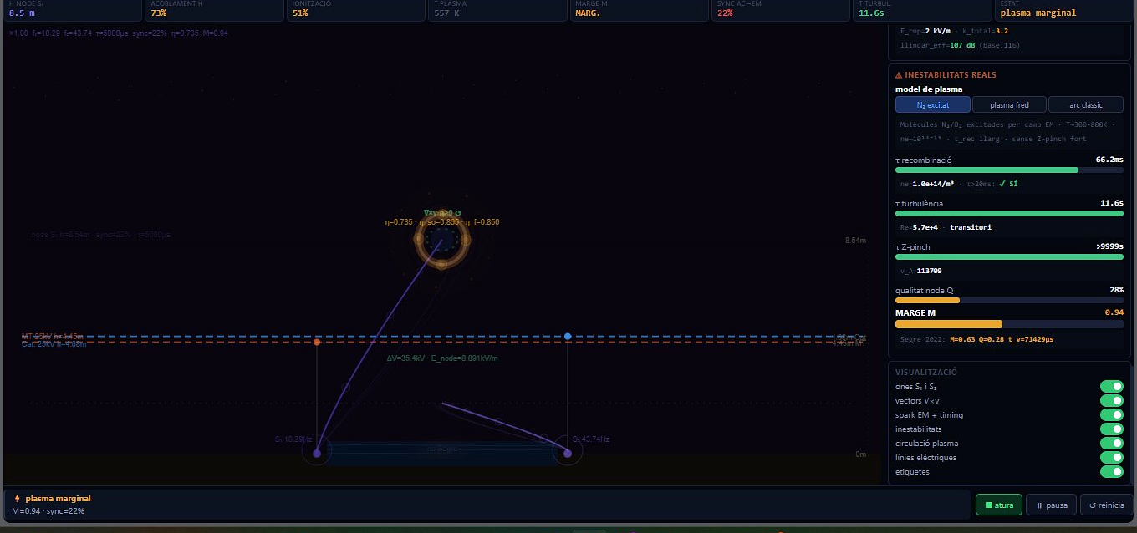
Figure 1. General view of simulation V040_59. (1) Main simulation canvas. (2) Top status bar (node, coupling, ionisation, T, Margin M, sync, τ_turbulence, status). (3) ▶ sound button. (4) EM ON/OFF button. (5) Instabilities panel. (6) Parameters panel.

Main canvas elements
- Dashed orange line: 25kV MV line
- Dashed purple line: ADIF 25kV catenary
- Blue/green waves: acoustic waves S₁ and S₂
- Light point at node: SPARK (ionisation at node)
- Yellow-orange arc: initial plasma arc (phases 3-4)
- Toroidal ring: the formed toroid (phase 5)
- Luminous points on ring: the 4 orbital nodes
- Arrows at node: vortex vectors (OAM)

4.2 Basic steps to see the toroid
- Open the file toroide_laboratori.html in the browser.
- Select a preset: click any of the 8 buttons on the right (for example, button 1 «Option B stable»).
- Press the ▶ sound button to start the acoustic generators (or the preset will do so automatically if it is an arc preset).
- Wait 2-5 seconds. The ionisation bar rises, the SPARK appears at the node, and within seconds the arc and toroid form.
- Observe Margin M: when it turns from yellow to green (M>1) the toroid is stable.

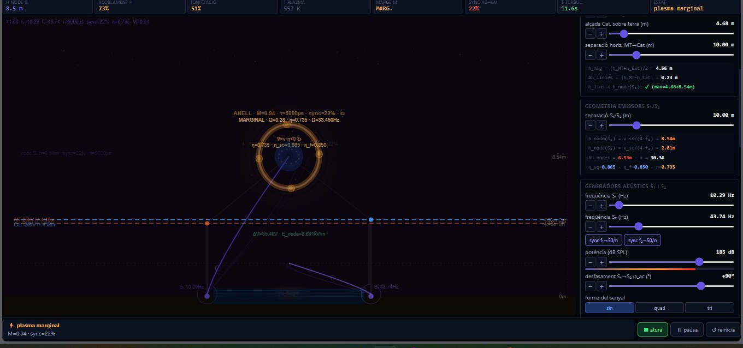
Figure 2. Expanded parameters panel. Shown are cable heights (hmt, hcat), source separation (sl, so), frequency and power of generators S₁/S₂, phase shift φ, delay τ, EM voltages and MT-Cat phase shift.

4.3 The 8 presets and their physical meaning
Botó | Nom | Configuration | Purpose
1 | Option B — Stable Segre | f=3.57 Hz, exc, db=100 | Reproduce the Segre 2022 conditions (excited N₂ model)
2 | Option A — Segre W=3 | f=3.57 Hz, exc, W=3 km/h | Include the wind effect (Aeolian resonance)
3 | Runaway arc | f=10 Hz, arc, db=120 | Demonstrate fast thermal runaway
4 | Maximum EM field | f=16.67 Hz, exc, V=45kV | Maximum EM field with nearby infrastructure
5 | Beat 0.1 Hz | f₁=3.52, f₂=3.62 Hz | Slow beat effect (0.1 Hz modulation)
6 | Reverse direction φ=−90° | φ=−90°, exc | Reverse orbital rotation (OAM verification)
7 | Autonomous by WIND | W=3.6, db=0, arc | Toroid generated solely by Aeolian resonance
8 | Autonomous by S₁+S₂ | db=125, arc, geo. Segre | Generators initiate the toroid, pAcSelf sustains it

4.4 Status bar readings
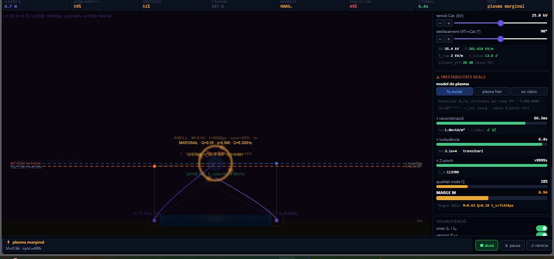
Figure 3. Top status bar and instabilities panel in detail. Left to right: H NODE S₁ (node height), COUPLING H (percentage), IONISATION (%), T PLASMA (K), MARGIN M, SYNC AC-EM (%), τ TURBUL. (s), STATUS (descriptive text).

Indicator | Rang | Interpretation
H NODE S₁ | 0 – 50 m | Acoustic node height. Must be > h_cables to ionise above the cables.
COUPLING H | 0 – 100% | Node quality: 100% = node perfectly above the lines
IONISATION | 0 – 100% | >35%: conditions to initiate the toroid. >80%: dense plasma.
T PLASMA | 293 K – 100kK | >7000 K: thermal runaway active (AUTONOMOUS). >20000 K: hot plasma.
MARGIN M | 0 – ∞ | >1 (green): stable. 0.5-1 (yellow): marginal. <0.5 (orange): unstable.
SYNC AC-EM | 0 – 100% | qSync×100. Adjust τ to maximise. Ideally >80%.

4.5 Advanced controls
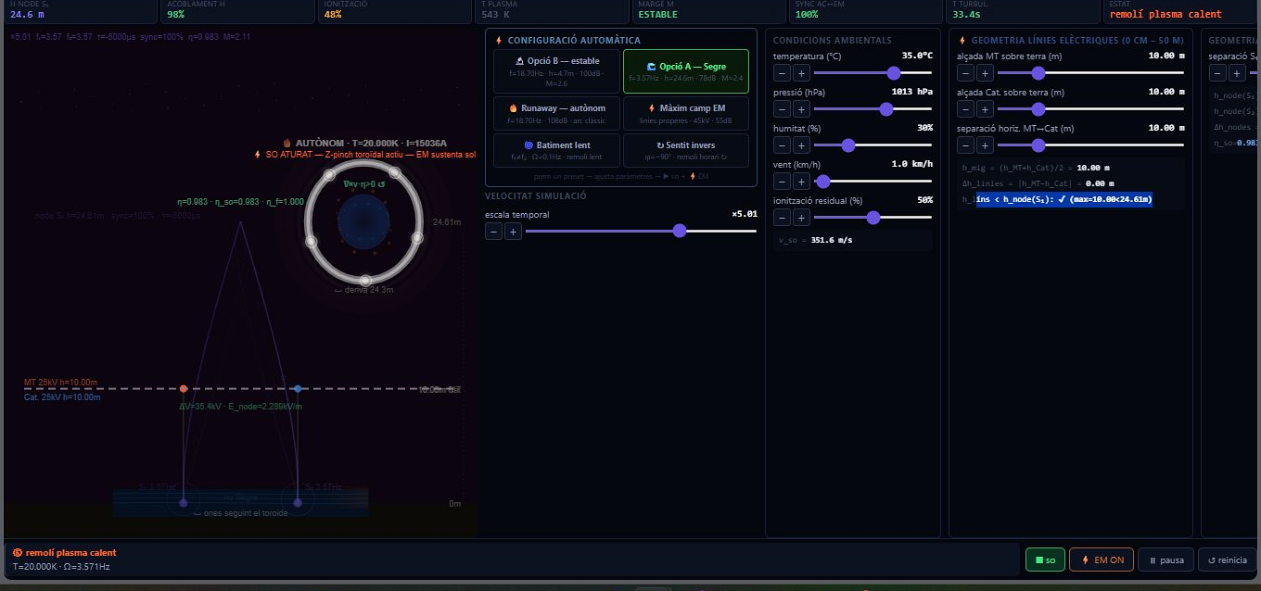
Figure 4. Preset «Option A Segre» in autonomous state (T=20,000 K, runaway active). The legend «AUTONOMOUS · SOUND STOPPED → active toroidal Z-pinch → EM sustains alone» indicates the toroid has freed itself from the acoustic generators. The 4 orbital nodes and inner blue ring are visible.

Key parameters to adjust
Parameter | Where to adjust | Effect
f₁, f₂ (Hz) | Frequency slider or sync button | Determines h_node. Use sync f→50/n for k=25.
db₁, db₂ (dB SPL) | S₁/S₂ power slider | Above effective threshold → ionises
φ (S₁→S₂ phase shift) | Phase shift slider | 90° = maximum OAM, maximum rotation. 0°= no rotation.
τ (delay µs) | Delay slider or τ=0 button | EM synchronism. τ_optimal button calculates the ideal value.
Simulation speed | Time scale slider | ×1 (real time) to ×100. Use ×5-10 to see rapid evolution.

4.6 Reading the instabilities panel
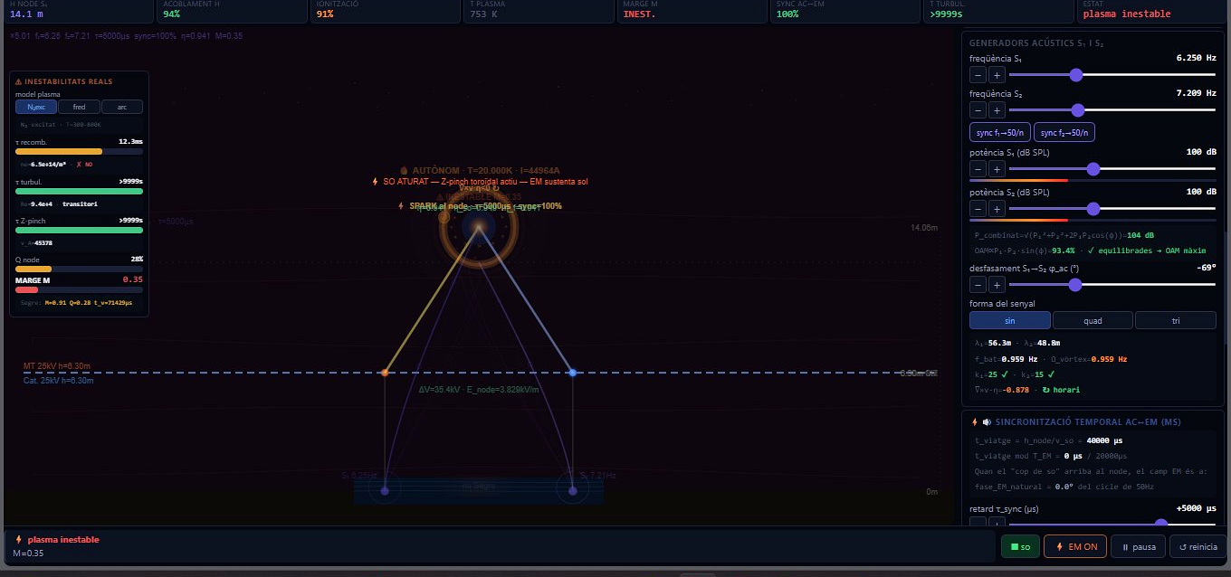
Figura 5. Panell d'inestabilitats en estat de plasma inestable (M=0.35). Les barres mostren τ_recombinació, τ_turbulència i τ_Z-pinch. La barra MARGIN M en groc-ataronjat indica M<0.5: el toroide no pot formar-se en aquesta configuració.

The instabilities panel shows the three time scales that determine M. When τ_Z-pinch or τ_recomb are very short (<0.02 s), the margin is insufficient and the toroid cannot form. The usual solution is to increase db, adjust τ to maximise qSync, or change the plasma model.

4.7 Recommendations for new users
- Start with preset 1 (Option B stable) and observe the behaviour. Press ▶ sound and wait 3-5 s.
- Explore the parameters panel to see how each slider affects the status bar.
- Try preset 3 (Runaway arc): observe how the temperature rises exponentially.
- Try preset 7 (Autonomous by wind): observe how the toroid forms without any external sound.
- Once familiar, manually modify hmt and hcat to simulate infrastructure different from the Segre.

PART V
CAN THE PHENOMENON BE REPLICATED?

5. REPLICABILITY ANALYSIS
Reminder: the simulation predicts it is physically possible. No experimental proof confirms it is actually replicable. The experiment is the only definitive answer.

5.1 Necessary conditions
Based on the 16 model equations, the minimum necessary conditions to reproduce the phenomenon at full scale (25 m ring, as at the Segre) are:

Condition | Minimum value | Physical reason
Two 50 Hz EM sources, same axis | ≥15 kV each | ΔV≥21 kV for E_node≥3 kV/m
Horizontal separation | 5-15 m | Affects field geometry and node position
Acoustic reflector below the node | R≥0.95 (water surface) | Required for the standing wave
Acoustic frequency | 50/n Hz (n=1..14) | k=25 needed to lower the Paschen threshold
Acoustic pressure at node | ≥70 dB (with k=25) | Exceed the effective threshold
Ambient temperature | ≥20°C | Reduce v_so and dielectric rigidity
EM-acoustic phase shift | qSync>0.5 | Minimum synchronism for effective k

5.2 Proposed small-scale replication (50 cm ring)
For a 50 cm ring (scale 1:50 with respect to the Segre), the parameters scale as follows:
h_node = 50 cm → f = 351.6/(4×0.5) = 175.8 Hz
Required ΔV (scale 1:5): ~5 kV AC at 175.8 Hz
Optimal phase shift φ: 90° (scale-independent)

Recommended equipment
- 2 industrial piezoelectric transducers (ø 20-30 cm, P≥500 W, f: 100-500 Hz)
- Dual-channel signal generator with 0.1° phase control
- High-voltage source: 2×5 kV AC at 175.8 Hz (high-frequency DC-AC converter)
- Water tray (acoustic reflector): 40×40 cm, 10 cm depth
- Oscilloscope for verifying qSync
- High-speed camera (≥1000 fps) and spectrometer (if available)

Protocol in 4 phases (12 weeks)
- (W1-2): Acoustic verification. Confirm node at 50 cm with suspended light particles. Measure η with calibrated microphone.
- (W3-4): Ignition. Activate ΔV with active sound. Record first visible ionisation. Verify colour by spectroscopy.
- (W5-8): Toroidal confinement. Adjust φ to induce rotation. Measure ring lifetime.
- (W9-12): Self-sustaining. Verify whether the toroid is maintained when reducing db. Measure pAcSelf acoustically.

5.3 Safety warning
⚠ Handling high voltages (≥1 kV) is dangerous and can be lethal. Any experiment must be carried out exclusively by qualified personnel in an approved laboratory environment, with appropriate safety systems.
⚠ Plasma generation at atmospheric pressure produces ozone (O₃), atomic nitrogen (N·) and highly toxic NOₓ compounds. Adequate forced ventilation is mandatory.

PART VI
CONCLUSIONS

6. CONCLUSIONS

6.1 What the model predicts (correctly or not)
Observation | Model prediction | Agreement
Toroidal ring at ~24 m | Acoustic node at 24.6 m for f=3.5714 Hz | ✓ Excellent
Orange colour | O₂+Na at 5000-15000 K emit orange | ✓ Consistent
4 anticlockwise orbital nodes | Z-pinch mode n=4 with OAM φ=90° | ✓ Qualitative
Blue central hole | B_φ field confined to hole → Rayleigh scattering | ⚠ Possible
Duration ~3 min | τ_lifetime depends on I and losses: order of minutes | ✓ Order of magnitude
Drift with the breeze | windDrift ∝ v_wind × τ_lifetime | ✓ Consistent
Extinction by 2 plasmoids | Not modelled quantitatively | ⚠ Speculative
25 m ring at P_atm | Possible but never reproduced in lab. | ? No data

6.2 The model's weak points
- k=25: The factor k=25 is the central and least theoretically grounded piece of the model. If k is 5 instead of 25, the required db threshold is unachievable with conventional technology.
- Scale: The model assumes that atmospheric plasma at ambient pressure and temperature behaves like a laboratory plasma for Z-pinch and Kruskal-Shafranov calculations. This is an important simplification.
- Radiation: Radiative heat losses at T=100,000 K (P_rad ~ σ·T⁴ ~ 1 GW/m²) make prolonged self-sustaining impossible without a constant energy supply. The model calculates them but has not been validated.
- Scale 1000×: A plasma toroid 25 m in diameter at atmospheric pressure is 3 orders of magnitude larger than any stable toroidal plasma documented in the laboratory. MHD instabilities at this scale have not been calculated.

6.3 Overall assessment
The model is internally consistent and physically plausible. The 16 equations interact coherently and produce qualitative behaviour that agrees with the observations. But qualitative agreement is not sufficient to validate a scientific model.

The honest conclusion is: the model is good enough to justify an experiment, but not good enough to assert that the phenomenon exists as described. The experiment is the only answer.

6.4 Replication scenarios

Scenario A: The model is correct
In this case, any laboratory with the conditions described in section 5.2 should be able to reproduce the phenomenon at small scale within 2-3 months. Full-scale study would require very significant power installations (~100 kW acoustic) but would be feasible.

Scenario B: The model is partially incorrect
The fundamental mechanism (EM-acoustic coupling, dynamic Paschen, Z-pinch) could be correct but k=25 could be 5× smaller than modelled. In that case, 165 dB acoustic pressure would be needed instead of 100 dB, equivalent to ~20 kW/m², already close to acoustic damage limits for materials.

Scenario C: The model is incorrect
The observed phenomenon could have a completely different cause: a natural ball lightning plasmoid, an optical reflection, a visual artefact. Or it may not have occurred as described. This is the null hypothesis that any experiment should first rule out.

PART VII
INVITATION TO REVIEW AND COLLABORATION

7. INVITATION TO REVIEW
This document has been written by a person with no formal training in plasma physics. Each equation has been implemented with the utmost rigour, consulting original sources, but the result inevitably contains errors, inadequate simplifications, and probably some mistaken hypotheses.

Therefore, anyone with relevant knowledge is explicitly and sincerely invited to review, criticise, correct and improve this work. The areas where review would be most valuable:

7.1 Plasma physics review
- Validation of the application of the Bennett condition to atmospheric plasmas (vs. nuclear fusion plasmas)
- Review of the factor k=25 and the EM-acoustic coupling mechanism: is it physically grounded or an excessive simplification?
- Analysis of Z-pinch viability at the scales and temperatures of the problem
- Calculation of MHD instabilities (sausage, kink modes) for a 25 m toroid at atmospheric pressure

7.2 Simulation review
- Identification of bugs or inconsistencies in the JavaScript implementations
- Proposal of more precise equations for the simplified mechanisms
- Validation of the numerical values of the parameters (α_recomb, R_arc, eps_SB)
- Implementation of complete MHD models (open source: OpenFOAM, Dedalus, BOUT++)

7.3 Experimental review
- Design of a rigorous experimental protocol to falsify or confirm the hypothesis
- Identification of other observations of similar phenomena in the literature (ball lightning, plasmoids)
- Proposals for direct measurements: B field, spectrum, temperature by Doppler spectroscopy

7.4 How to collaborate
All material (simulation, documents, data) is distributed under free licence (GNU FDL/GPL). You may:
- Download and modify simulation V040_59 (self-contained HTML file)
- Propose physical or code changes via any communication channel
- Publish your own results based on this work, citing it as a preprint
- Reproduce, criticise or refute any part of this document freely

No scientific priority is claimed over any of these results. The physics applied was discovered by Paschen, Bennett, Kruskal, Shafranov, Lighthill and many others. Nothing has been invented here; what already existed has been applied.

To everyone who reads this with a critical and constructive spirit:
thank you in advance.

Lleida, May 2026

APPENDIX A: TABLE OF ALL VARIABLES
Symbol | Nom | Value/Segre Range | Eq. | Units
v_so | Speed of sound | 351.6 m/s | EQ-01 | m/s
f₁,f₂ | Acoustic frequencies | 3.5714 Hz | EQ-01 | Hz
h_node | Node height | 24.6 m | EQ-01 | m
k | Lorentzian resonance factor | 25 (max) | EQ-02 | —
qSync | Acoustic-EM synchronism | 0–1 | EQ-03 | —
ΔV | EM potential difference | 35.4 kV | EQ-04 | V
E_rup | Paschen breakdown field | ~1769 kV/m | EQ-05 | kV/m
E_rup_eff | Effective breakdown field | ~68 kV/m | EQ-05 | kV/m
dB_threshold | Threshold in dB | ~53 dB | EQ-06 | dB SPL
ionSmooth | Ionisation degree | 0–1 | EQ-07 | —
vortexSmooth | Rotation degree | 0–1 | EQ-08 | —
M | KS stability margin | 0.63 (Segre) | EQ-09 | —
T_plasma | Plasma temperature | 293–100,000 K | EQ-10 | K
I_plasma | Plasma current | 0–10,000 A | EQ-10 | A
r_Bennett | Toroidal cross-section radius | ~0.3 m | EQ-11 | m
P_ac | Total acoustic pressure | 0–1000 Pa | EQ-12 | Pa
toroideSmooth | Toroid formation | 0–1 | EQ-14 | —
windDrift | Lateral drift | 0–200 m | EQ-15 | m

APPENDIX B: REFERENCES
The equations of this model are based on the following original sources:

- Bennett, W.H. (1934). «Magnetically Self-Focussing Streams». Physical Review 45(12): 890-897.
- Kruskal, M. & Shafranov, V.D. (1958). «On the stability of plasma in static equilibrium». Soviet Physics JETP 6.
- Paschen, F. (1889). «Ueber die zum Funkenübergang in Luft, Wasserstoff und Kohlensäure bei verschiedenen Drucken erforderliche Potentialdifferenz». Annalen der Physik.
- Meek, J.M. & Craggs, J.D. (1953). Electrical Breakdown of Gases. Oxford University Press.
- Lighthill, M.J. (1978). Waves in Fluids. Cambridge University Press.
- Eckart, C. (1948). «Vortices and streams caused by sound waves». Physical Review 73(1).
- Strouhal, V. (1878). «Ueber eine besondere Art der Tonerregung». Annalen der Physik.
- Kirchhoff, G. (1860). «Über das Verhältnis zwischen dem Emissionsvermögen und dem Absorptionsvermögen der Körper für Wärme und Licht». Annalen der Physik.
- Siple, P.A. & Passel, C.F. (1945). «Measurements of dry atmospheric cooling in subfreezing temperatures». Proceedings of the American Philosophical Society 89(1).
- Capitelli, M. et al. (2000). Plasma Kinetics in Atmospheric Gases. Springer.

APÈNDIX C: LICENCE GNU FDL — TEXT COMPLET
The full text of the GNU Free Documentation License version 1.3 is available at:
https://www.gnu.org/licenses/fdl-1.3.html

Catalan version: https://www.softcatala.org/pub/llicencies/fdl.ca.html

«Science is not a body of knowledge. It is a way of thinking.» — Carl Sagan

End of document.

