Assignment #5 Source Code:

**#include <vector>**

**#include <string>**

**#include <fstream>**

**#include <iostream>**

**using** **namespace** std;

**class** **LinReg2** {

**public**:

LinReg2(string filename);

**void** compObjLOCtoNewLOC() {compare(ObjLOC, ActLOC);}

**void** compEstNewLOCtoNewLOC() {compare(EstLOC, ActLOC);}

**double** getB0() {**return** B_0;}

**double** getB1() {**return** B_1;}

**private**:

**void** compare (vector<**double**> X, vector<**double**> Y);

**double** B_0;

**double** B_1;

vector<**double**> ObjLOC;

vector<**double**> EstLOC;

vector<**double**> ActLOC;

};

LinReg2::LinReg2(string filename) {

B_0 = 0, B_1 = 0;

ifstream in;

in.open(filename.c_str());

**double** value;

in >> value;

**while** (in.good())

{

ObjLOC.push_back(value);

in >> value;

EstLOC.push_back(value);

in >> value;

ActLOC.push_back(value);

in >> value;

}

in.close();

}

**void** LinReg2::compare(vector<**double**> X, vector<**double**> Y) {

**double** sumX = 0, sumY = 0, sumXY = 0, sumX2 = 0;

**for** (**int** i = 0; i < Y.size(); i++)

{

sumX += X[i];

sumY += Y[i];

sumXY += (X[i] * Y[i]);

sumX2 += (X[i] * X[i]);

}

**double** n = (**double**)Y.size();

**double** avgX = sumX / n;

**double** avgY = sumY / n;

**double** num = sumXY - n * avgX * avgY;

**double** denom = sumX2 - n * avgX * avgX;

B_1 = num / denom;

B_0 = avgY - B_1 * avgX;

}

**int** main( **int** argc, **char**\* argv[])

{

string filename;

**if**(argc == 1)

filename = "input.txt";

**else** **if** (argc == 2)

filename = argv[1];

**else**

{

cout << "Invalid Arguement.\n";

**return** 0;

}

LinReg2 LR(filename);

LR.compObjLOCtoNewLOC();

cout << "y = B0 + B1*x|| for y is actual new and changed LOC and x is estimated object LOC:\n";

cout << "B0: " << LR.getB0() << "\n";

cout << "B1: " << LR.getB1() << "\n";

LR.compEstNewLOCtoNewLOC();

cout << "y = B0 + B1*x|| for y is actual new and changed LOC and x is estimated new and changed LOC:\n";

cout << "B0: " << LR.getB0() << "\n";

cout << "B1: " << LR.getB1() << "\n";

**return** 1;

}

Use-Case Diagram:

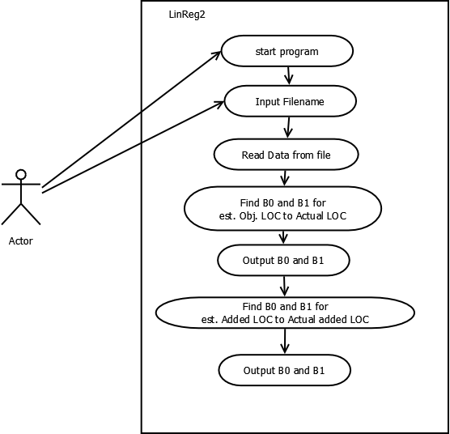

UML Class Diagram:

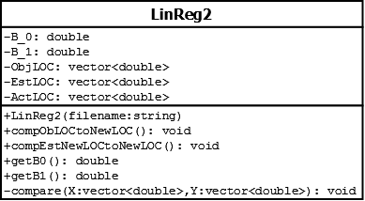

Capture showing compilation and working:

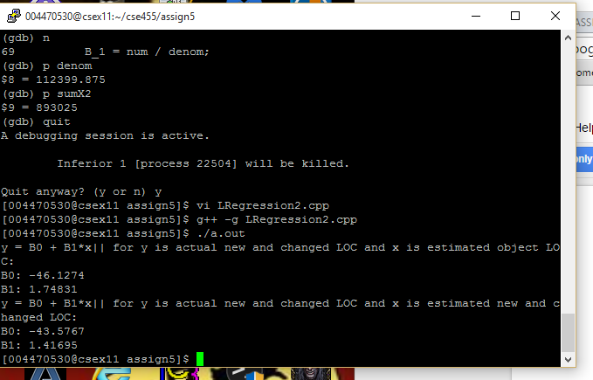

Output Table:

|  |  |  |  |  |
| --- | --- | --- | --- | --- |
| **Test** | **Expect Results** | | **Actual Results** | |
|  | β0 | Β1 | β0 | Β1 |
| Table: Estimated Object LOC versus Actual New and Changed LOC | -46.1252 | 1.7483 | -46.1274 | 1.74831 |
| Table: Estimated New and Changed LOC versus Actual New and Changed LOC | -43.5528 | 1.4169 | -43.5767 | 1.41695 |