# Report 1

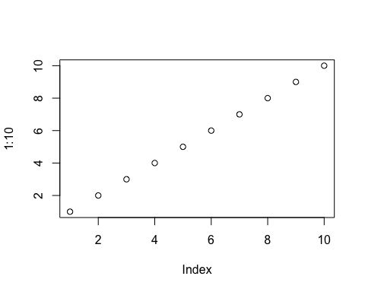

Figure : Plot 1

## Subsection

Table : Head of mtcars dataset

| mpg | cyl | disp | hp | drat | wt | qsec | vs | am | gear | carb |
| --- | --- | --- | --- | --- | --- | --- | --- | --- | --- | --- |
| 21.0 | 6 | 160 | 110 | 3.90 | 2.620 | 16.46 | 0 | 1 | 4 | 4 |
| 21.0 | 6 | 160 | 110 | 3.90 | 2.875 | 17.02 | 0 | 1 | 4 | 4 |
| 22.8 | 4 | 108 | 93 | 3.85 | 2.320 | 18.61 | 1 | 1 | 4 | 1 |
| 21.4 | 6 | 258 | 110 | 3.08 | 3.215 | 19.44 | 1 | 0 | 3 | 1 |
| 18.7 | 8 | 360 | 175 | 3.15 | 3.440 | 17.02 | 0 | 0 | 3 | 2 |
| 18.1 | 6 | 225 | 105 | 2.76 | 3.460 | 20.22 | 1 | 0 | 3 | 1 |