**Bottle Holder**

* Estimated printing time - Approx 12 hours
* Material:
  + Type - PLA, recommend ABS
  + Estimated amount - 127.4g, 42.71m
  + Estimated price - $3.82
* Print settings:
  + Nozzle temperature - 205 C
  + Bed temperature - 60 C
  + Layer height - 0.20mm
  + Infill density - 30
  + Infill pattern - Cubic
  + Bottom layers - 5
  + Top layers - 5
  + Shells - 2
  + Support for holes and overhangs
  + Raft - 5 layers, 3 solid

**Threaded Mount**

* Uses a 1/4-20 bolt as the connection / pivot point when attaching to the bottle holder
* Estimated printing time - Approx 3.5 hours
* Material:
  + Type - PLA, recommend ABS
  + Estimated amount - 39.0g, 13.08m
  + Estimated price - $1.17
* Print settings:
  + Nozzle temperature - 205 C
  + Bed temperature - 60 C
  + Layer height - 0.20mm
  + Infill density - 50
  + Infill pattern - Cubic
  + Bottom layers - 5
  + Top layers - 5
  + Shells - 2
  + Support used for hole and threads
  + Raft - 5 layers, 3 solid

**Assembled Sampler**

**Printing Notes**

* Temperature settings will need to be adjusted to print ABS materials:
  + Bed temperature - 100 C
  + Nozzle temperature - 250 C
* The 3D model file will be in .stl format and units are in inches.
* Prices are based on PLA filament, ABS will be more expensive but should be marginal.

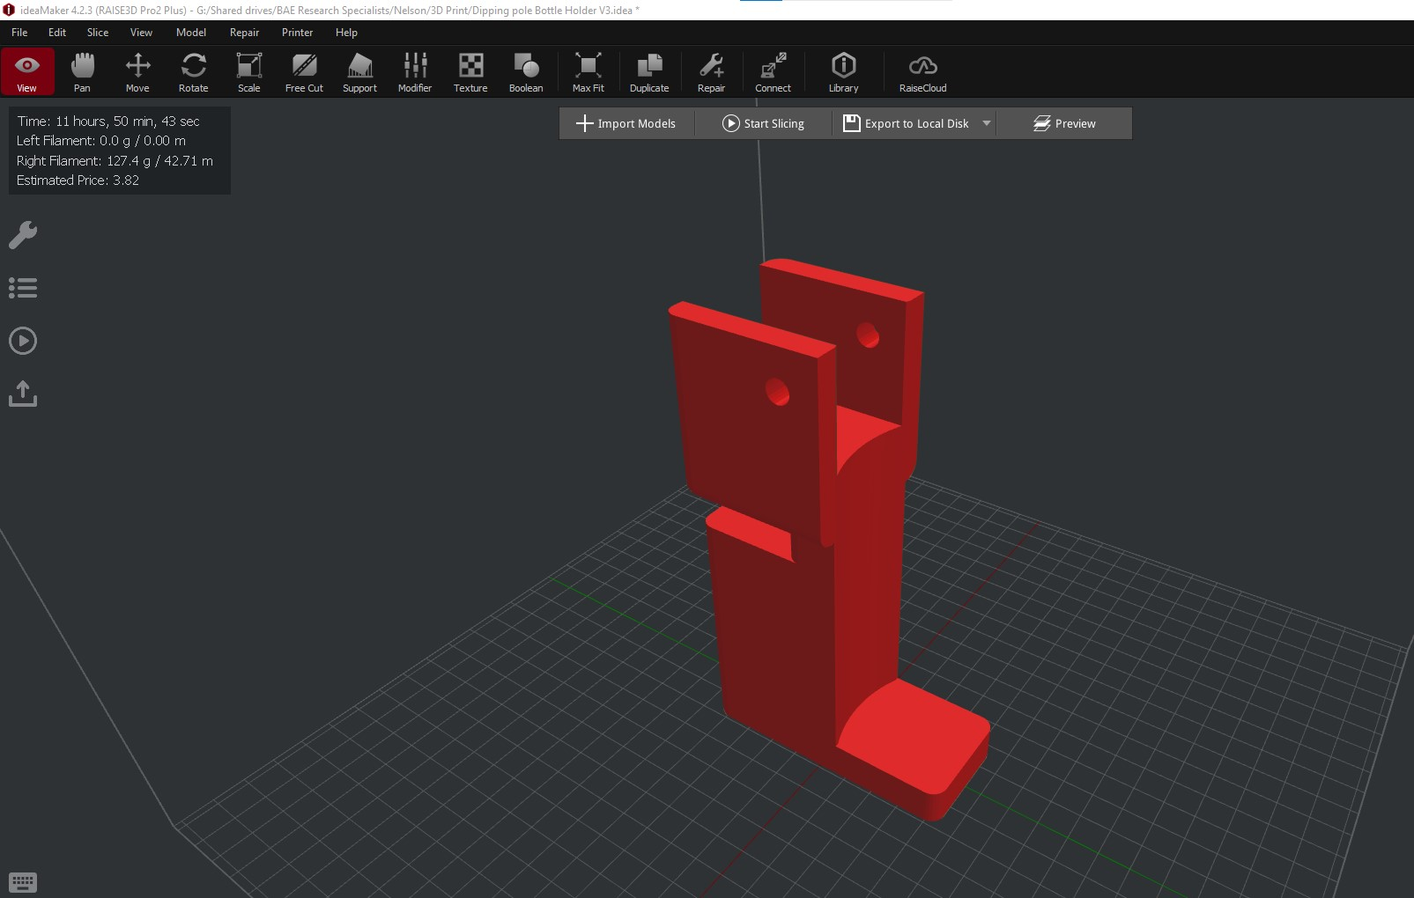

3D model of bottle holder in the ideaMaker environment.

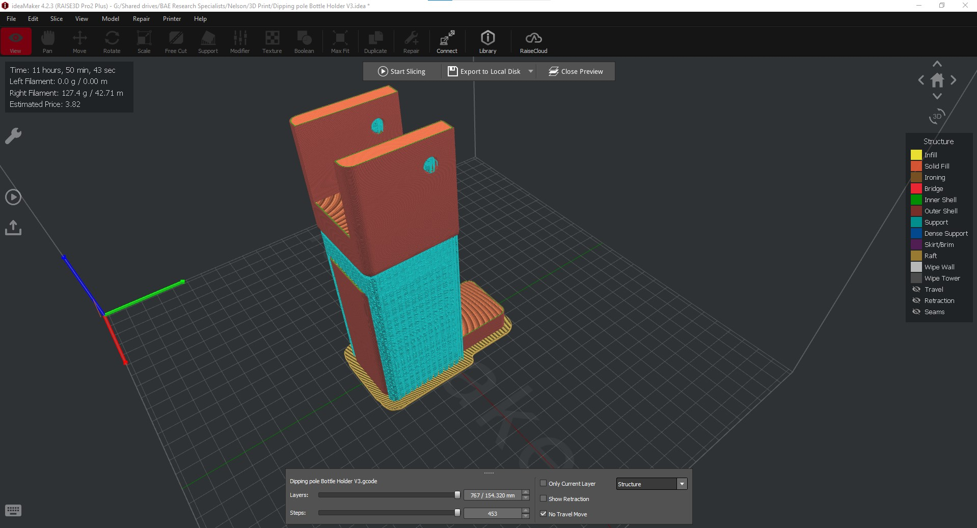

Model of bottle holder after it has been spliced to create a .Gcode file showing different types of printing structures.

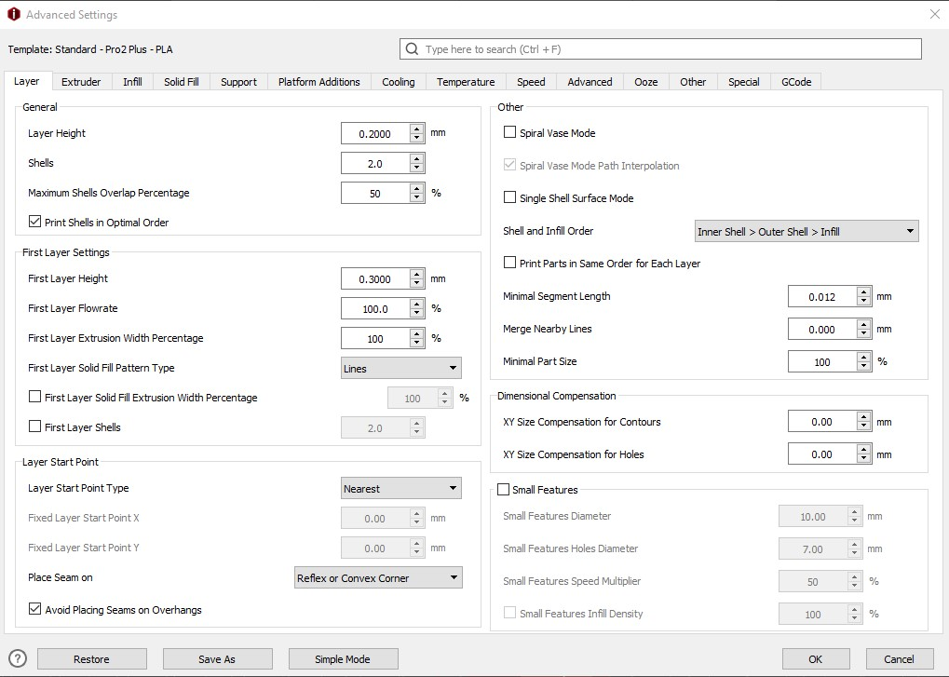

Layer settings.

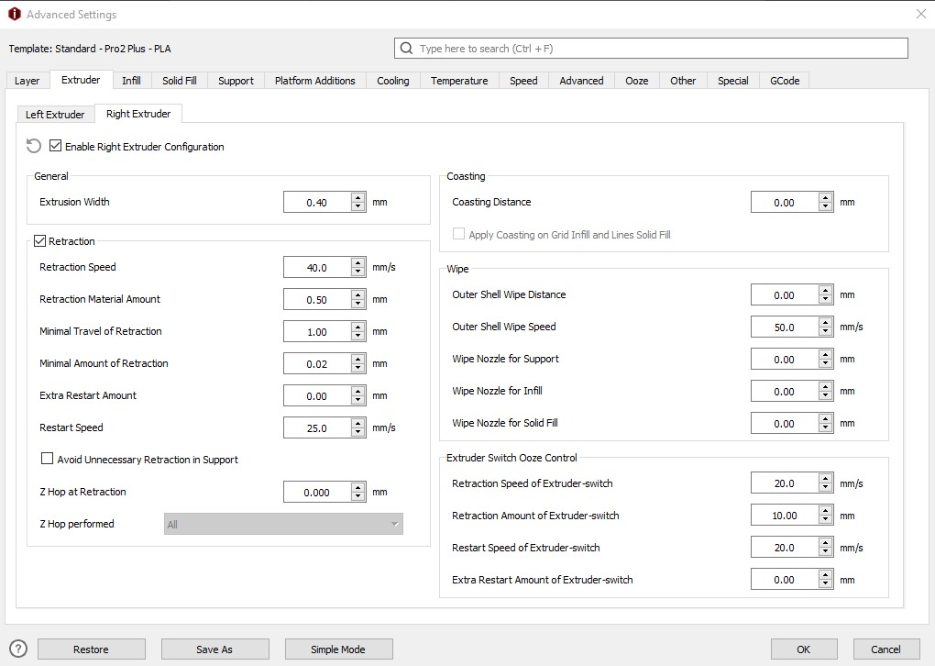

Extruder settings.

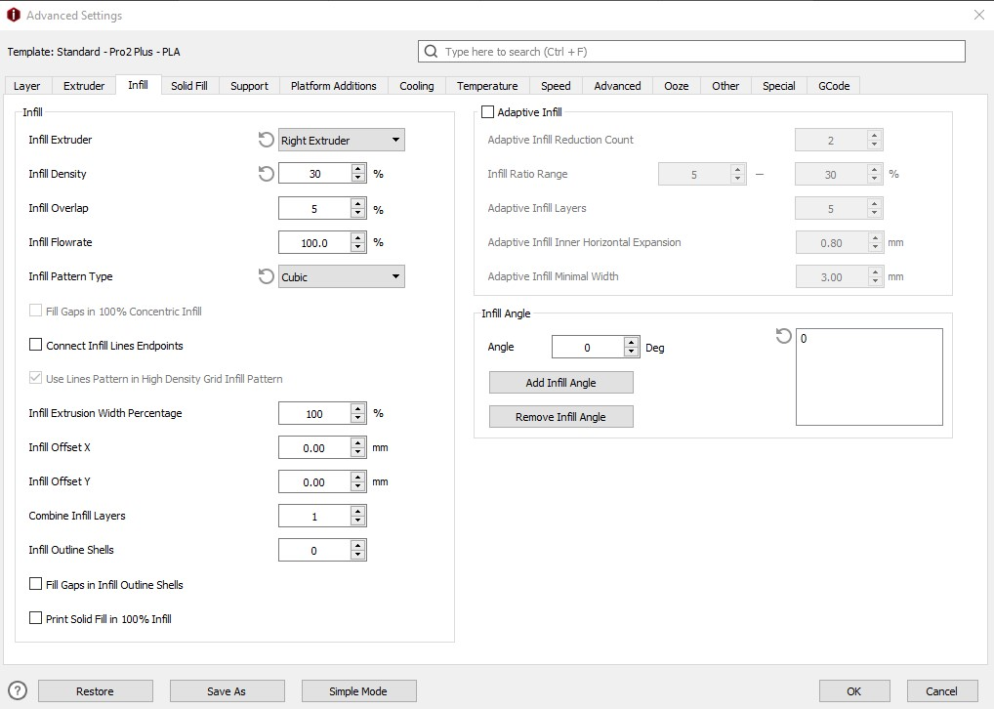

Infill settings.

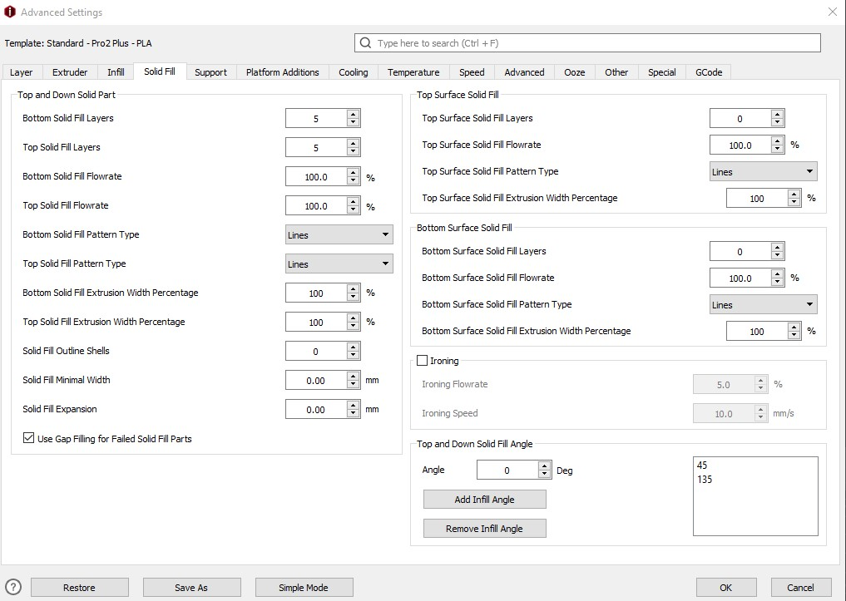

Solid fill settings.

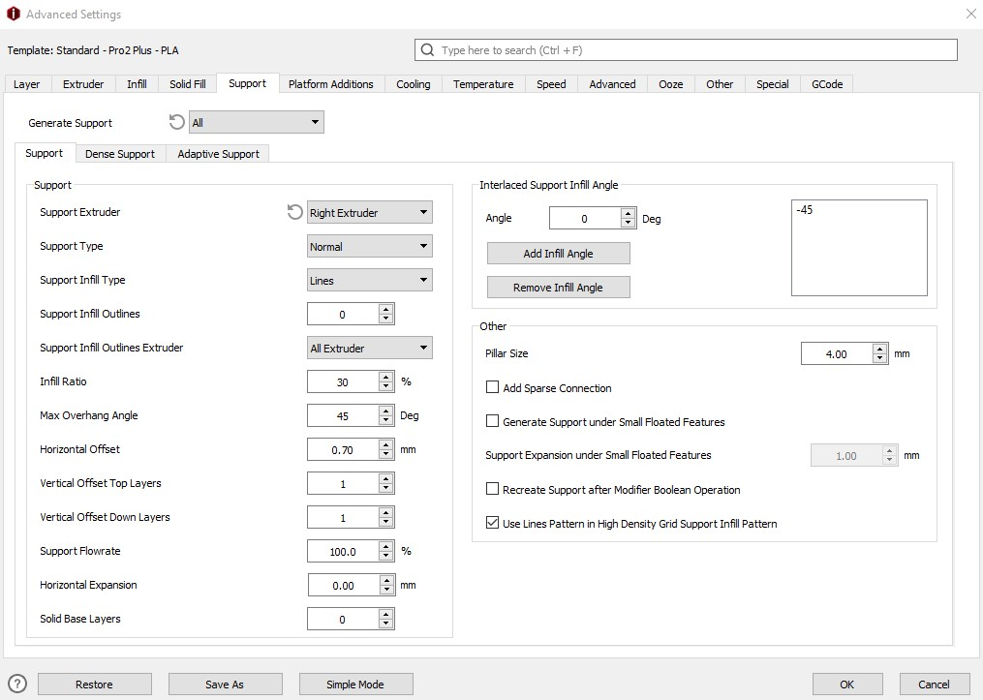

Support settings.

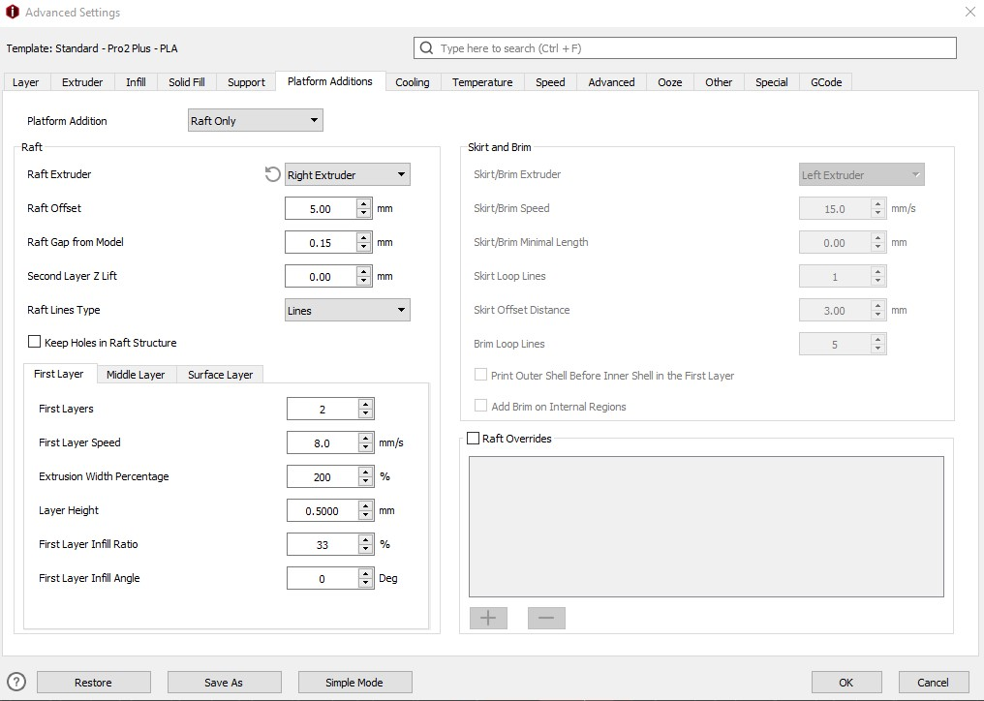

Raft settings.

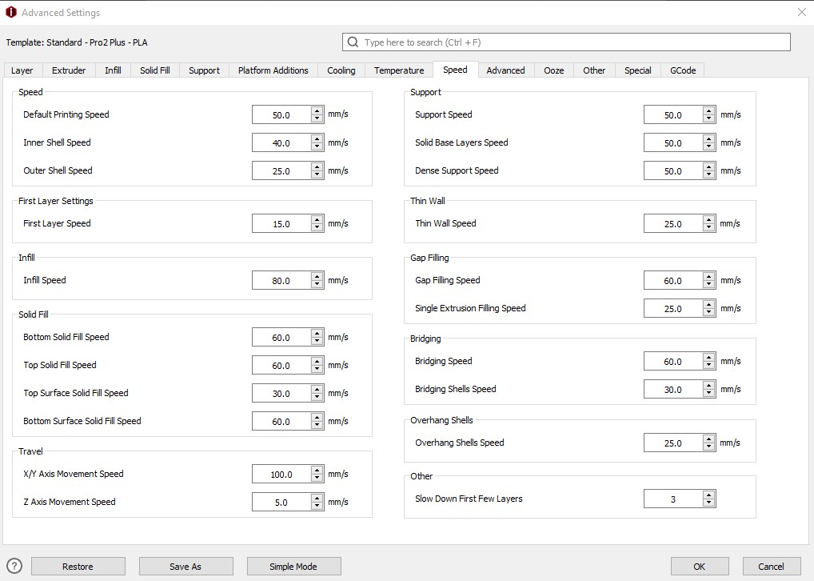

Speed settings.

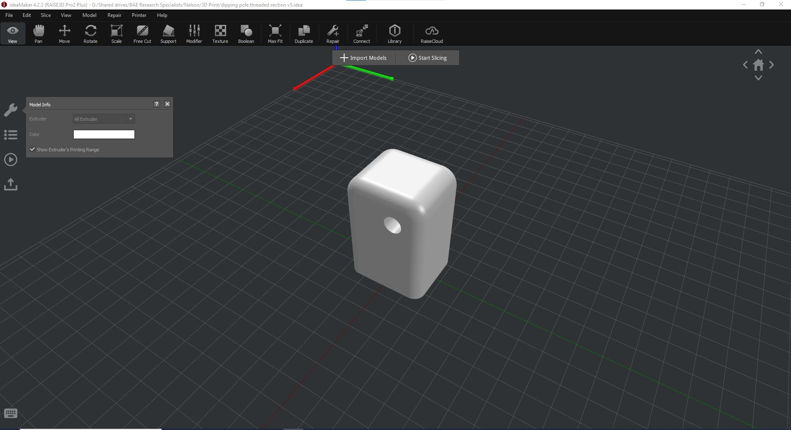

3D model of threaded mount in the ideaMaker environment.

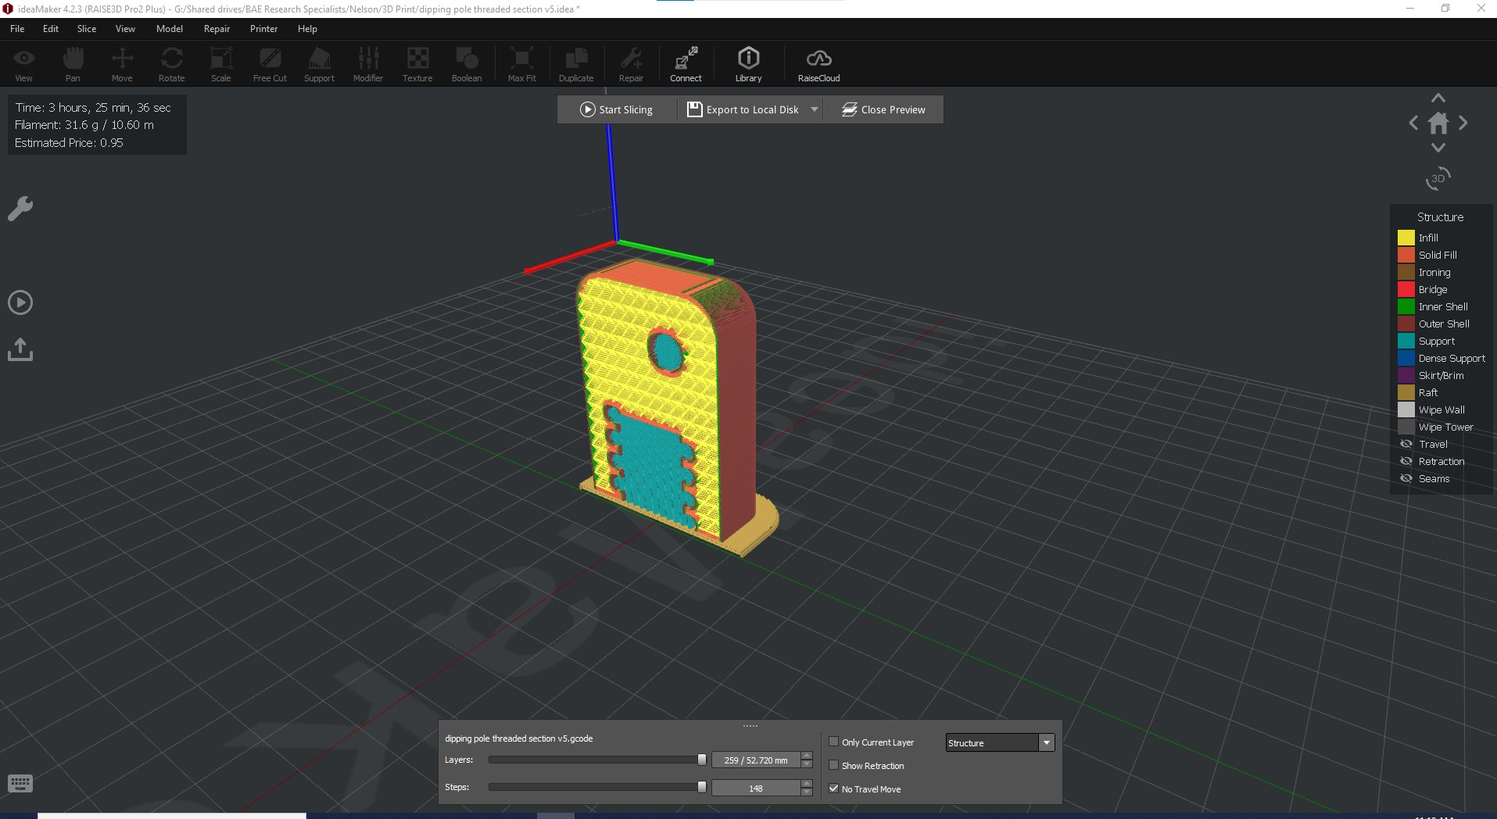

Cross section of threaded mount after slicing, showing support material (blue) inside threaded area and mounting hole. Cubic infill is also shown (yellow).