Lab exercise 4: Diffusion - Biophysical Chemistry

By Ryno Lawson

4.2.1 – The value is 0. As ATP is depleted over time the probabilty of the ion decreases as there be no longer any ATP to pump it.

4.3.1 change = stepLength * np.sign(np.random.rand()-0.5)

4.3.2
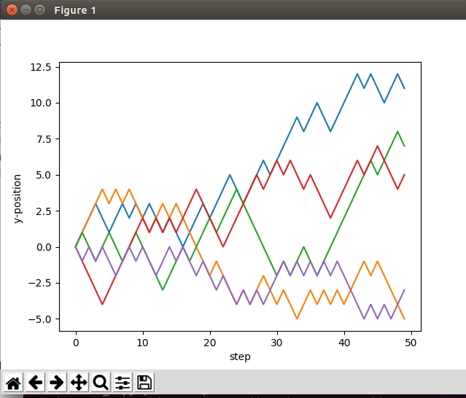

4.3.3 It is a random walk because it is a succession of step which have no predictable pattern.

4.4.1 No matter the number of steps the average position at end of the walk is zero.

The number of steps is proportional to the squared distance from origin at end of walk.

4.5.1 It looks like Boltzmann constant which is linear
4.5.2
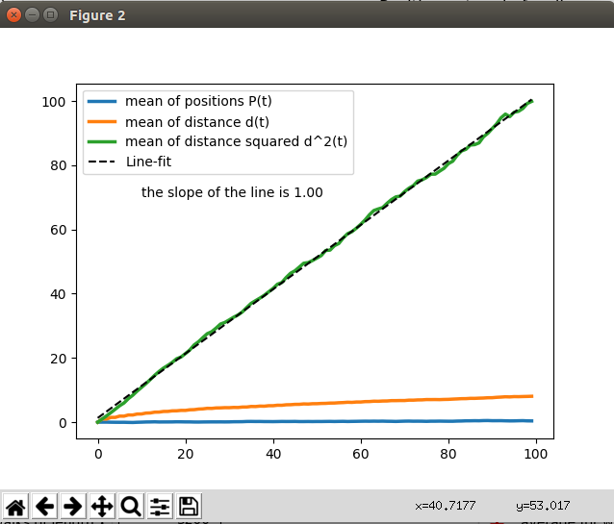

Yes this is a linear plot of the Boltzmann constant.

4.6.1 Kt is a rate of number of molecule over time
4.6.2 It will get faster
4.6.3

4.7.1
for i in np.arange(steps-1):
# Make a random number this observation
change = stepLength * np.sign(np.random.rand()-0.5)

positions[i+1] = positions[i] + change
if positions[i+1] == 11:
positions[i+1] = 9
if positions[i+1] == -11:
positions[i+1] = -9
return positions
4.7.2 Yes the above task did mess up the linear curve

4.8.1 Osmosis
4.8.2

Please could you provide references for the tutorials as they are difficult to do without the tutors assistance and there is a lot of junk to search through on the internet. I feel the these are not explained properly and there is a lot to be confused by with regards what is expected as answer.

