Lab exercise 5: 2D-grid folding - Biophysical Chemistry

by Ryno Lawson

5.2.2.1
1 = 0
2 = 2
3 = 4
4 = 4
5 = 0
6 = 2
7 = 4
8 = 2

5.2.2.2
The high scoring conformations follow a similar route back to the beginning. They consists mostly of H residues. They tend to repeat the residues in sequence.

5.3.1.1 The model looks to test new conformations. When it finds a favourable conformation to keeps it for many more permutations the the none favourable conformations. These change frequently especial around the W residues.

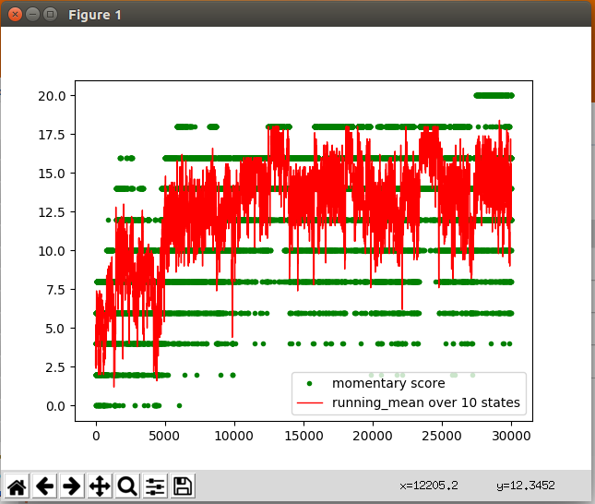

5.3.1.3
Protein folding is a conformation which seeks to shield a residue by stablizing the conformations with local or global bond formation.
5.3.1.5
This seems to hold the state to be more consistent. The makes it difficult for it to change energy states. So then the change in energy is more stable. This is like changing the temperature when looking at the Boltzmann functions although its the delta E.

5.3.2.1 Yes the plot falls out of the high score states regularly.
5.3.2.2 It corresponds to an increase of temperature.
5.3.2.3 This simulation does not take the physiological relevant state which would occur at physiological temperatures for the energy landscape. It looks to try all possible states, but does not stay the most stable state at the physiological conditions. Even if it finds the lowest energy state it continues on to other states. This does not show much about the kinetics of the transition.

