Lab Exercise 6: Docking - Biophysical Chemistry

By Ryno Lawson

6.1.1

The drawback is the with no flexiblity of the receptor , we are not able to sample local conformations of ligand binding and nonbinding and we are then not able to take the entorpic effect into account. If the induced fit is important this model excludes an important factor of receptor/ligand binding.

6.1.2
The entropy can be determined using the Boltzmann constant and the natural log of the Volume. S=kb.lnV

6.3.1

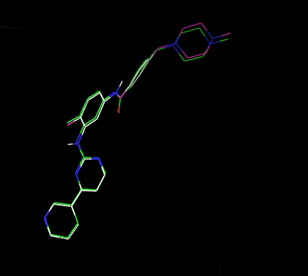

6.3.2
If you had an idea of where it would be favorable for the ligand to bind you could limit the box to this area. For instance in a Transmembrane protein the hydrophobic region or in a barrel .

