Lab exercise 7: Free energy landscapes - Biophysical
Chemistry

By Ryno Lawson

7.1.1.1
∆G = P - Q . A negative ∆G would mean that is more probable to find the bound state/membrane state than the unbound/non-membrane state. This implies there is a high binding affinity.

7.1.1.2
The sign would be positive as it P would be greater than Q. More probable to have P state the Q state. ∆G = P – Q

7.2.1.1
True

7.2.1.2
For 10km you could choose an x = 1m which would be ~10000 calculations but highly accurate. This would be slower than x=1km or x=100m but with a computer it is computable but it would be laborious if done manually. x=1km would be fine for a general estimate.

7.3.1.1
True. The energy levels of 2 states are not dependent on the path between 2 states.

7.3.1.2
True. As different path would have different energy barriers.

7.3.1.3
False. H accuracy would be depend on the path chosen as the quality of information sampled from the 2 path and time taken on to calculate the result would be factors to consider.

7.4.1.1
In 4A the Highest energy is not the lowest populated state in the corresponding graphs.

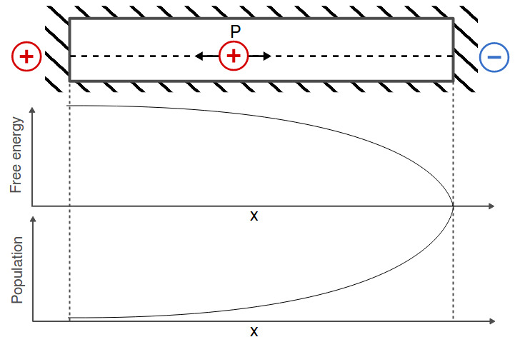
7.5.1.1

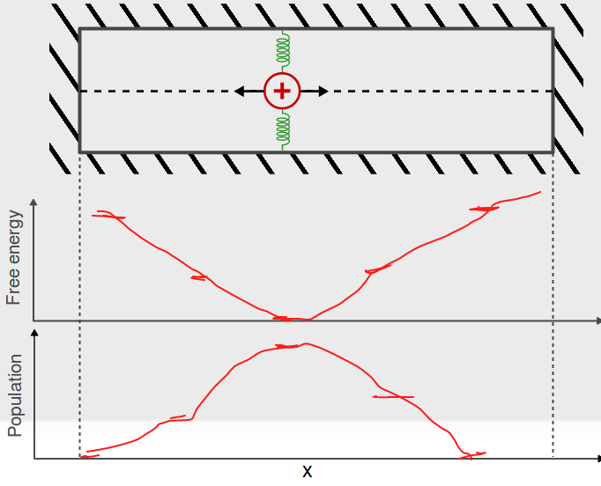
7.5.1.2

7.5.1.3

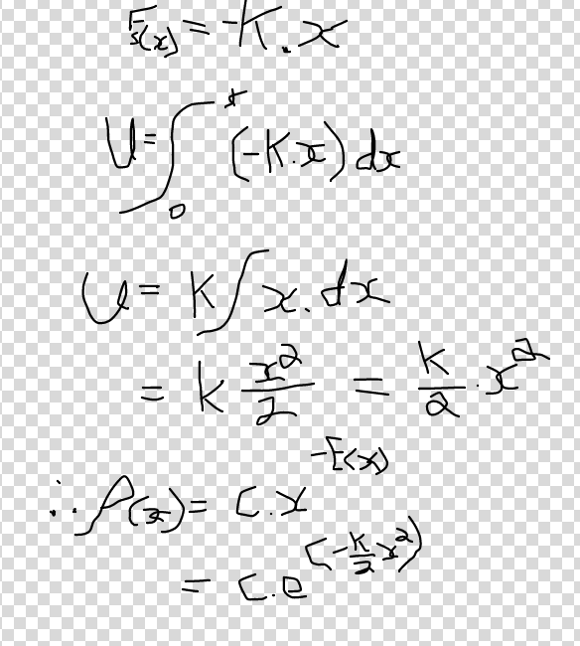

7.6.1.1
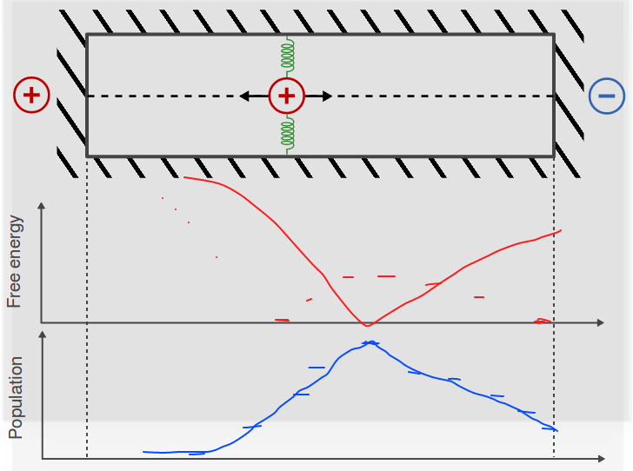

7.6.1.2
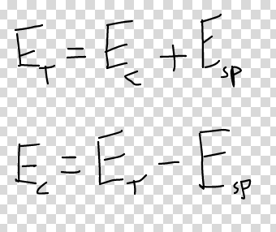

7.7.1.1
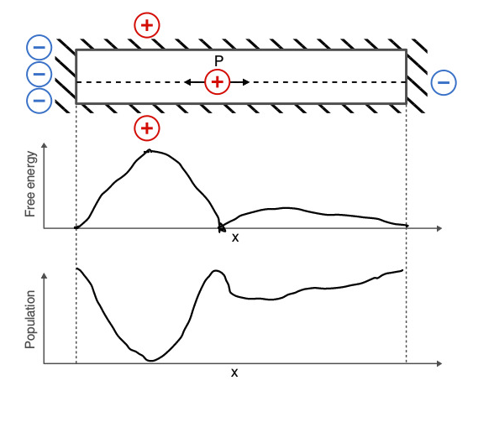

7.7.1.2
You could lower the energy barrier and decrease the x intervals.

8.1.1
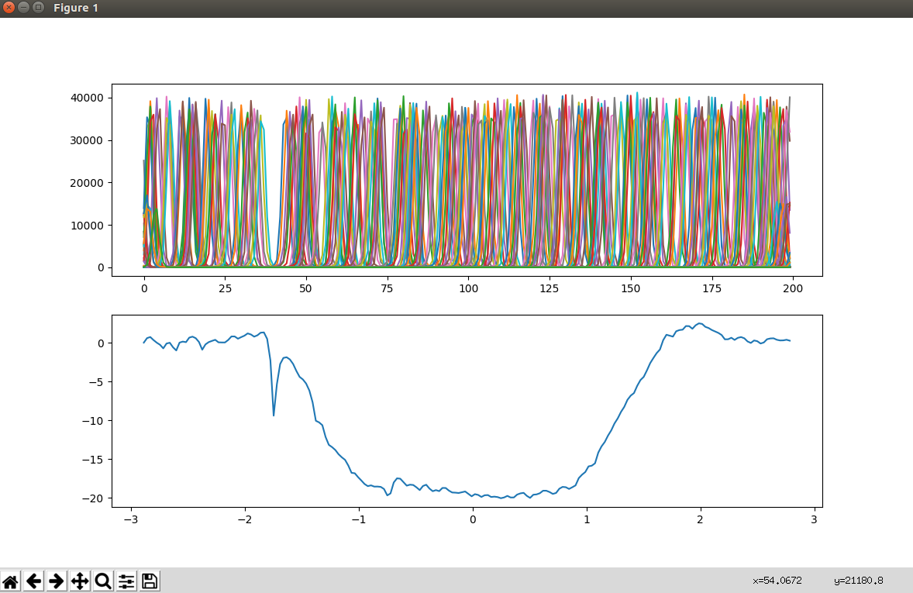

One could expect it to be symmetrical as it passes through 2 barriers. But we know that there is a potential different between the cytosol and the extracellular space which mean there should be different energy changes when entering the membrane compared to exiting the membrane.

8.1.2
It is really noisy with many colors of curves. There is a gap which corresponds to the dip in the profile. Its density of curves changes

8.1.3
The is no dip in the profile before it enters the membrane. Therefore there is no area of where there is less density of cures in the the landscape.

