Lab exercise 8: Gromacs Simulation - Biophysical Chemistry

by Ryno Lawson

8.5.1
The ugliness is cause by the periodic boundary condition which when visualised strectches the molecules to the opposite side of the periodic box.

8.6.1
6.428m.s-1

8.6.2
It enters the membrane slowly as if it is being pulled in. Then it exits the membrane fast as if it is pushed out . This shows a positive free energy gradient

8.6.3
The visual representation is not realistic.

8.6.4

8.7.1

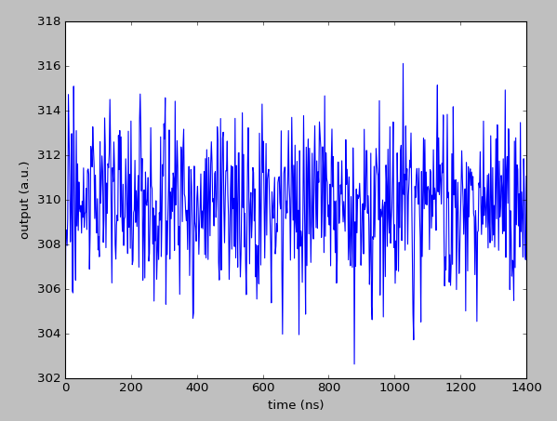

average temperature
309.84K

8.7.2

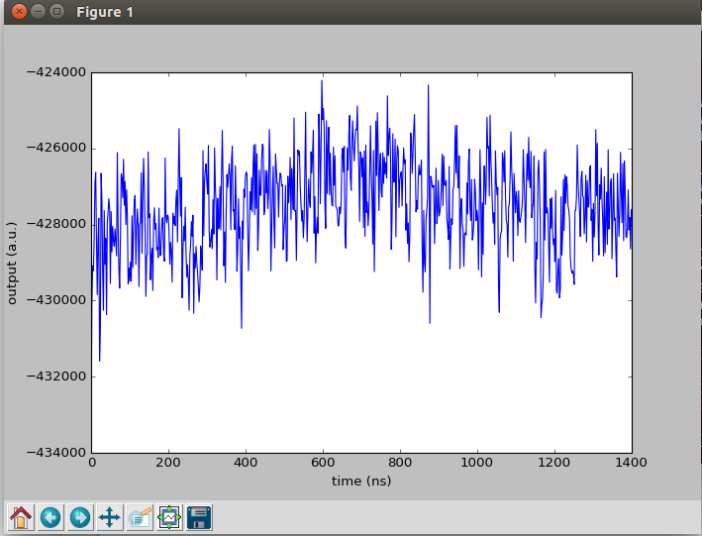

-427521.67702389444 kcal

8.7.3
With the movement of the protein from water to the membranes, the protein lose’s hydrogens bonds with water where there is a gain in energy which is unfavourable when lossing hydrogen bonds.

8.7.4
Yes if we analysed the entropy we would see an increase in value of the entropy during the transition.

