Lab exercise 3: Kinetics - Biophysical Chemistry

By Ryno Lawson

3.2.1 True, as this is the basis of the Boltzmann distribution that the population of a stater is determined by the energy of the state.
3.2.2 True, as Boltzmann makes no mention of change the energy for forbidden or permit barriers
3.2.3 No the population should not change when a single transition is forbidden due to the statement above

3.2.4
1 2 3 4
1 0 1 0 1
2 1 0 1 0
3 0 1 0 1
4 1 0 1 0

3.3.1 15 000 steps

3.3.2

1 2 3 4
1 0 1 0 0
2 1 0 1 0
3 0 1 0 1
4 0 0 1 0

21000 steps

3.4.1
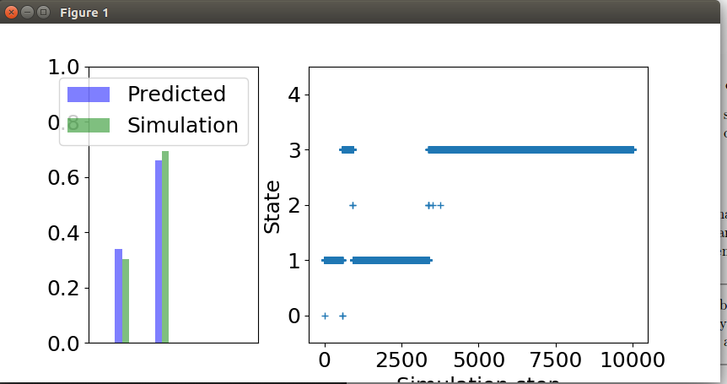

3.4.2
Yes it does look different depending on the starting state. This could be attributed to the small number of steps run in the stimulation.
3.5.1 Infinite amount of time we would expect to see the exact predict and simulate.

3.5.2 The catalyst removes the biase of the initial state by over coming the transition barrier through forcing the transition to the other state and thus changing the population of the states

3.5.3 The catalyst lowers the activation energy required to overcome the transition barrier.

3.6.1 It is rarely observed because it is an highly improbable states which is never sampled by Boltzmanns distribution. This is dues to it being a local maxinum state which is not a desirable states.

3.6.2 Ion gated channels can be depend on a catalyst which changes the charge of the channel or the potential across the barrier.

