Lab exercise 2: Entropy - Biophysical Chemistry

Ryno Lawson

2.4.1 E or ∆E is Kelvin in units.

2.4.2 Enthalpy is measured in kcal/mole but without Boltzmann constant is kcal in units leave E or ∆E over T in Kelvin. But in order to negate the Kelvin units we give energy in Kelvin as units.

2.4.3 The result is a integer in Kelvin and not with many deciminals like the last lab. The numbers we are inputing are already corrected for the k constant. In principle the equation is the same without the constant for correction.

2.4.4 This allows for more precision as there are not many arbitary figures to preform calculations to the significant figures.

2.5.1 prediction_dist = np.exp((-mstates)/T). This makes sense as this takes the values from the enth.dat file and uses them as Energies for Boltzmann distribution

2.5.2 There was a tiny discrepancy as this predict distribution did not sample enough states.

2.5.3 I left out k in the formula and only used the energies in K over the temp in units K.

2.6.1
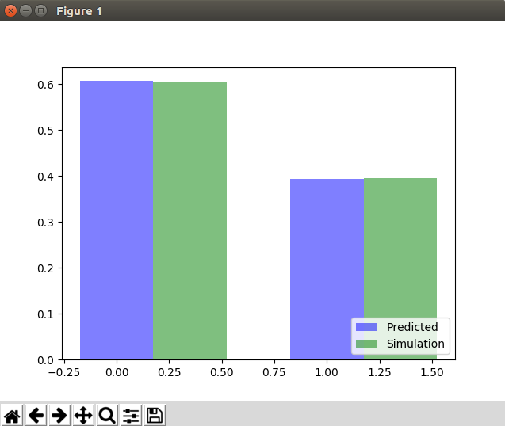
2.6.2 +1
2.6.3 C is dependent of the number of states. C represents Entropy . Joules per Kelvin

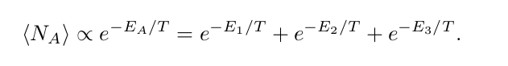

E_{A}= E₁-T.ln3
E_{A}= E₁-T.C

2.6.4
#Mulitplicity
new_simul = np.zeros(2)
new_simul[0] = sum(simulation_dist[0:3])
new_simul[1] = simulation_dist[-1]

new_pred = np.zeros(2)
new_pred[0] = np.exp(-(mstates[0]-T*np.log(3))/T)
new_pred[1] = np.exp(-(mstates[-1]/T))

new_pred /= new_pred.sum()

2.6.5 Free energy. It depends the the level of observation. For the macrostate its call free energy as it lacks multipicity. The microstate contain multiplicity and there has a enthalpy component.

2.6.6. In the real world system it depends on the level of observation and the details of which are known to the observer in order to distinguish the differences between microstates which determine the extent of multiplicity or else the entropy if details of the differences of microstate are determined.

