MODULE 3

Finding Genes

AIMS
- To establish the concept of ORFs and their relationship to genes
- To describe the features used by software to find ORFs/genes
- To become familiar with Web-based programmes used to find ORFs/genes

OBJECTIVES
The student should be able to:
- Distinguish between the concepts of ORF and gene
- Use ORF Finder to find ORFs in prokaryotic nucleotide sequences
- Use GENSCAN to find genes in eukaryotic nucleotide sequences

INTRODUCTION
Usually the primary challenge that follows the sequencing of anything from a small segment of DNA to a complete genome is to establish where the various functional elements such as genes, promoters, terminators etc., lie in the sequence. This module concentrates on the identification of regions of DNA that potentially encode proteins. Such a region is called an Open Reading Frame (ORF), a term which means that the region certainly looks like a gene, but it hasn’t yet been proved to actually be a gene. The situation in prokaryotes is relatively straightforward since scarcely any eubacterial and archaeal genes contain introns. The situation is much more complicated in eukaryotes where the majority of genes are composed of introns and exons, and the analysis must detect the intron/exon boundaries and assemble the exons into a contiguous coding sequence.

There are two basic approaches to detecting which ORFs are actually coding regions, i.e., genes. These approaches either rely on detecting SIGNALS or detecting CONTENT. There are also more sophisticated approaches that take an integrated approach that combines both signal and content detection. So what are signals and content? Signals, in the context of gene finding, are features in the DNA sequence that are associated with genes: these would include promoters, polyadenylation sites, transcription factor binding sites, terminators etc. Content is defined by diffuse patterns in the DNA that differ between coding and non-coding regions and arise from the constraints imposed on a coding region by its function of encoding a protein.

Finding ORFS
The simplest method in prokaryotes, which virtually always lack interrupted genes, is to scan the DNA for start and stop codons. The DNA is double stranded and each strand has three potential reading frames. Thus the scan must look at all six reading frames. Any region of DNA between a start codon and a stop codon in the same reading frame could potentially code for a polypeptide, and is therefore an ORF. Obviously, small potential coding sequences like this will occur frequently by chance, and therefore the longer they are the more likely they are to represent real coding regions, genes. You could then use the computer to translate these ORFs and search the resulting conceptual polypeptides against the database of known proteins to see if there was anything similar. Indeed, the TFASTA search (see Module 4) is based on this kind of reasoning. This approach is complicated by the fact that though there are only three stop codons in the genetic code of all organisms, there is some variation in start codons. Although the methionine codon AUG is the most common start codon alternative start codons are used in a number of prokaryotic and organelle genes. These alternative start codons include GUG, UUG and AUA.

Finding content
Many methods for the detection of genes rely on computational methods that detect regular though very diffuse patterns in base composition in the DNA sequence. These diffuse patterns arise for the following reasons:
- many organisms there is a detectable preference for G or C over A and T in the third (“wobble”) position in a codon
- all organisms do not utilize synonymous codons with the same frequency - consequently there is a codon bias
- there is an unequal usage of amino acids in proteins sufficient to cause a bias in all three positions of codons and increase the overall codon bias
- the %GC content of the first two codon positions of the universal genetic code is approximately 50%, therefore, organisms which have a low or high %GC content will exhibit a marked bias at the third position of codons to achieve their overall %GC content.
One systematic study of more than twenty compositional properties indicated that hexamer composition gave the best discrimination between coding and non-coding regions (Fickett and Tung, 1992). The most recent approaches to using compositional features to distinguish coding from non-coding regions employ ‘Markov models’. A description of these models is beyond the scope of this module, but they are well explained by Burge and Karlin (1998)

Finding signals
The detection of compositional bias in the DNA has nothing to do with the natural processes of transcription and translation. It has been possible for some time to produce consensus sequences for features such as promoters, transcription factor binding sites, exon/intron boundaries, transcription start points etc. However, consensus sequences are typically not very reliable for discriminating true sites from pseudosites. A more sophisticated approach that utilizes similar information to that of the consensus sequence is the Position Weight Matrix (PWM). A score is given to each possible nucleotide at each possible position of the signal. For any particular sequence, considered as a possible occurrence of the signal, the appropriate scores are summed up to give an overall score. A threshold value is set and if the overall score exceeds the threshold then the site is accepted as genuine.

Finding Genes in Prokaryotes
Computational approaches to finding genes in prokaryotes generally work on the assumption that ORFs that are longer than some reasonable threshold are likely to be genes. Later on in the exercises we will use a simple programme of this type (ORF Finder) to find potential genes in a prokaryotic DNA sequence, but there are problems associated with such a simplistic approach:
- very small genes may be missed;
- there may be problems associated with establishing the precise N-terminal end of the gene since initiation might actually occur at an internal AUG within the ORF
- there may be overlapping genes.
To overcome these limitations, more sophisticated programmes employ Markov models to detect compositional biases and increase the reliability of gene detection – such methods include the popular GENMARK and GLIMMER programmes.

Finding Genes in Eukaryotes

Content
Compositional bias in eukaryotic DNA can be analysed as described above. The Markov models employed are usually species specific.

Introns exons and splice sites
Most gene finding programmes that can be used with eukaryotic genomic sequences include procedures which are designed to detect exons and to precisely locate the boundary between the exon and the contiguous intron. In this context we can recognize 4 different types of exons:
- initial exons, from the initiation codon to the first splice site;
- internal exons from splice site to splice site;
- terminal exons from splice site to stop codon;
- single introns corresponding to uninterrupted, intronless genes, i.e., running from initiation codon to stop codon.
Each different type of exon causes different detection problems. The frequency with which a programme detects ‘true’ splice sites is known as its ‘sensitivity’, and its ‘specificity’ reflects the number of predicted sites which are correct. The spliceosome recognizes sites at the 5’ and 3’ ends of introns and nearly all spliceosomal introns begin with GT and end with AG. Most eukaryotic gene finding programmes apply this rule to search for exon/intron boundaries

Transcription Signals
The principal transcription signals employed in gene detection are as follows:
- the initiator or CAP signal located at the transcription startpoint;
- the TATA box;
- transcription factor binding sites;
- polyadenylation signals;

Translation Signals
The principal signals associated with translation that are employed in gene detection are as follows:
- The Kozak signal located immediately upstream of the AUG initiation codon;
- The termination codon(s) present in the terminal exon and absent from the initial and internal exons;

Integrated Methods
Most early methods of gene detection in eukaryotes used only single signal or content sensors, and consequently were comparatively inaccurate. There is now an increasing number of integrated gene finding programmes, employing multiple signal and content sensors, which are being applied to the analysis of complete genomes. The process of deconstructing a DNA sequence into genes, each of which is composed of introns and exons, has been likened to parsing a sentence by breaking it down into its component grammatical parts. Hence, these integrated methods are often referred in a linguistic metaphor as Integrated Gene Parsing. Integrated approaches to detecting genes generally begin by searching for signals, performing a content analysis and finally by attempting to define the intron/exon boundaries. It is important that, when a potential intron/exon boundary is predicted, the content on either side of the boundary should be analysed to confirm that one side has the features of a coding region and the other side does not. To continue the linguistic metaphor, the rules for what functional features follow what other features are defined in a “gene structure grammar”, and which because of the algorithms employed are known as Hidden Markov Models (HMMs). Recently developed programmes that take this integrated approach include GENSCAN, GRAIL, GENEPARSER, FGENE. The program GENSCAN, which will be used in one of the exercises, incorporates descriptions of the basic transcriptional, translational and splicing signals, as well as length distributions and compositional features of exons, introns and intergenic regions. A comprehensive list of gene finding programmes can be found at Software and Databases for Computational Biology on the Internet.

A practical approach
When analysing an eukaryotic genomic sequence the following general strategy should be adopted:
- remove repetitive elements (ALUs, etc.). Repeats can confuse some analyses and rarely overlap promoters or exons.
- Perform database search on conceptual translation of DNA (BlastX or Tfasta, see Module 4)
- Perform gene finding search using more than one particular programme
- Translate resultant ORFs and do a functional analysis (PIX, Blocks, Pfam etc. see Module 5)

EXERCISES
The two exercises involved with this module are:

- To identify ORFs and translate them in a 10 kb base fragment of prokaryotic DNA using the ORF Finder software.
- To identify a gene in a fragment of human genomic DNA using GENSCAN software.

1.ORF Finder

  - Open the DNA sequence bacteriophage.txt in notepad and copy the sequence to the clipboard.
  - Access the Web-based version of ORF finder at the National Centre for Biotechnology Information http://www.ncbi.nlm.nih.gov/gorf/gorf.html.
  - You should see the screen shown below.

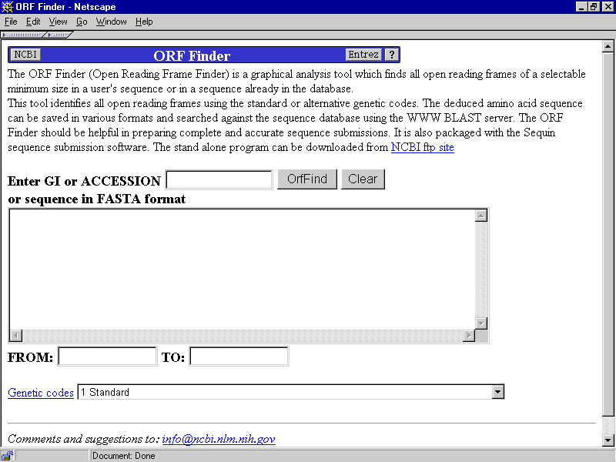

  - Click in the text box and paste the sequence (ctrl V) from the clipboard
  - You must decide which option to use for the genetic code prior to carrying out the analysis. Click the drop down selection box and select the appropriate genetic code
  - Click the ORF Find button and you should soon see the results of your analysis in a screen similar to the one below
1.6 You may wish to enter the optional settings
1.7 Help on the use of ORF Finder is available at http://www3.ncbi.nlm.nih.gov/gorf/orfhelp.html.

GENSCAN
  - Open the DNA sequence file arabidopsis.txt in notepad and copy the sequence to the clipboard.
  - Access a Web-based version of GENSCAN.
  - You should see the screen shown below. Paste the sequence into the DNA sequence box

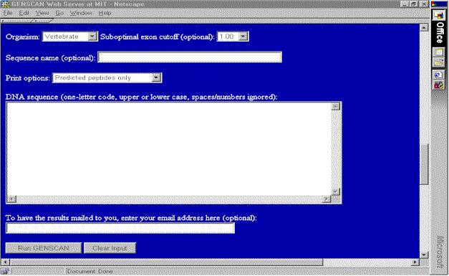

2.4 The program has certain parameters that need to be set before you run it. Select Arabidopsis from the dropdown selection of organisms. Everything else can be left at its default value.

References and Useful Links
- Burge CB, Carlin S (1998) Finding the genes in genomic DNA. Current Opinion in Structural Biology 8, 346-354.
- Fickett JW (1996) Finding genes by computer: the state of the art. Trends in Genetics 12(8), 316-320.
- Fickett JW, Tung C-S (1992) Assessment of protein coding measures. Nucleic Acids Research 20, 6441-6450.
- Haussler D (1998) Computational genefinding. Trends Guide to Bioinformatics (Trends Supplement) 12-15.
- http://cmgm.stanford.edu/classes/genefind – a largely complete list of genefinding programmes and links to them
- http://linkage.rockefeller.edu/wli/gene/intro.html – Introduction to the Problem of Computational Gene Recognition
- GENSCAN
- Genemark

