8. Task D: Portfolio evidence and appendix map
Why these matters
From next week, you will start focusing on your individual report. If your evidence is messy now, your report will be weak. This week you must organize evidence clearly so that each student can refer to it in their own portfolio.
Appendix item |  | Evidence type |  | GitHub location |  | Who will use it in report? |  | Appendix number
Team meeting minutes |  | screenshot |  | Evidence of Meeting (folder) |  | Bipan |  | Appendix 1.1
Team meeting minutes |  | Screenshot |  | Evidence of Meeting (folder) |  | Anu |  | Appendix 1.2
Team meeting minutes |  | screenshot |  | Evidence of Meeting (folder) |  | Ramesh |  | Appendix 1.3
Team meeting minutes |  | screenshot |  | Evidence of Meeting (folder) |  | Sandeep |  | Appendix 1.4
Game concept canvas | Design evidence |  | Week3 (folder) |  | Ramesh, Bipan, Anu, Sandeep and Harman |  | Appendix 2.1
Storyboard | Design evidence |  | Week3 (folder) |  | Ramesh, Bipan, Anu, Sandeep and Harman |  | Appendix 2.2
Prototype screenshots | Development evidence |  | In progress |  |  |  | Appendix 3.1
Testing record | Testing/iteration evidence |  | In progress |  |  |  | Appendix 3.2
Peer/tutor feedback | Feedback evidence |  | In progress |  |  |  | Appendix 4.1
Individual contribution log | Personal contribution evidence |  | Week3 (folder)  , Indivisual_Contribution_Log(file) |  | Ramesh, Bipan, Anu, Sandeep and Harman |  | Appendix 5.1
AI use log | Ethics/AI evidence |  | Week3 (folder), Ai_Use_Evidence |  | Ramesh, Bipan, Anu, Sandeep and Harman |  | Appendix 6.1

Appendix:

Team meeting minutes:
Appendix 1.1:
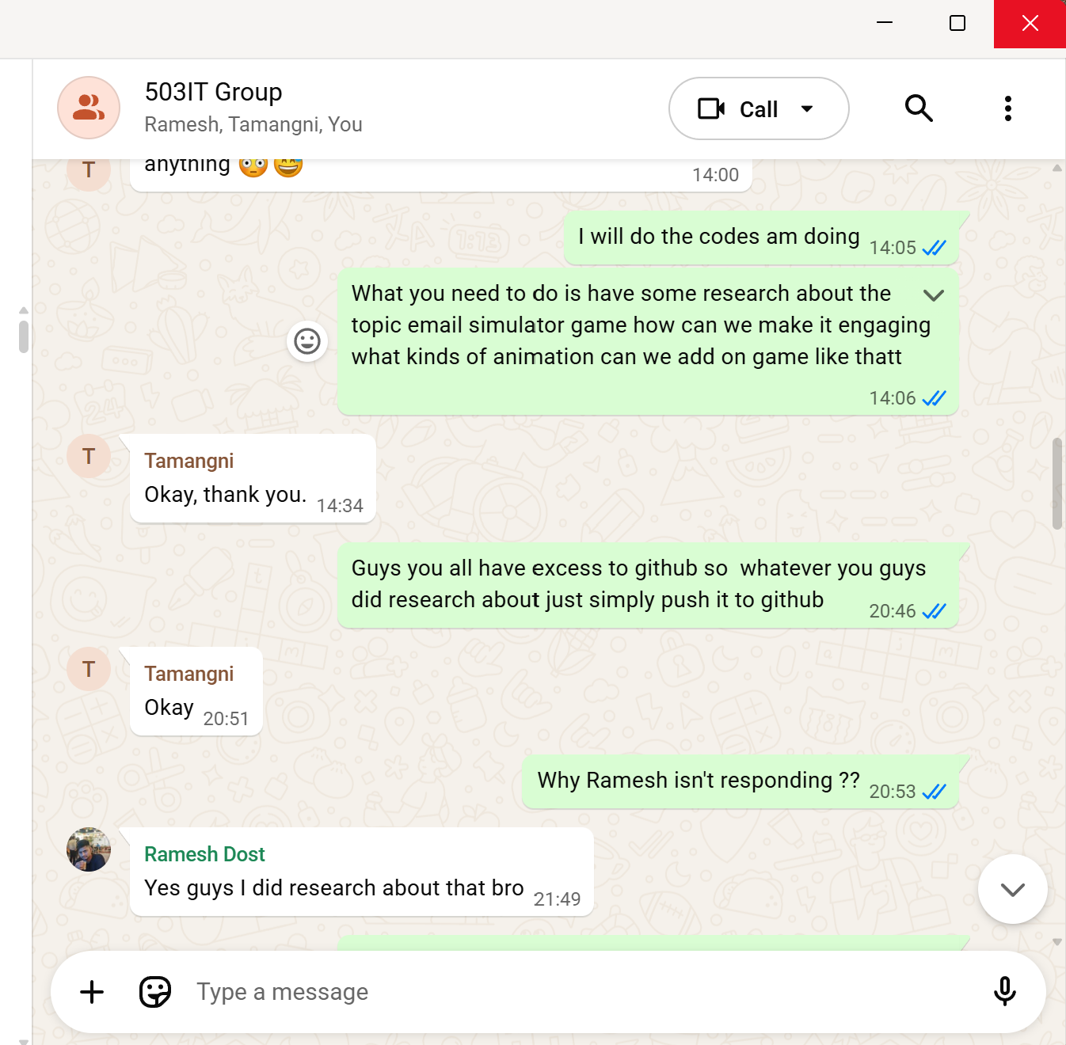
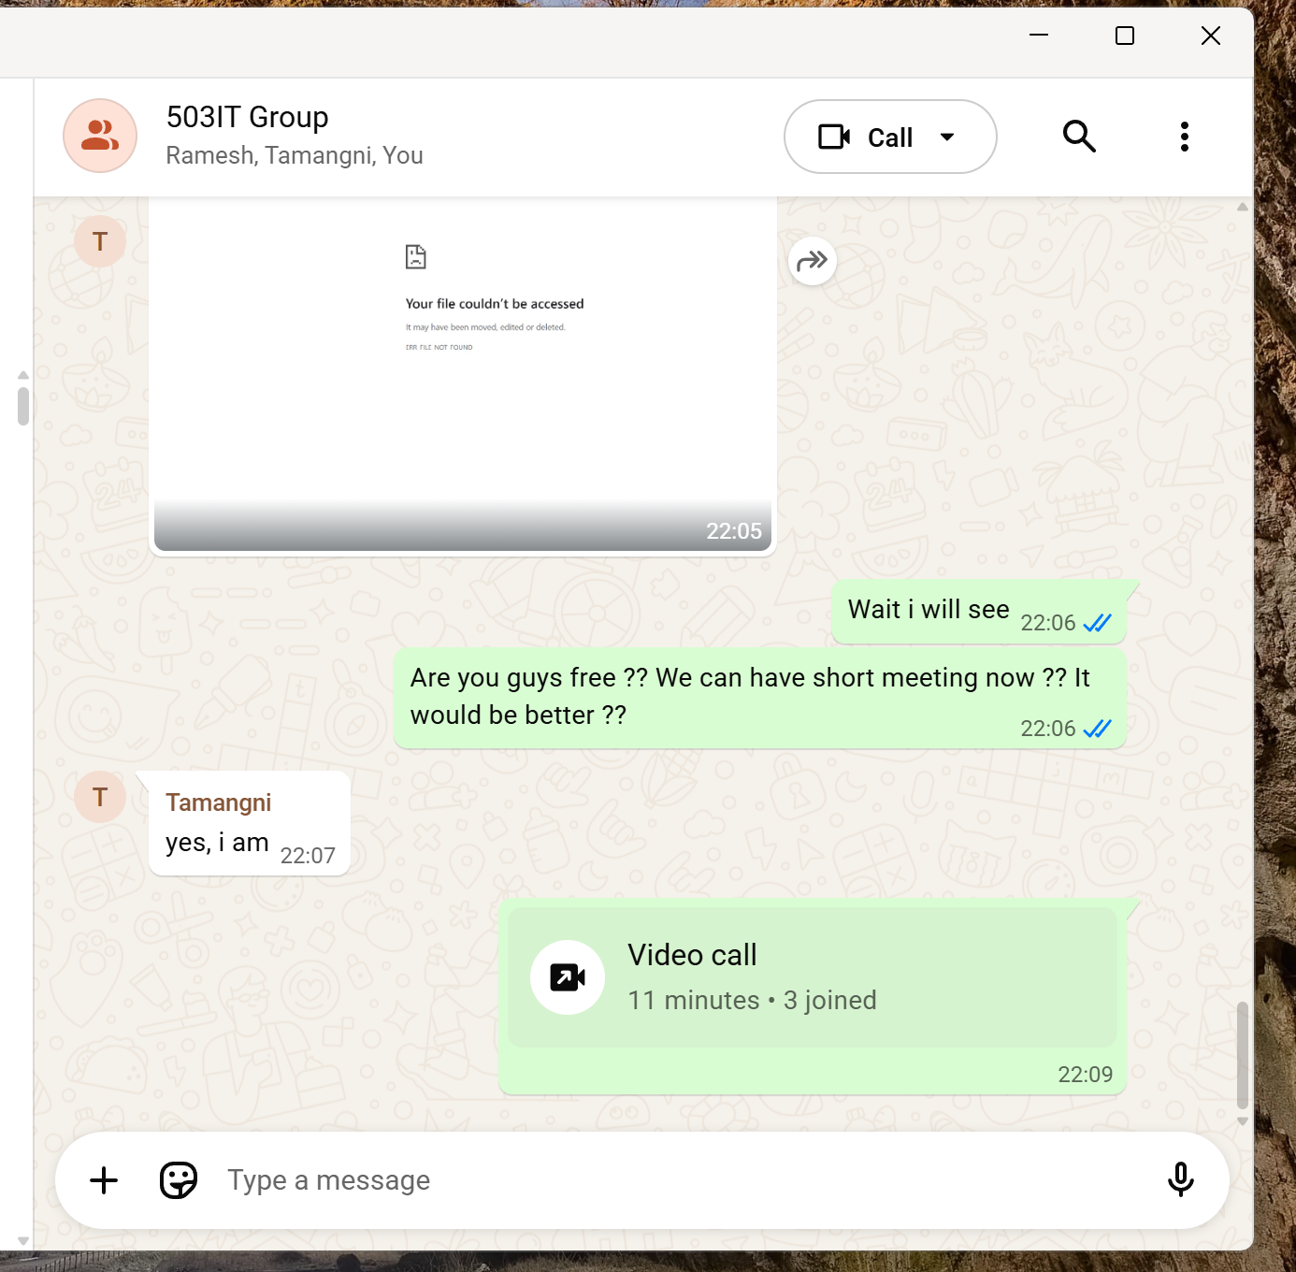
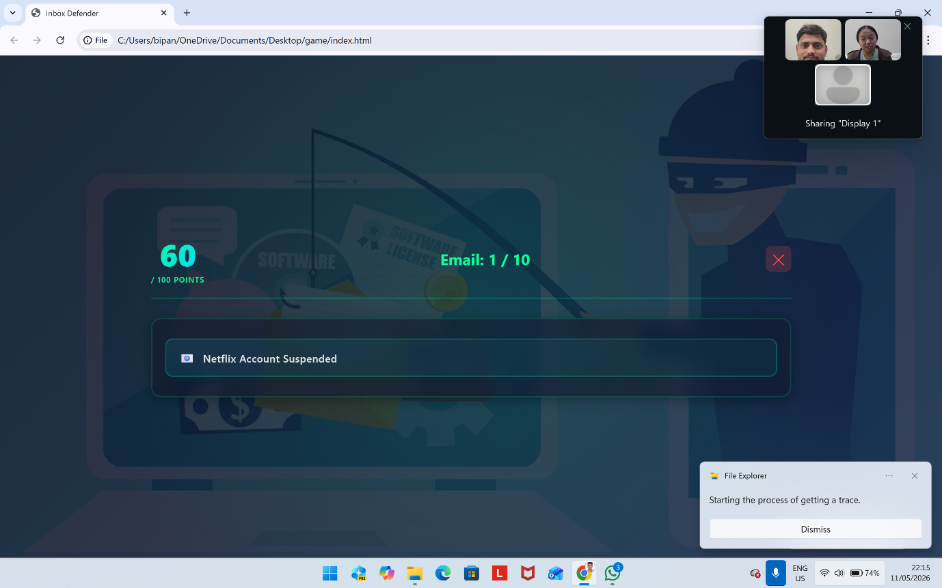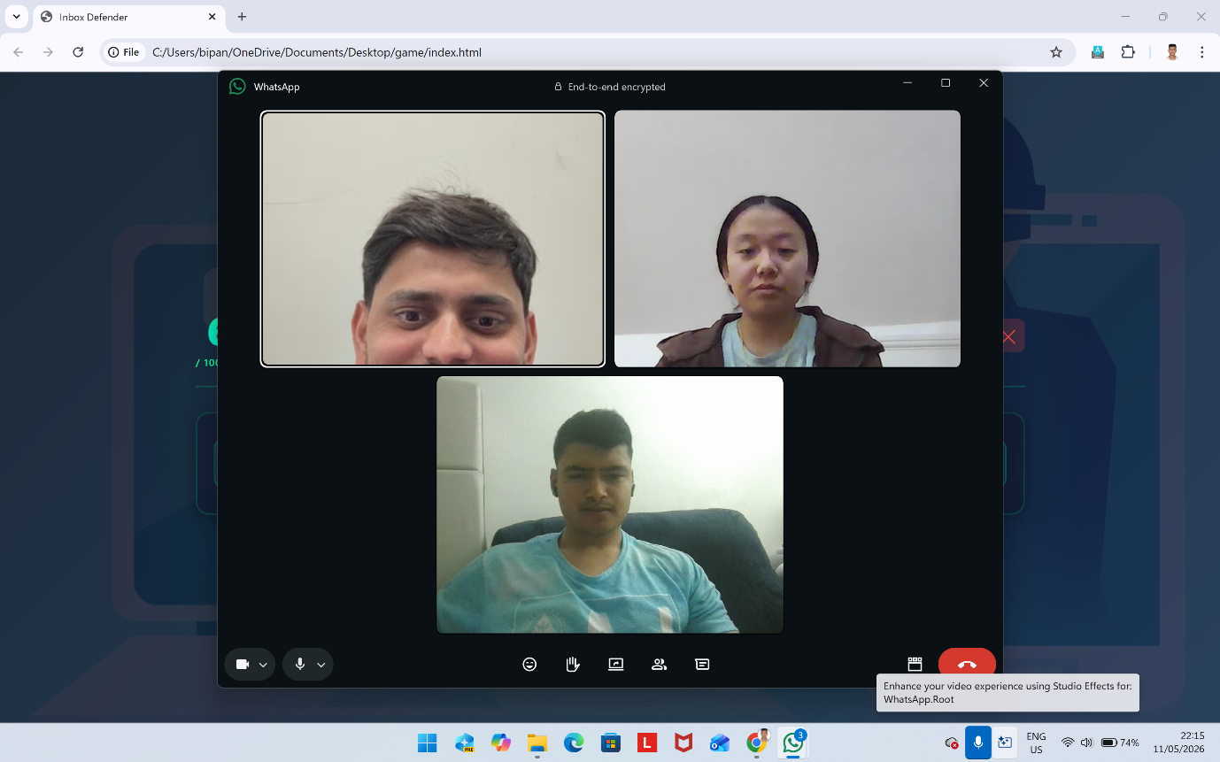

Appendix 1.2:
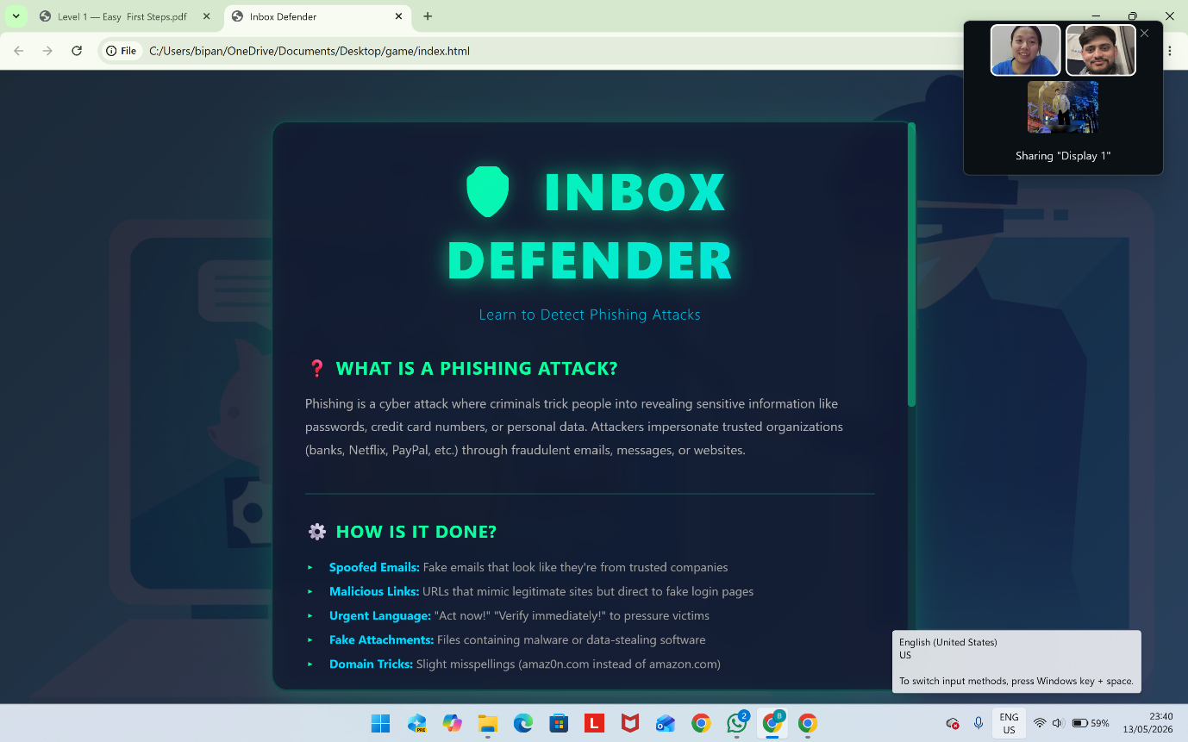

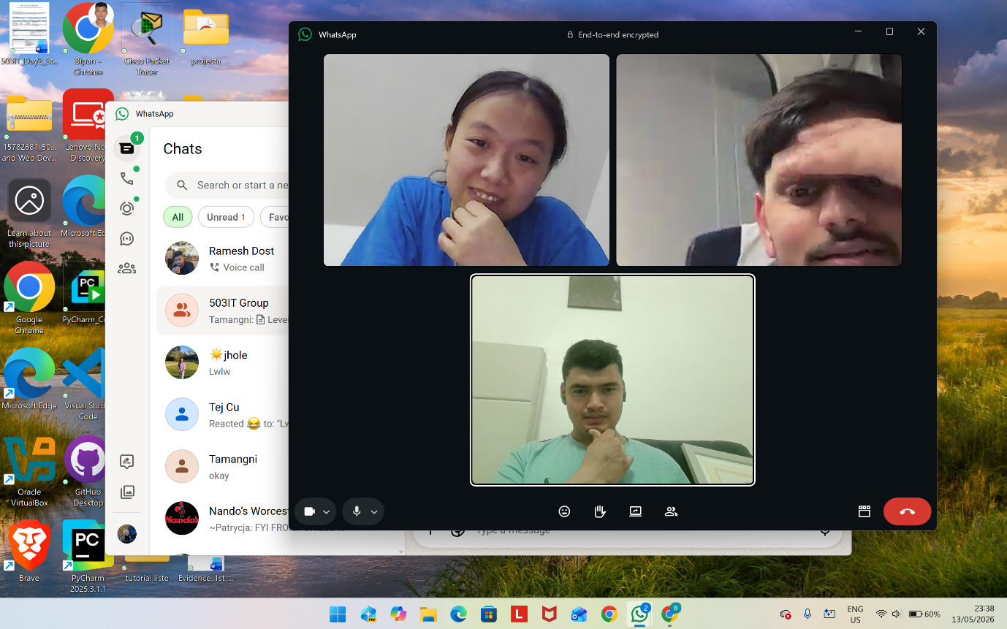

Appendix 1.3:

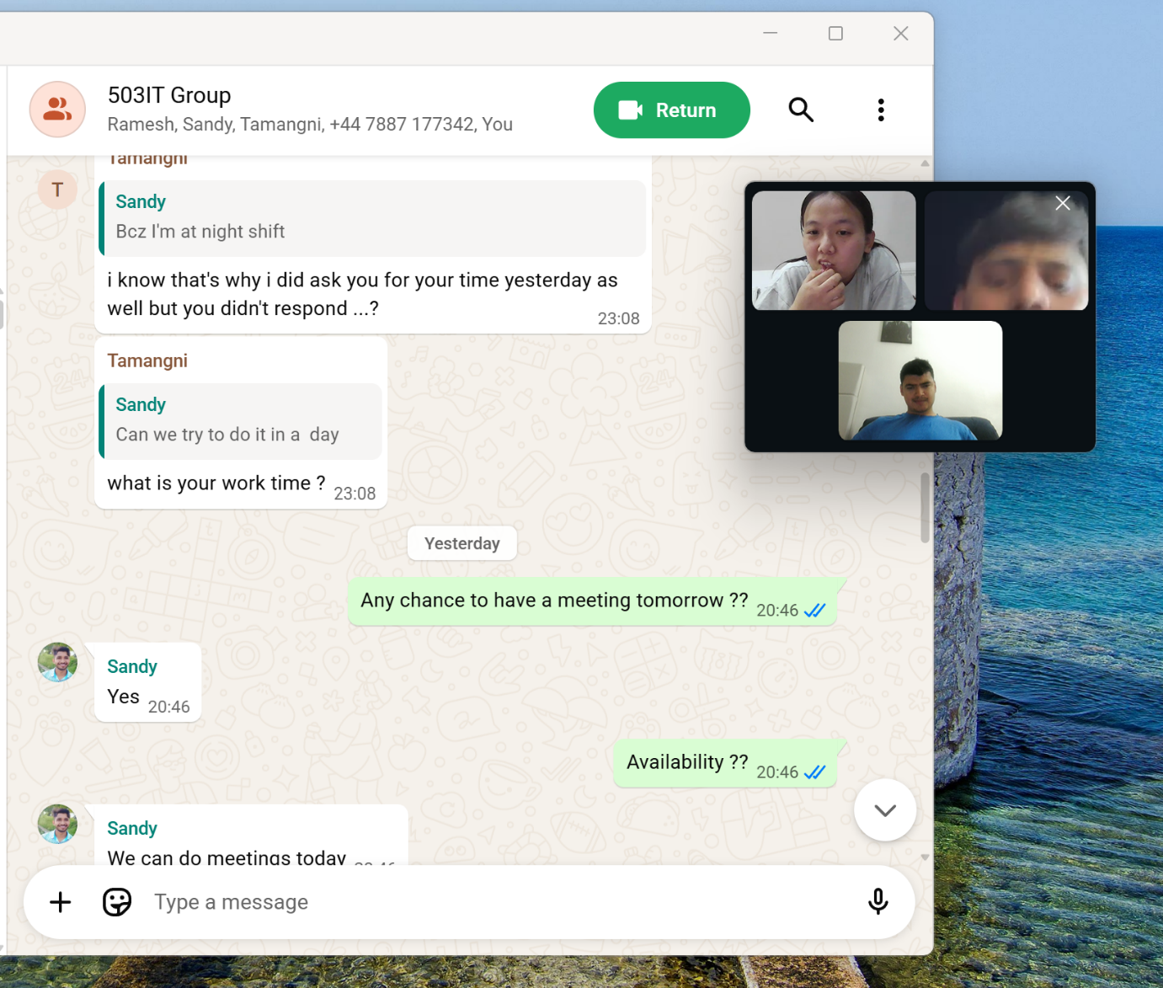

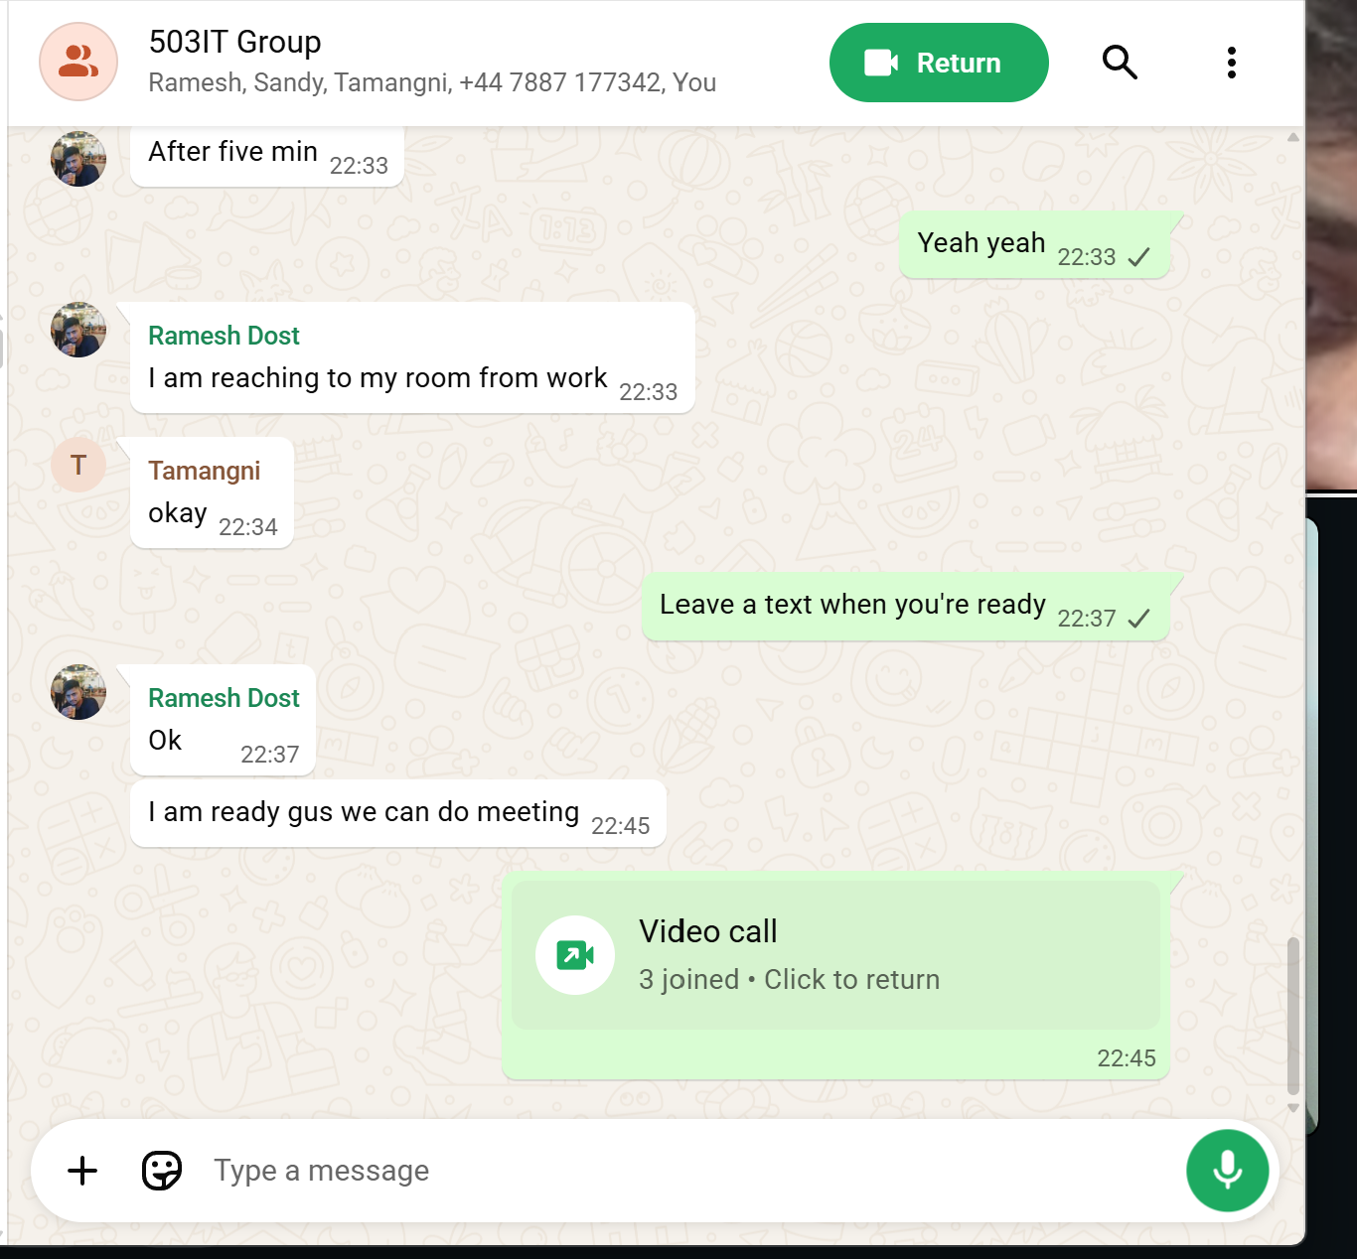

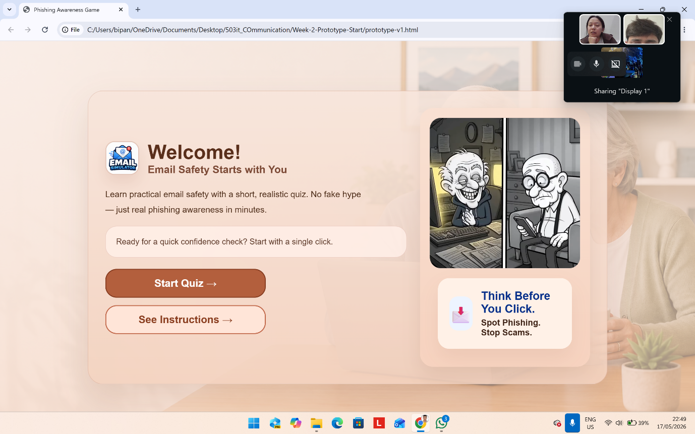

Appendix 1.4:
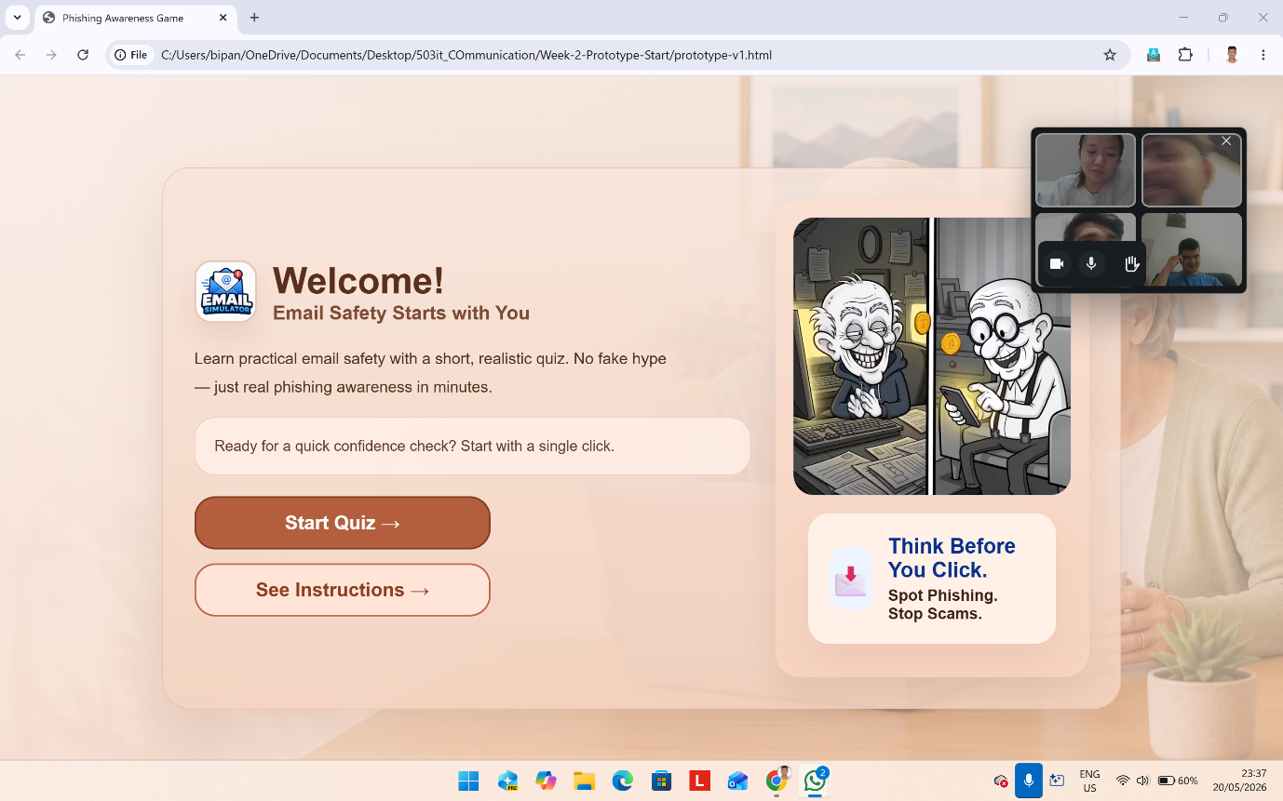

Appendix 2.1:
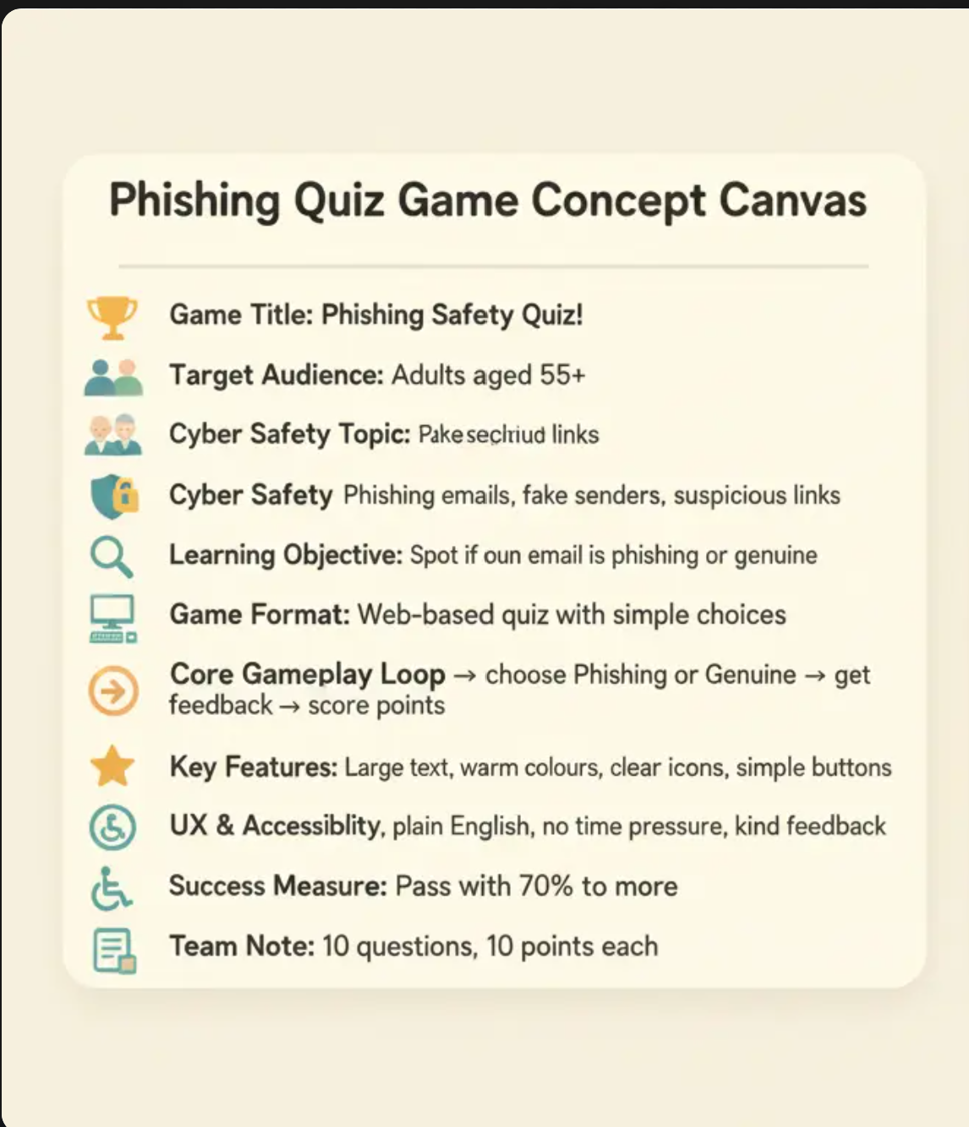

Appendix 2.2:
