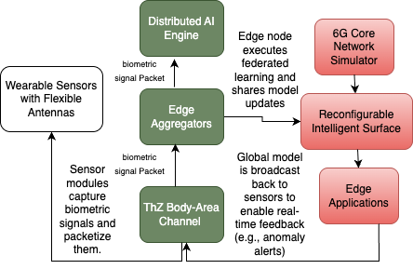

Figure 1:THzSenseNet Framework with Distributed Intelligence and QoE-Aware Routing.