**NAME : GOSAI BIPASHA RAJUBHAI**

**ROLL NO. : 18**

**SEM :- 7TH**

**SUBJECT : FULL STACK -705**

**ASSIGNMNET :- 1**

**1. Develop a web server with following functionalities:**

**- Serve static resources.**

**- Handle GET request.**

**- Handle POST request.**

**Server.js**

const http = require('http');

const fs = require('fs');

const path = require('path');

const url = require('url');

const querystring = require('querystring');

const PORT = 3000;

// Function to serve static files

const serveStaticFile = (res, filePath, contentType) => {

    fs.readFile(filePath, (error, content) => {

        if (error) {

            res.writeHead(500);

            res.end(`Sorry, there was an error: ${error.code} ..\n`);

        } else {

            res.writeHead(200, { 'Content-Type': contentType });

            res.end(content, 'utf-8');

        }

    });

};

// Create the server

const server = http.createServer((req, res) => {

    const parsedUrl = url.parse(req.url, true);

    // Handle GET request

    if (req.method === 'GET') {

        if (parsedUrl.pathname === '/') {

            serveStaticFile(res, path.join(__dirname, 'public', 'index.html'), 'text/html');

        } else if (parsedUrl.pathname === '/submit') {

            // Handle form submission here if needed

            res.writeHead(200, { 'Content-Type': 'text/plain' });

            res.end('Form submitted successfully!');

        } else {

            // Serve other static files

            const filePath = path.join(__dirname, 'public', parsedUrl.pathname);

            const extname = String(path.extname(filePath)).toLowerCase();

            const mimeTypes = {

                '.html': 'text/html',

                '.js': 'text/javascript',

                '.css': 'text/css',

                '.json': 'application/json',

                '.png': 'image/png',

                '.jpg': 'image/jpg',

                '.gif': 'image/gif',

                '.svg': 'image/svg+xml',

                '.wav': 'audio/wav',

                '.mp4': 'video/mp4',

                '.woff': 'application/font-woff',

                '.ttf': 'application/font-ttf',

                '.eot': 'application/vnd.ms-fontobject',

                '.otf': 'application/font-otf',

                '.txt': 'text/plain',

                '.xml': 'application/xml',

                '.pdf': 'application/pdf',

                '.zip': 'application/zip',

                '.css': 'text/css',

            };

            const contentType = mimeTypes[extname] || 'application/octet-stream';

            serveStaticFile(res, filePath, contentType);

        }

    }

    // Handle POST request

    else if (req.method === 'POST' && parsedUrl.pathname === '/submit') {

        let body = '';

        req.on('data', chunk => {

            body += chunk.toString(); // Convert Buffer to string

        });

        req.on('end', () => {

            const postData = querystring.parse(body);

            console.log('Received data:', postData.data);

            res.writeHead(200, { 'Content-Type': 'text/plain' });

            res.end('Data received: ' + postData.data);

        });

    } else {

        res.writeHead(404);

        res.end('404 Not Found');

    }

});

// Start the server

server.listen(PORT, () => {

    console.log(`Server is listening on http://localhost:${PORT}`);

});

**index.html**

<!DOCTYPE html>

<html lang="en">

<head>

    <meta charset="UTF-8">

    <meta name="viewport" content="width=device-width, initial-scale=1.0">

    <title>My Web Server</title>

</head>

<body>

    <h1>Welcome to My Web Server!</h1>

    <form method="POST" action="/submit">

        <input type="text" name="data" placeholder="Enter some data" required>

        <button type="submit">Submit</button>

    </form>

</body>

</html>

**Output :-**

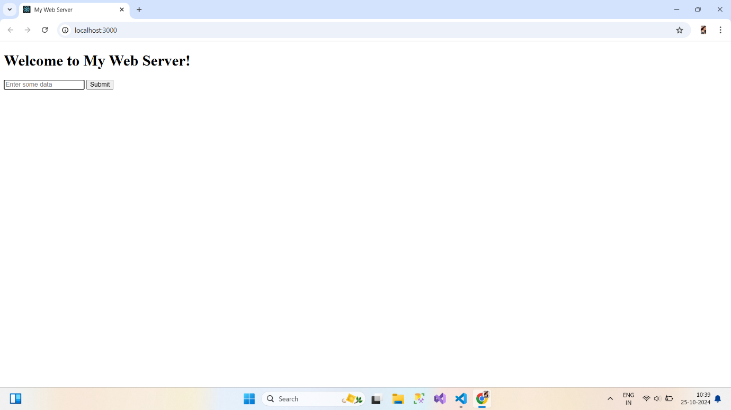

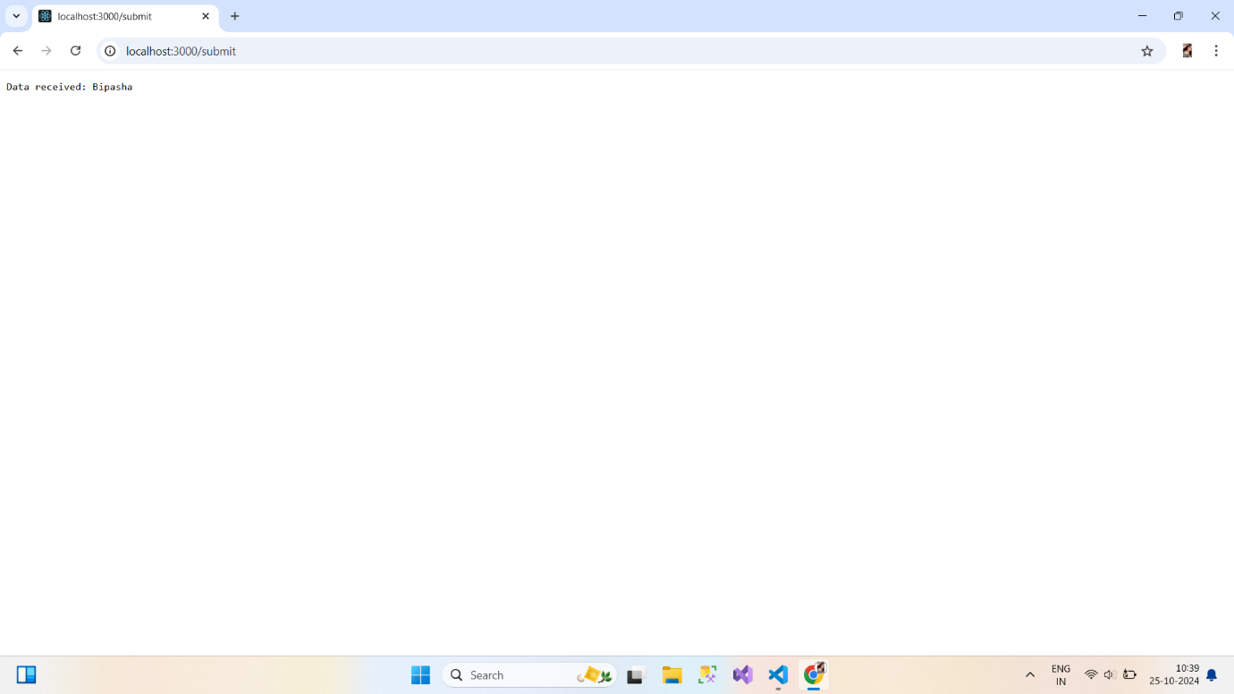

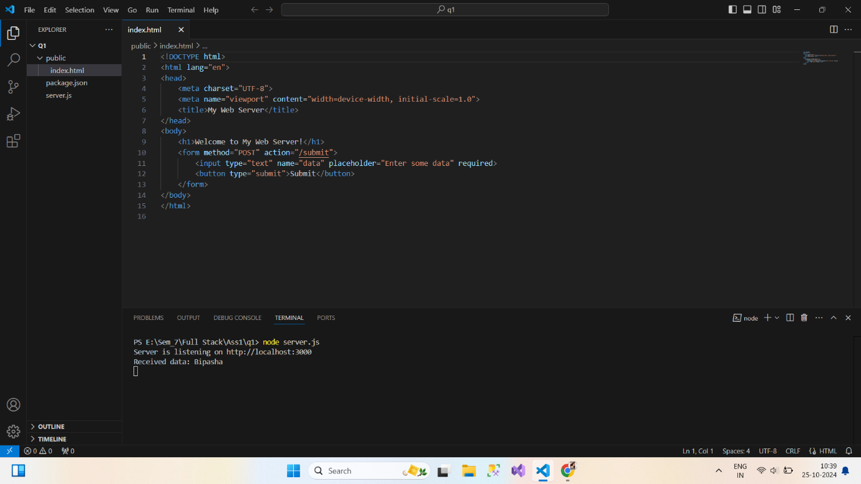

**2. Develop nodejs application with following requirements:**

**- Develop a route "/gethello" with GET method. It displays "Hello NodeJS!!" as response.**

**- Make an HTML page and display.**

**- Call "/gethello" route from HTML page using AJAX call. (Any frontend AJAX call API can be**

**used.)**

**server.js**

const express = require('express');

const path = require('path');

const app = express();

const PORT = 3000;

// Serve static files from the public directory

app.use(express.static('public'));

// Route for /gethello

app.get('/gethello', (req, res) => {

    res.send('Hello NodeJS!!');

});

// Serve the HTML page

app.get('/', (req, res) => {

    res.sendFile(path.join(__dirname, 'public', 'index.html'));

});

// Start the server

app.listen(PORT, () => {

    console.log(`Server is listening on http://localhost:${PORT}`);

});

**index.html**

<!DOCTYPE html>

<html lang="en">

<head>

    <meta charset="UTF-8">

    <meta name="viewport" content="width=device-width, initial-scale=1.0">

    <title>Hello NodeJS</title>

    <script src="https://code.jquery.com/jquery-3.6.0.min.js"></script>

</head>

<body>

    <h1>Welcome to the NodeJS App</h1>

    <button id="getHelloButton">Get Hello Message</button>

    <div id="response"></div>

    <script>

        $(document).ready(function() {

            $('#getHelloButton').click(function() {

                $.ajax({

                    url: '/gethello',

                    method: 'GET',

                    success: function(data) {

                        $('#response').text(data);

                    },

                    error: function() {

                        $('#response').text('Error occurred while fetching data.');

                    }

                });

            });

        });

    </script>

</body>

</html>

**Output :-**

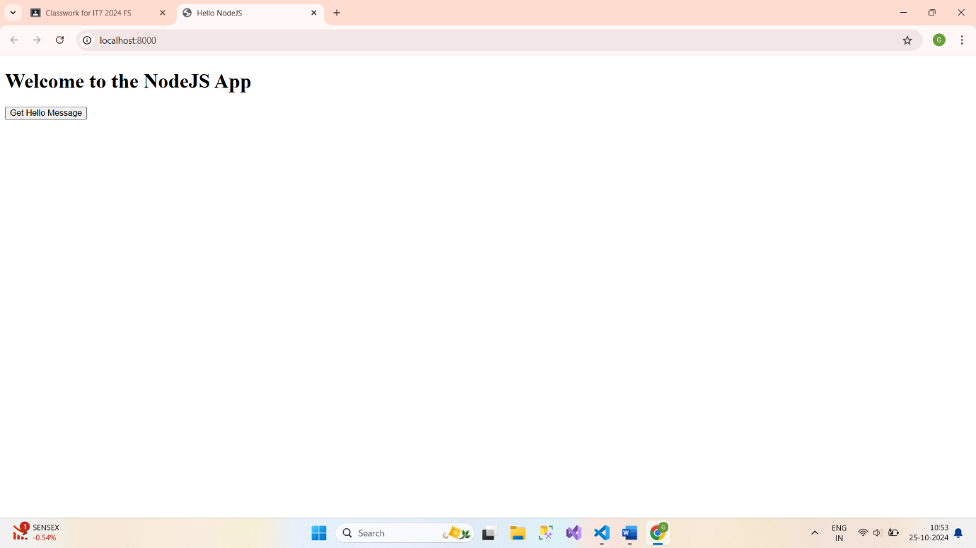

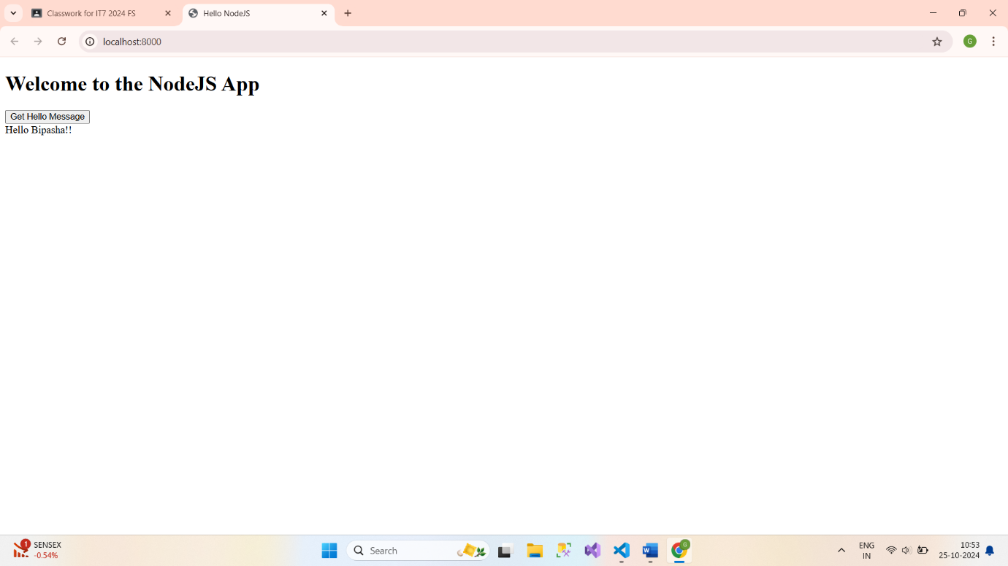

**3. Develop a module for domain specific chatbot and use it in a command line application.**

**app.js**

const readline = require('readline');

const Chatbot = require('./chatbot');

// Initialize the chatbot with a specific domain

const chatbot = new Chatbot('Customer Support');

const rl = readline.createInterface({

    input: process.stdin,

    output: process.stdout

});

console.log('Welcome to the chatbot application!');

console.log('Type "exit" to quit.\n');

const askQuestion = () => {

    rl.question('You: ', (input) => {

        if (input.toLowerCase() === 'exit') {

            console.log('Chatbot: Goodbye!');

            rl.close();

            return;

        }

        const response = chatbot.respond(input);

        console.log(`Chatbot: ${response}\n`);

        askQuestion(); // Ask the next question

    });

};

// Start the conversation

askQuestion();

**chatbot.js**

// chatbot.js

class Chatbot {

    constructor(domain) {

        this.domain = domain;

        this.responses = {

            greeting: `Hello! I'm a chatbot specialized in ${this.domain}. How can I assist you today?`,

            farewell: `Goodbye! If you need any further assistance in ${this.domain}, feel free to ask!`,

            hours: `Our hours of operation are 9 AM to 5 PM, Monday to Friday.`,

            services: `We offer a variety of services including customer support, product inquiries, and technical assistance.`,

            faq: `You can ask me about our services, hours of operation, or any other questions you might have!`,

            default: `I'm sorry, I didn't understand that. Can you please rephrase your question?`

        };

    }

    respond(message) {

        const lowerMessage = message.toLowerCase();

        if (lowerMessage.includes('hello') || lowerMessage.includes('hi')) {

            return this.responses.greeting;

        } else if (lowerMessage.includes('bye') || lowerMessage.includes('goodbye')) {

            return this.responses.farewell;

        } else if (lowerMessage.includes('hours')) {

            return this.responses.hours;

        } else if (lowerMessage.includes('services') || lowerMessage.includes('what do you offer')) {

            return this.responses.services;

        } else if (lowerMessage.includes('faq') || lowerMessage.includes('questions')) {

            return this.responses.faq;

        } else {

            return this.responses.default;

        }

    }

}

module.exports = Chatbot;

**Output :-**

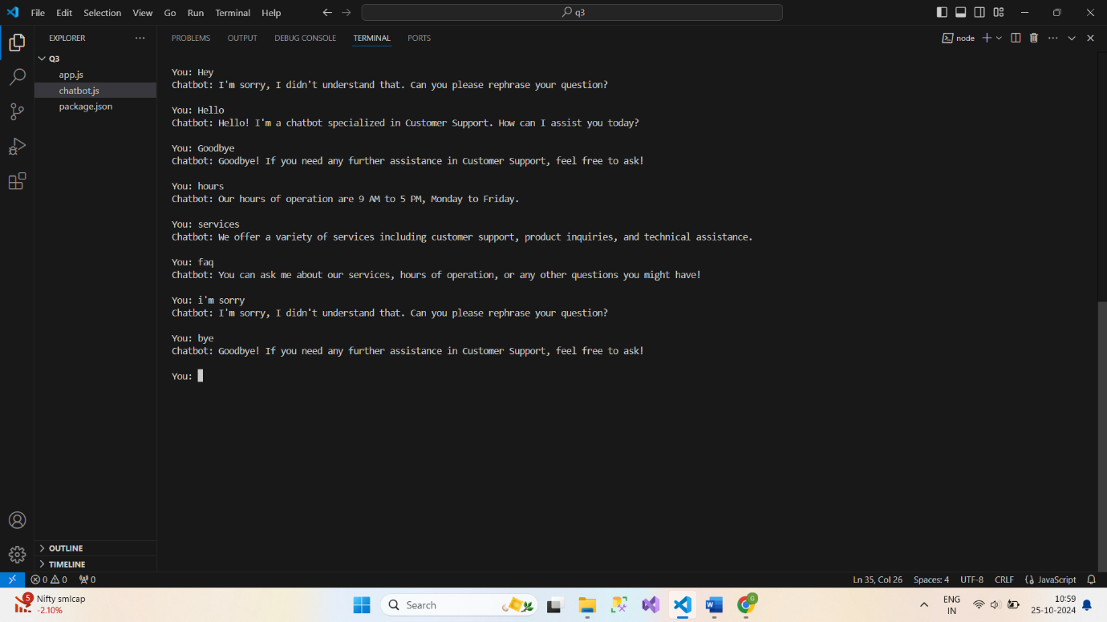

**4. Use above chatbot module in web based chatting of websocket.**

**Server.js**

// server.js

const express = require('express');

const path = require('path');

const WebSocket = require('ws');

const chatbot = require('./chatbot');

const app = express();

const PORT = 2000;

// Serve static HTML file

app.use(express.static(path.join(__dirname, 'public')));

// Create HTTP server and WebSocket server

const server = app.listen(PORT, () => {

  console.log(`Server running on http://localhost:${PORT}`);

});

const wss = new WebSocket.Server({ server });

// WebSocket connection handler

wss.on('connection', (ws) => {

  console.log('New client connected!');

  ws.on('message', (message) => {

    console.log(`Received: ${message}`);

    const response = chatbot(message);

    ws.send(`Bot: ${response}`);

  });

  ws.on('close', () => {

    console.log('Client disconnected.');

  });

});

**chatbot.js**

// chatbot.js

const responses = {

    "hello": "Hi! How can I assist you?",

    "bye": "Goodbye!",

    "help": "I can assist with general queries."

  };

  function chatbot(input) {

    return responses[input.toLowerCase()] || "I didn't understand that.";

  }

  module.exports = chatbot;

**chat.html**

<!-- /public/index.html -->

<!DOCTYPE html>

<html lang="en">

<head>

  <meta charset="UTF-8">

  <meta name="viewport" content="width=device-width, initial-scale=1.0">

  <title>Chat with Bot</title>

</head>

<body>

  <h1>Chat with Bot</h1>

  <div id="chatbox"></div>

  <input type="text" id="input" placeholder="Type a message" />

  <button onclick="sendMessage()">Send</button>

  <script>

    const ws = new WebSocket('ws://localhost:3000');

    ws.onmessage = function(event) {

      const chatbox = document.getElementById('chatbox');

      chatbox.innerHTML += `<p>${event.data}</p>`;

    };

    function sendMessage() {

      const input = document.getElementById('input');

      ws.send(input.value);

      const chatbox = document.getElementById('chatbox');

      chatbox.innerHTML += `<p>You: ${input.value}</p>`;

      input.value = ''; // Clear input field after sending

    }

  </script>

</body>

</html>

**Output :-**

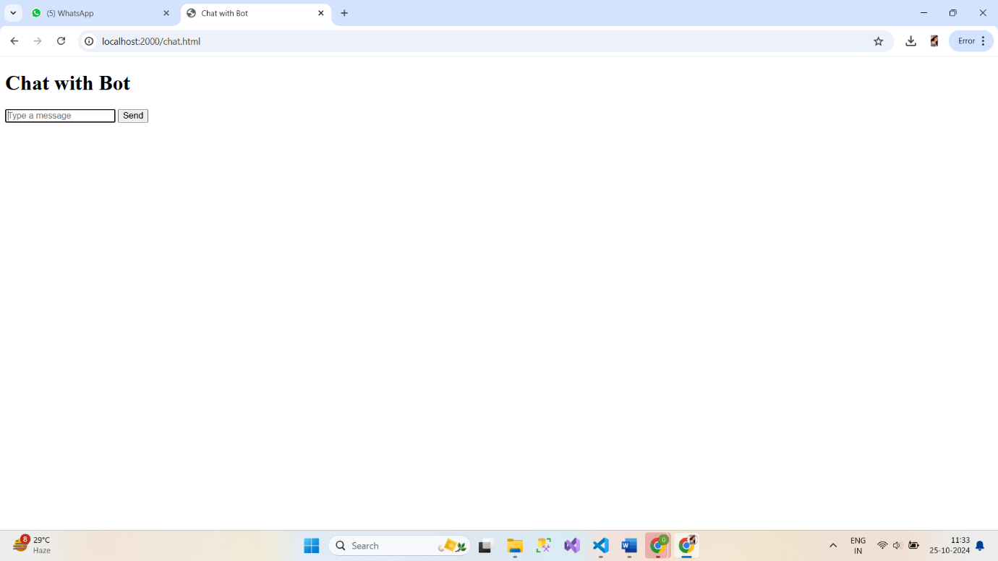

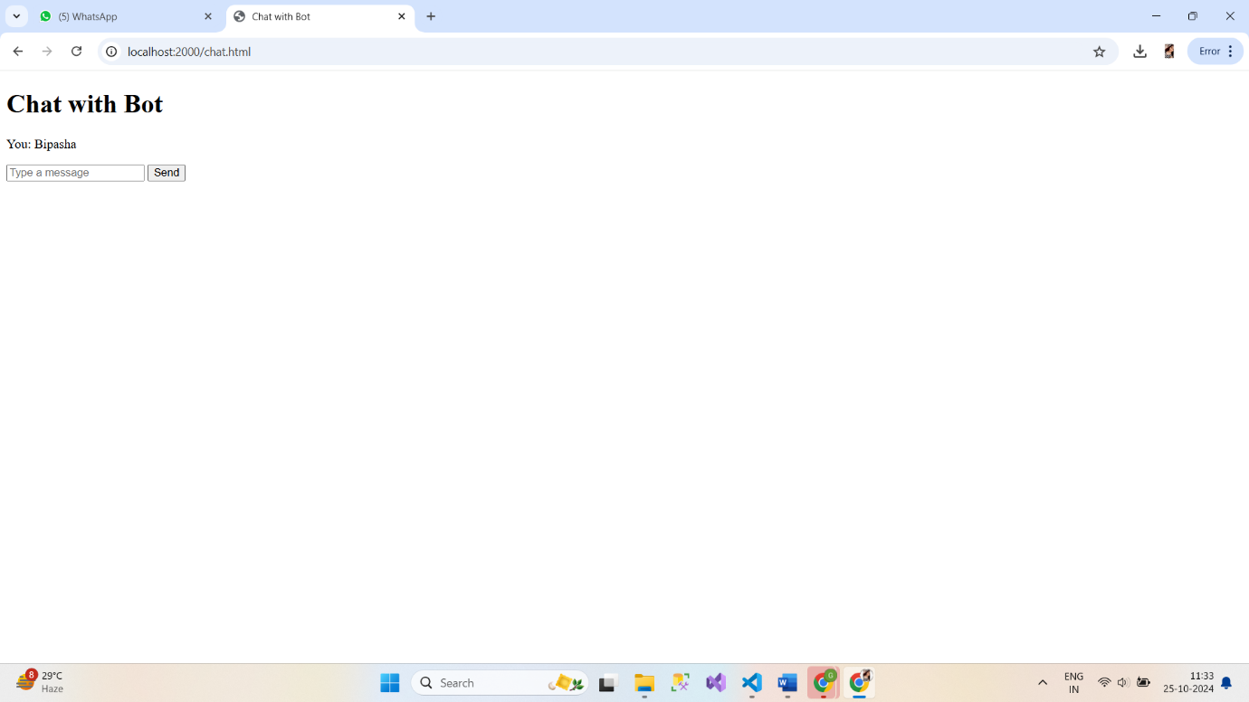

**5. Write a program to create a compressed zip file for a folder.**

**file1.txt**

Hello, Bipasha!

**file2.txt**

This is a test file.

**zipFolder.js**

const fs = require('fs-extra');

const archiver = require('archiver');

function zipFolder(sourceFolder, outPath) {

    const output = fs.createWriteStream(outPath);

    const archive = archiver('zip', {

        zlib: { level: 9 } // Set the compression level

    });

    output.on('close', () => {

        console.log(`ZIP file created: ${outPath} (${archive.pointer()} total bytes)`);

    });

    archive.on('error', (err) => {

        throw err;

    });

    archive.pipe(output);

    archive.directory(sourceFolder, false); // Include all files in the folder

    archive.finalize();

}

// Example usage

const folderToZip = 'example-folder'; // Change this to the folder you want to zip

const outputZipPath = 'output.zip'; // Name of the output zip file

zipFolder(folderToZip, outputZipPath);

**output.zip**

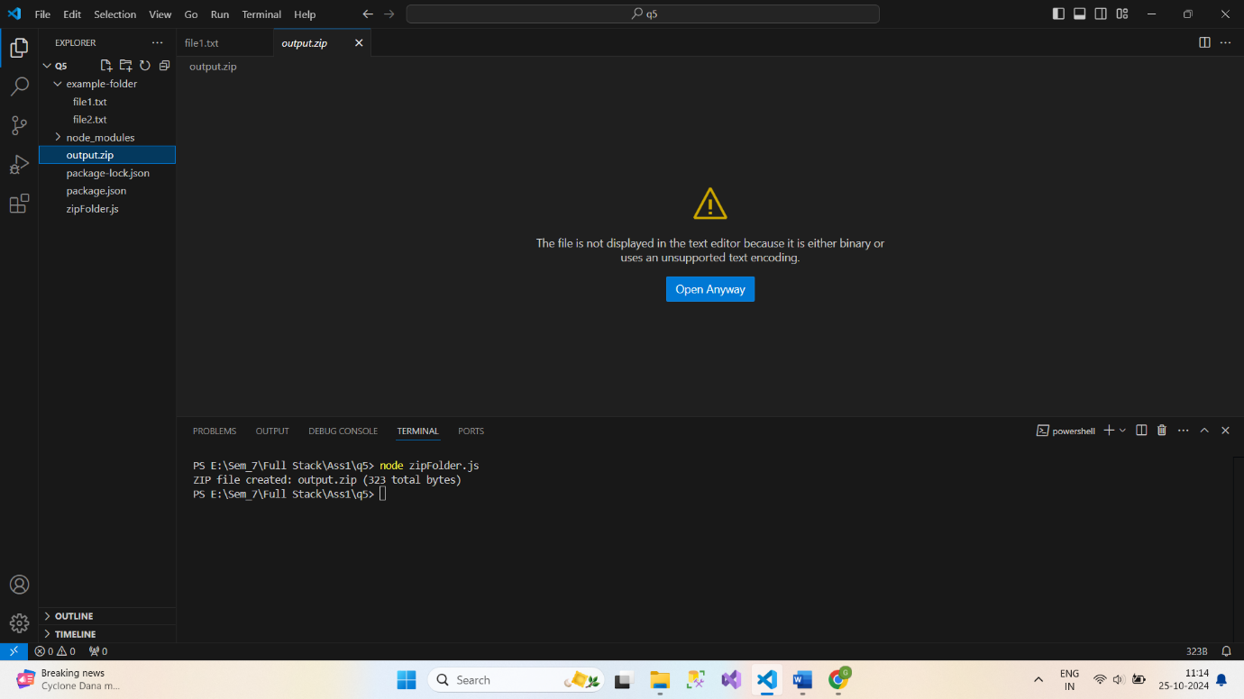

**6. Write a program to extract a zip file.**

**file1.txt**

Hello, Bipasha!

**file2.txt**

This is a test file.

**extractZip.js**

// extractZip.js

const fs = require('fs');

const unzipper = require('unzipper');

function extractZip(zipFilePath, outputFolder) {

    fs.createReadStream(zipFilePath)

        .pipe(unzipper.Extract({ path: outputFolder }))

        .on('close', () => {

            console.log(`Extraction completed: ${outputFolder}`);

        })

        .on('error', (err) => {

            console.error(`Error during extraction: ${err.message}`);

        });

}

// Example usage

const zipFilePath = '../q5/output.zip'; // Adjust the path if needed

; // Change this to the path of your zip file

const outputFolder = 'extracted-files'; // Folder where extracted files will be saved

extractZip(zipFilePath, outputFolder);

**Output :-**

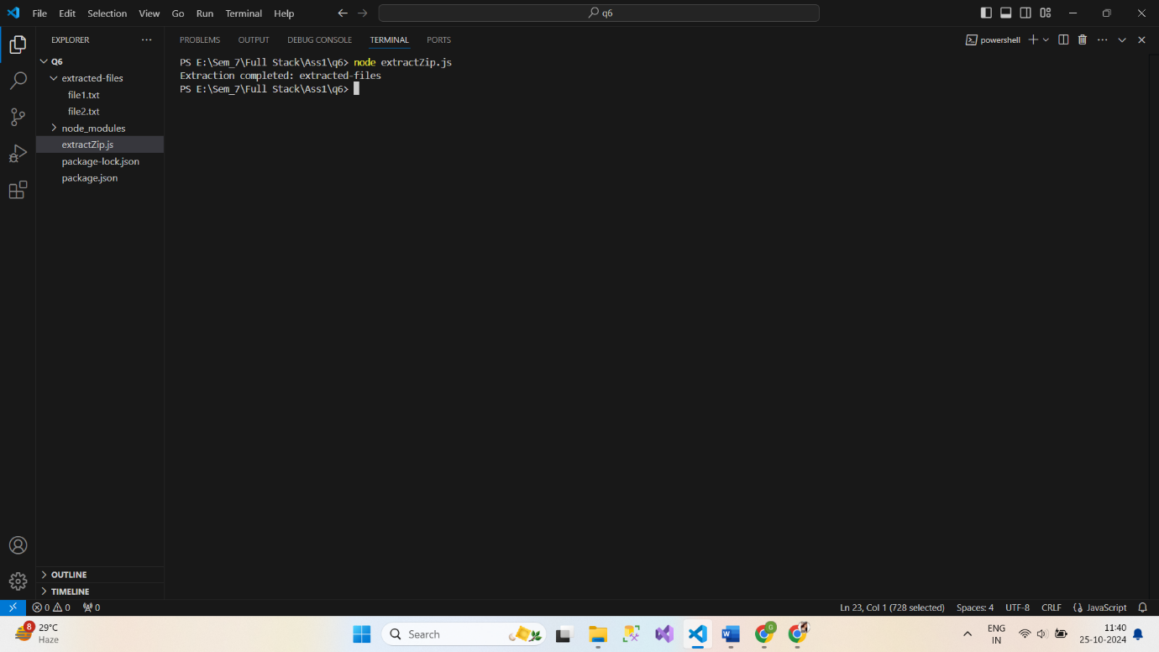

**7. Write a program to promisify fs.unlink function and call it.**

**promisifiedUnlink.js**

const fs = require('fs');

const util = require('util');

// Promisify the fs.unlink function

const unlink = util.promisify(fs.unlink);

// Function to delete a file

async function deleteFile(filePath) {

    try {

        await unlink(filePath);

        console.log(`File deleted: ${filePath}`);

    } catch (err) {

        console.error(`Error deleting file: ${err.message}`);

    }

}

// Example usage

const fileToDelete = 'test.txt'; // Change this to the file you want to delete

// Create a test file for demonstration

fs.writeFileSync(fileToDelete, 'This is a test file.');

deleteFile(fileToDelete);

**Output :-**

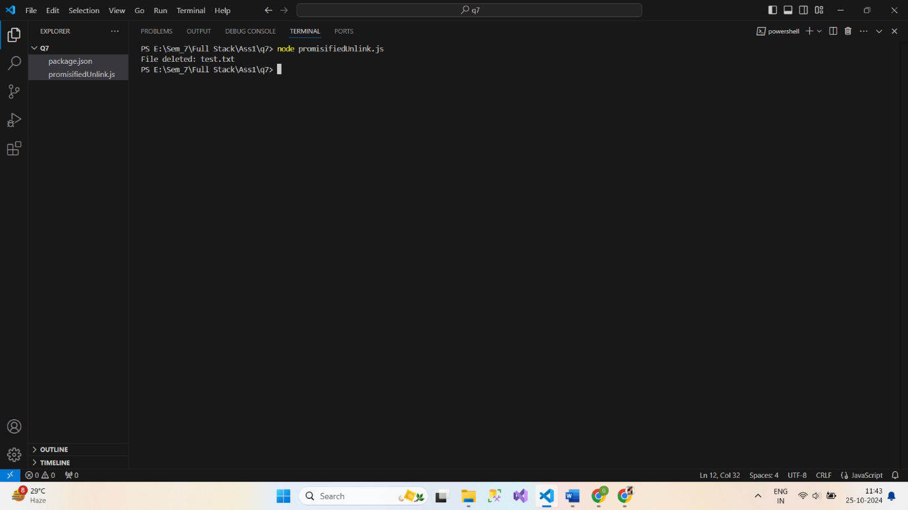

**8. Fetch data of google page using note-fetch using async-await model.**

**fetchGoogle.js**

import fetch from 'node-fetch';

import * as cheerio from 'cheerio'; // Use named import

async function fetchGooglePage() {

    try {

        const response = await fetch('https://www.google.com');

        if (!response.ok) {

            throw new Error(`HTTP error! Status: ${response.status}`);

        }

        const data = await response.text();

        const $ = cheerio.load(data);

        // Example: Get the title of the page

        const title = $('title').text();

        console.log(`Title: ${title}`);

        // Example: Get the first link

        const firstLink = $('a').first().attr('href');

        console.log(`First link: ${firstLink}`);

    } catch (error) {

        console.error(`Error fetching Google page: ${error.message}`);

    }

}

fetchGooglePage();

**Output :-**

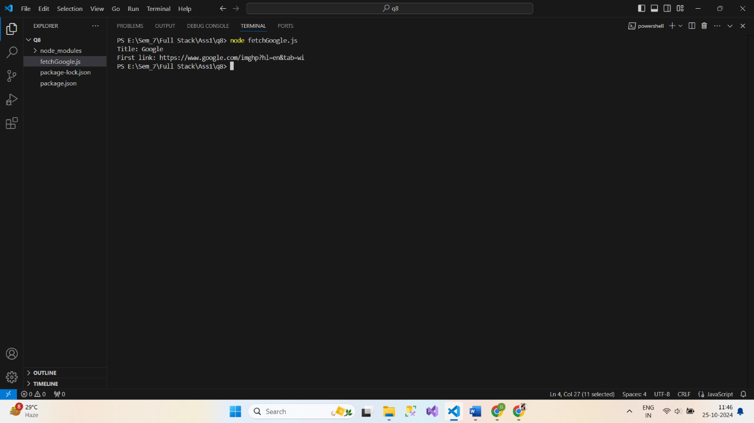

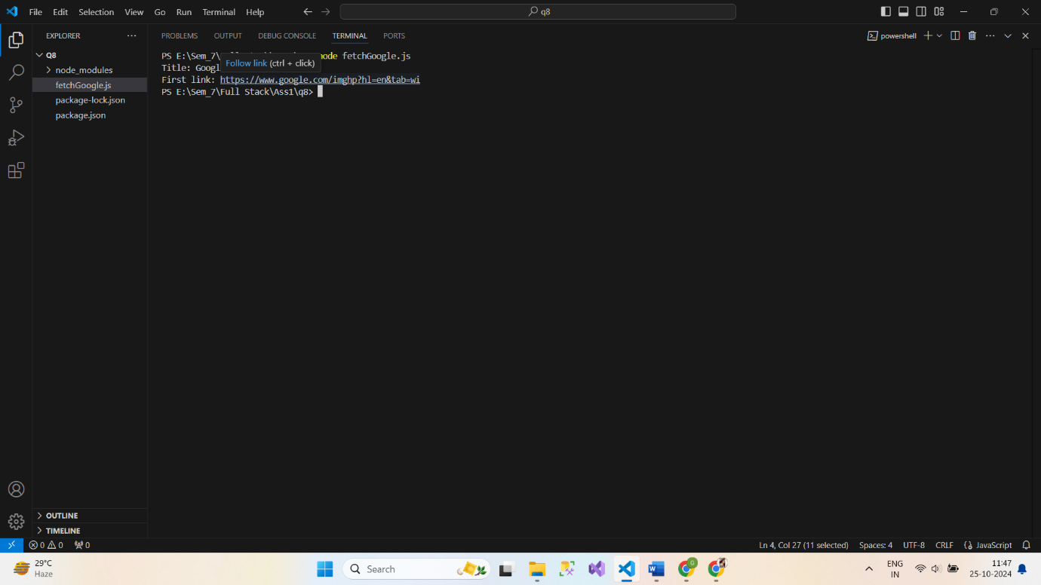

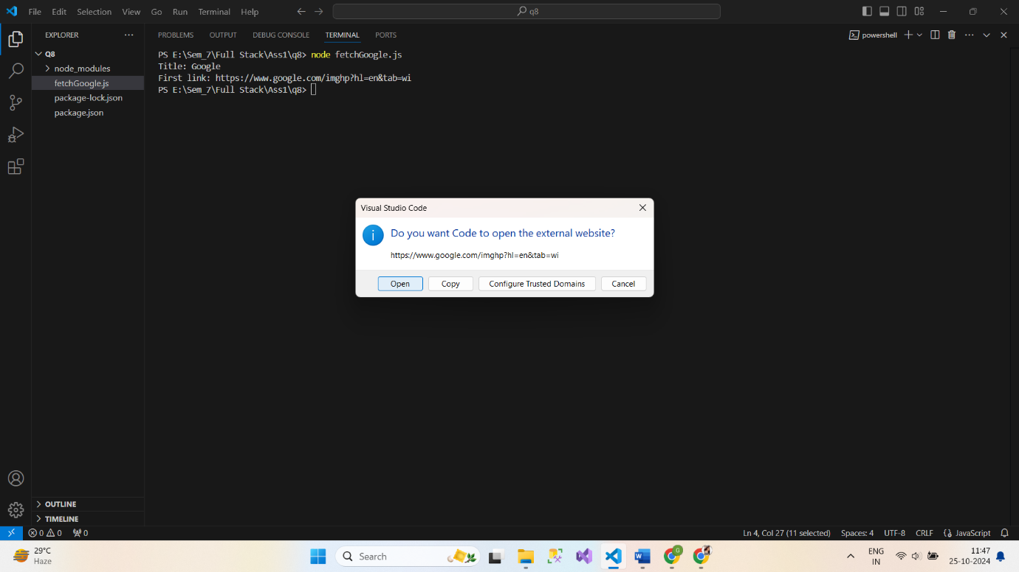

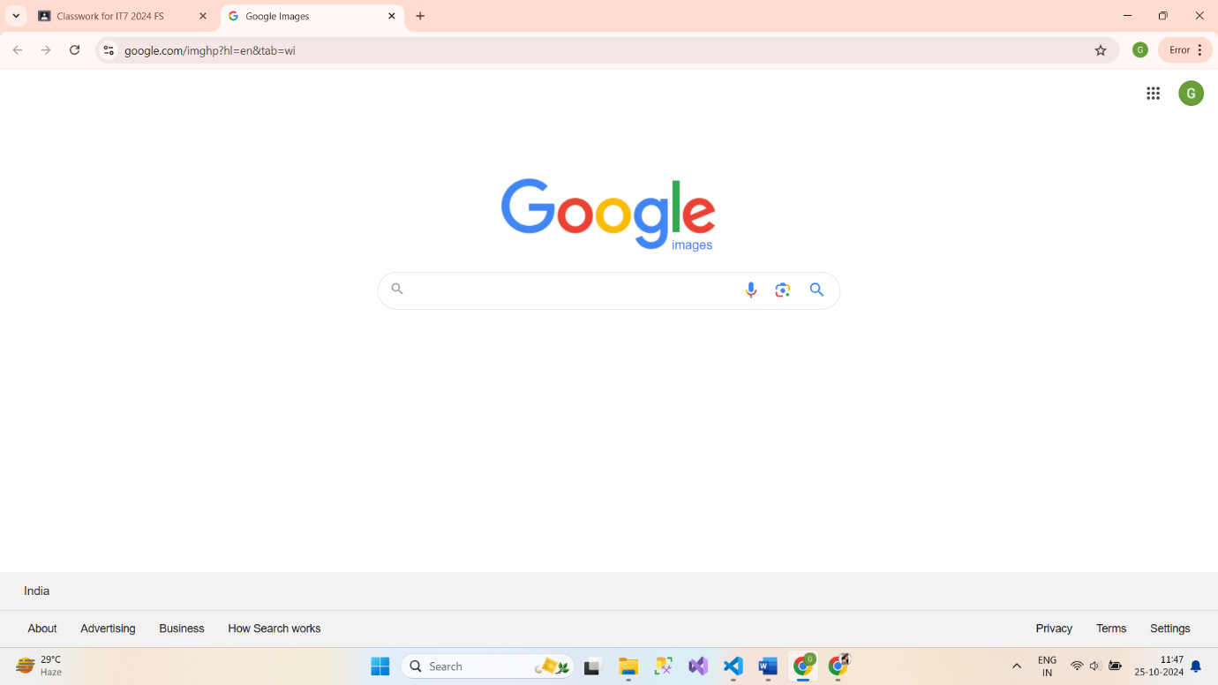

**9. Write a program that connect Mysql database, Insert a record in employee table and**

**display all records in employee table using promise based approach.**

**app.js**

const mysql = require('mysql2/promise');

const dbConfig = {

    host: 'localhost',

    user: 'yourUsername',

    password: 'yourPassword',

    database: 'company'

};

async function connectDB() {

    const connection = await mysql.createConnection(dbConfig);

    console.log('Connected to the database.');

    return connection;

}

async function insertEmployee(connection, name, position, salary) {

    const query = 'INSERT INTO employee (name, position, salary) VALUES (?, ?, ?)';

    await connection.execute(query, [name, position, salary]);

    console.log('Employee record inserted.');

}

async function displayEmployees(connection) {

    const [rows] = await connection.execute('SELECT * FROM employee');

    console.log('Employee Records:');

    console.table(rows);

}

async function main() {

    const connection = await connectDB();

    try {

        await insertEmployee(connection, 'Bipasha Gosai', 'Developer', 60000);

        await displayEmployees(connection);

    } catch (error) {

        console.error('Error:', error);

    } finally {

        await connection.end();

        console.log('Connection closed.');

    }

}

main();

**10. Set a server script, a test script and 3 user defined scripts in package.json file in your nodejs**

**application.**

**script1.js**

console.log('This is user-defined script 1.');

**script2.js**

console.log('I am Gosai Bipasha.');

**script3.js**

console.log('IT Student at VNSGU.');

**server.js**

import express from 'express';

const app = express();

const PORT = 3000;

app.get('/', (req, res) => {

    res.send('Hello Bipasha!');

});

app.listen(PORT, () => {

    console.log(`Server is running on http://localhost:${PORT}`);

});

**Output :-**

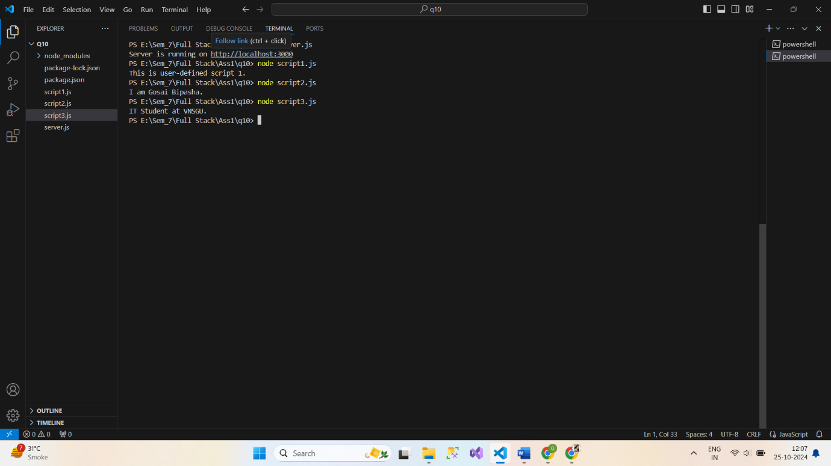

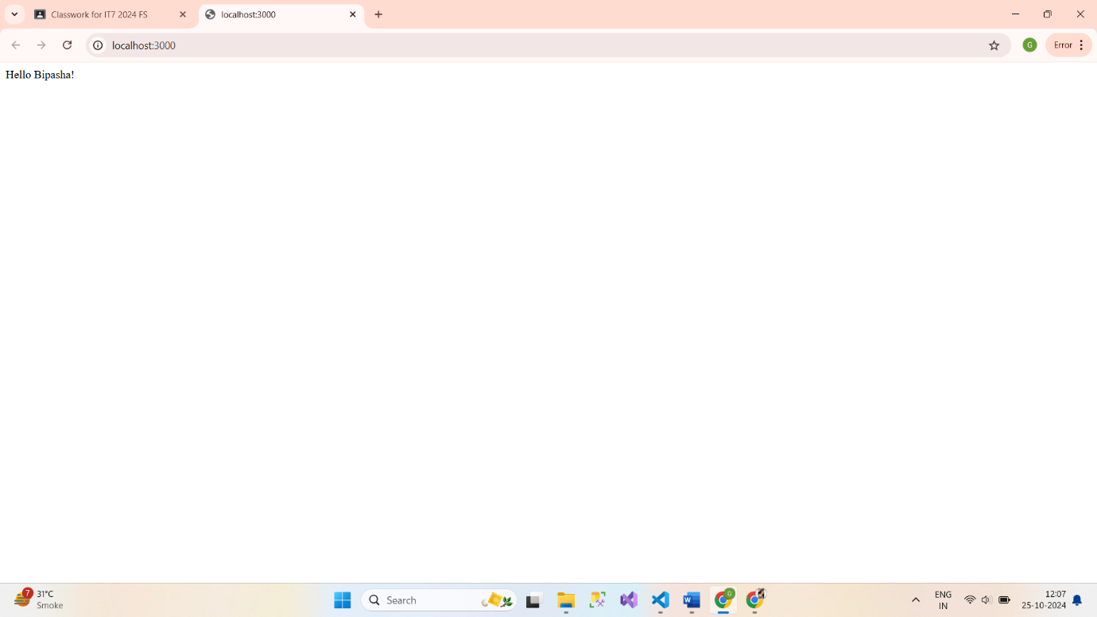

**11. Develop an application to show live cricket score.**

**server.js**

// server.js

const express = require('express');

const app = express();

const PORT = process.env.PORT || 8000;

// Set EJS as the templating engine

app.set('view engine', 'ejs');

// Serve static files

app.use(express.static('public'));

// Sample static cricket scores

const scores = [

    {

        series: { name: 'IPL 2023' },

        team1: { name: 'Team A' },

        team2: { name: 'Team B' },

        status: 'Team A: 100/5 (18.0 overs) - Team B: 155/2 (17.0 overs) - Team B won by 8 wickets'

    },

    {

        series: { name: 'ODI Series' },

        team1: { name: 'Team C' },

        team2: { name: 'Team D' },

        status: 'Team C: 198/10 (40.0 overs) - Team D: 201/3 (35.0 overs) - Team D won by 7 wickets'

    }

];

// Home route

app.get('/', (req, res) => {

    res.render('index');

});

// Scores route

app.get('/scores', (req, res) => {

    res.render('scores', { scores });

});

// Start the server

app.listen(PORT, () => {

    console.log(`Server is running on http://localhost:${PORT}`);

});

**index.ejs**

<!DOCTYPE html>

<html lang="en">

<head>

    <meta charset="UTF-8">

    <meta name="viewport" content="width=device-width, initial-scale=1.0">

    <title>Live Cricket Score</title>

</head>

<body>

    <h1>Welcome to Live Cricket Score</h1>

    <a href="/scores">View Live Scores</a>

</body>

</html>

**scores.js**

<!DOCTYPE html>

<html lang="en">

<head>

    <meta charset="UTF-8">

    <meta name="viewport" content="width=device-width, initial-scale=1.0">

    <title>Live Cricket Scores</title>

    <style>

        body {

            font-family: Arial, sans-serif;

            margin: 20px;

        }

        table {

            width: 100%;

            border-collapse: collapse;

            margin-top: 20px;

        }

        th, td {

            padding: 12px;

            text-align: left;

            border-bottom: 1px solid #ddd;

        }

        th {

            background-color: #f2f2f2;

        }

        tr:hover {

            background-color: #f5f5f5;

        }

        h1 {

            color: #333;

        }

    </style>

</head>

<body>

    <h1>Live Cricket Scores</h1>

    <a href="/">Back to Home</a>

    <table>

        <thead>

            <tr>

                <th>Series</th>

                <th>Teams</th>

                <th>Status</th>

            </tr>

        </thead>

        <tbody>

            <% if (scores.length > 0) { %>

                <% scores.forEach(match => { %>

                    <tr>

                        <td><%= match.series.name %></td>

                        <td><%= match.team1.name %> vs <%= match.team2.name %></td>

                        <td><%= match.status %></td>

                    </tr>

                <% }) %>

            <% } else { %>

                <tr>

                    <td colspan="3">No live matches at the moment.</td>

                </tr>

            <% } %>

        </tbody>

    </table>

</body>

</html>

**Output:-**

