Testing:

Step 1:
These killer Sudoku puzzles have been taken from the examples provided in the specification.

9by9:

The following shows the solved 9 by 9:
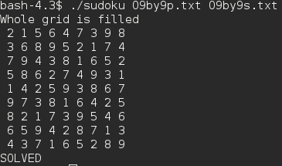

The following shows an Invalidsol:

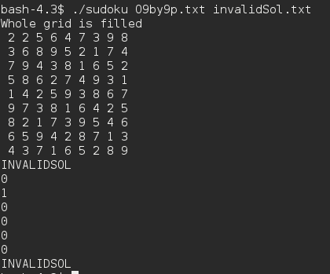

The following shows an Invalidproblem:

The following shows an Incomplete solution file:
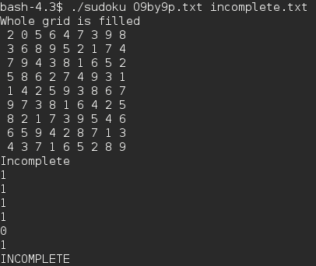

4by4:

The following shows the solved 4by4:
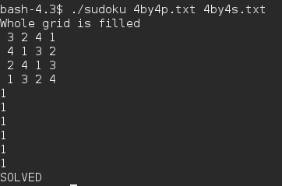

The following shows an Invalidsol:
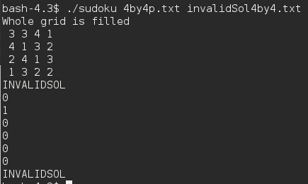

The following shows an Invalidproblem:

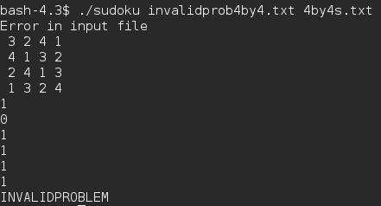

The following shows an Incomplete 4by4 solution file:
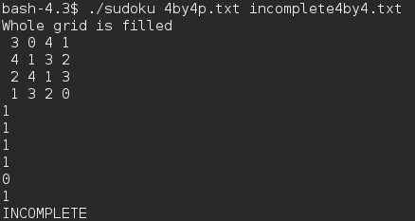

Step 2:

9by9 Solved by the solver:
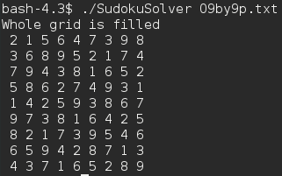

4by4 Solved by the solver:
