CONTENTS

* Introduction

1. Objectives
2. Applications
3. Components

* Methodology
* Literature Review
* Feasibility
* Outputs, Problems Faced and Limitations
* Conclusion

Introduction

A digital clock is a type of clock that displays the time using digits rather than traditional clock hands. It's commonly seen on electronic devices like smart phones, computers, and alarm clocks. It refers to a circuit or component that generates a continuous, synchronized signal to mark the passage of time. It is typically built using digital logic gates and operates by producing a series of pulses at a specific frequency. These pulses are used to synchronize the operation of various digital circuits or devices.

Objective:

This project aims to design and implement a digital clock using a combination of electronic components such as decade counters, basic logic gates, BCD to seven segment decoder, and a seven segment display. The clock system is asynchronous decade counters to count the clock pulse and logic gates to control the display time on the seven segment display. The BCD to seven segment decoder is used to convert the binary coded decimal output of the counters to appropriate signals for the seven segment display. The end result is a fully functional digital clock that can be used to accurately display the time.

Applications:

• It is used to display time in digital format.

• Timekeeping in homes and offices.

• Stopwatches.

• Automotive display.

• Alarm and times.

• Industrial control systems.

Components used:

1. Logic gates
2. Decade counter
3. Frequency Generator
4. BCD to seven segment display
5. Seven segment display
6. Multism simulator

1. Logic Gates:

There are several basic logic gates used in performing operations in digital systems. The common ones are

* OR Gate
* AND Gate
* NOT Gate
* XOR Gate

Additionally, these gates can also be found in a combination of one or two. Therefore, we get other gates, such as NAND Gate, NOR Gate, EXOR Gate and EXNOR Gate.

**AND gate**

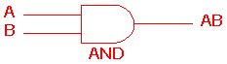 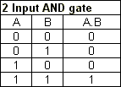

The AND gate is an electronic circuit that gives a **high** output (1) only if **all** its inputs are high.  A dot (.) is used to show the AND operation i.e. A.B.  Bear in mind that this dot is sometimes omitted i.e. AB

**OR gate**

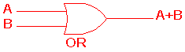 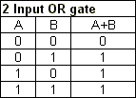

The OR gate is an electronic circuit that gives a high output (1) if **one or more** of its inputs are high.  A plus (+) is used to show the OR operation.

**NOT gate**

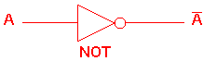 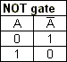

The NOT gate is an electronic circuit that produces an inverted version of the input at its output.  It is also known as an *inverter*.  If the input variable is A, the inverted output is known as NOT A.  This is also shown as A', or A with a bar over the top, as shown at the outputs. The diagrams below show two ways that the NAND logic gate can be configured to produce a NOT gate. It can also be done using NOR logic gates in the same way.

http://www.ee.surrey.ac.uk/Projects/CAL/digital-logic/gatesfunc/graphics/NOT.gif

**NAND gate**

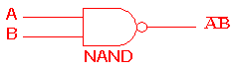 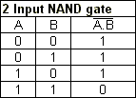

This is a NOT-AND gate which is equal to an AND gate followed by a NOT gate.  The outputs of all NAND gates are high if **any** of the inputs are low. The symbol is an AND gate with a small circle on the output. The small circle represents inversion.

**NOR gate**

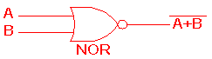 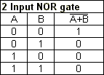

This is a NOT-OR gate which is equal to an OR gate followed by a NOT gate.  The outputs of all NOR gates are low if **any** of the inputs are high.

The symbol is an OR gate with a small circle on the output. The small circle represents inversion.

2. BCD or Decade Counter:

A decade counter is a binary counter designed to count to 1001 (decimal 9).A binary coded decimal (BCD) is a serial digital counter that counts ten digits. And it resets for every new clock input. As it can go through 10 unique combinations of output, it is also called as “Decade counter”. A BCD counter can count 0000, 0001, 0010, 1000, 1001, 1010, 1011, 1110, 1111, 0000, and 0001 and so on.

A 4 bit binary counter will act as decade counter by skipping any six outputs out of the 16 (24) outputs. There are some available ICs for decade counters which we can readily use in our circuit, like 74LS90. It is an asynchronous decade counter.

[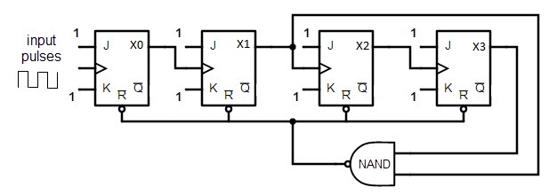](https://www.electronicshub.org/wp-content/uploads/2015/08/BCD-or-Decade-counter-circuit.jpg)

The above figure shows a decade counter constructed with JK flip flop. The J output and K outputs are connected to logic 1. The clock input of every flip flop is connected to the output of next flip flop, except the last one.

The output of the NAND gate is connected in parallel to the clear input ‘CLR’ to all the flip flops. This ripple counter can count up to 16 i.e. 24.

BCD to Seven Segment Decoder:

BCD to 7-segment display decoder is a special decoder which can convert binary coded decimals into another form which can be easily displayed through a 7-segment display. In Binary Coded Decimal (BCD) encoding scheme each of the decimal numbers (0-9) is represented by its equivalent binary pattern (which is generally of 4-bits).Seven segment display does not work by directly supplying voltage to different segments of LEDs. First, our decimal number is changed to its BCD equivalent signal then BCD to seven segment decoder converts that signals to the form which is fed to seven segment display.

This BCD to seven segment decoder has four input lines (A, B, C and D) and 7 output lines (a, b, c, d, e, f and g), this output is given to seven segment LED display which displays the decimal number depending upon inputs.

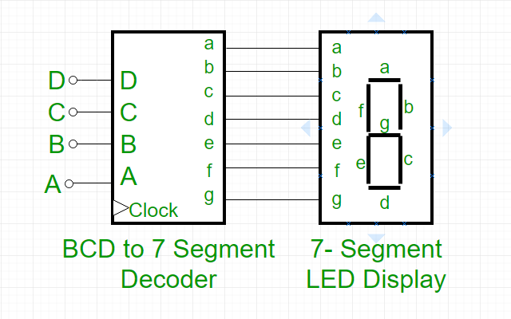

**Truth Table –** For common cathode type BCD to seven segment decoder :

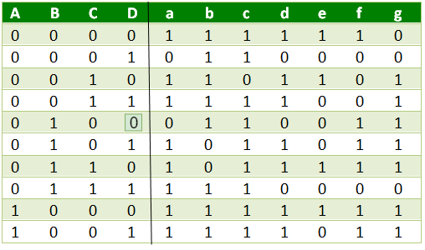

4. Seven Segment Display:

Seven segment displays were created to display decimal numerals. With its 7 segments, the display can show numbers from 0 to 9. Additionally, they can also display upper case letters A, C, E, F and lower-case letters b and d.

Seven segment displays are the output display device that provides a way to display information in the form of images or text or decimal numbers which is an alternative to the more complex dot matrix displays. It is widely used in digital clocks, basic calculators, electronic meters, and other electronic devices that display numerical information. It consists of seven segments of light-emitting diodes (LEDs) which are assembled like numerical 8.

### https://media.geeksforgeeks.org/wp-content/uploads/20200413202717/Untitled-Diagram-2111.png

The number 8 is displayed when the power is given to all the segments and if you disconnect the power for ‘g’, then it displays the number 0. In a seven-segment display, power (or voltage) at different pins can be applied at the same time, so we can form combinations of display numerical from 0 to 9. Since seven-segment displays cannot form alphabets like X and Z, so it cannot be used for the alphabet and they can be used only for displaying decimal numerical magnitudes. However, seven-segment displays can form alphabets A, B, C, D, E, and F, so they can also be used for representing  each display unit is usually has a dot point (DP).  The display point could be located either towards the left or towards the right of the display pattern. This type of pattern can be used to display numerals from 0 to 9 and letters from to F hexadecimal digits.  The truth table is given below:

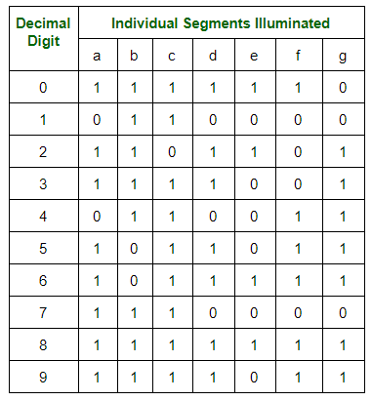

5. The Frequency Generator:

A frequency generator is one of a class of electronicdevices that generates electrical signals with set properties of amplitude, frequency, and wave shape. These systems are mainly used for testing, signal tracing, debugging, troubleshooting, amplifier response adjustment, etc. There is a variety of signal generators available in the market where each type includes modulation and amplitude property. So the output of the signal generator can be changed through setting its amplitude as well as frequency in the simulation process. Some frequency generator can generate a single frequency, while others can generate a range of frequencies or even a sweep of frequency.

6.Multisim simulator:

Multisim software is based on the process of modeling a real phenomenon with a set of mathematical formulas. It is, essentially, a program that allows the user to observe an operation through simulation without actually performing that operation. Multisim software combines SPICE simulation and circuit design into an environment optimized to simplify common design tasks, which helps to improve performance, minimize errors, and shorten time to prototype. The software allows users to design and simulate electronic circuits before building them in real life. Users can create and test circuit designs, analyze circuit behavior, and debug designs using variety of simulation tools.

3. Working of the Digital Clock:

Above figure is the simulated circuit of a working digital clock. It consists of 6 decade counters, 6 seven segment displays and 6 decoders for respective counter with one clock or frequency operation. The anode type displays are connected to a power supply at each display respectively which display the output of each counters and decoders are used to decode the outputs/signal pulse from counter. This display clock generally displays the hours, seconds and minutes for which they are categorized in three parts connected together using logic gates for simulated circuit to work.

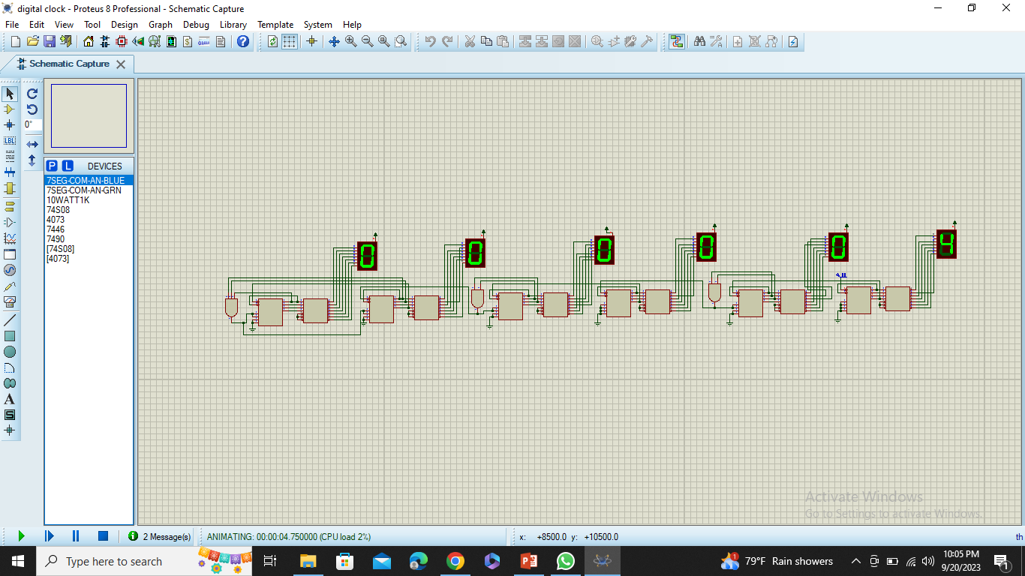

Second: In this part of simulation, the second counter count upto 59 and then again reset for the next clock pulse in next clock cycle. The counter restarts to count as it counts 60 for which the output for 60 i.e. (high pulse) generated through are passed for resetting through the input for logical gate i.e. (AND) gate and as a clock pulse for the minutes.

Minutes: It is also a similar process as for the second. The terminal given for resetting is passed as a clock pulse for the

minute in a counter which counts for 59 and gives output on a display increases by 1 as its previous counter complete 59 count in seconds. Now as it counts 59 then the counter is supplied a input for reset for the signal of 6 high through dual anal AND gates.

Hours: In the simulation for hours the counter must count from 00 to 12 for 12 hours. Digital clock for which the second digital counter must count upto 2 only if first counter count 1 else it count from 0 to 9 for which the clock pulse is supplied from previous counter of minute as minute counter count 59. The hours circuit counts from 0 to 12 only after that it again goes for reset by supplying the output from logic gate for required counts and complete the one rotation and the process goes on.

4. Feasibility:

Feasibility is an evaluation of a proposed project or system to determine if it is technically and economically viable. The purpose of the feasible test is to determine whether the project is worth pursuing, based on a number of factors such as.

The project is technically feasible due to the following reasons:

• The wide availability of components and tools.

• Easy to design and develop a digital clock

•Easy to operate

• The use of digital logic gates and other basic electronic components can

be used to create a simple digital logic clock circuit.

5. Outputs and Problem faced:

We achieve a digital clock that can accurately keep track of time and display it on a screen or display. We get a design that meets the safety and regulatory standards and the desired aesthetic and usability requirements.

During the project some of the problems occurred like difficulty designing desired aesthetic and design, difficulty in creating user-friendly environment, difficulty in achieving accurate time keeping and integrating with other systems and devices. These problems were solved by re designing and testing (termed as testing and debugging) process.

Conclusion

Designing a digital clock requires technical skills. The main objective is to create functional, accurate, user-friendly device. The design of the clock was lengthy and rewarding process. We used everything that we have learned throughout this class to put it together. Overcoming technical challenges, meeting safety standards and scalability, we designed a digital clock that has been tested and successfully implemented. In general, this project has been successfully carried out and satisfies the overall aim and objectives of the project. In this project, we learned time management and teamwork.