FARWESTERN UNIVERSITY
A
Project Proposal
On
Digital Nagarik Wadapatra

For the partial fulfillment of requirements for the Degree of Bachelor in Science of
Computer Science and Information Technology
Submitted to:
Central Department of CSIT
Submitted by:
Bibek Mishra (6)
Bipin Bohara (8)
Dev raj Bhatt (10)
Kiran Chaudhary (19)
Muskan Giri (21)
BSc. CSIT, 6th Semester

DECLARATION

We, Bibek Mishra, Bipin Bohara, Dev Raj Bhatt, Kiran Chaudhary and Muskan Giri students of BSC CSIT 6th, Far Western University central department of csit, hereby declare that the project work entitled “My Digital Nagarik Wodapatra” is the original place of work under the supervision of Mr. Parkash Saud, Department of CSIT and submitted in the partial fulfillment of the requirements of BSC CSIT program.

…………………. ……………………
Bibek Mishra Bipin Bohara
(***********) (*********)
Date: --- Date: -----

…………………. …………………….
Dev Raj Bhatt Kiran Chaudhary
(21535018) (**********)
Date: 18-Feb-2025 Date: 18-Feb-2025

………………….
Muskan Giri
(*******)
Date:-------------

ACKNOWLEDGEMENT
Any achievement, be it scholastic or otherwise does not depend solely on the individual efforts but on the guidance, encouragement and cooperation of intellectuals, elders and friends. We would like to take this opportunity to thank them all.
First of all, we would like to thank the FWU for providing us with all the necessary requirements for our project.
We are grateful to acknowledge the guidance and encouragement that has been given to us by Mr. Parkash Saud, Lecturer, Department of CSIT, FWU, who has rendered a valuable assistance and guidance.
We also extend our thanks to the entire faculty of the Department of BSC CSIT, FWU, Kanchanpur, who have encouraged us throughout the course of the project.
Last, but not the least, we would like to thank our family and friends for their inputs to improve the project.

Group Members:

Bibek Mishra | 0000000
Bipin Bohara | 000000000
Dev Raj Bhatt  Kiran Chaudhary  Muskan Giri | 0000000  0000000  0000000

CERTIFICATE

This is to certify that the project report entitled “Digital Nagarik Wodapatra” is a report of the work carried out by “Bibek Mishra, Bipin Bohara, Dev Raj Bhatt, Kiran Chaudhary” under the guidance and supervision of Mr. Parkash Saud for the partial fulfillment of degree of BSC CSIT.

To the best of our knowledge and belief, this work embodies the work of candidates themselves, has duly been completed, fulfils the requirement of the ordinance relating to the Bachelor degree of the university and is up to the standard in respect of content, presentation and language for being referred to the examiner.

Mr. Parkash Saud | MR. Karn Dev bhatt
Ass. Prof., Department of CSIT | HOD, Department of CSIT
FWU | FWU
Mahendranagar, Kanchanpur | Mahendranagar, Kanchanpur
……….……………… | ………………….
Signature | Signature

………………………...

Signature of External

ABSTRACT

My Digital Nagarik Wodapatra is the project, which aims in developing a digitalized system designed to streamline and manage the daily operations of urban administration, including event planning, budget tracking, public notices, and waste management. My Digital Nagarik Wodapatra system is envisioned to transform urban management by leveraging advanced technologies to ensure efficient, transparent, and secure operations. The system will include an admin login feature, allowing administrators to monitor and oversee the entire system effectively. Key features of the Digital Nagarik Wodapatra include the ability to insert data, search data, and display data across various modules such as events, budgets, notices, and waste management. After analyzing the current challenges faced by urban administrators, we recognized the need for a user-friendly interface, as many users may have only basic computer knowledge .This system will serve as a comprehensive platform to foster better communication, resource management, and community engagement within the city.

Table of Contents
CHAPTER 1 1
INTRODUCTION 1
1.1 Introduction 1
1.2 Problem specification 1
1.3 Objective 1
CHAPTER 2 2
METHODOLOGY 2
2.1 Introduction of Methodology 2
2.1.1 Requirement Analysis 2
2.1.2 Feasibility Study 3
2.1.2.1 Economic Feasibility 3
2.1.2.2 Technical Feasibility 3
2.1.2.3 Operational Feasibility 4
2.1.2.4 Legal Feasibility 4
2.1.2.5 Schedule Feasibility 5
2.1.3 System analysis 6
2.1.4 System design 6
2.1.4.1 System Flow Chart 7
2.1.4.2 Er-Diagram 8
2.1.4.3 Server Architecture 9
2.1.4.4 Developed Modules 10
2.1.5 System Testing 14
2.1.6 System Implementation 14
2.1.7 System Maintenance 14
CHAPTER 3 15
ADVANTAGES AND DELIVERABLES 15
3.1 Advantages 15
3.2 Deliverables 15
CONCLUSION
REFERENCES

CHAPTER 1

INTRODUCTION

1.1 Introduction
The project entitled “Digital Nagarik Wodapatra” is a small computer-based web application designed to streamline and enhance urban administration processes. This software package is tailored to address key areas of city management, including event planning, budget tracking, public notices, and waste management. The Digital Nagarik Wodapatra system is developed to manage urban activities systematically, enabling administrators to plan events, allocate budgets, issue public notices, and monitor waste management efficiently .The Digital Nagarik Wodapatra application allows users to insert, search, across various modules. It also provides features to generate reports on urban activities, track financial transactions, and maintain a record of all operations. A special feature of the system is its ability to record every transaction accurately and provide a simple, user-friendly interface. This ensures that even users with minimal technical expertise can navigate and utilize the system effectively.

1.2 Problem specification
- Limited public engagement and feedback mechanisms.
- Poor monitoring and management of waste collection.
- Time consuming.
- No visibility to budget transparency.
- Lack of efficiency.

1.3 Objective
- To provide citizens with a single platform for municipal information and services happening in their locality.

CHAPTER 2

METHODOLOGY

2.1 Introduction of Methodology
We follow the system development life cycle approach to complete this project. This system phase is organized in a linear order. To develop this project, we follow the stage of this approach.
February 18, 2024is present day .
Requirement analysis
Feasibility study
System design
System Development
System Testing
System implementation
Maintenance

Fig 2.1: Waterfall model for software development

2.1.1 Requirement Analysis
In this project, we will discuss and analyze the developing process of the Patient Management System including software requirement specification (SRS) and comparison between the existing and proposed system and within the predefined budget. It is used to identify the necessary improvements needed in the project plan.

2.1.2 Feasibility Study
The feasibility study is the initial stage of any project, which brings together the elements of knowledge that indicate if a project is possible or not. The main goal of feasibility is to determine whether the proposed project is worth pursuing. The study determines two fundamental categories: cost and benefit. As the name implies, a feasibility analysis is used to determine the visibility of an idea, such as ensuring a project is legally and technically feasible as well as economically justifiable. So in this phase, we study economic feasibility, technical feasibility, schedule feasibility and we also study legal feasibility.

2.1.2.1 Economic Feasibility
Economic feasibility is the cost and logistical outlook for a project. In this study, we analysed the cost needed that has been needed to develop this project.
_{S .N.} | Components | Price
1. | Planning and Research | 4500
2. | Development cost | 7,500
3. | Procurement | 8,000
4. | Internet | 5000
5. | Documentation | 1000
6. | Other stationary | 1000
 | Total | 27,000

Table 2.1.2.1: Economical Feasibility

2.1.2.2 Technical Feasibility
Technical feasibility is concerned with the technical area of the system. The technical area can be classified into two section-hardware and software. To decide the technical feasibility, we use the hardware and software components as follows:

2.1.2.2.1 Requirement for development of project

2.1.2.2.1.1 Hardware Requirement
- Processor: Intel, Ryzen CPU.
- RAM: At least 8 GB RAM.
- Hard Disk: At least 30 GB.
- Minimum Screen Resolution (1200x 720)

2.1.2.2.1.2 Software Requirement
- Visual Studio Code.
- Xampp

2.1.2.2.2 Requirement for installing the project
- Processor Intel CPU.
- RAM: At least 8 GB RAM.
- Hard Disk: At least 5 t0 10 GB.
- Windows Operating System

2.1.2.3 Operational Feasibility
Operational feasibility examines whether the proposed method can fix it with existing operations or easy to operate with a modified system. After providing the proper training to the real user of software, it is then feasible to operate “My Digital Nagarik Wodapatra”.

2.1.2.4 Legal Feasibility
My Digital Nagarik Wodapatramust comply with several legal requirements, including copyright law, priority law, data protected law, accessibility law. Medicals must ensure that they are obtaining appropriate permission and licences for copyright materials, protecting patron's personal information making the system accessible to all patrons and complying with any contractual obligation.

2.1.2.5 Schedule Feasibility
This project schedule has been designed as per the requirements and constraints involved. This project is scheduled to be completed in about 4 months. In this feasibility, we study the time taken to complete to analysis, planning, designing, coding, and testing of documentation and final presentation.
ACTIVITIES | Nov | December |  |  | January |  |  | February
ACTIVITIES | week  1-2 | week  1 | week  2 | week  3-4 | week  1 | week  2-3 | week  4 | week  1-2 | week  3-4
Project analysis
Proposal submission
proposal defense
Feasibility study
Designing
Coding
midterm
defense
Testing
Integration
Final testing
Documentation
Final Defense

Table 2.1.2.5: Schedule Feasibility

2.1.3 System analysis
In this phase, we analysis about the system in field of the My Digital Nagarik Wodapatra and we have seen some drawbacks in this system .Therefore, to overcome the drawback of this system also to add some new features, we have analysis about our new system.

2.1.4 System design
In this phase we can design the general concept or flow of our system. We study about the stakeholder related to the My Digital Nagarik Wodapatra. The conceptual design of this system is as below.

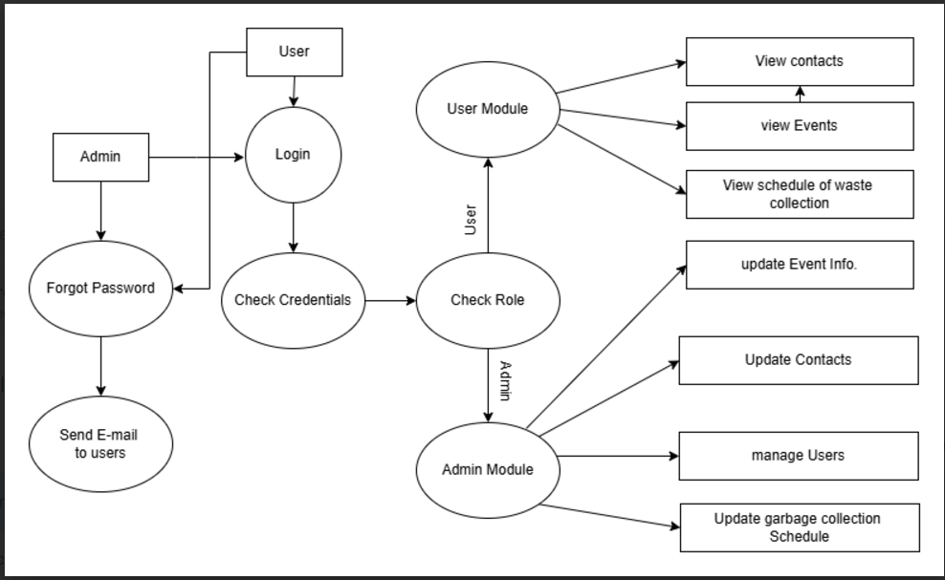

Fig 2.1.4: System Design

2.1.4.1 System Flow Chart

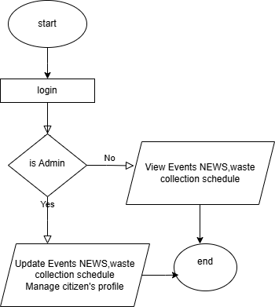
Fig 2.1.4.1:Flow Chart

2.1.4.2 Er-Diagram

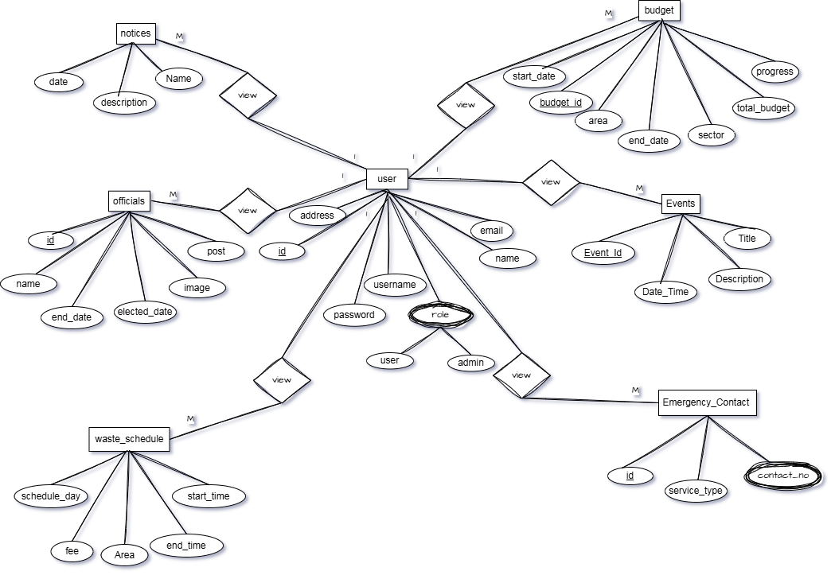
Fig 2.1.4.2: ER Diagram

2.1.4.3 Server Architecture

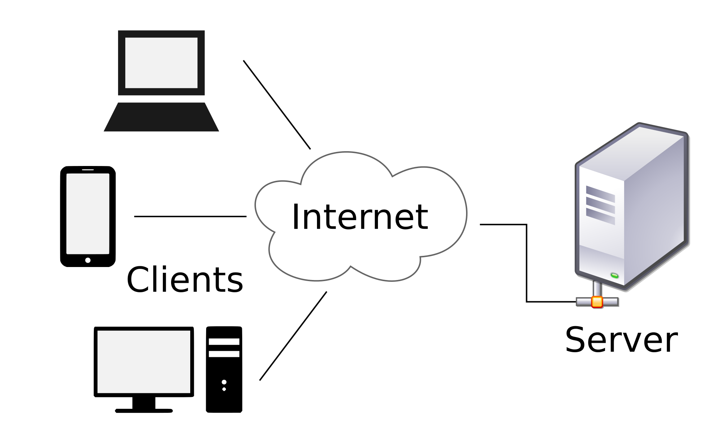

Fig 2.1.4.3: Client Server Architecture

2.1.4.4 Developed Modules
2.1.4.4.1 Front module


2.1.4.4.2 About us module
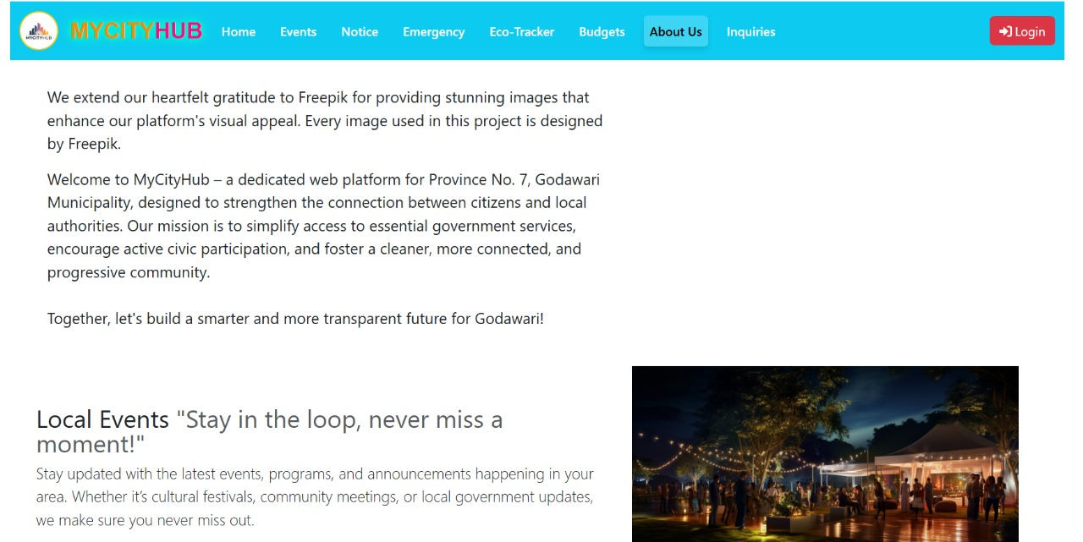

2.1.4.4.3 Events module
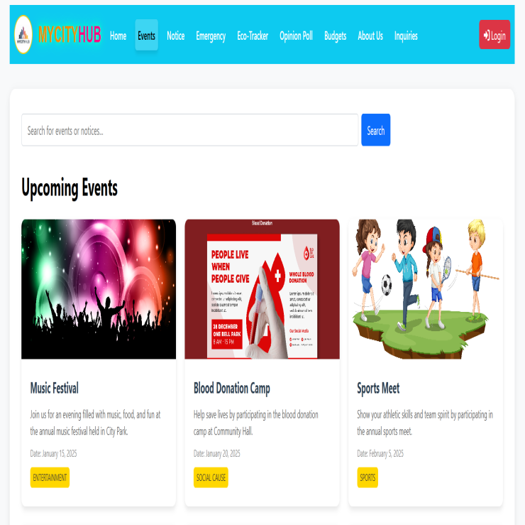

2.1.4.4.4 Notices module
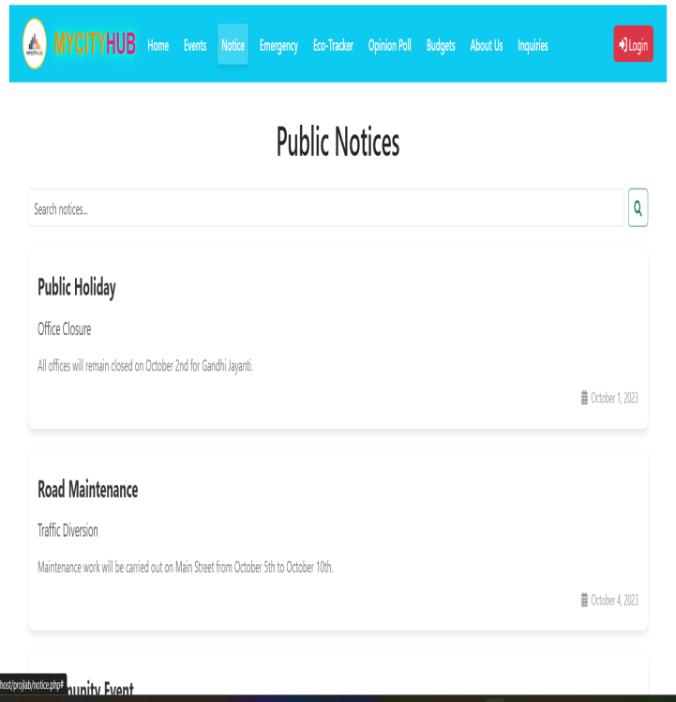

2.1.4.4.5 Budget Transparency module
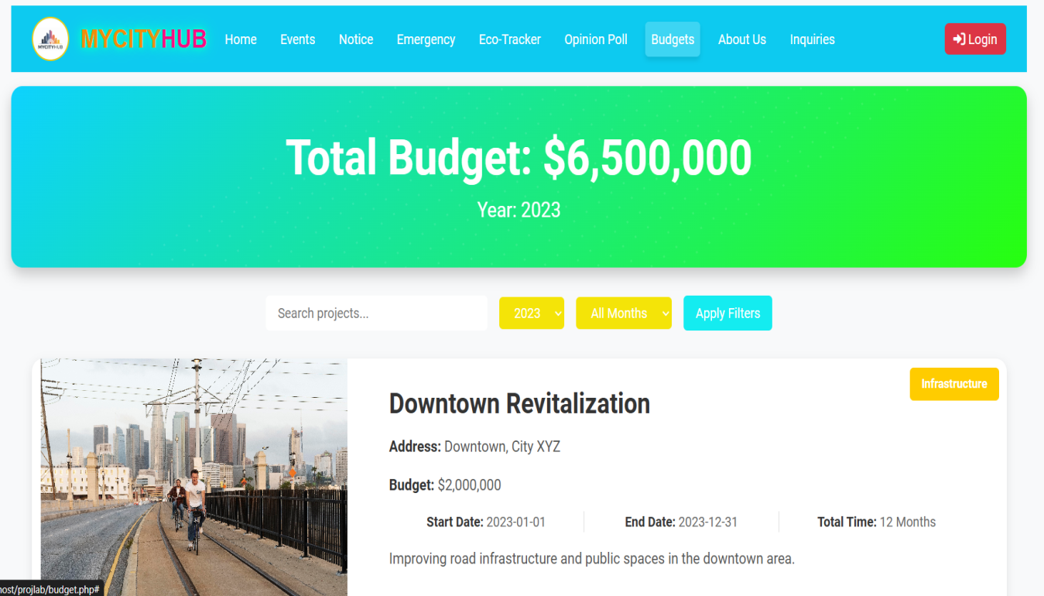

2.1.4.4.6 Eco-Tracker module
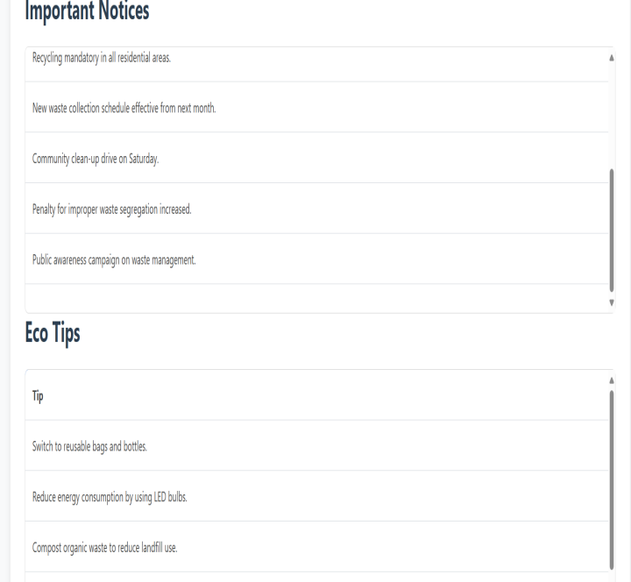
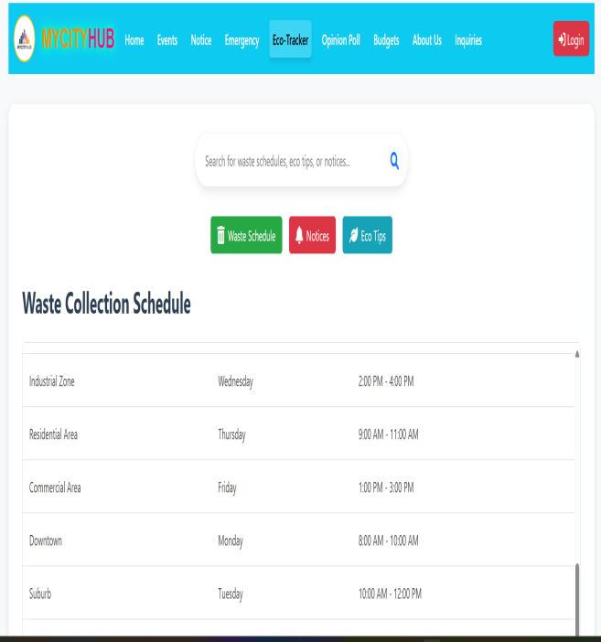

2.1.4.4.7 Inquiries module
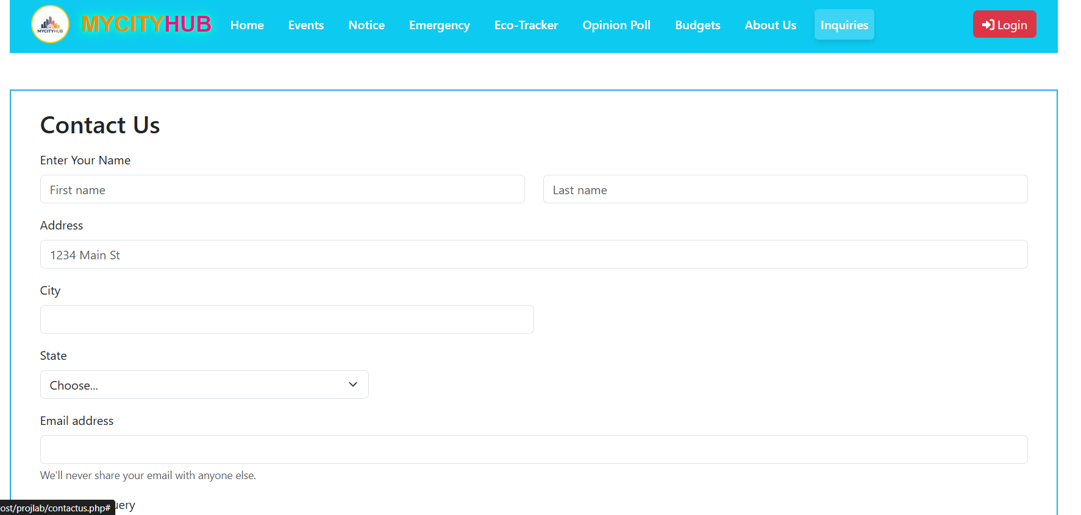

2.1.4.4.8 Login module
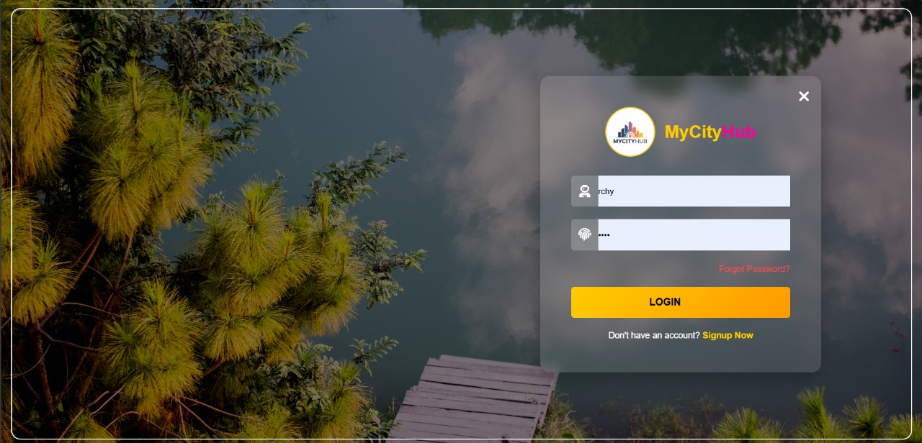

2.1.5 System Testing
Software testing is the process of evaluation of a software item to detect differences between given input and expected output. This system is tested as white box testing because we know source code and test the logic of the code and internal design of the code. Also aware of how does it works.

2.1.6 System Implementation
It is the process of using the project in client’s computer after the executive file has been created, the project is copied from saved source to any secondary device. This system has implemented in our secondary device. But we haven’t implemented in others user device yet.

2.1.7 System Maintenance
Program maintenance is the technique of updating, alerting or correcting the existing program. This system takes 60% effort maintenance. In the further days we will maintain the system as it required. Now this system is worth for perform task and no maintenance is required.

CHAPTER 3

ADVANTAGES AND DELIVERABLES

3.1 Advantages
- User-friendly Interface.
- Improved Efficiency.
- Enhanced Transparency.
- Digital base system.
- Better Public Engagement.

3.2 Deliverables
- Project report
- Source code via email.

CONCLUSION

The Digital Nagarik Wodapatra system aims to digitalize urban administration processes to reduce human errors and enhance the efficiency of managing events, budgets, notices, and waste management. By providing a centralized platform for input and output records, the system ensures transparency and accessibility in urban operations. It also facilitates better planning and organization of city-related activities, improving overall public service delivery. While there are numerous advanced systems and software available in the market with exceptional user interfaces and experiences, the primary goal of this project is to apply our foundational knowledge in web development technologies, such as PHP, to create a functional and straightforward Digital Nagarik Wodapatra system. By utilizing fundamental PHP syntax and techniques, we aim to demonstrate our ability to develop a practical and efficient system for urban management, even with limited resources. This project serves as a testament to our learning and problem-solving capabilities in the field of software development.

REFERENCES

[1] | Government of Maldives, "One Government Portal," One.gov.mv. Available: https://one.gov.mv/. [Accessed: Nov. 15, 2024].
[2] | Dhangadhi Municipality, "Dhangadhi Municipality Official Website," Dhangadhimun.gov.np. Available: https://www.dhangadhimun.gov.np/en. [Accessed: Dec. 2, 2024].
[3] | Nagarjun Municipality, "Nagarjun Municipality Official Website," Nagarjunmun.gov.np. Available: https://nagarjunmun.gov.np/. [Accessed: Nov 27, 2024].

