DATABASE MANAGEMENT PROJECT

NAME: BIPIN PRASAD BIHARI

21CSB0B09

Topic: ADVANCED PHARMACY MANAGEMENT SYSTEM

# Problem Statement: -

As the Pandemic was there, it is not safe to buy medicines by going to the pharmacy shop at this time. So, we also provide online service to order medicines and trying to deliver them Using Drones So That Human contact can be Reduced. Along with that Consultation with doctors is also very difficult at this time. Therefore, we provide service to Consult with the doctors online.

Design A Data-Base to Manage the **Advanced Pharmacy system** with these Additional services?

# ER Diagram:

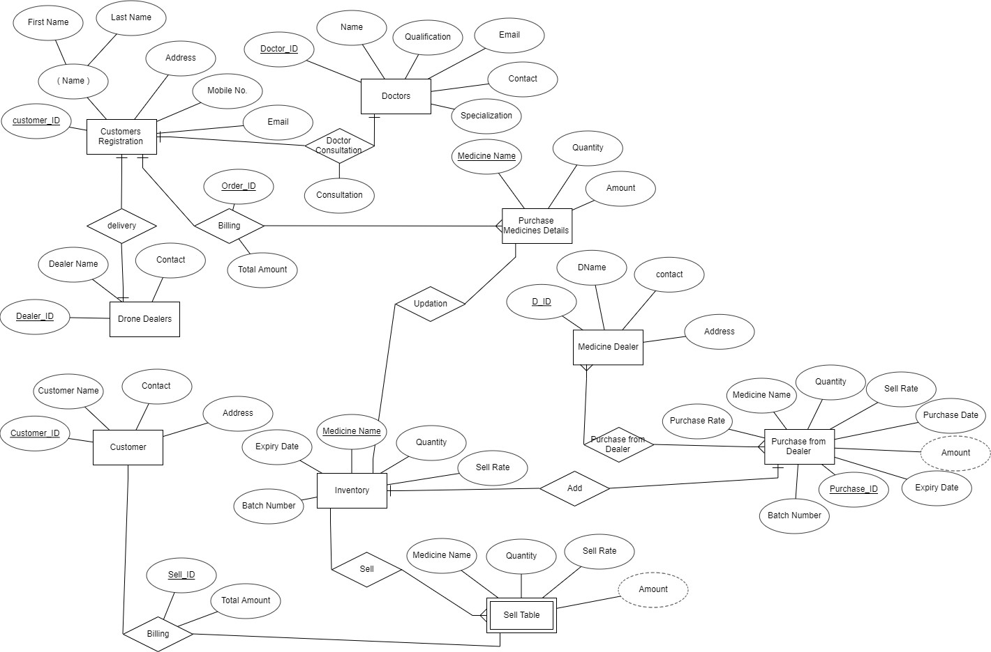

ASSUMPTIONS:-

1. Customer_Registration table is used to store the data of Online customers.
2. Customer Table is used to store the data of Offline Customers.
3. Inventory table is used to store the data of Currently Available Medicines with their Quantity.

# Schema:-

DOCTOR(Doctor_ID(PK),Name,Email,Contact,Specialization,Qualification,customer_ID(FK)) Customer_Registration(customer_ID(PK),FirstName,LastName,Address,Mobile No. , Email) Purchase_Medicines_Details(MedicineName(PK),Quantity,Amount,cutomer_ID(FK),order_ID(FK),Me dicine Name(FK))

Billing(order_ID,TotalAmount,customer_ID(FK))

Drone Dealers(Dealer_ID(PK),Dealer Name,Contact, customer_ID(FK)) Medicine Dealer(D_ID(PK),DName,Contact,Address)

Purchase from Dealer(D_ID(FK),Purchase_ID(FK))

Purchase Medicines Data(Purchase_ID(Pk),Quantity,PurchaseRate,SellRate,Purchase Date, Expiry Date ,Batch Number,Medicine Name(FK))

Inventory(Medicine Name(PK),Quantity,Expiry Date, Batch Number,Sell Rate) Sell Table(Quantity,SellRate,Customer_ID(FK),Medicine Name(FK),Sell_ID(FK)) Customer(Customer_ID(PK),Customer Name,Contact, Address) Billing(sell_ID(PK),TotalAmount,Customer_ID(FK))

# Relational Schema:-

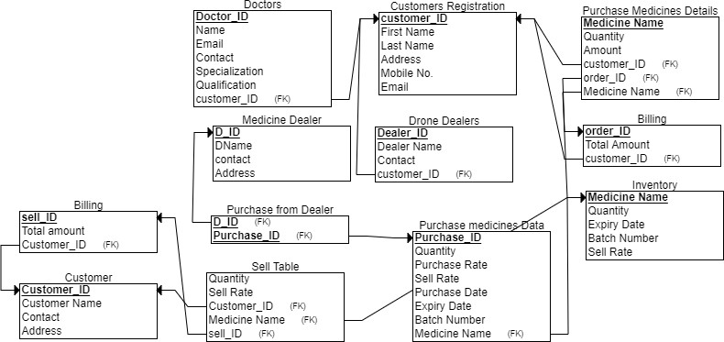

**Normalisation:-**

1. DOCTOR(Doctor_ID(PK),Name,Email,Contact,Specialization,Qualification,customer_ID(FK)) Doctor_ID -> Name

Doctor_ID ->Email Doctor_ID ->Contact Doctor_ID ->Specialisation Doctor_ID ->Qualification

Email -> Contact

Candidate Key – Doctor_ID

This is in 1NF,2NF but not in 3NF.

Doctor_ID -> Email and Email -> Name

Email is a non-prime Attribute that’s why it’s not in 3NF

Doctor1(Doctor_ID(PK),Specialization,Qualification,customer_ID(FK)) This is in 3NF form

Doctor2(Email(PK), Contact) This is in 3NF form

1. Customer_Registration(customer_ID(PK),FirstName,LastName,Address,Mobile No. , Email) Customer_ID -> Name

Customer_ID ->Address

Customer_ID ->Mobile No. Customer_ID ->Email

Candidate Key –Customer_ID This is in 1NF,2NF and 3NF.

1. Purchase_Medicines_Details(MedicineName(PK),Quantity,Amount,customer_ID(FK),order_ID(FK

),Medicine Name(FK))

Medicine_Name -> Quantity Medicine Name ->Amount Medicine Name ->customer_ID Medicine Name ->order_ID

Candidate key – Medicine Name This in 1NF,2NF and 3NF

1. Billing(order_ID,TotalAmount,customer_ID(FK)) Order_ID -> Total Amount

Order_ID ->customer_ID Candidate key – order_ID This is in 1NF ,2NF and 3NF.

1. Drone Dealers(Dealer_ID(PK),Dealer Name,Contact, customer_ID(FK))

Dealer_ID -> Dealer Name Dealer_ID -> Contact Customer_ID ->Dealer_Name

Candidate key – Dealer_ID

This is in 1NF ,2NF but not in 3NF.

Drone Dealers1(Dealer_ID(PK),DealerName,Contact) Drone Dealers2(Customer_ID,Dealer_ID)

1. Medicine Dealer(D_ID(PK),DName,Contact,Address) D_ID ->D_Name

D_ID -> Contact D_ID -> Address

Candidate key – D_ID

This is in 1NF , 2NF and 3NF.

1. Purchase from Dealer(D_ID(FK),Purchase_ID(FK)) D_ID ->Purchase_ID

Candidate key – D_ID

This is in 1NF,2NF and 3NF.

1. Purchase Medicines Data(Purchase_ID(Pk),Quantity,PurchaseRate,SellRate,Purchase Date, Expiry Date ,Batch Number,Medicine Name(FK))

Purchase_ID -> Quantity Purchase_ID -> Purchase Rate Purchase_ID -> Sell Rate Purchase_ID -> Purchase Date Purchase_ID ->Expiry_Date Purchase_ID -> Batch Number Purchase_ID -> MedicineName Medicine_Name ->Quantity Medicine Name -> Sell Rate Medicine Name -> Expiry Date Purchase Date ->Purchase_ID

Candidate Key – Purchase_ID,(Medicine Name,Purchase Date) This is in 1NF ,2NF but not in 3NF.

Purchase Medicines Data1(Purchase_ID(Pk),Purchase Date)

Purchase Medicines Data2(Medicine Name(PK),Sell Rate,ExpiryDate,Batch Number,) Now These are in 3NF

1. Inventory(Medicine Name(PK),Quantity,Expiry Date, Batch Number,Sell Rate)

Medicine Name ->Quantity Medicine Name -> Expiry Date Medicine Name -> Batch Number Medicine Name -> Sell Rate

This is in 1NF ,2NF and 3NF.

1. Sell Table(Quantity,SellRate,Customer_ID(FK),Medicine Name(FK),Sell_ID(FK)) Customer_ID->Sell_ID

Medicine Name -> Sell Rate Medicine Name -> Quantity

Candidate keys – Medicine Name ,Customer_ID This is not in 2NF.

Sell Table1(Quantity,SellRate,Customer_ID(FK),Medicine Name(FK))

Sell Table2(Customer_ID(FK),Sell_ID(FK)) This is in 3NF.

1. Customer(Customer_ID(PK),Customer Name,Contact, Address)

Customer_ID ->customer_Name Customer_ID -> Contact Customer_ID -> Address

Candidate key – Customer_ID. This in 1NF,2NF and 3NF.

1. Billing(sell_ID(PK),TotalAmount,Customer_ID(FK))

Sell_ID -> Total Amount Sell_ID ->customer_ID

Candidate key – Sell_ID This is in 1NF ,2NF and 3NF.

# Create Tables SQL Commands:

CREAľE ľABḺE C"stomcís_Rcgistíatio⭲ (

Iiíst_Namc :aíckaí2(20) NOľ NUḺḺ, Ḻast_Namc :aíckaí2(20),

Addícss :aíckaí2(40),

Mobilc_No. ⭲"mbcí(10) NOľ NUḺḺ,

Email :aíckaí2(20) NOľ NUḺḺ, c"stomcí_IK INľ NOľ NUḺḺ,

PRIMARY KEY (c"stomcí_IK)

);

CREAľE ľABḺE C"stomcí (

C"stomcí_Namc :aíckaí2(20) NOľ NUḺḺ,

Co⭲tact_ :aíckaí2(20) NOľ NUḺḺ,

Addícss :aíckaí2(20) , C"stomcí_IK INľ NOľ NUḺḺ,

PRIMARY KEY (C"stomcí_IK)

);

CREAľE ľABḺE Mcdici⭲c_Kcalcí (

KNamc :aíckaí2(20) NOľ NUḺḺ,

co⭲tact ⭲"mbcí(10) NOľ NUḺḺ,

Addícss :aíckaí2(20) NOľ NUḺḺ,

K_IK INľ NOľ NUḺḺ,

PRIMARY KEY (K_IK)

);

CREAľE ľABḺE I⭲:c⭲toíQ (

Mcdici⭲c_Namc :aíckaí2(20) NOľ NUḺḺ,

Q"a⭲titQ INľ NOľ NUḺḺ, ExpiíQ_Katc Katc NOľ NUḺḺ, Batck_N"mbcí INľ NOľ NUḺḺ, Scll_Ratc INľ NOľ NUḺḺ,

PRIMARY KEY (Mcdici⭲c_Namc)

);

CREAľE ľABḺE Billi⭲g (

oídcí_IK INľ NOľ NUḺḺ, ľotal_Amo"⭲t INľ NOľ NUḺḺ, c"stomcí_IK INľ NOľ NUḺḺ,

PRIMARY KEY (oídcí_IK),

IOREIGN KEY (c"stomcí_IK) REIERENCES C"stomcís_Rcgistíatio⭲(c"stomcí_IK)

);

CREAľE ľABḺE Billi⭲g (

scll_IK INľ NOľ NUḺḺ, ľotal_amo"⭲t INľ NOľ NUḺḺ, C"stomcí_IK INľ NOľ NUḺḺ,

PRIMARY KEY (scll_IK),

IOREIGN KEY (C"stomcí_IK) REIERENCES C"stomcí(C"stomcí_IK)

);

CREAľE ľABḺE Koctoí1( Koctoí_IK INľ NOľ NUḺḺ,

Spccializatio⭲ :aíckaí2(20) NOľ NUḺḺ, Q"aliricatio⭲ :aíckaí2(20) NOľ NUḺḺ, C"stomcí_IK INľ NOľ NUḺḺ,

PRIMARY KEY(Koctoí_IK),

IOREIGN KEY(C"stomcí_IK) REIERENCES C"stomcís_Rcgistíatio⭲(C"stomcí_IK)

);

CREAľE ľABḺE Koctoí2(

Email :aíckaí2(20) NOľ NUḺḺ, Co⭲tact INľ NOľ NUḺḺ, PRIMARY KEY (Email)

);

CREAľE ľABḺE Kío⭲c Kcalcís1( Kcalcí_IK INľ NOľ NUḺḺ,

Kcalcí Namc :aíckaí(20) NOľ NUḺḺ, Co⭲tact INľ NOľ NUḺḺ,

PRIMARY KEY (Kcalcí_IK)

);

CREAľE ľABḺE Kío⭲c Kcalcís2( C"stomcí_IK INľ NOľ NUḺḺ, Kcalcí_IK INľ NOľ NUḺḺ

);

CREAľE ľABḺE P"íckasc_Mcdici⭲cs_Kctails (

Mcdici⭲c_Namc :aíckaí2(20) NOľ NUḺḺ,

Q"a⭲titQ INľ NOľ NUḺḺ,

Amo"⭲t INľ NOľ NUḺḺ, c"stomcí_IK INľ NOľ NUḺḺ, oídcí_IK INľ NOľ NUḺḺ,

PRIMARY KEY (Mcdici⭲c_Namc),

IOREIGN KEY (c"stomcí_IK) REIERENCES C"stomcís_Rcgistíatio⭲(c"stomcí_IK),

IOREIGN KEY (oídcí_IK) REIERENCES Billi⭲g(oídcí_IK),

IOREIGN KEY (Mcdici⭲c_Namc) REIERENCES I⭲:c⭲toíQ(Mcdici⭲c_Namc)

);

CREAľE ľABḺE P"íckasc Mcdici⭲cs Kata1( P"íckasc_IK INľ NOľ NUḺḺ,

P"íckasc Katc KAľE NOľ NUḺḺ, PRIMARY KEY (P"íckasc_IK)

);

CREAľE ľABḺE P"íckasc Mcdici⭲cs Kata2( Mcdici⭲c Namc :aíckaí(20) NOľ NUḺḺ, Scll Ratc INľ NOľ NUḺḺ,

Expiíc Katc KAľE NOľ NUḺḺ, Batck N"mbcí INľ NOľ NUḺḺ, PíimaíQ KcQ(Mcdici⭲c Namc)

);

CREAľE ľABḺE Scll ľablc1( Q"a⭲titQ INľ NOľ NUḺḺ, Scll Ratc INľ NOľ NUḺḺ, C"stomcí_IK INľ NOľ NUḺḺ,

Mcdici⭲c Namc :aíckaí(20) NOľ NUḺḺ,

IOREIGN KEY(C"stomcí_IK) REIERENCES C"stomcí(C"stomcí_IK),

IOREIGN KEY (MEKICINE_NAME) REIERENCES INVENľORY(MEKICINE_NAME)

);

CREAľE ľABḺE Scll ľablc2( C"stomcí_IK INľ NOľ NUḺḺ, Scll_IK INľ NOľ NUḺḺ,

IOREIGN KEY(C"stomcí_IK) REIERENCES C"stomcí(C"stomcí_IK), IOREIGN KEY(Scll_IK) REIERENCES Billi⭲gs(Scll_IK)

);

CREAľE ľABḺE P"íckasc_ríom_Kcalcí (

K_IK INľ NOľ NUḺḺ,

P"íckasc_IK INľ NOľ NUḺḺ,

PRIMARY KEY (K_IK, P"íckasc_IK),

IOREIGN KEY (K_IK) REIERENCES Mcdici⭲c_Kcalcí(K_IK),

IOREIGN KEY (P"íckasc_IK) REIERENCES P"íckasc_mcdici⭲cs_Kata(P"íckasc_IK)

);

**Inserting Values In Tables:-**

cusotmer registration table InsertintoCustomers_Registrationvalues('christopher','comstock' ,'Wrngl’, ‘TS’, IND', 9871593584, 'comstock@gmail.com', 1);

insert into Customers_Registration values ('Harry', 'Styles', 'BZA,AP,IND',2541251253,'HarryStyles0102@gmail.com', 2); insert into Customers_Registration values ('Nail', 'Horan', 'Krnl,AP,IND',6985421580,'Nail0171@gmail.com', 3);

insert into Customers_Registration values ('Shawn', 'Mendes', 'Indore,MP,IND',5897415895,'ShawnMendes@yahoo.com', 4); insert into Customers_Registration values ('Taylor', 'Swift', 'Delhi,Delhi,IND',9894598720,'taylor@swifies.com', 5);

======================cusotmer table=====================

insert into cusotmer values('Olivia',9876589120,'BZA,AP,IND',1001); insert into cusotmer values('Rosee',9872389120,'Indore,MP,IND',1002);

insert into cusotmer values('Liam Payne',8976589120,'Ballarshah,Maharastra,IND',1003); insert into cusotmer values('Marshmello',9812389120,'BZA,AP,IND',1004);

insert into cusotmer values('Ryan Ronalds',9636589120,'chennai,TN,IND',1005); insert into cusotmer values('Selena',9876525890,'Ooty,kerala,IND',1006);

medicine dealer

insert into medicine_dealer values ('Rajat',9876543210,'Wrngl,TS,IND',2001); insert into medicine_dealer values ('Vamsi',9123453210,'Delhi,Delhi,IND',2002); insert into medicine_dealer values ('Vijay',9876599910,'chennai,TN,IND',2003); insert into medicine_dealer values ('Harsh',9874783210,'Indore,MP,IND',2004);

===========================inventory===========================

insert into inventory values ('Dolo 550',20,23-05-2024,3001,75); insert into inventory values ('baclofen',70,23-09-2026,3002,60); insert into inventory values ('Halcion',20,23-05-2024,3003,20);

insert into inventory values ('caffeine citrate solution-oral',55,05-10-2022,3004,44); insert into inventory values ('Jantoven',100,31-05-2031,3005,60);

insert into inventory values ('magaldrate-oral',40,08-07-2027,3006,150); insert into inventory values ('maraviroc',60,03-07-2026,3007,85);

insert into inventory values ('Odomzo',174,23-01-2030,3008,75); insert into inventory values ('ofloxacin',125,01-01-2027,3009,10);

billing table 1

insert into billing values (4001,50,2001); insert into billing values (4002,170,2002); insert into billing values (4003,88,2003); insert into billing values (4004,144,2004);

==========================billing table 2=============================

insert into billing values (5001,50,2001); insert into billing values (5002,170,2002); insert into billing values (5003,88,2003); insert into billing values (5004,144,2004);

doctor1 table

insert into doctor1 values (6001,'general therapy','MBBS',1); insert into doctor1 values (6001,'Eye specalist','MBBS',2); insert into doctor1 values (6001,'heart surgeory','MBBS',3); insert into doctor1 values (6001,'thort infection','MBBS',5);

=============================doctor2 table================================

insert into doctor2 values [(Vamsi0610@gmail.com,](mailto:(Vamsi0610@gmail.com) 974136850); insert into doctor2 values [(Vijay0411@gmail.com,](mailto:(Vijay0411@gmail.com) 974136850); insert into doctor2 values [(Rajat0212@gmail.com,](mailto:(Rajat0212@gmail.com) 974136850); insert into doctor2 values [(christopher19@gmail.com,](mailto:(christopher19@gmail.com) 974136850);

drone dealers1 table

insert into drone_dealers1 values (8001,'Tarun',0852 245 222); insert into drone_dealers1 values (8002,'Sam',0853 155 571); insert into drone_dealers1 values (8003,'Vakeel',0853 888 985); insert into drone_dealers1 values (8004,'Jaydev',0853 144 141); insert into drone_dealers1 values (8005,'Naveen',0852 114 545);

===========================drone dealers2===================================

insert into drone_dealers2 values (1,8002); insert into drone_dealers2 values (2,8003); insert into drone_dealers2 values (3,8004); insert into drone_dealers2 values (5,8005); insert into drone_dealers2 values (6,8001);

purchase medicine details

Insert into purchase_medicine_details values('Dolo550',20,100,1,4001,3001); Insert into purchase_medicine_details values(' baclofen ',10,200,1,4004,3002); Insert into purchase_medicine_details values(' maraviroc ',24,140,1,4003,3005); Insert into purchase_medicine_details values(' Odomzo ',30,230,1,4002,3003); Insert into purchase_medicine_details values(‘ofloxacin’,40,250,1,4000,3004);

purchase medicines data1

Insert into purchase_medicine_data1 values(101,27-04-2021); Insert into purchase_medicine_data1 values(102,24-04-2021); Insert into purchase_medicine_data1 values(107,21-03-2021); Insert into purchase_medicine_data1 values(104,22-03-2021); Insert into purchase_medicine_data1 values(103,27-04-2021);

purchase medicines data2

Insert into purchase_medicine_data2 values(‘baclofen’ ,12,27-04-2021,132414); Insert into purchase_medicine_data2 values(' maraviroc ',15,24-04-2021,549253); Insert into purchase_medicine_data2 values(' Odomzo ',20,21-03-2021,232412); Insert into purchase_medicine_data2 values(‘ofloxacin’,13,22-03-2021,432134); Insert into purchase_medicine_data2 values('Dolo550’,4,27-04-2021,452311);

Sell Table_1

Insert into Sell Table_1 values(30,12,4010,‘baclofen’); Insert into Sell Table_1 values(12,14,4002,‘Dolo 550’); Insert into Sell Table_1 values(14,17,4003,‘ Odomzo’); Insert into Sell Table_1 values(45,13,4001,‘ ofloxacin’);

Sell Table_2

Insert into Sell Table_2 values(4002,5001); Insert into Sell Table_2 values(4004,5005); Insert into Sell Table_2 values(4003,5008); Insert into Sell Table_2 values(4001,5007);

Purchase_from_Dealer Insert into Sell Table_1 values(2001,1); Insert into Sell Table_1 values(2003,2); Insert into Sell Table_1 values(2004,3); Insert into Sell Table_1 values(2005,4);