**Lab 1: Understanding Object-Relational Mapping (ORM) with Entity Framework Core**

**Objective**

To understand the fundamental concepts of Object-Relational Mapping (ORM) and how Entity Framework Core serves as a bridge between C# objects and relational database tables in a retail inventory management system context.

**Theoretical Questions and Detailed Answers**

**Question 1: What is Object-Relational Mapping (ORM)?**

**Answer:**  
Object-Relational Mapping (ORM) is a programming technique that creates a virtual object database that can be used from within a programming language. In the context of C# and .NET, ORM acts as a bridge between object-oriented programming concepts and relational database management systems.

**Key Components of ORM:**

* **Object Model:** Represents data as C# classes and objects
* **Relational Model:** Represents data as tables, rows, and columns in a database
* **Mapping Layer:** Translates between objects and relational data

**How ORM Works:**

1. **Class-to-Table Mapping:** Each C# class corresponds to a database table
2. **Property-to-Column Mapping:** Each property in a class maps to a column in the corresponding table
3. **Object-to-Row Mapping:** Each instance of a class represents a row in the database table
4. **Relationship Mapping:** Associations between classes (like foreign keys) are mapped to database relationships

**Example Mapping:**

C# Class: Product  
Properties: ProductId, Name, Price, CategoryId  
  
Database Table: Products  
Columns: ProductId (Primary Key), Name, Price, CategoryId (Foreign Key)

**Question 2: How does ORM map C# classes to database tables?**

**Answer:**  
ORM establishes a systematic mapping between object-oriented and relational paradigms through several mechanisms:

**1. Entity Mapping:**

* Each C# class (entity) represents a database table
* Class name typically corresponds to table name
* Properties of the class map to columns in the table

**2. Data Type Mapping:**

* C# data types are automatically converted to appropriate SQL data types
* Example: string → NVARCHAR, int → INT, DateTime → DATETIME2

**3. Primary Key Mapping:**

* Properties named Id or {ClassName}Id are automatically recognized as primary keys
* Can be explicitly configured using attributes or Fluent API

**4. Relationship Mapping:**

* **One-to-Many:** Navigation properties with collections (e.g., List<Order>)
* **Many-to-One:** Navigation properties with single objects (e.g., Customer)
* **Many-to-Many:** Junction tables are created automatically

**5. Configuration Methods:**

* **Data Annotations:** Attributes applied directly to classes and properties
* **Fluent API:** Configuration using method chaining in DbContext
* **Conventions:** Default mapping rules applied automatically

**Practical Example:**

public class Product  
{  
 public int ProductId { get; set; } // Maps to ProductId (Primary Key)  
 public string Name { get; set; } // Maps to Name (NVARCHAR)  
 public decimal Price { get; set; } // Maps to Price (DECIMAL)  
 public int CategoryId { get; set; } // Maps to CategoryId (Foreign Key)  
 public Category Category { get; set; } // Navigation property  
}

**Question 3: What are the comprehensive benefits of using ORM?**

**Answer:**  
ORM provides numerous advantages that significantly improve software development productivity and maintainability:

**1. Development Productivity:**

* **Reduced Code Volume:** Eliminates need to write repetitive SQL queries and data access code
* **Faster Development:** Developers can focus on business logic rather than database intricacies
* **IntelliSense Support:** Full IDE support with auto-completion and compile-time checking
* **Strongly Typed Queries:** LINQ provides compile-time safety and better debugging

**2. Maintainability and Flexibility:**

* **Database Independence:** Code can work with different database providers with minimal changes
* **Schema Evolution:** Database schema changes can be managed through migrations
* **Centralized Configuration:** All mapping logic is centralized and easily modifiable
* **Version Control:** Database schema changes can be tracked and versioned

**3. Performance Optimization:**

* **Lazy Loading:** Data is loaded only when needed, reducing initial query overhead
* **Query Optimization:** ORM can optimize queries automatically
* **Caching:** Built-in caching mechanisms improve performance
* **Batch Operations:** Efficient handling of bulk operations

**4. Security Benefits:**

* **SQL Injection Prevention:** Parameterized queries prevent SQL injection attacks
* **Input Validation:** Automatic validation of data types and constraints
* **Connection Management:** Proper handling of database connections and transactions

**5. Testing and Debugging:**

* **Unit Testing:** Easier to mock and test data access layer
* **Query Logging:** Built-in logging capabilities for debugging
* **Error Handling:** Standardized exception handling across the application

**Entity Framework Core vs Entity Framework 6: Detailed Comparison**

|  |  |  |
| --- | --- | --- |
| **Feature** | **Entity Framework Core** | **Entity Framework 6** |
| **Platform Support** | Cross-platform (Windows, Linux, macOS) | Windows-only (.NET Framework) |
| **Performance** | Lightweight, optimized for modern applications | Heavier, more resource-intensive |
| **Database Providers** | Extensive provider ecosystem (SQL Server, PostgreSQL, MySQL, SQLite, etc.) | Limited to SQL Server, Oracle, MySQL |
| **Deployment** | Can be deployed as part of application | Requires .NET Framework on target machine |
| **Modern Features** | JSON columns, compiled models, interceptors, bulk operations | Limited modern features |
| **LINQ Support** | Enhanced LINQ with better translation | Basic LINQ support |
| **Async Support** | Full async/await support throughout | Limited async support |
| **Memory Usage** | Lower memory footprint | Higher memory consumption |
| **Development Status** | Actively developed and updated | Maintenance mode only |
| **Learning Curve** | Steeper for beginners but more powerful | Easier for beginners |

**Entity Framework Core 8.0: Advanced Features**

**1. JSON Column Mapping**

* **Purpose:** Store and query JSON data directly in database columns
* **Benefit:** Eliminates need for separate NoSQL database for document storage
* **Use Case:** Storing product specifications, user preferences, or configuration data

**2. Compiled Models**

* **Purpose:** Pre-compile entity models for faster startup and query execution
* **Benefit:** Significant performance improvement in production environments
* **Implementation:** Models are compiled at build time rather than runtime

**3. Interceptors and Diagnostics**

* **Purpose:** Add custom logic during database operations
* **Capabilities:** Logging, auditing, data transformation, performance monitoring
* **Flexibility:** Can intercept queries, commands, connections, and transactions

**4. Bulk Operations Enhancement**

* **Purpose:** Efficiently handle large-scale data operations
* **Features:** Bulk insert, update, delete operations
* **Performance:** Significantly faster than individual record operations

**5. Advanced Query Capabilities**

* **SQL Raw Queries:** Execute raw SQL with full EF Core integration
* **Table-Valued Functions:** Support for database functions returning tables
* **Temporal Tables:** Built-in support for SQL Server temporal tables

**Create a .NET console app:**

dotnet new console -n RetailInventory

cd RetailInventory

**Install EF Core Packages:**

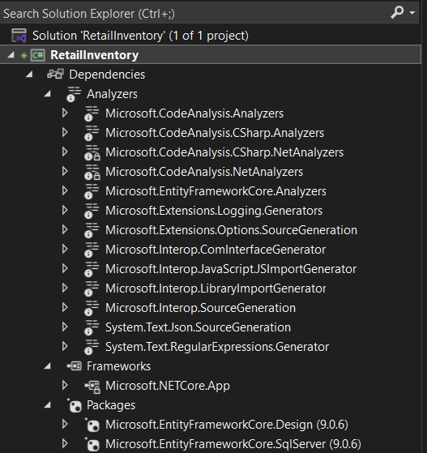

**Conclusion**

Object-Relational Mapping through Entity Framework Core provides a powerful abstraction layer that significantly simplifies database interactions in C# applications. By understanding these fundamental concepts and leveraging EF Core's advanced features, developers can build robust, maintainable, and high-performance data access layers for modern applications.

The transition from traditional SQL-based data access to ORM-based approaches represents a paradigm shift that enhances productivity while maintaining the flexibility and power needed for enterprise-level applications.