

**Tribhuvan University**

**Vedas College**

**A Final Year Project Report**

**On**

**Sentiment Analysis of Text using Long Short Term Memory**

**Under the Supervision of**

**Ramesh Chaudhary**

**Submitted To:**

**Department of Computer Science and Information Technology**

**Vedas College**

**In partial fulfillment of the requirement for the bachelor’s degree in Computer Science and Information Technology**

**Submitted By:**

**Alina Shrestha (15513/074)**

**BipinSunar (15524/074)**

**Ishan Maharjan (15527/074)**

**March 7, 2022**

# ACKNOWLEDGEMENT

The success of this project depended heavily upon the teamwork of our members. That said there are various other factors at play which have led to the fruition of our project. As such we would like to extend our unbridled gratitude towards all the personnel who have helped us see our project and also Vedas College for providing us this opportunity to explore our ideas as a project. It assisted us in undertaking various researches which allowed us to amass knowledge about various technical and nontechnical aspects of project development.

We would like to express our special thanks to our supervisor **Mr. Ramesh Chaudhary** who stood by us for the entire duration of our project development, providing us with various pointers which led us to successfully completing our project. His support and motivation were a key element of our success.

We also present our respect and gratitude towards our Director (Prashant Thakur), and all the friends, co-workers and the whole team for their colossal support and continuous inspiration.

And last but not the least; we would like to give our best regards and deepest gratitude to our family who provided us with special care and precious guidance which energized us for our research and project accomplishment both practically and theoretically.

We perceive this project as an opportunity for growth as well as the opportunity to see how far we have come towards becoming an IT professional. Hope to continue forward with the knowledge and skills we have amassed and also to continue cooperation with all you guys in the near future.

Sincerely,

Alina Shrestha 15513

BipinSunar 15524

Ishan Maharjan 15527

# ABSTRACT

In a world where generate large number of data is being generated every day,sentiment analysis has become a key component to systematically extract, identify, and quantify the data. Sentiment Analysis is the computational study of people’s opinions, sentiments, attitudes, and emotions expressed in written language. It is one of the most active research areas in natural language processing and text mining in recent years. Its popularity is mainly due to two reasons. First, it has a wide range of applications because opinions are central to almost all human activities and are key influencers of our behaviors. Whenever we need to make a decision, we want to hear others’ opinions. Second, it presents many challenging research problems, which had never been attempted before the year 2000. Part of the reason for the lack of study before was that there was little opinionated text in digital forms. It is thus no surprise that the inception and the rapid growth of the field coincide with those of social media on the Web. In fact, the research has also spread outside of computer science to management sciences and social sciences due to its importance to business and society as a whole.

Having the need of an analyzer to keep track of what others have as an opinion; especially when growing a business or starting something new, our system analyzes the input data’s emotion. We collect data and information for our system through different sources applying data collection and analyzing techniques. In this paper, we propose a method to classify the data based on LSTM Classification. Data collected from interviews, online and social media are of greater importance to understand the sentiment of people. Also, the functional requirements of our project are user UI, admin UI, data update, user login, access information and so on. The non-functional requirements of our projects are easy to use, accuracy, speed and effectiveness.

Various tools and technologies are used for the development of the application. The System is based on the agile model. As for the tools, we have used software like Git, Jupyter notebook, Visual Studio Code etc.

**Table of Contents**

ACKNOWLEDGEMENT ii

ABSTRACT iii

LIST OF ABBREVIATIONS vi

Chapter 1. Introduction 7

1.1Introduction 7

1.2 Problem Statement 8

1.3 Objective 8

1.4 Scope and Limitation 8

1.5 Development Methodology 9

1.6. Report Organization 9

Chapter 2 Background study and Literature Review 11

2.1 Background study 11

2.2 Literature Review 12

2.2.1 Review of Similar System: 12

Chapter 3 System Analysis 13

3.1 System Analysis 13

3.1.1 Requirement analysis 13

3.1.2 Feasibility Analysis 15

3.1.3 Analysis 17

Chapter 4: System Design 20

4.1. Design 20

4.1.1. Interface Design 20

4.1.2. Sequence Diagram 20

4.1.3. Input Output Design 22

4.2. Algorithm Details 23

Chapter 5: Implementation and Testing 24

5.1. Implementation 24

5.1.1. Tools Used 24

5.1.2. Long Short Term Memory algorithm: 25

5.2. Testing 30

5.2.1 Unit testing 30

5.2.2. System Testing 31

5.2.3 Accuracy Measurement 31

5.3. Result Analysis 31

Chapter 6: Conclusion and Future Recommendation 32

6.1. Conclusion 32

6.2. Future Recommendation 32

References 33

APPENDIX 35

# LIST OF ABBREVIATIONS

LSTM: Long Short Term Memory

CSS: Cascading Style sheets

DFD: Data Flow Diagram

HTTP: Hyper Text Transfer Protocol

SDLC: Software Development Life Cycle

WBS: Work Breakdown Structure

NLP: Natural Language Processing

# Chapter 1. Introduction

## 1.1Introduction

Sentiment is an attitude, thought, or judgment prompted by feeling. From a user’s perspective, people are able to post their own content through various social media, such as forums, micro-blogs, or online social networking sites. Sentiment analysis is a topic of great interest and development due to higher uses of social media opinions, messages and reviews are generated and shared in uncontrollable amount; analysis of these data can make greater difference in product delivery, customer satisfaction and business survival. Since publicly and privately available information over Internet is constantly growing, a large number of texts expressing opinions are available in all over the internet and social networking sites. With the help of sentiment analysis systems, this unstructured information could be automatically transformed into structured data of public opinions about products, services, brands, politics, or any topic that people can express opinions about. This data can be very useful for commercial applications like marketing analysis, public relations, product reviews, product feedback, and customer service. Sentiment analysis, just as many other NLP problems, can be modeled as a classification problem where sentences are classified into a positive or negative opinion also known as polarity classification. Today’s sentiment analysis algorithm can handle huge volumes of customer feedback consistently and accurately. Though it may seem easy on paper, Sentiment Analysis is actually a tricky subject. Understanding emotions through text are not always easy. Sometimes even humans can get misled, so computers are no exception.

## 1.2 Problem Statement

Sentiment analysis is the task to identify an e-text (text in form of electronic data such as comments, messages, reviews, tweets) to be positive or negative. The problem in sentiment analysis is classifying the polarity of a given text at the document, sentence or aspect level. Efficient analysis of the emotion of the people reviews on the product can better help business companies and sellers to make changes to their products and improvise according to the demands and desires of the people.

## 1.3 Objective

The objective of this study is to identify, extract, quantify, and study the expressions of comments using LSTM Classification. And, hence to build a model, that will classify the comments into Positive or Negative domain. The main objective is given below:

1. To analysis the opinion of people on products and services.
2. To study the political views of people of current affairs.
3. To know the scope of this organization.

## 1.4 Scope and Limitation

The scope for this project work is to analysis emotions and opinions of people. The main focus of the project work “Sentiment Analysis” is to classify comments and subjective expressions into three domains of Positive andNegative through classification algorithm.

Some of the scopes are:

1. This system can be used as a social media monitoring.
2. This system can be used for brand monitoring.
3. This system can be used in customer service.
4. This system can be used as product analysis.
5. This system can be used as market research and analysis.
6. It can be used as workforce analytic and voice of employees.
7. It can be used to train artificial intelligent machines.

The different limitations of this project are:

1. It is difficult to address multi sentiment on a single sentence.
2. It is difficult to classify the irony and sarcasm.
3. Use of emoji needs lot of preprocessing.
4. Hard to find the polarity with respect to contextual

## 1.5 Development Methodology

The development methodology that we use to develop our system is Agile Methodology.

**Agile Methodology**

AGILE methodology is a practice that promotes continuous iteration of development and testing throughout the software development lifecycle of the project. In the Agile model, both development and testing activities are concurrent, unlike the Waterfall model. The Agile software development methodology is one of the simplest and effective processes to turn a vision for a business need into software solutions. Agile is a term used to describe software development approaches that employ continual planning, learning, improvement, team collaboration, evolutionary development, and early delivery. It encourages flexible responses to change. The agile software development emphasizes on four core values.

1. Individual and team interactions over processes and tools

2. Working software over comprehensive documentation

3. Customer collaboration over contract negotiation

4. Responding to change over following a plan.

Agile development refers to any development process that is aligned with the concepts of the Agile Manifesto. The Manifesto was developed by a group fourteen leading figures in the software industry, and reflects their experience of what approaches do and do not work for software development.

We use agile methodology for our project because of following reasons:

* Product is developed fast and frequently delivered (weeks rather than months.)
* Even late changes in requirements are welcomed.
* It continuously gave attention to technical excellence and good design.

## 1.6. Report Organization

This report is organized into 6 different chapters as follows:

**Chapter 1: Introduction**

In this chapter, the project is introduced in detail with problem statement, objectives, scope and development methodology.

**Chapter 2: Background Study and Literature Review**

It consists of background study, literature review of the system along with the research done on this subject and also contains study of existing system.

**Chapter 3: System Analysis**

It consists of requirement analysis, feasibility analysis of the project and the description of process modelling with DFD.

**Chapter 4: System Design**

It consists of interface design, input output design, sequence diagram and the process design of the proposed system. It also contains the description of algorithm.

**Chapter 5: Implementation and Testing**

Implementation consists of tools, implementation details of algorithm and Testing consists of methods and model predict the crop with various input data. It also consists of result analysis where accuracy of model is evaluated.

**Chapter 6: Conclusion and Recommendation**

It consists of result analysis, conclusion and the intended future work related to the projects.

# Chapter 2 Background study and Literature Review

## 2.1 Background study

The booming of mobile Internet and social media are growing fast in the technology industry worldwide and it is predicted that mobile Internet will also increase. With the availability of accessing the Internet at our fingertips makes everything easier and faster. Stories are shared, feelings are being expressed, everything in social media.

Sentiment analysis or can be known as opinion mining is an important factor nowadays. Interpreting one’s simple statement could lead to resolving issues and preventing it from occur. Humans may be interpreting one statement differently. This is mainly because we are thinking differently, our intelligence gives a huge impact on what we are saying and experiences that we have are varies from one another.

The main aim is to make a system that can understand contextual opinions and data sets and their sentiments. In recent ages, huge volumes of data are unused and unmonitored globally. Sentiment analysis helps to conclude the attitude of the writer of the statement. The result will be called as polarity which can be either positive sentiment, negative sentiment.

1. *Positive Sentiment*

Texts that will be grouped into this section will be positive texts with positive words such as “like” and “love”.

1. *Negative Sentiment*

Texts that will be grouped into this section will be negative texts with direct negative words such as “hate” and “idiot”.

Effective monitoring and structure organizing of these data can make meaningful insights for government about country’s political views, or for business about their products and services. Sentiment Analysis can provide a more preferable rating, recommending and analyzing environment for people. Instead of spending time in reading and figuring out the positivity and negativity of text we can use automated techniques for sentiment analysis.

## 2.2 Literature Review

The purpose of this project study is to classify the sentiment of people through opinion. In this chapter, the major ground work and preliminaries related to the subject of the study, is review. The various related approaches and review of our project is review in his chapter.

In the information era, the development of Web2.0 is very high, it has also encouraged people to issue their content digitally and comment on other people’s content. So, users online not only search information, but also generate novel content [1]. Talking about being on the internet, the most used thing there is social media. In abroad, as the number of social media sites increased, for example, twitter and Instagram have more meanings instead of only a system, which saves user’s content [3]. It shows that social media is more and more important. Just as X. Yang said: in the information era, twitter has a great ability to feel people’s emotion at any time through huge UGC (user generated content) and even the enterprise development, government can be affected by Twitter [4]. Hence, more tools were generated for making further data mining and analysis about the Web text. Sentiment analysis was also introduced in health care using natural language processing (NLP) [6]. Thus, performing data analysis has higher value than before and the text data on the internet still has huge influences on our daily decision making.

### 2.2.1 Review of Similar System:

1.  Social Mention: Social Mention is a social media search that allows you to easily track and measure what people are saying about you, your company, a new product, or any topic across the web's social media landscape in real-time.

Features:

-          It currently provides a point-in-time social media search and analysis service, daily social media alerts

2.  Media Toolkit: Media toolkit is a media monitoring tool that tracks relevant searches and online trends. It is used for online reputation management, crisis communication, influencer marketing, market research, as well as customer service, lead generation, and even product development.

Advanced Features:

-          Auto Sentiment Analysis of Mentions.

# Chapter 3 System Analysis

## 3.1 System Analysis

System analysis is process of studying a procedure to identify its goal, purpose and also a problem-solving technique that breaks down a system into its component pieces. Under system analysis we have:

### 3.1.1 Requirement analysis

Requirement analysis is the process to gathering requirements of a new product or project. The source of the information is to learn related system, gather documents and research papers and study them.Requirement analysis basically consists of two types:

#### 3.1.1.1 Functional Requirement

A functional requirement is a description of a software system or component that is required to perform a specific function. A function can be defined as anything that is related to a system's behavior or output. These are statements of services about what the system should provide, how the system should react to particular inputs and how the system should behave in particular situations.

The functional requirement for this system are as follow:

* Allow user to input the word/sentences.
* Allow user to view the sentiment of entered word/sentences.

**Use Case Diagram**

A use case is a methodology used in system analysis to identify, clarify, and organize system requirements. The use case diagram of sentiment analysis system represents interaction between the user and the system.

Input Text

Preprocess

Feature Extraction

Classification

User System

Figure 2.1 Use Case Diagram for Sentiment Analysis

The diagram shows that user gave input text/sentences in the system. The user inputted word/sentences in the system was preprocessed by the system by removing noises, extracting important features and classifying of sentences to their corresponding polarity. The result is then displayed to the user.

The user would be able to input the text and after matching process system analyze the sentiment behind the text and improve the quality of products as per the requirement.

#### 3.1.1.2 Non-Functional Requirement

Non-functional requirements are the requirements that are not directly concerned with the specific function delivered by the system. It specifies the quality attribute of the software system. Some of the non-functional requirements related to the system are descried below:

**Interface**

We have friendly web application as user interface where user could input the data for analysis.

**Performance**

This system of Sentiment analysis was able to provide information (sentiment) to the user and the information displayed was accurate and correct to higher extend.

**Usability**

The applications to be developed are built in a user-friendly interface such that even a common person can understand it and make the most use of it. Users can access the system from anywhere at any time with a quite good internet connection.

**Maintainability**

The system needs to be maintained. The analysis procedure in this project’s system needs to be carried out to increase the precision of the system.

### 3.1.2 Feasibility Analysis

Feasibility analysis aim to objectively and logically uncover the strengths and weaknesses of an existing business or proposed venture, opportunities and threats as presented by the environment, the resources required to carry for best analysis. The feasibility study is necessary to determine if creating a new or improved system is friendly with the cost, benefits, operation, technology and time. The following are the feasibility that are concerned with our project:

#### 3.1.2.1 Technical Feasibility

All the tools and software product required to construct this project is easily available in the web. It do not require special environment to execute. In this feasibility, the current resources of both hardware and software along with required technology are analyzed to develop the project.It is planned to use available datasets, process them (data cleaning), use deep Learning Algorithms for analyzing and finally visualize the results in WebView. For datasets, it can be accessed from various online websites and for WebView there will be use of Django.The application requires simple user interfaces but implementation of algorithm and real calculation are complex. It can be done with some assistance from our supervisor.

#### 3.1.2.2 Operational Analysis

It is concerned with the operating capabilities of the system. For the efficient operation, the reports and classification provided by our project (Sentiment Analysis) can help decision makers to have proper decisions. Result generated from the system are easier to read and understand. Hence, the system is feasible operationally.

#### 3.1.2.3 Economic Analysis

The purpose of economic feasibility is to determine the positive economic benefits. In context to the project work, the system developed is a web application, which requires all the hardware and software support as required by other application. The required specification of laptop and a good internet connection is needed in order to build the system.

#### 3.1.2.4. Schedule Analysis

The purpose of Schedule feasibility is to determine division work with time.

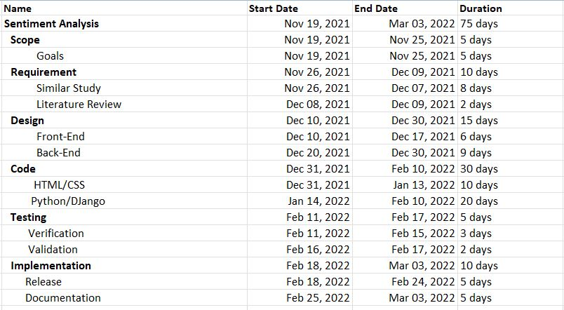

Fig: work breakdown Structure

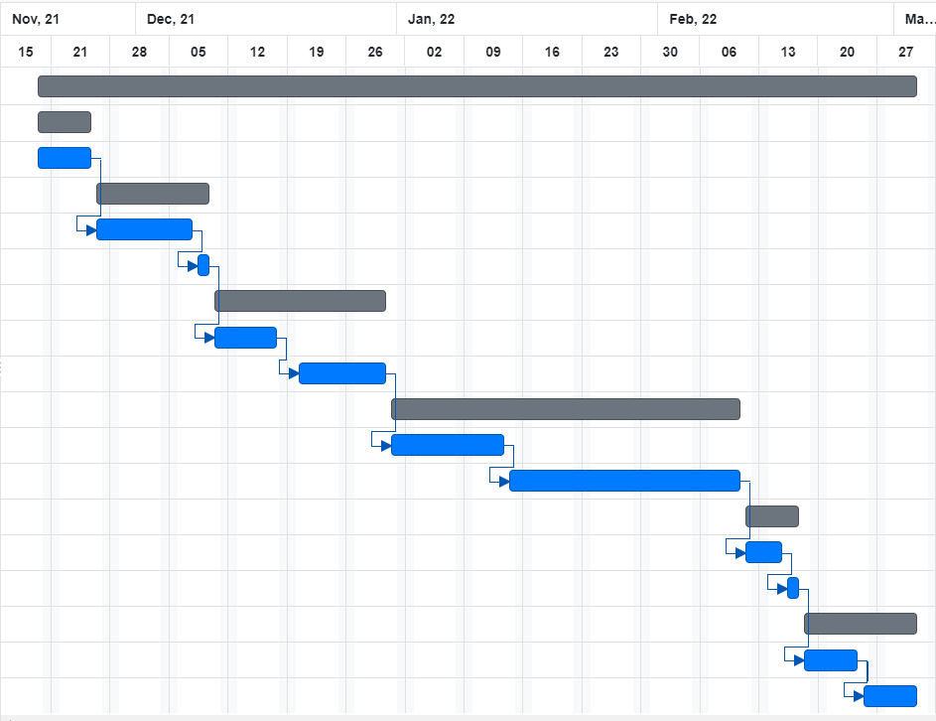

Fig: Gantt Chart

### 3.1.3 Analysis

**DFD (Data Flow Diagram)**

Data flow diagram is an analysis tool to represent the flow of data through an informative system. It provides information about the outputs and inputs of each entity and the process itself.

**Level 0 DFD**

Level 0 DFD is also the context diagram which is designed to be an abstraction view, showing the system as a single process with its relationship to external entities. It is similar to the block diagram.

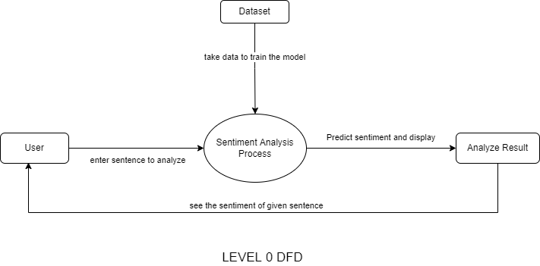

Fig: Level 0 DFD

**Level 1 DFD**

DFD Level 1 provides a more detailed breakout of pieces of the Context Level Diagram. This level 1 DFD shows the overall process for the sentiment analysis that is loading of datasets, training and testing of data, tokenized trained data, create model, load model and input text from user to System, analyze result. The user can provide inputs sentence/word and then get the result of best polarity. The level 1 DFD is shown below:

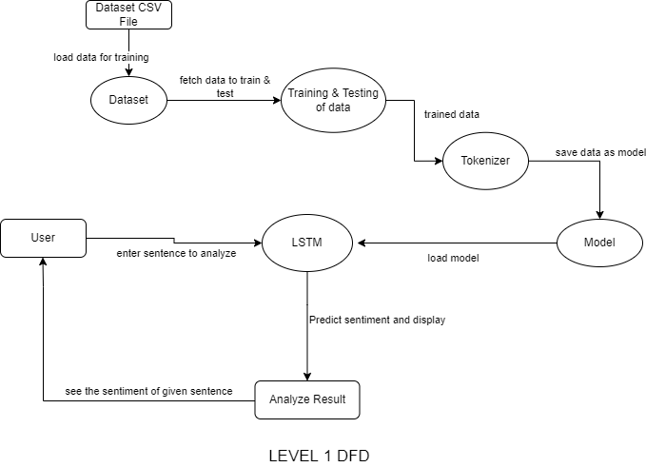Fig: Level 0 DFD

# Chapter 4: System Design

## 4.1. Design

### 4.1.1. Interface Design

User interface (UI) design refers to the visual layout of the elements in a website or other devices that determines how a user interact it and how information is displayed on the screen. Interface design must have different features like responsive, effective, consistent, attractive etc.

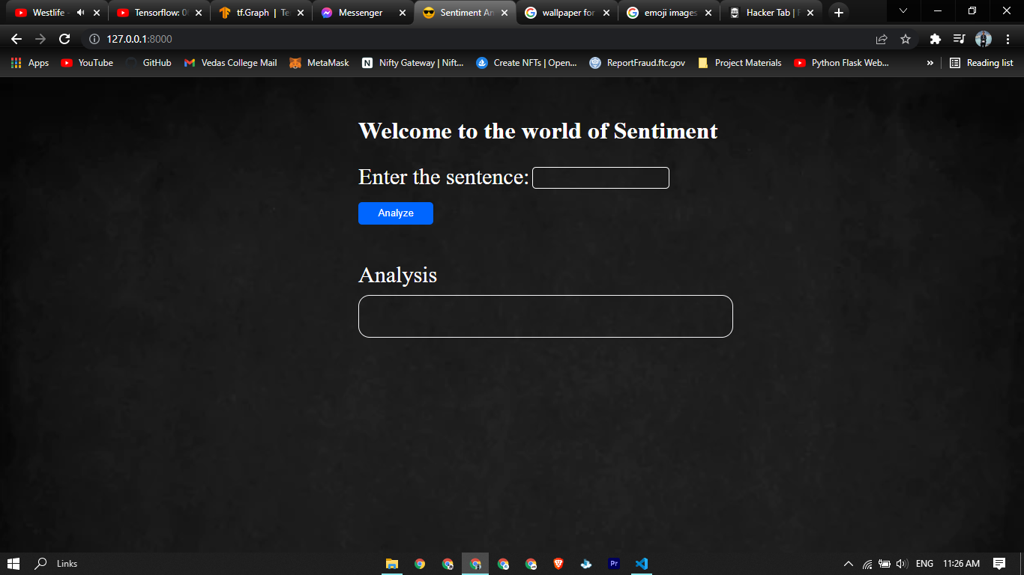–

Fig: Snipshot of the system

### 4.1.2. Sequence Diagram

A sequence diagram is an interaction diagram that emphasizes the time ordering of messages sent between objects. It is also known as Event diagrams as it describes how and in what order a group of objects works together. The sequence diagram for the system is shown below.

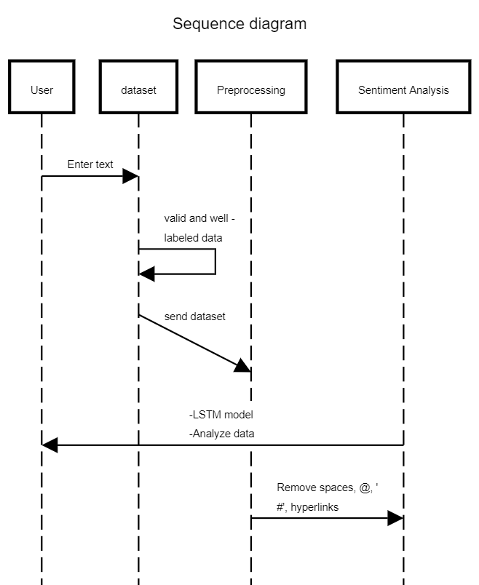

Fig: Sequence diagram

### 4.1.3. Input Output Design

The quality of system input determines the quality of system output. The design of input focuses on controlling the amount of input required, controlling the errors and keeping the process simple. Input design is the process of converting a user-oriented description of the input into a computer based system. Data in the system will be given through simple input text field.

The design of output is the most important task of any system. A quality output is one, which meets the requirements of the end user and delivers the information clearly. In any system results of processing are communicated to the end user and to other system through outputs. In output design it is determined how the information is to be displayed for immediate need. Efficient and intelligent output design improves the system’s relationship to help user decision-making.

We collect data and information for our system through different sources applying data collection and analyzing techniques. Then the collected data is processed (data cleaning), use LSTM Algorithms for analyzing and finally visualize the results in Web View with the help of Django.

In the user side,the user inputs word/sentences in the system which will be then preprocessed by the system by removing noises, extracting important features and classifying of sentences to their corresponding polarity. The result is then displayed to the user as an output.

## 4.2. Algorithm Details

The algorithm used for development of the system is LSTM Algorithm.

**Long Short Term Memory**

Input: Dataset

Output: Polarity level(0, 1).

Step 1. Take input the current input, the previous hidden state, and the previous internal cell state.

Step 2. For each gate, calculate the parameterized vectors for the current input and the previous hidden state by element-wise multiplication

Step 3. Apply the respective activation function for each gate element-wise on the parameterized vectors

Step 4. Calculate the current internal cell state by first calculating the element-wise multiplication vector of the input gate and the input modulation gate.

Step 5. Then calculate the element-wise multiplication vector of the forget gate and the previous internal cell state and then adding the two vectors.

Step 6. Calculate the current hidden state by first taking the element-wise hyperbolic tangent of the current internal cell state vector and then performing element-wise multiplication with the output gate.

# Chapter 5: Implementation and Testing

## 5.1. Implementation

Text Input

Preprocessing

Feature Extraction

Classification

Figure 4.1 Implementation model for Sentiment

First of all input from user were taken using input text-field and then data preprocess was done by removing unnecessary symbols and punctuation. TFIDF approach was used to extract important from data. Finally, LSTM layers was used to classify the text into corresponding class of positive or negative.

### 5.1.1. Tools Used

#### 5.1.1.1 Implementation Tools

**Front End:**

Different tools used for Front End are:

* HTML: HTML (HyperText Markup Language) is the most basic building block of the Web. It defines the meaning and structure of web content.
* CSS: CSS (Cascading Style Sheets) is a [style sheet language](https://en.wikipedia.org/wiki/Style_sheet_language) used for describing the [presentation](https://en.wikipedia.org/wiki/Presentation_semantics) of a document written in a [markup language](https://en.wikipedia.org/wiki/Markup_language) such as [HTML](https://en.wikipedia.org/wiki/HTML).

**Back End:**

Different tools used for Back End are:

* Python: Python is a [high-level](https://en.wikipedia.org/wiki/High-level_programming_language) [general-purpose programming language](https://en.wikipedia.org/wiki/General-purpose_programming_language). Python can be used on a server to create web applications.
* Django:Django is a Python-based free and open-source web framework that follows the model–template–views architectural pattern.

#### 5.1.1.2 Other tools

* **Jupyter Notebook:**The Jupyter Notebook is a web-based interactive computing platform.
* **Visual Studio Code:** Visual Studio Code is a code editor redefined and optimized for building and debugging modern web and cloud applications.

### 5.1.2. Long Short Term Memory algorithm:

Long short-term memory (LSTM) is an artificial recurrent neural network (RNN) architecture used in the field of deep learning.

LSTM networks are well-suited to classifying, processing and making predictions based on time series data, since there can be lags of unknown duration between important events in a time series. LSTMs were developed to deal with the vanishing gradient problem that can be encountered when training traditional RNNs. Relative insensitivity to gap length is an advantage of LSTM over RNNs, hidden Markov models and other sequence learning methods in numerous applications.

Unlike standard feedforward neural networks, LSTM has feedback connections. It can process not only single data points (such as images), but also entire sequences of data (such as speech or video). For example, LSTM is applicable to tasks such as unsegmented, connected handwriting recognition, speech recognition and anomaly detection in network traffic or IDSs (intrusion detection systems).

A common LSTM unit is composed of a cell, an input gate, an output gate and a forget gate. The cell remembers values over arbitrary time intervals and the three gates regulate the flow of information into and out of the cell.

**Inner workings of the LSTM**

The secret sauce to the LSTM lies in its gating mechanism within each LSTM cell. In the normal RNN cell, the input at a time-step and the hidden state from the previous time step is passed through a tanhactivation function to obtain a new hidden state and output.

LSTMs, on the other hand, have a slightly more complex structure. At each time step, the LSTM cell takes in 3 different pieces of information -- the current input data, the short-term memory from the previous cell (similar to hidden states in RNNs) and lastly the long-term memory.

The short-term memory is commonly referred to as the hidden state, and the long-term memory is usually known as the cell state.

The cell then uses gates to regulate the information to be kept or discarded at each time step before passing on the long-term and short-term information to the next cell.

These gates can be seen as water filters. Ideally, the role of these gates is supposed to selectively remove any irrelevant information, similar to how water filters prevent impurities from passing through. At the same time, only water and beneficial nutrients can pass through these filters, just like how the gates only hold on to the useful information. Of course, these gates need to be trained to accurately filter what is useful and what is not.

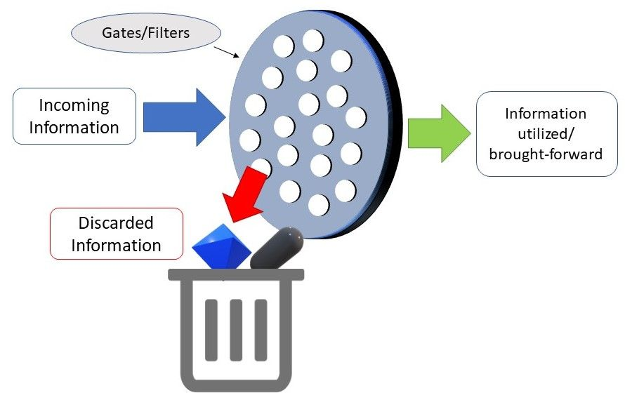LSTM Gates can be seen as filters

These gates are called the Input Gate, the Forget Gate, and the Output Gate. There are many variants to the names of these gates; nevertheless, the calculations and workings of these gates are mostly the same.

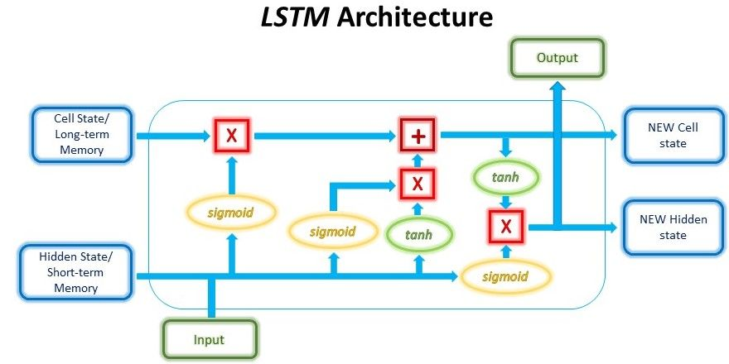Inner Workings of the LSTM cell

Let’s go through the mechanisms of these gates one-by-one.

**Input Gate**

The input gate decides what new information will be stored in the long-term memory. It only works with the information from the current input and the short-term memory from the previous time step. Therefore, it has to filter out the information from these variables that are not useful.

Mathematically, this is achieved using 2 layers. The first layer can be seen as the filter which selects what information can pass through it and what information to be discarded. To create this layer, we pass the short-term memory and current input into a sigmoid function. The sigmoid function will transform the values to be between 0 and 1, with 0 indicating that part of the information is unimportant, whereas 1 indicates that the information will be used. This helps to decide the values to be kept and used, and also the values to be discarded. As the layer is being trained through back-propagation, the weights in the sigmoid function will be updated such that it learns to only let the useful pass through while discarding the less critical features.

https://lh6.googleusercontent.com/32bzQUDk4d_r1K16_rnTBw3RF54O4iHgRrzNF4qhSmdjCyyEFeFGvla-oWyLkP3t0M_9pxQe_kqXRodlQ5Xhg7j7OQ19FFfL_-m-Iv4VugIsjHMp-O9WoGh5y2VHKeRFC91UR60g

The second layer takes the short term memory and current input as well and passes it through an activation function, usually the $$tanh$$ function, to regulate the network.

https://lh3.googleusercontent.com/2rGrOwqFzuez87euAnxoRv94dwrVaDisjUnzb8oW1ihpr0Gkkg8CQ31ywux8zefqqxaTnOrvaQwVAgGxSUfnRLOkUtg61TDWxstuZAXcFIrXEtDFks9ktv_cTlfcKEfZ3WWLUPhq

The outputs from these 2 layers are then multiplied, and the final outcome represents the information to be kept in the long-term memory and used as the output.

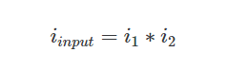

**Forget Gate**

The forget gate decides which information from the long-term memory should be kept or discarded. This is done by multiplying the incoming long-term memory by a forget vector generated by the current input and incoming short-term memory.

Just like the first layer in the Input gate, the forget vector is also a selective filter layer. To obtain the forget vector, the short-term memory, and current input is passed through a sigmoid function, similar to the first layer in the Input Gate above, but with different weights. The vector will be made up of 0s and 1s and will be multiplied with the long-term memory to choose which parts of the long-term memory to retain.

https://lh3.googleusercontent.com/B75t-IVZGgWf4rJxhP2br8S9V63-m7eFXNYMoAJ1OVALy_OCVJFxab-ueBcth2Oedz3zh45ieq_4BqlVLa_SnhaccU0gZCwC12hvKefaF4GThkaSWCpJ3M8bmPYpdUt1M4Urn2Ai

The outputs from the Input gate and the Forget gate will undergo a pointwise addition to give a new version of the long-term memory, which will be passed on to the next cell. This new long-term memory will also be used in the final gate, the Output gate.

https://lh3.googleusercontent.com/5d6LqNTiuetw7trrjaU6RFkd7zrEmlj3S6PA_P4K6jQprY9-kmDqvdsG8eicn_7edoTl1m1bz6duGDjqWfSbu8KdilsJBmX1H8w8eTy_Tyisr8CvHtSfwUgpwU7LyHZ_gNid93ln

**Output Gate**

The output gate will take the current input, the previous short-term memory, and the newly computed long-term memory to produce the new short-term memory/hidden statewhich will be passed on to the cell in the next time step. The output of the current time step can also be drawn from this hidden state.

First, the previous short-term memory and current input will be passed into a sigmoid function (Yes, this is the 3rd time we’re doing this) with different weights yet again to create the third and final filter. Then, we put the new long-term memory through an activation $$tanh$$ function. The output from these 2 processes will be multiplied to produce the new short-term memory.

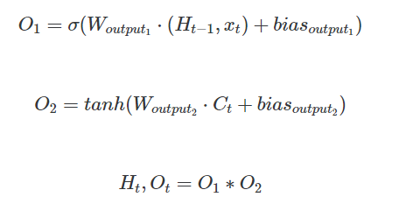

The short-term and long-term memory produced by these gates will then be carried over to the next cell for the process to be repeated. The output of each time step can be obtained from the short-term memory, also known as the hidden state.

## 5.2. Testing

### 5.2.1 Unit testing

Unit testing refers to the testing of every small modular components of the system, keeping them isolated from other modules. Here we mention testing result of the various part of the system. In unit testing, we design the whole system in modularized pattern and each module was tested.

Table: Unit Testing

|  |  |  |  |  |
| --- | --- | --- | --- | --- |
| SN | Input | Expected  Output | Observed  Output | Final Output |
| 1. | I love this place. | Positive | Positive | Positive |
| 2. | This is not a good brand | Negative | Negative | Negative |
| 3. | Bad food bad life | Negative | Negative | Negative |

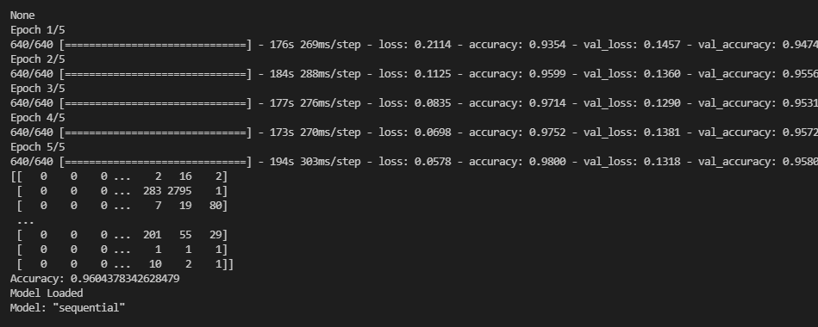

Fig: Unit Testing

### 5.2.2. System Testing

In this testing phase our system as a whole was tested. Every individual component was integrated and tested against user and hardware compatibility.

### 5.2.3 Accuracy Measurement

Different accuracy measurement technique like: precision, recall and f-score were used. Precision and Recall gave their individual accuracy score whereas F-score gave harmonic mean of precision and recall. Accuracy measures are as follows:

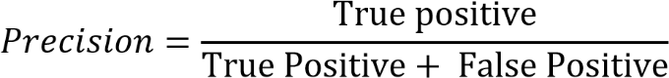

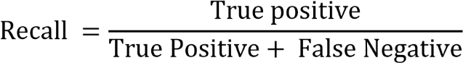

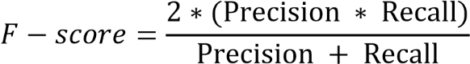

While training 80% of data and testing 20% of data, we have got F- Score of 47.64%.

## 5.3. Result Analysis

There are 2 columns and 31973 rows in the dataset. The dataset is divided into 80% for training and 20% for testing. The model is trained using the training data. After that model is provided with test data and the sentiment analysis is done.

Precision: Precision measures how accurate are the predictions that is the percentage of the predictions are correct. True Positive (TP), True Negative (TN), False Positive (FP) and False Negative (FN). The formula of Precision is as follows:



Recall: Recall measures how many good positives are found that is how many possible positive cases are found. Recall is given by:



# Chapter 6: Conclusion and Future Recommendation

## 6.1. Conclusion

Sentiment Analysis has become key component to systematically extract, identify, and quantify the data. We address the problem of sentiment classification on dataset. It mainly focuses on determining whether the given data contains negative or positive emotions. When we use sentiment analysis, we can effectively evaluate market place and detect the user emotions.

The system, Sentiment Analysis based on long short term memory (LSTM) Classification was able to provide 96.04%. F- Score for 80/20 train-test split data set. Using this sentiment analysis system, we can effectively evaluate people's opinion on products and political affairs. Currently the system can classify the inputted comments to the Negative or Positive classes. This classification can help companies to collect feedback and to make better products and services. Political status and people's opinions can be extracted from this classification at some level.

## 6.2. Future Recommendation

As we have seen that increasing the training data set has given greater classification accuracy in the system. It is recommended to have more data sets to make the model. Polarity could be increased from three classes to five classes to make the system more dynamic.

# References

[1] Wadawadagi R, Pagi V (2020) Sentiment analysis with deep neural networks: comparative study and performance assessment. ArtifIntell Rev. https://doi.org/10.1007/s10462-020-098 45-2

[2] B. Jayanag, K. Vineela, and S. Vasavi, “A study on feature subsumption for sentiment classification in social networks using natural language processing,” no. 18, 2012.

[3] Yoo S, Song J, Jeong O (2018) Social media contents based sentiment analysis and prediction system 105:102–111

[4] Yang X, Xu S, Wu H, Bie R (2019) Sentiment analysis of Weibo comment texts based on extended vocabulary and convolutional neural network. Procedia ComputSci 147:361–368

[5] E. Haddi, X. Liu, and Y. Shi, “The role of text pre-processing insentiment analysis,” in ITQM, ser. Procedia Computer Science, Y. Shi,Y. Xi, P. Wolcott, Y. Tian, J. Li, D. Berg, Z. Chen, E. Herrera-Viedma, G. Kou, H. Lee, Y. Peng, and L. Yu, Eds., vol. 17. Elsevier, 2013, pp.

[6] Kumar S, Kumar S, Suri JS (2019) Computer methods and programs in biomedicine effect of incremental feature enrichment on healthcare text classification system: a machine learning paradigm. Comput Methods Programs Biomed 172:35–51

[7]“Long Short Term Memory Networks Explanation,” GeeksforGeeks, Jul. 09, 2019. <https://www.geeksforgeeks.org/long-short-term-memory-networks-explanation/>.

[8]“LSTM Long Short Term Memory | Architecture and Calculation | Whiteboard explanation | Formula,” www.youtube.com. https://www.youtube.com/watch?v=Opj2AT0iYCw (accessed Mar. 07, 2022).

[9]S. W. J. E. M. Saraee, "A data mining approach to analysis and prediction," in University of Salford England the Fifth International Conference on Data Mining Text Mining and their Business Applications, pp. 344352, England,

September 2004.

[10] Supreme Motnam, Krushikanth R. Apala, " Prediction of movies box office performance using social media", no. 28, pp. 1209-10, 2013.

[11] D. D. Rossiter, “Project Report Twitter Emotion Analysis.” <https://www.cse.ust.hk/~rossiter/independent_studies_projects/twitter_emotion_analysis/twitter_emotion_analysis.pdf>.

[12]“Python Sentiment Analysis For Text Analytics,” *www.youtube.com*. https://www.youtube.com/watch?v=kmbXGZbce0Q&t=572s&ab_channel=FreeProjectz (accessed Mar. 07, 2022).

[13]https://www.facebook.com/jason.brownlee.39, “The 5 Step Life-Cycle for Long Short-Term Memory Models in Keras,” *Machine Learning Mastery*, Jun. 06, 2017. https://machinelearningmastery.com/5-step-life-cycle-long-short-term-memory-models-keras/.

[14] kissflow, “9 Key Benefits of Using the Agile Methodology,” *Kissflow*, Oct. 17, 2020. <https://kissflow.com/project/agile/benefits-of-agile/>.

[15]https://www.facebook.com/pranjal.srivastava3, “Essentials of Deep Learning : Introduction to Long Short Term Memory,” *Analytics Vidhya*, Dec. 23, 2017. <https://www.analyticsvidhya.com/blog/2017/12/fundamentals-of-deep-learning-introduction-to-lstm/>.

[16]“AI-driven Sentiment Analysis | Brand24.” https://brand24.com/ai-driven-sentiment-analysis/?adgr=txt-top-v-sentiment-tools&keyword-ext=sentiment%20analysis%20tools&placement=&location=1011034&adgr=txt-top-v-sentiment-tools&gclid=CjwKCAiAsYyRBhACEiwAkJFKoop3FHkU3ngWqeRh5WghSOq3sKFh2tUu20j4G9HqvOpD4l-s5rAbEhoCUNUQAvD_BwE (accessed Mar. 07, 2022).

[17]“Sentiment Analyzer,” *MonkeyLearn*. https://monkeylearn.com/sentiment-analysis-online/.

[18]“Text Understanding from Scratch,” *www.scienceopen.com*, Apr. 2016, Accessed: Mar. 07, 2022. [Online]. Available: https://www.scienceopen.com/document?vid=08f67b6d-922c-45a7-a93b-12e25f6b3f48.

# APPENDIX

