Form 'C'
Arrival Report of Foreigner in Individual House
Applicant ID : 13072250FW4J

13072250FW4J
Accomodation Details
 | 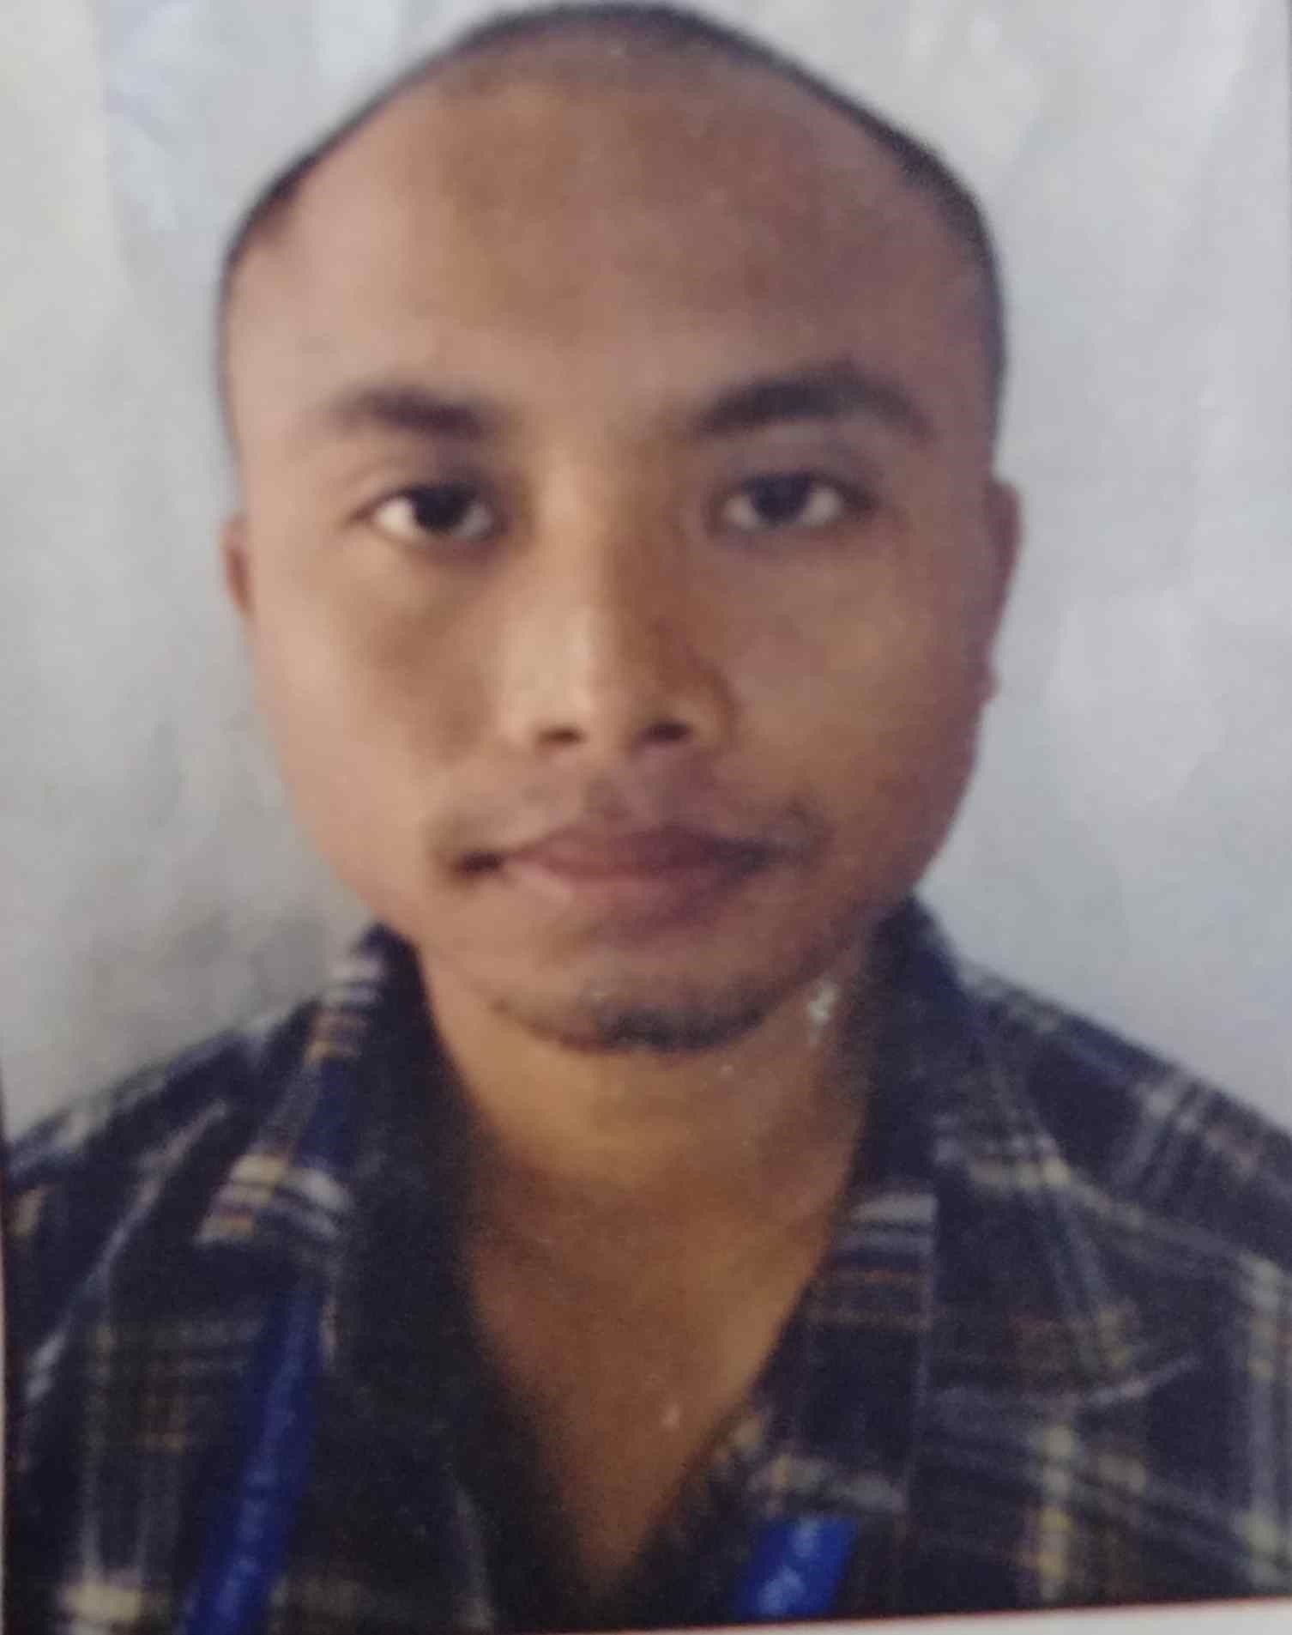
  Name | Jognesh vaghela
  Address | Akshara society wagodia (391760)
  City/District | VADODARA
  State | GUJARAT
  Star Rating
  Phone no. | 9826412035
  Mobile no. | 8858227580
Personal Details
Surname | SINGH
Given name | AMAN
Sex | Male
Date of birth | 10/08/1998 | Special Category | Others
Nationality | NEPAL
Address in country where residing permanently
Address |  | MIRCHAIYA -11,SHIRA,NEPAL
City |  | MIRCHAIYA
Country |  | NEPAL
 | Remark |  | No
Address/Reference in India
Address | AKSHARA SOCIETY WAGODIA room no 155
City/District | VADODARA
State | GUJARAT
Pincode | 391760
Passport Details
Passport No. | 15017310666
Place of Issue | SHIRA, NEPAL
Date of Issue | 06/04/2017
Expiry Date
Visa Details
Visa Number |  | Date of Issue
Valid Till |  | Visa Type
Place of Issue |  | Visa Subtype
Arrival Details
Arrived From |  |  | MIRCHAIYA , MIRCHAIYA , NEPAL
Date of arrival in India |  |  | 03/08/2021
Date of Arrival in Individual House |  |  | 03/08/2021
Time of Arrival in Individual House |  |  | 12:30 | Intended Duration of Stay in Individual House | 365
 | N
Whether Employed in India
Other Details
Purpose of Visit |  | Studies
Next  Destination | Place | WAGODHIYA
Next  Destination | City/District | VADODARA
Next  Destination | State | GUJARAT
Contact No.(in India) |  | 7069982968
Mobile No.(in India)
Contact No.(Permanently residing country) |  | 9815113703
Mobile No.(Permanently residing country)
Remarks(If any)
Page 1 of 1

