Assignment-2

Name:Biplav bhusal

Class:BCA’5th

Subject:WEB-I

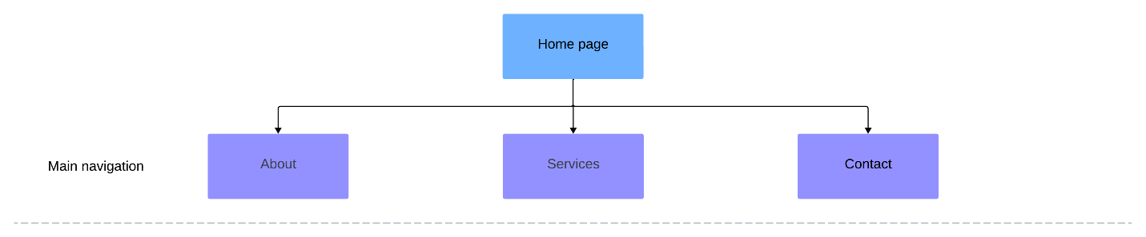

Reference:

Web reference:Design from below web site.

https://m.shein.com/?lang=en