**1. Web Design Guidelines**

* What is Web Design?
* What is Wireframing?
* Wireframing Tools: <https://www.mybalsamiq.com/login>
* Before design a website first design the Wireframe. After the confirmation start to work to build the website.
* What is UI(User Interface) & UX(User Experience)?
* Web Typogrphy:

5 Basics Priciples for Good Typography:

* Font Choice:

Serif vs Sans Serif

* Size
* Line Height

Example: 14px text size works well at a 21px[150%] of line height.

* Alignment
* Readability
* Web Colors
* Icons for Web
* Images for Web
* Whitespacing for Web Design
* Getting Inspiration for Web Design
* Quiz 1: Web Design Quiz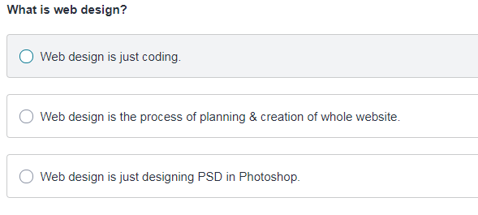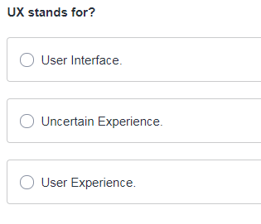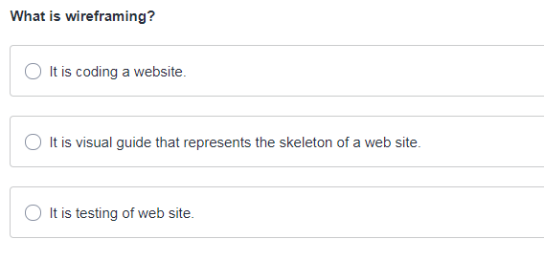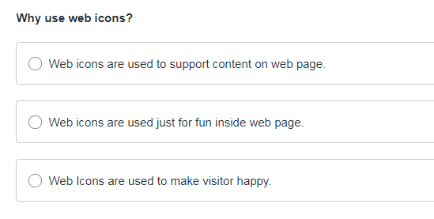
* 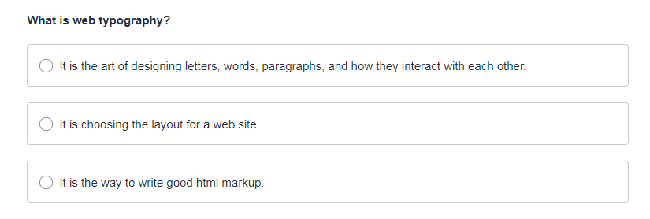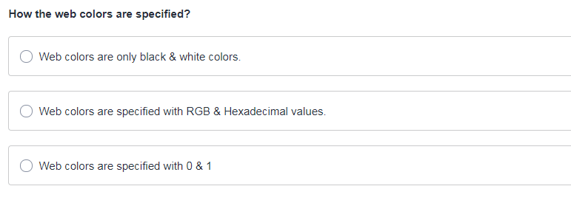
* Conclusion To Web Design Guidelines

Conclusion To Web Design Guidelines

In this section, you have learned about web design guidelines. These guidelines are very important and I would like you to apply these guidelines on your project. So well, you have learned about below list of guidelines.

1. **Web Design:**
   1. Knowing about web design
   2. Important elements of web design
   3. Difference between Frontend & Backend developer
   4. And a look at some modern websites
2. **Wireframing**
   1. Idea of wireframing
   2. Example of wireframing
   3. Different online tools for making wireframing
   4. Working on wireframing example
3. **UI & UX**
   1. Understanding of User Interface – UI
   2. Understanding of UX – User Experience
   3. Real world example of UI & UX
4. **Typography for Web**
   1. Understanding of web typography
   2. Choosing font
   3. Difference between Serif & Sans Serif
   4. Size for text type
   5. Line height recommendation
   6. Text alignment and readability
   7. Choosing good online fonts
   8. Working on online tools for good typography
5. **Web Colors**
   1. Idea about web colors
   2. RGB & Hexadecimal color
   3. RGB & Hexadecimal colors
   4. Choosing the right color
   5. Online tool for web color scheme
6. **Icons for Web**
   1. Web Icons
   2. Why icons are important
   3. How to use icons
7. **Images for web**
   1. Purpose of image usage for web
   2. Tips to use images effectively in web design
      1. Selection Of Images
      2. Use Effective Images
      3. Placement Of Images
      4. Size & Resolution of Images
      5. Image Optimization
8. **White spacing**
   1. Idea of whitespacing
   2. Why whitespace matters.
9. **Inspiration for web**

**2. Getting Started With  
HTML**

* Choosing Code Editor
* What Is HTML?
* Basic HTML Structure
* Coding Small Business Page With HTML5
* HTML Quiz

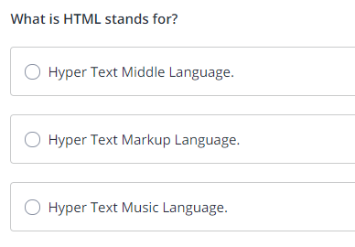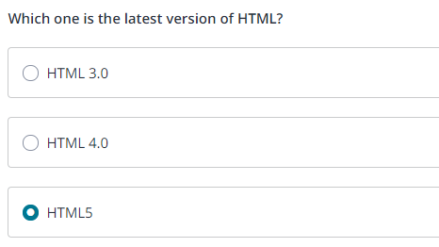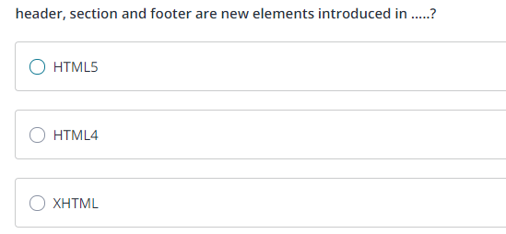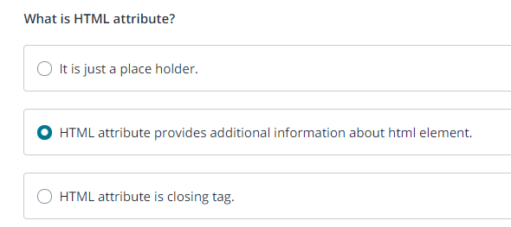Conclusion To Getting Started With HTML

In this section, you start learning about HTML and you got basic idea of what html is and how to write basic structure.  You also learn how to start writing html markup of a very simple business page.  And I hope, you also would have made choice for you code editor.  In this section, you learn below list of things:

1. **Code Editor**
   1. Free Notepad++ Editor
   2. Sublime Text Editor
   3. Bracket Text Editor
2. **What Is HTML**
   1. HTML is markup language
   2. Very easy to learn and implement
   3. Awareness about HTML versions
   4. Learn about html tag syntax
   5. Learn about html tags and attributes
3. **Basic HTML structure**
   1. Learn about basic HTML structure
4. **Code Small Business Web Page**
   1. Start on small business page.
   2. Learn about adding comments & div tag
   3. Write markup for small business page

**3. Styling With CSS**

* Google Chrome Developer Tools
* What is CSS?
* CSS Box Model
* Class & ID Selectors
* Add CSS To Small Business Page
* CSS Quiz

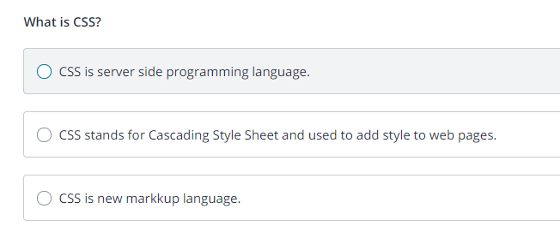

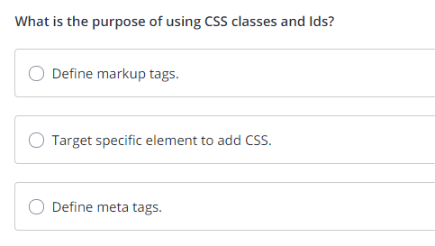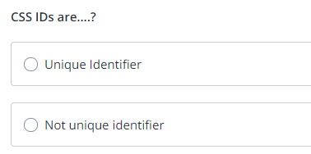

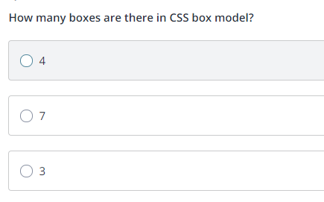

Conclusion To Styling With CSS

In this section, you start learning about CSS (Cascading Style Sheet). You learned about CSS box model and Classes & Ids. And then we moved forward applying these classes and rule set to small business page.  You got also familiar with Google Chrome Developer Tool. So you learned below things in this section.

1. **Google Chrome Developer Tool**
   1. Learn about inspecting elements
2. **What is CSS**
   1. CSS is Cascading Style Sheet
   2. Use to apply style to a web page
   3. Learn about CSS rut set Syntax
   4. Learn how to add external style sheet
   5. 3 ways to add CSS
      1. Inline style
      2. Internal style sheet
      3. External style sheet
   6. Learn about link tag
3. **CSS Box model**
   1. **Content box**
      1. All content image, text, heading etc goes inside this content box
   2. **Padding Box**
      1. Padding is used to generate space around content
   3. **Border box**
      1. Border box is just border around content
   4. **Margin Box**
      1. Margin generates space around the content but outside of boarded box
4. **CSS Classes & Ids**
   1. Learn about CSS Class selector
   2. Learn about CSS ID selector

And then we start adding CSS to this small business page.