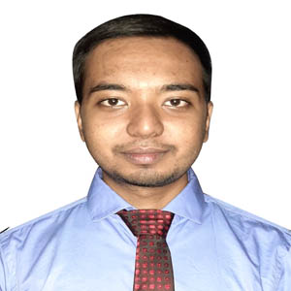

**BIPLOB KUMAR PAINE**

**Organized, Technical, Analytical**

Being an engineering graduate, I am willing to work in such an environment which provides me challenges and opportunities to expose my knowledge and potentials through my technical skills and hard work. I have a proactive attitude and like to find positive ways to stimulate and engage with people. I believe that if I am given the opportunity to serve, I can provide dedication and devotion to the assigned job.

**2013**

* **BSc in Computer Science and Engineering**

American International University-Bangladesh (AIUB), Dhaka.

G.P.A- 3.59 out of 4.00

N.S Govt. College, Natore.

G.P.A- 4.33 out of 5.00

* **Higher Secondary Certificate**

**2015**

United International University (UIU), Dhaka.

Major: Cyber Security

* **MSc in Computer Science and Engineering**
* Bike Riding
* Gardening
* Watching Science Fiction Movie
* **Bangla** (Native)
* **English**
* Completed 4 months internship as a Teaching Assistant in “Computer Networks” course under the supervisor Tasnim Rahman, faculty member of computer science in American International University-Bangladesh (AIUB).

**EXPERIENCE**

annanto2248@gmail.com

**🖂**

**🕽**

+8801772976852

**🏠**

Nikunjo 2, Khilkhet, Dhaka

**EDUCATION**

**2022-Present**

**CONTACT**

**2016-2021**

* **Secondary School Certificate**

Natore Govt. Boys’ High School, Natore.

G.P.A- 5.00 out of 5.00

**G.P.A- 5.00 out of 5.00**

**LANGUAGE**

**SKILL**

**REFERENCE**

* Completed CCNAv7: Introduction to Networks course and got certificate from CISCO.
* Completed NDG Linux Essentials course and got certificate from CISCO.
* Completed Microsoft Word course and got certificate from Ghoori Learning.
* Completed Microsoft PowerPoint course and got certificate from 10 Minute School.
* Completed Microsoft Excel course and got certificate from 10 Minute School.
* jsdjsdcsdh

**HOBBY**

* **DR. MOHAMMAD NURUL HUDA**

Director & Professor

Dept. of CSE, UIU

E-mail: mnh@cse.uiu.ac.bd

**REFERENCE**

**DECLARATION**

* **MOHAMMAD MAMUN ELAHI**

**Assistant Professor**

Dept. of **CSE**, UIU

E-mail: mmelahi@cse.uiu.ac.bd

Undersigned certified that to the best of my knowledge and belief this resume correctly describes my qualifications and me. Any wilful misstatement describes here in may lead to my disqualification or dismissal, if I employed.



---------------------

(Signature)