Software Requirement Specification

for

Student Management System

**Version 1.0**

**Prepared by**

Arup Datta (2016331010)

Muthmainna Mou (2016331017)

Biplob Mina (2016331068)

Sharmin Ahmed (2016331091)

Archi Arani Basak (2016331103)

**September 07, 2019**

# Content

**1 Introduction**3

1.1 Purpose 3

1.2 Intended Audience and Reading Suggestions 3

1.3 Product Scope 3

1.4 References 3

**2 Overall Description**4

2.1 Product Perspective 5

2.2 Product Functions 5

2.3 User Classes and Characteristics 6

2.4 Operating Environment 6

2.5 Design and Implementation Constraints 7

2.6 User Documentation 7

2.7 Assumptions and Dependencies 7

**3 External Interface Requirements**7

3.1 User Interfaces 7

3.1.1 Admin user interface 7

3.1.2 Public user interface 8

3.2 Hardware Interfaces 8

3.3 Software Interfaces 8

3.4 Communications Interfaces 8

**4 System Features**9

4.1 Create Class 9

4.2 Add or remove students 9

4.3 Give Assignments 9

4.4 Upload Class materials 10

4.5 Announcement 10

4.6 Update schedule 10

4.7 Join Class 11

4.8 Submit Assignment 11

4.9 Get notifications 12

4.10 View result 12

4.11 Update skills 12

4.12 View upcoming schedules 14

4.13 Search 14

4.14 Login 14

4.15 Logout 15

**5 Other Nonfunctional Requirements**16

5.1 Security Requirements 16

5.2 Software Quality Attributes 16

5.2.1 Reliability 16

5.2.2 Availability 16

5.2.3 Security 16

5.2.4 Maintainability 16

**6 Appendices**17

## 1. Introduction

### 1.1 Purpose

The purpose of this Software requirement specification (SRS) document is to gather requirements for Student Management System. This SRS Document contains the complete software requirements for the Online Student Management System and describes the design decisions, architectural design and the detailed design needed to implement the system. It provides the visibility in the design and provides information needed for software support.

### 1.2 Intended Audience and Reading Suggestions

The expected audiences for this document are head of the department, people of the administration. It will also be read by our project team.

### 1.3 Product Scope

The main purpose of the Student Management System is to provide a platform for better interaction between students and teachers. Users will be able to get all the features of the outlet via the internet. The new system will provide a user friendly interface that would be convenient for the teachers and students to exchange class materials and discuss problems. The benefit of using the system is that it can be accessible by all the users from any place.

### 1.4 References

[IEEE] The applicable IEEE Std 830-1993, IEEE Standard for Software Requirements Specifications, published in IEEE Standard Collection 2001 edition.

## 2. Overall Description

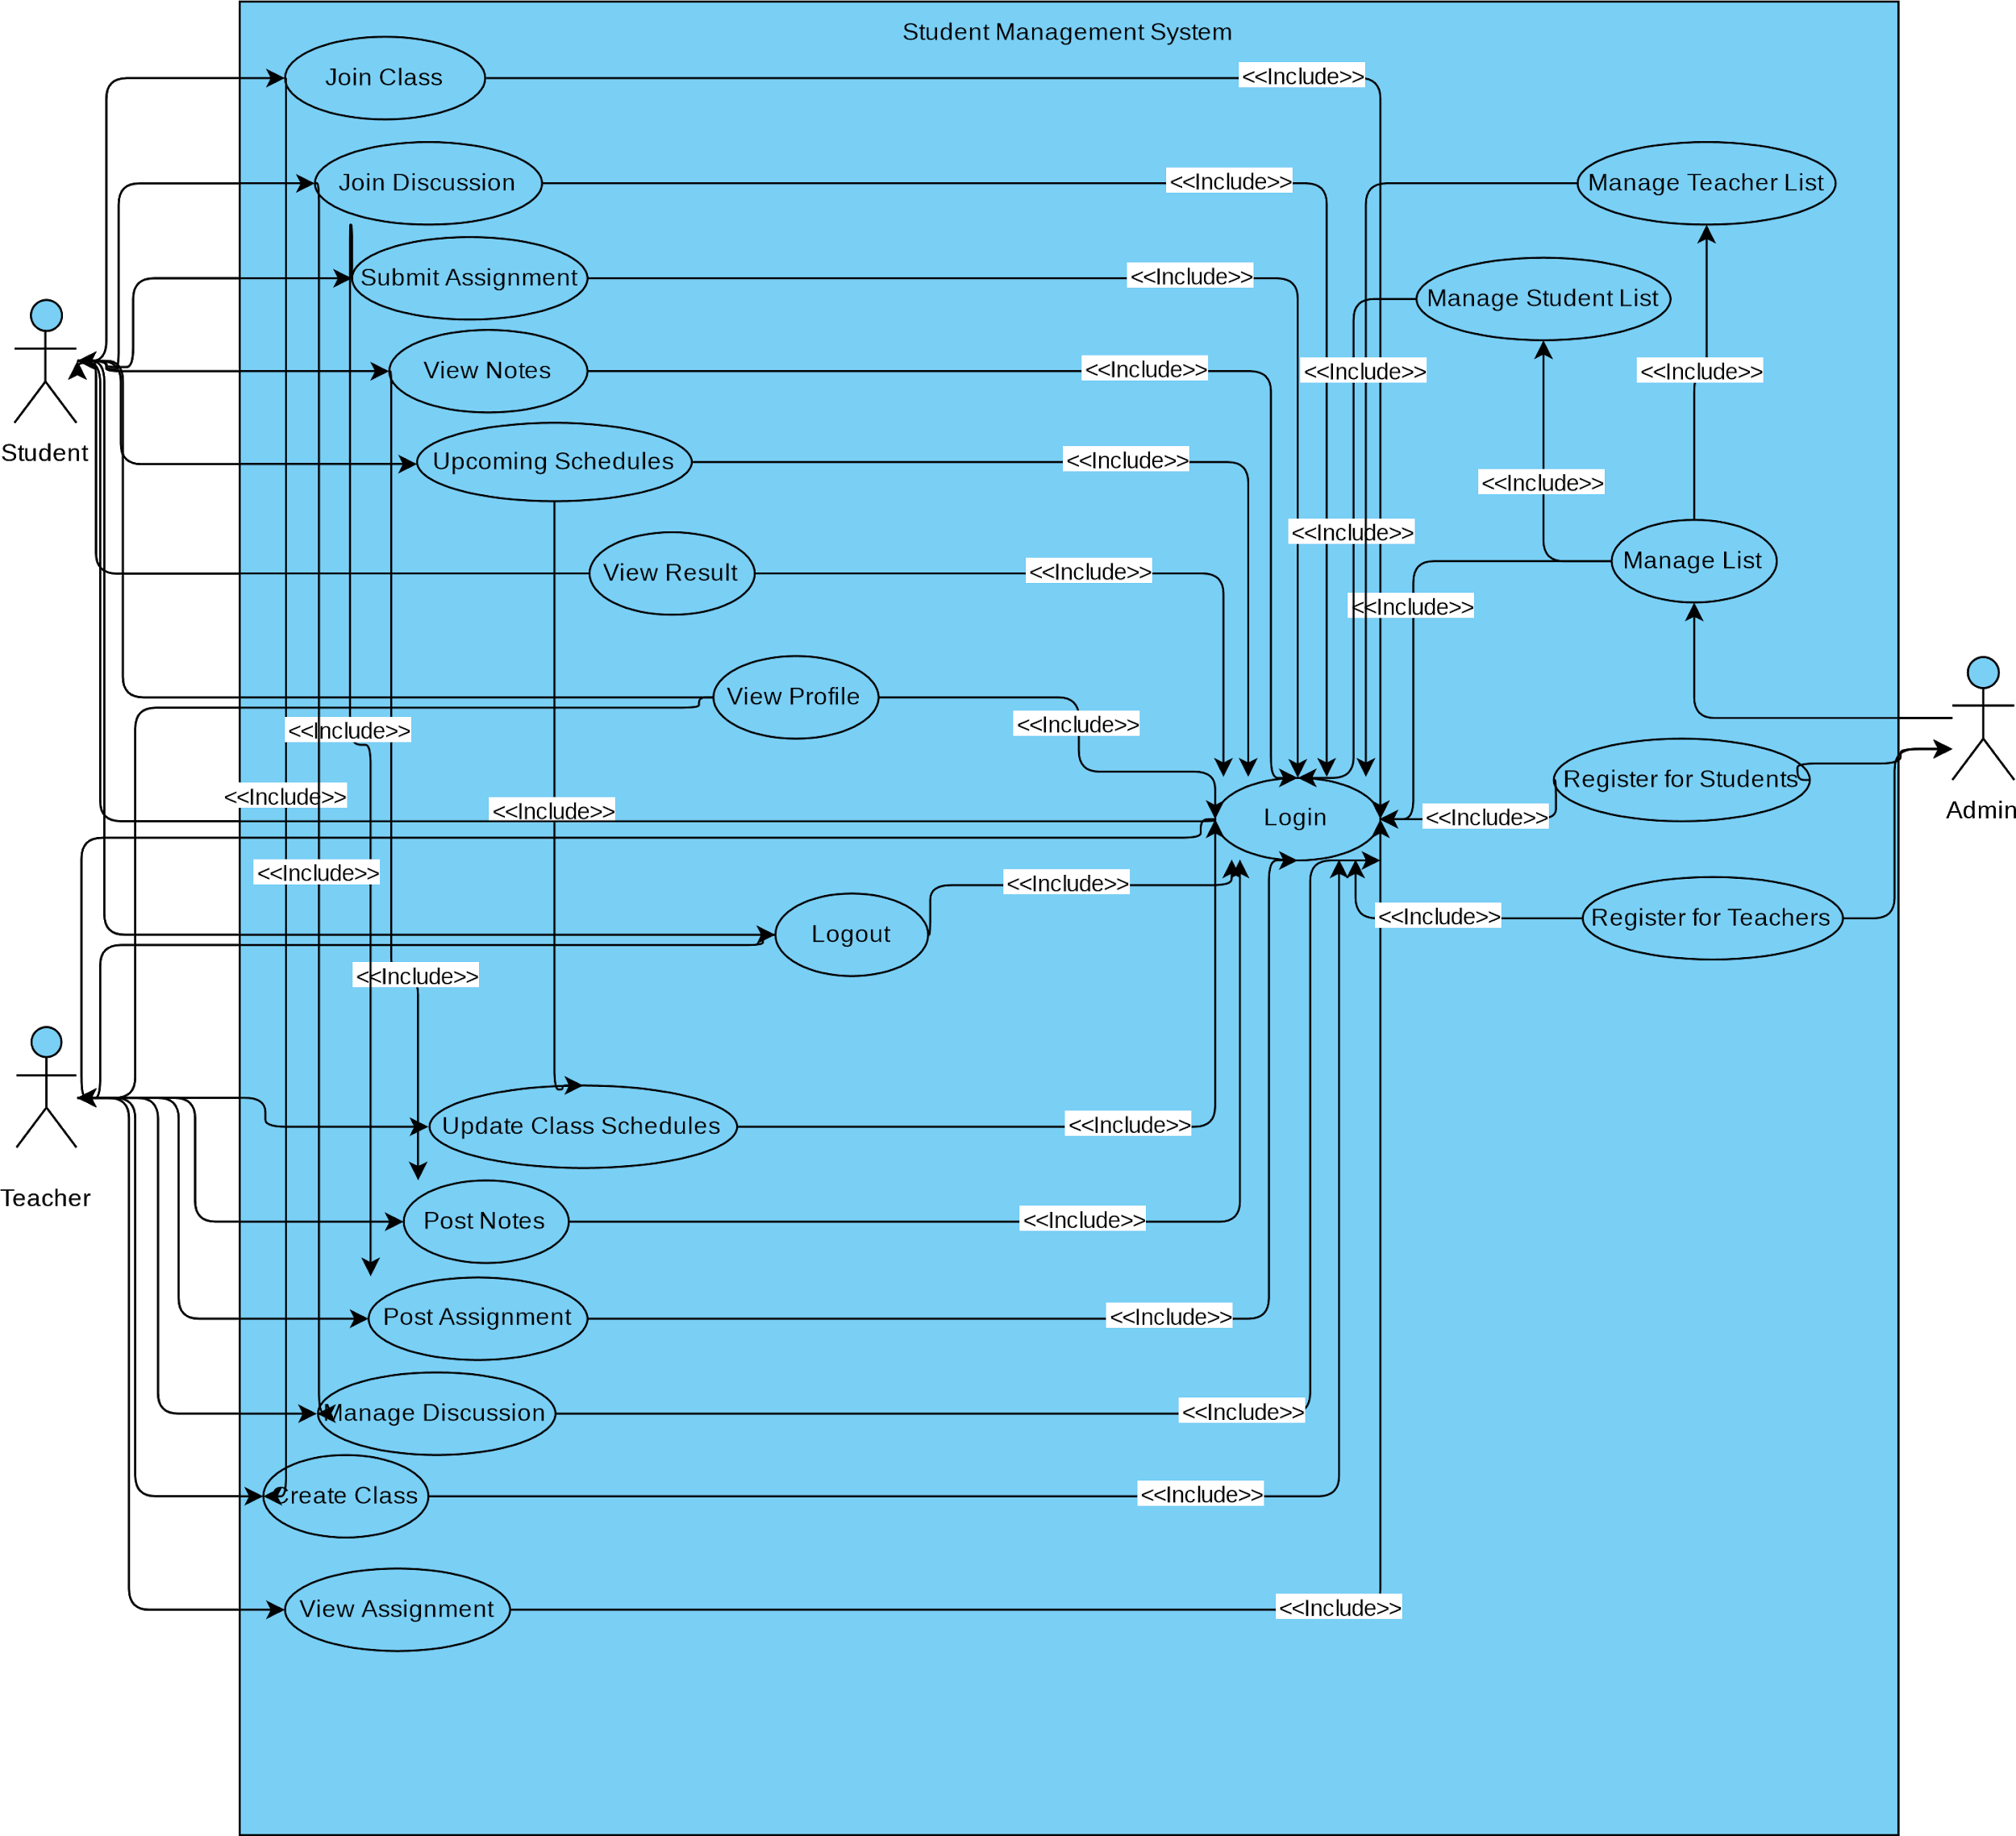

**Figure 1:** Use case Diagram for Student Management System

Student Management System allows authorized members to access the records of academically registered students. Admin can add new students and teachers to the system and give them userID (for student is the registration no, and teachers’ is teacherID). Admin can also add other admins. Teacher can create/remove classes. Teachers can upload the class materials and assignments and give upcoming schedule of exams or other notices. Admin will add the students in the classes (Example: Organization will see if the student has paid for the classes and add the student based on that). Students can get the class materials and submit assignments and get evaluated for the assignments. They can also see upcoming schedules and discuss in the class.

### 2.2 Product Functions

The system will deal with three types of users. Teacher, student and admin. Following is a list of some functionalities that the system will provide:

For Admin:

1. Create accounts
2. Update basic information
3. Delete accounts
4. Add students in the classes

For Teachers:

1. Create class
2. Give assignments or tasks
3. Upload class materials, forms
4. Announce any schedule such as upcoming exams
5. Update own class/exam schedule

For students:

1. Join class
2. Submit their assignment
3. Get notifications for upcoming schedules
4. View Result
5. View Notes
6. Discuss

### 2.3 User Classes and Characteristics

All of the Student Management Users must be familiar with the Internet and web. We have three types of users, they are admin, teachers and students

Admins:

Admin is a technical person who has sufficient knowledge on windows system as well as web platform.

Teachers:

Teachers need to have elementary knowledge of computers and the web.

Students:

Students also need to be familiar with computers and Web.

### 2.4 Operating Environment

For Operating Environment we use,

1. MS- Windows Operating System
2. MySQL
3. Xampp
4. Python 3.7
5. Django 2.2

1. Browser

### 2.5 Design and Implementation Constraints

The following constraints limit the developers options:

1. System will have HTTPS protocol for accessing to web server.
2. System will be able to store 10,000 user data.
3. System will store user password encrypted.
4. System will be able to handle 500 user access to server simultaneously.

### 2.6 User Documentation

Manuals for Admin Users will be provided. Admin will be able to use system after 2 hours of training.

### 2.7 Assumptions and Dependencies

### 

There is a list of assumptions and dependencies:

1. Admin will be able to access server in both ways (local and over the internet).
2. Teacher and students will be able to access server over internet.

## 3. External Interface Requirements

User interfaces for all users will be graphical user interface(GUI). These interfaces will be web based.

The admin user interface will enable the admin to perform all the functionalities which the system provides for this type of user. Admin can create or delete accounts and update basic information. Also admin can publish exam results. These features will be available through web interface.

Registered user interface:

1. Teacher: This interface allows teachers to login, logout, search students based on name, registration no, department, skills. They also can create class, add or remove students, give assignments, upload class materials, make announcements, update class schedules. These features will be available through web interface.
2. Students: This interface allows students to login, logout, search, join class, submit assignments, view results, add skills, view upcoming schedules. They will also get notifications. These features will be available through web interface.

Non-Registered user interface: This interface allows the users to login. These features will be available through web interface.

### 3.2 Hardware Interfaces

Since the service is web based the users will need a personal computer or an internet connection supported mobile. The nature of the data in generally text and image. Texts will be in English language.

### 3.3 Software Interfaces

1. Name: MS- Windows Operating System

Source: Microsoft Corporation

1. Name: MySQL

Source: Oracle Corporation

1. Name: Xampp
2. Name: Google Chrome(Browser)

Version: 76.0.3809.100

Source: Google

### 3.4 Communications Interfaces

1. HTTPS protocol for accessing to web server by remote users.
2. TCP/IP protocol for data communication over network.
3. Access method will be carrier sense multiple access collision detected (CSMA/CD)

## 4. System Features

Requirement ID : Functions.CreateClass

Title : Create Class

Description : Only teachers will be able to create class

Identifier/Source : Arnab Sen Sharma, lecturer of CSE dept of SUST, in the meeting held on 29/07/2019.

Rationale : To establish communication between teacher and students for a particular class.

Dependencies : Teacher must login to the system

Priority : High.

### 4.2 Add or remove students

Requirement ID : Functions.AddorRemoveStudents

Title :Add or remove students

Description : Admins can add or remove students

Identifier/Source : Arnab Sen Sharma, lecturer of CSE dept of SUST, in the meeting held on 29/07/2019.

Rationale : Students can view and participate in the tasks given in the classroom. The students who are not supposed to be in the classroom can be removed.

Priority : High.

### 4.3 Give Assignments

Requirement ID : Functions.GiveAssignments

Title : Give Assignments

Description : Teachers can give assignments and a specific time limit to complete the task

Identifier/Source : Arnab Sen Sharma, lecturer of CSE dept of SUST, in the meeting held on 29/07/2019.

Rationale : The students can view the assignment and submit it within the time limit.

Priority : Medium

### 4.4 Upload Class materials

Requirement ID : Functions.UploadClassMaterials

Title : Upload Class Materials or Forms

Description : Teachers can upload any type of class materials such as books, links, forms, files. The students can download the materials and view them.

Identifier/Source : Arnab Sen Sharma, lecturer of CSE dept of SUST, in the meeting held on 29/07/2019.

Rationale : The students can get the resources from the classroom without having to search in the web.

Priority : Medium

### 4.5 Announcement

Requirement ID : Functions.Announcement

Title : Make announcement (such as exams)

Description : Teacher can make an announcement of any upcoming schedules or exams.

Identifier/Source : Arnab Sen Sharma, lecturer of CSE dept of SUST, in the meeting held on 29/07/2019.

Rationale : Students get notification through the announcements and remain up-to-date.

Dependencies : N/A

Priority : Medium

### 4.6 Update schedule

Requirement ID : Functions.UpdateSchedule

Title : Update own schedule

Description : Teacher can update own class schedule. If the teacher wants to cancel the class, he/she will click the cancel button. And if the teacher can take the class, he/she will click okay button. This will automatically send notification to the students.

Identifier/Source : Arnab Sen Sharma, lecturer of CSE dept of SUST, in the meeting held on 29/07/2019.

Rationale :Teachers can confirm whether they can take the class. Students can get to know their class schedule.

Dependencies : N/A

Priority : Medium

### 4.7 Join Class

Requirement ID : Functions.JoinClass

Title : Join Class.

Description : Students will be able to join class if they are given the class code.

Identifier/Source : Arnab Sen Sharma, lecturer of CSE dept of SUST, in the meeting held on 29/07/2019.

Rationale : To get the class schedules, materials or assignments of the class.

Dependencies : The students must be logged in.

Priority : High

### 4.8 Submit Assignment

Requirement ID : Functions.SubmitAssignment

Title : Submit Assignment.

Description : Students will be able to submit the given tasks or assignments within the time limit.

Identifier/Source : Arnab Sen Sharma, lecturer of CSE dept of SUST, in the meeting held on 29/07/2019.

Rationale : So that students can submit the given assignment.

Dependencies : The student must be logged in and join the classroom.

Priority : Medium

### 4.9 Get notifications

Requirement ID : Functions.GetNotification

Title : Get notifications.

Description : Students will be notified when the class schedule is updated, any assignments or tasks are given, class materials are uploaded or the upcoming exam schedules are given.

Identifier/Source : Arnab Sen Sharma, Lecturer of CSE dept of SUST, in the meeting held on 29/07/2019.

Rationale : So that students are notified if any class materials or assignments are given or any changes occur in class schedule.

Dependencies : The student must be logged in and join the classroom.

Priority : High

### 4.10 View result

Requirement ID : Functions.ViewResult

Title : View Result.

Description :Students will be able to view the result published by the admin. They can view results of every semester and every course.They can also get to know their cumulative cgpa.

Identifier/Source : Arnab Sen Sharma, lecturer of CSE dept of SUST, in the meeting held on 29/07/2019.

Rationale : Students can know their result whenever the result is published.

Dependencies : The students must be logged in.

Priority : High

### 4.11 View upcoming schedules

Requirement ID : Functions.UpcomingSchedules

Title : Upcoming schedules.

Description : The users i.e students and teacher can view their schedules of upcoming days.

Identifier/Source : Arnab Sen Sharma, lecturer of CSE dept of SUST, in the meeting held on 29/07/2019.

Rationale : The students can get to know the schedules of upcoming classes, exams or assignments. Teachers can know their upcoming schedules.

Dependencies : The user must be logged in.

Priority : Medium

### 4.13 Search

Requirement ID : Functions.Search

Title : Search for students.

Description : Teachers or students can search for students based on names, department name, registration no, skills. Then the students will be filtered out.

Identifier/Source : Arnab Sen Sharma, lecturer of CSE dept of SUST, in the meeting held on 29/07/2019.

Rationale : Teachers or students can filter out and find students.

Dependencies : The user must be logged in.

Priority : Low

### 4.14 Login

Requirement ID : Functions.Login

Title : Login to the system.

Description : The users shall be able to login into the system using their username and password.

Identifier/Source : Arnab Sen Sharma, lecturer of CSE dept of SUST, in the meeting held on 29/07/2019.

Rationale : The system would have to distinguish authorized users and unauthorized users.

Dependencies : The user must be registered.

Priority : High

### 4.15 Logout

Requirement ID : Functions.Logout

Title : Logout from the system.

Description : Logged in user should be able to logout of the system.

Identifier/Source : Arnab Sen Sharma, lecturer of CSE dept of SUST, in the meeting held on 29/07/2019.

Rationale : Logged in users may need to be logged out of the system.

Restrictions & Risks : N/A

Dependencies : The user must be logged in.

Priority : High

|  |  |
| --- | --- |
|  |  |

## 5. Other Nonfunctional Requirements

### 5.1 Security Requirements

The system will not be usable (but will be accessible) by unauthorized users. To use the features, a person must register in the system. Only registered members can login using their username and password and use the features.

There will be proper privileges according to the user type. i.e. Admin or Member(Student and teachers).

### 5.2 Software Quality Attributes

#### 5.2.1 Reliability

1. The system should perform its operations and functionalities without any crash.
2. The system should be able to recover from data loss due to system failure etc.

#### 5.2.2 Availability

1. The system will be available always, even during the system backups and recoveries.

#### 5.2.3 Security

1. There will be proper user privileges according to the user type i. admin, teacher, students.
2. Users will be able to login into the system only by using his or her email address and password.

#### 5.2.4 Maintainability

There are no maintainability requirements.

## 6. Appendices

Admin : The person who will check and update the website all the time and register or delete users.

Database : A tabular system that stores all the data related to the website.

HTTPS : HyperText Transfer Protocol (Secured)

TCP/IP : Transmission Control Protocol/Internet Protocol

CSMA/CD : Carrier Sense Multiple Access with Collision Detection.