Thực hành KTMT Lab 12
Lê Quốc Đảng
20225801
Assignment 1
- Code
.eqv IN_ADRESS_HEXA_KEYBOARD 0xFFFF0012
.eqv OUT_ADRESS_HEXA_KEYBOARD 0xFFFF0014
.data
mess: .asciiz "\n"
.text
main:
li $t1, IN_ADRESS_HEXA_KEYBOARD
li $t2, OUT_ADRESS_HEXA_KEYBOARD
li $t3, 0x01 # check row 4 with key 0, 1, 2, 3
li $t4, 0x02 # check row 4 with key 4, 5, 6, 7
li $t5, 0x04 # check row 4 with key 8, 9, A, B
li $t6, 0x08 # check row 4 with key C, D, E, F

polling:
sb $t3, 0($t1) # must reassign expected row
lb $a0, 0($t2) # read scan code of key button
bne $a0, $zero, print
sb $t4, 0($t1) # must reassign expected row
lb $a0, 0($t2) # read scan code of key button
bne $a0, $zero, print
sb $t5, 0($t1) # must reassign expected row
lb $a0, 0($t2) # read scan code of key button
bne $a0, $zero, print
sb $t6, 0($t1) # must reassign expected row
lb $a0, 0($t2) # read scan code of key button
bne $a0, $zero, print
j sleep
print:
li $v0, 34 # print integer (hexa)
syscall
la $a0, mess #print "\n"
li $v0, 4
syscall
sleep:
li $a0, 3000 # sleep 3000ms
li $v0, 32
syscall
back_to_polling:
j polling # continue polling
exit:
- Thực thi
-Chương trình thực hiện lần lượt gán giá trị $t1 lần lượt bằng 0x01, 0x02, 0x04, 0x08 để kiểm tra xem hàng nào được bấm. Load giá trị $t2, nếu != 0 thì in ra.

-Kết quả
- Bấm phím 0
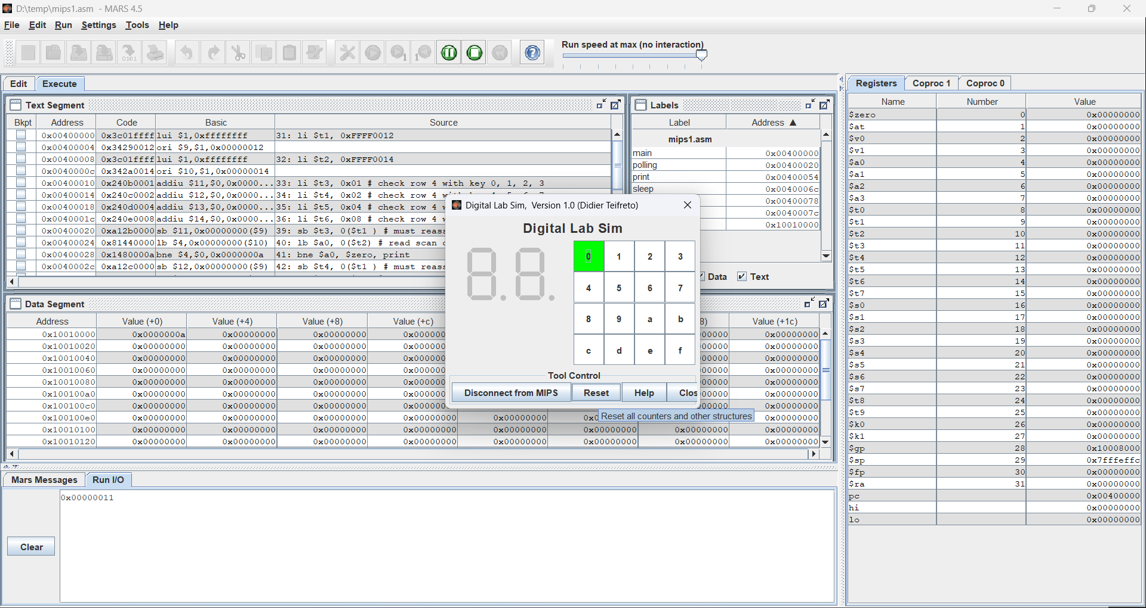
- Bấm phím 1
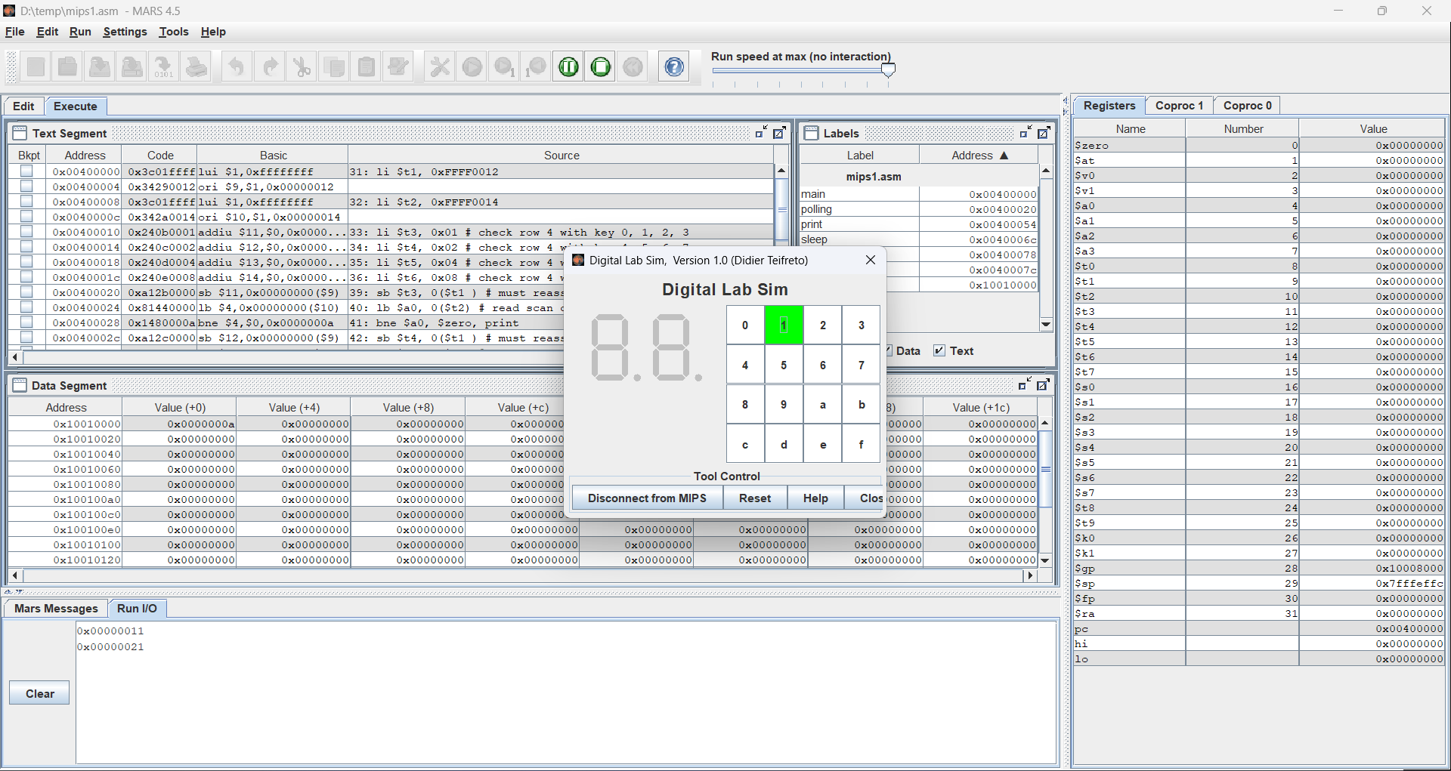
- Bấm phím 2
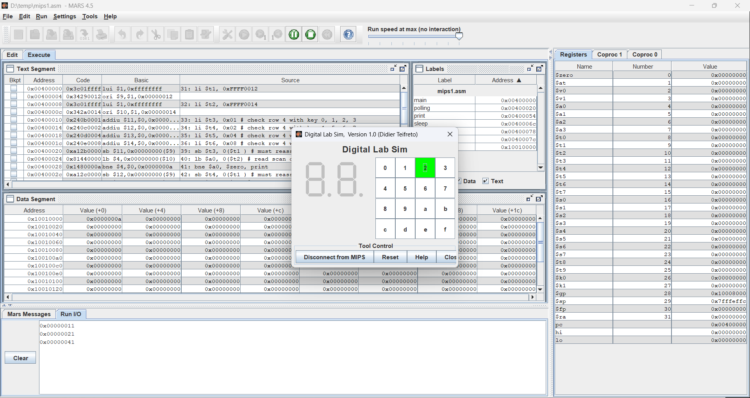
- Và lần lượt như vậy, được kết quả là
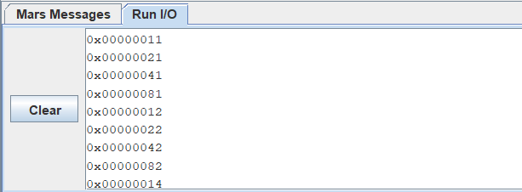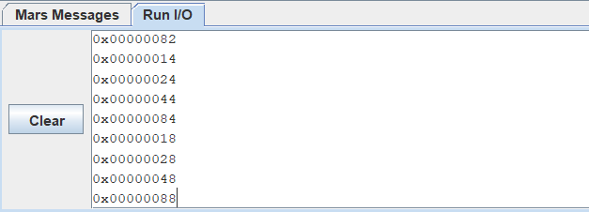

Assignment 2
- Code
.eqv IN_ADRESS_HEXA_KEYBOARD 0xFFFF0012
.eqv OUT_ADRESS_HEXA_KEYBOARD 0xFFFF0014
.data
Message1: .asciiz "Oh my god. Someone's presed a button: "
Message2: .asciiz "\n"

#~~~~~~~~~~~~~~~~~~~~~~~~~~~~~~~~~~~~~~~~~~~~~~~~~~~~~~~~~~~~~~~~~
# MAIN Procedure
#~~~~~~~~~~~~~~~~~~~~~~~~~~~~~~~~~~~~~~~~~~~~~~~~~~~~~~~~~~~~~~~~~
.text
main:
#---------------------------------------------------------
# Enable interrupts you expect
#---------------------------------------------------------
# Enable the interrupt of Keyboard matrix 4x4 of Digital Lab Sim
li $t1, IN_ADRESS_HEXA_KEYBOARD
li $t7, 0x80 # bit 7 of = 1 to enable interrupt
sb $t7, 0($t1)
#---------------------------------------------------------
# No-end loop, main program, to demo the effective of interrupt
#---------------------------------------------------------
Loop: nop
nop
nop
nop
b Loop # Wait for interrupt
end_main:
#~~~~~~~~~~~~~~~~~~~~~~~~~~~~~~ ~~~~~~~~~~~~~~~~~~~~~~~~~~~~~~~~~~~
# GENERAL INTERRUPT SERVED ROUTINE for all interrupts
#~~~~~~~~~~~~~~~~~~~~~~~~~~~~~~~~~~~~~~~~~~~~~~~~~~~~~~~~~~~~~~~~~
.ktext 0x80000180
#--------------------------------------------------------
# Processing
#--------------------------------------------------------

addi $v0, $zero, 4 # show message
la $a0, Message1
syscall

li $t1, IN_ADRESS_HEXA_KEYBOARD
li $t2, OUT_ADRESS_HEXA_KEYBOARD
li $t3, 0x01 # check row 4 with key 0, 1, 2, 3
li $t4, 0x02 # check row 4 with key 4, 5, 6, 7
li $t5, 0x04 # check row 4 with key 8, 9, A, B
li $t6, 0x08 # check row 4 with key C, D, E, F

sb $t3, 0($t1) # must reassign expected row
lbu $a0, 0($t2) # read scan code of key button
bne $a0, $zero, print
sb $t4, 0($t1) # must reassign expected row
lbu $a0, 0($t2) # read scan code of key button
bne $a0, $zero, print
sb $t5, 0($t1) # must reassign expected row
lbu $a0, 0($t2) # read scan code of key button
bne $a0, $zero, print
sb $t6, 0($t1) # must reassign expected row
lbu $a0, 0($t2) # read scan code of key button
bne $a0, $zero, print

print:
li $v0, 34 # print integer (hexa)
syscall

addi $v0, $zero, 4 # show message
la $a0, Message2
syscall

li $t7, 0x80 # bit 7 of = 1 to enable interrupt
sb $t7, 0($t1)

#--------------------------------------------------------
# Evaluate the return address of main routine
# epc <= epc + 4
#--------------------------------------------------------
next_pc:mfc0 $at, $14 # $at <= Coproc0.$14 = Coproc0.epc
addi $at, $at, 4 # $at = $at + 4 (next instruction)
mtc0 $at, $14 # Coproc0.$14 = Coproc0.epc <= $at
return: eret # Return from exception
- Thực thi
-Chương trình thực hiện kiểm tra phím được bấm tương tụ như bài 1. Sau khi in ra kí tự được bấm thì gán giá trị ở IN_ADRESS_HEXA_KEYBOARD = 0x80 để enable interrupt.
-Bấm phím 0
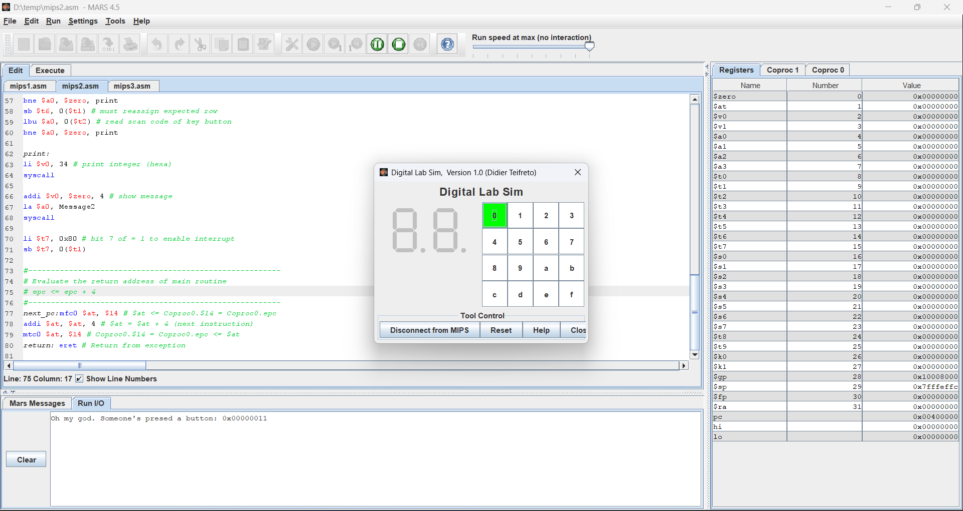
-Bấm phím 9
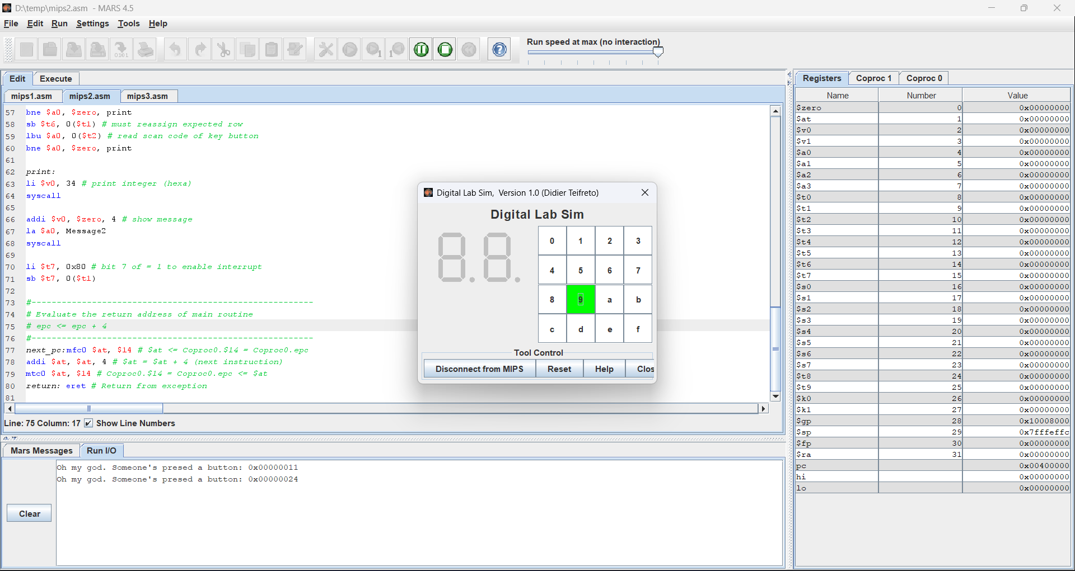
-Bấm phím f
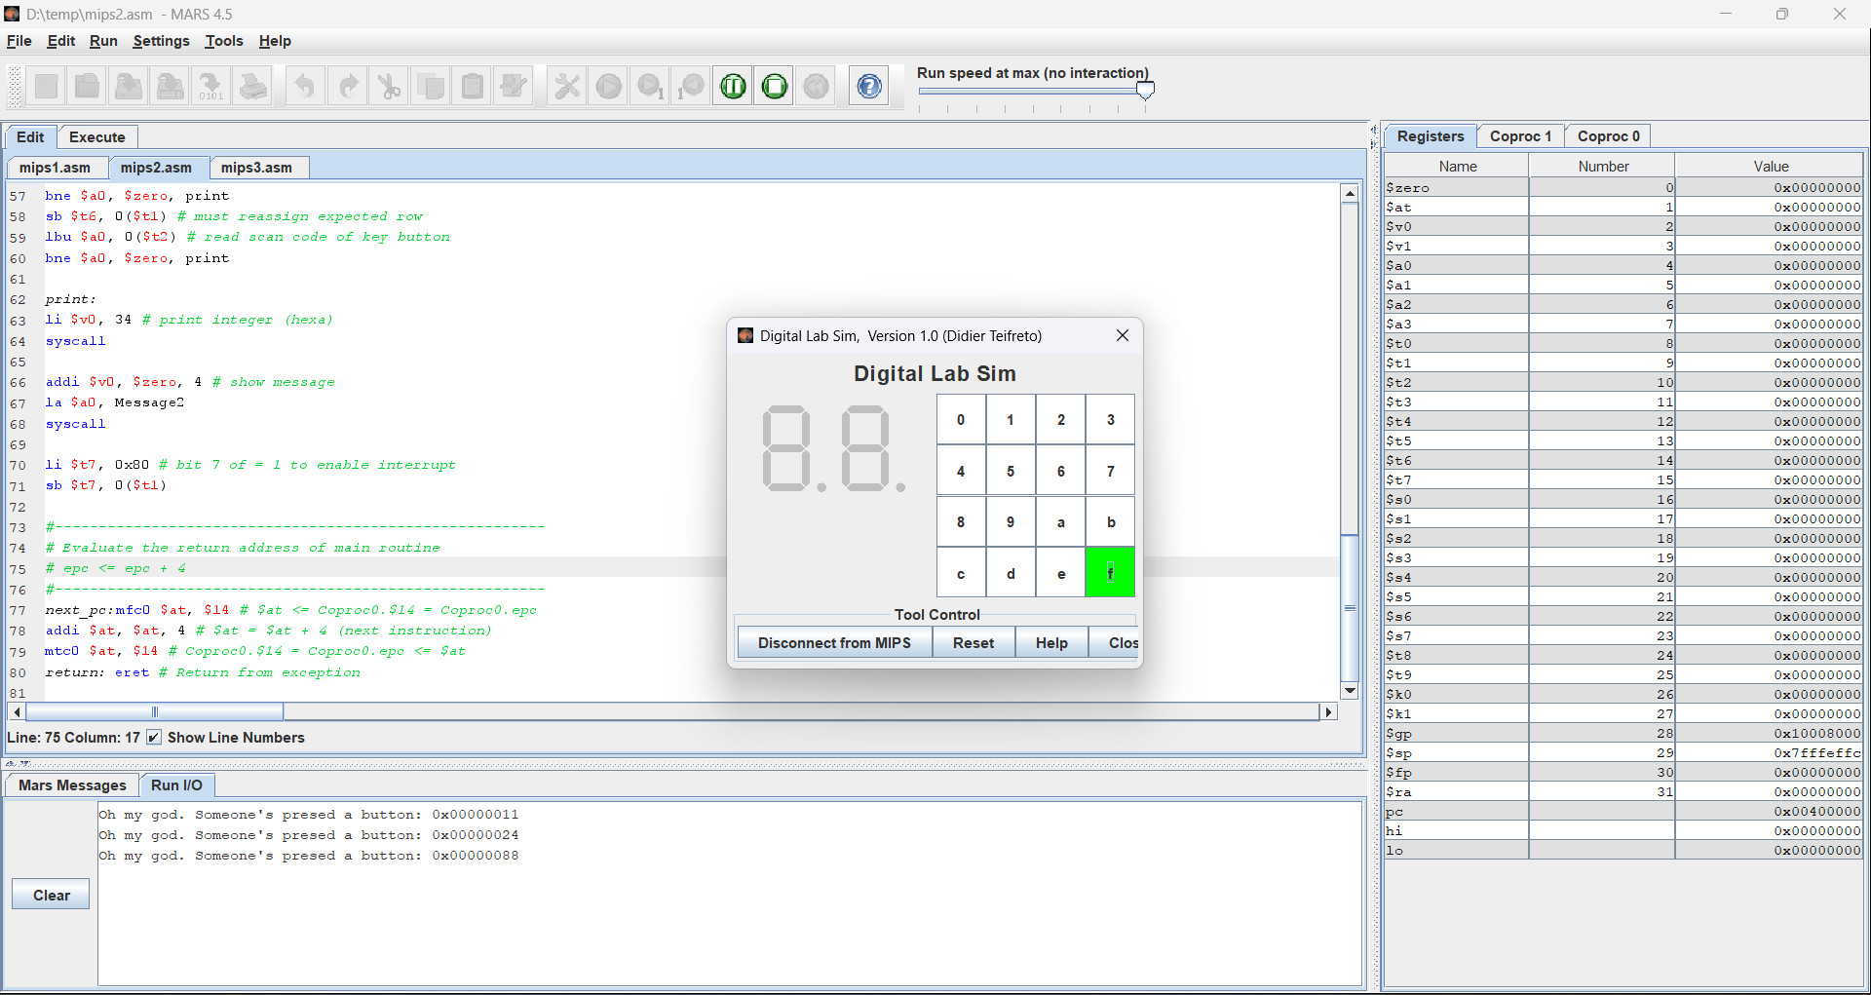
Assignment 3
- Code
.eqv IN_ADRESS_HEXA_KEYBOARD 0xFFFF0012
.eqv OUT_ADRESS_HEXA_KEYBOARD 0xFFFF0014
.data
Message: .asciiz "Key scan code "
#~~~~~~~~~~~~~~~~~~~~~~~~~~~~~~~~~~~~~~~~~~~~~~~~~~~~~~~~~~~~~~~~~
# MAIN Procedure
#~~~~~~~~~~~~~~~~~~~~~~~~~~~~~~~~~~~~~~~~~~~~~~~~~~~~~~~~~~~~~~~~~
.text
main:
#---------------------------------------------------------
# Enable interrupts you expect
#---------------------------------------------------------
# Enable the interrupt of Keyboard matrix 4x4 of Digital Lab Sim
li $t1, IN_ADRESS_HEXA_KEYBOARD
li $t2, OUT_ADRESS_HEXA_KEYBOARD
li $t3, 0x80 # bit 7 = 1 to enable
sb $t3, 0($t1)
#---------------------------------------------------------
# Loop an print sequence numbers
#---------------------------------------------------------
xor $s0, $s0, $s0 # count = $s0 = 0
Loop: addi $s0, $s0, 1 # count = count + 1
prn_seq:addi $v0,$zero,1
add $a0,$s0,$zero # print auto sequence number
syscall
prn_eol:addi $v0,$zero,11
li $a0,'\n' # print endofline
syscall
sleep: addi $v0,$zero,32
li $a0,1000 # sleep 300 ms
syscall
nop # WARNING: nop is mandatory here.
b Loop # Loop
end_main:
#~~~~~~~~~~~~~~~~~~~~~~~~~~~~~~~~~~~~~~~~~~~~~~~~~~~~~~~~~~~~~~~~~
# GENERAL INTERRUPT SERVED ROUTINE for all interrupts
#~~~~~~~~~~~~~~~~~~~~~~~~~~~~~~~~~~~~~~~~~~~~~~~~~~~~~~~~~~~~~~~~~
.ktext 0x80000180
#-------------------------------------------------------
# SAVE the current REG FILE to stack
#-------------------------------------------------------
IntSR: addi $sp,$sp,4 # Save $ra because we may change it later
sw $ra,0($sp)
addi $sp,$sp,4 # Save $ra because we may change it later
sw $at,0($sp)
addi $sp,$sp,4 # Save $ra because we may change it later
sw $v0,0($sp)
addi $sp,$sp,4 # Save $a0, because we may change it later
sw $a0,0($sp)
addi $sp,$sp,4 # Save $t1, because we may change it later
sw $t1,0($sp)
addi $sp,$sp,4 # Save $t2, because we may change it later
sw $t2,0($sp)
addi $sp,$sp,4 # Save $t3, because we may change it later
sw $t3,0($sp)
addi $sp,$sp,4 # Save $t4, because we may change it later
sw $t4,0($sp)
addi $sp,$sp,4 # Save $t5, because we may change it later
sw $t5,0($sp)
addi $sp,$sp,4 # Save $t6, because we may change it later
sw $t6,0($sp)
#--------------------------------------------------------
# Processing
#--------------------------------------------------------
prn_msg: addi $v0, $zero, 4
la $a0, Message
syscall
get_cod: li $t1, IN_ADRESS_HEXA_KEYBOARD
li $t2, OUT_ADRESS_HEXA_KEYBOARD
li $t3, 0x01 # check row 1 with key 0, 1, 2, 3
li $t4, 0x02 # check row 2 with key 4, 5, 6, 7
li $t5, 0x04 # check row 3 with key 8, 9, A, B
li $t6, 0x08 # check row 4 with key C, D, E, F
sb $t3, 0($t1 ) # must reassign expected row
lbu $a0, 0($t2) # read scan code of key button
bne $a0, $zero, prn_cod
sb $t4, 0($t1 ) # must reassign expected row
lbu $a0, 0($t2) # read scan code of key button
bne $a0, $zero, prn_cod
sb $t5, 0($t1 ) # must reassign expected row
lbu $a0, 0($t2) # read scan code of key button
bne $a0, $zero, prn_cod
sb $t6, 0($t1 ) # must reassign expected row
lbu $a0, 0($t2) # read scan code of key button
bne $a0, $zero, prn_cod
prn_cod:li $v0,34
syscall
li $v0,11
li $a0,'\n' # print endofline
syscall
#--------------------------------------------------------
# Evaluate the return address of main routine
# epc <= epc + 4
#--------------------------------------------------------
next_pc:mfc0 $at, $14 # $at <= Coproc0.$14 = Coproc0.epc
addi $at, $at, 4 # $at = $at + 4 (next instruction)
mtc0 $at, $14 # Coproc0.$14 = Coproc0.epc <= $at
#--------------------------------------------------------
# RESTORE the REG FILE from STACK
#--------------------------------------------------------
restore: li $t7, 0x80 # bit 7 of = 1 to enable interrupt
sb $t7, 0($t1)
lw $t6, 0($sp) # Restore the registers from stack
addi $sp,$sp,-4
lw $t5, 0($sp) # Restore the registers from stack
addi $sp,$sp,-4
lw $t4, 0($sp) # Restore the registers from stack
addi $sp,$sp,-4
lw $t3, 0($sp) # Restore the registers from stack
addi $sp,$sp,-4
lw $t2, 0($sp) # Restore the registers from stack
addi $sp,$sp,-4
lw $t1, 0($sp) # Restore the registers from stack
addi $sp,$sp,-4
lw $a0, 0($sp) # Restore the registers from stack
addi $sp,$sp,-4
lw $v0, 0($sp) # Restore the registers from stack
addi $sp,$sp,-4
lw $at, 0($sp) # Restore the registers from stack
addi $sp,$sp,-4
lw $ra, 0($sp) # Restore the registers from stack
addi $sp,$sp,-4
return: eret # Return from exception

- Thực thi
-Chương trình kiểm tra nút được bấm tương tự như bài 2. Sau khi in ra kí tự được bấm thì gán giá trị ở IN_ADRESS_HEXA_KEYBOARD = 0x80 để enable interrupt.
-Bấm phím 1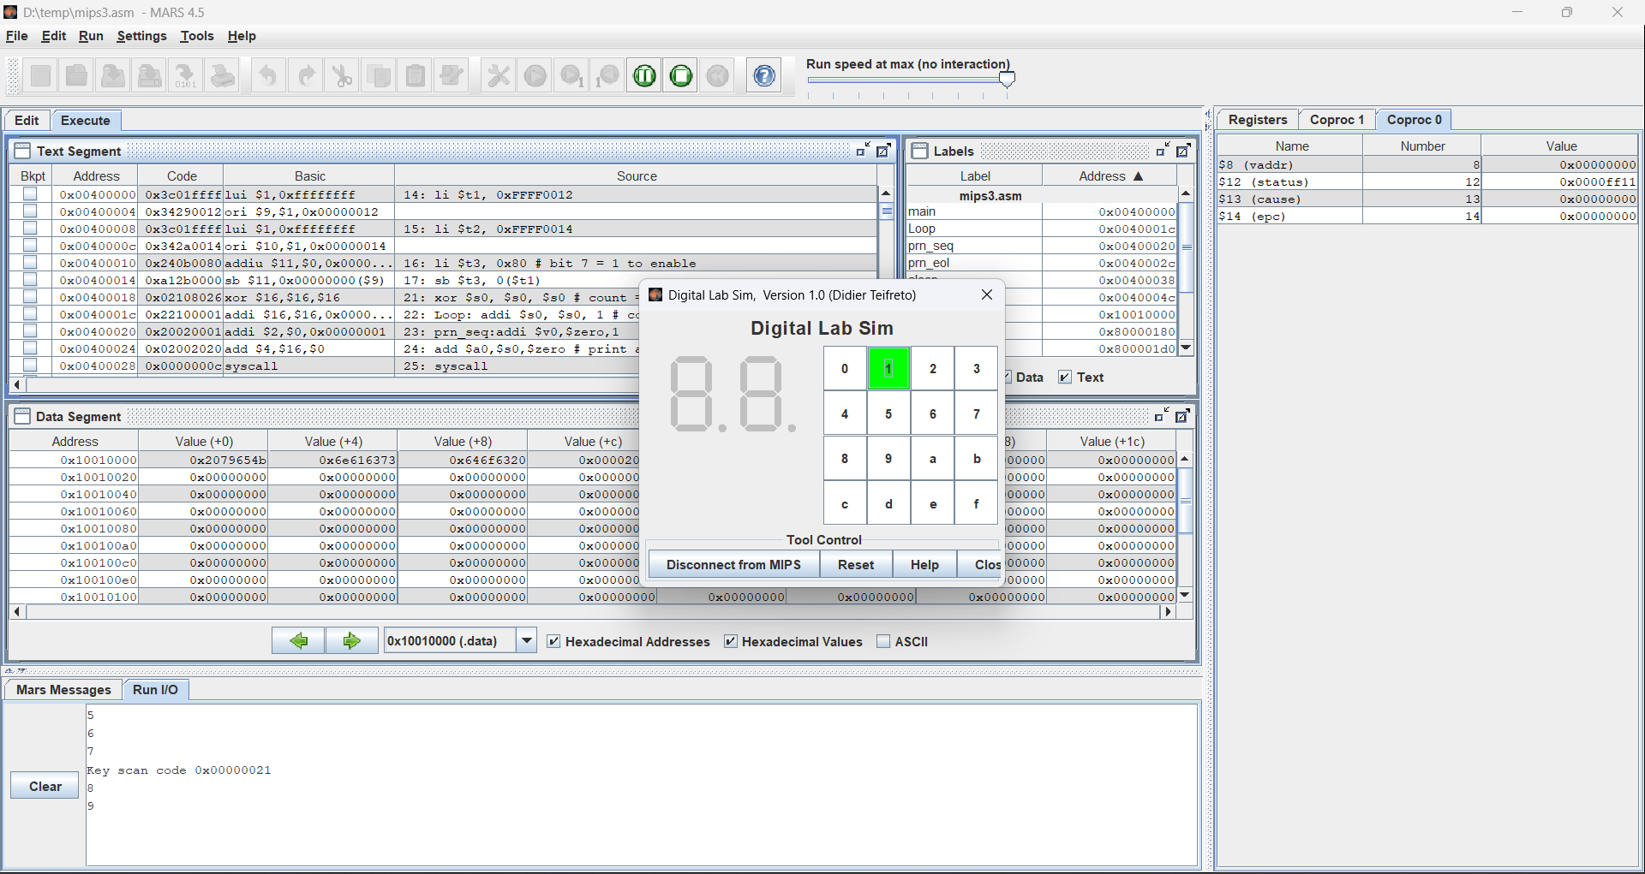
-Bấm phím a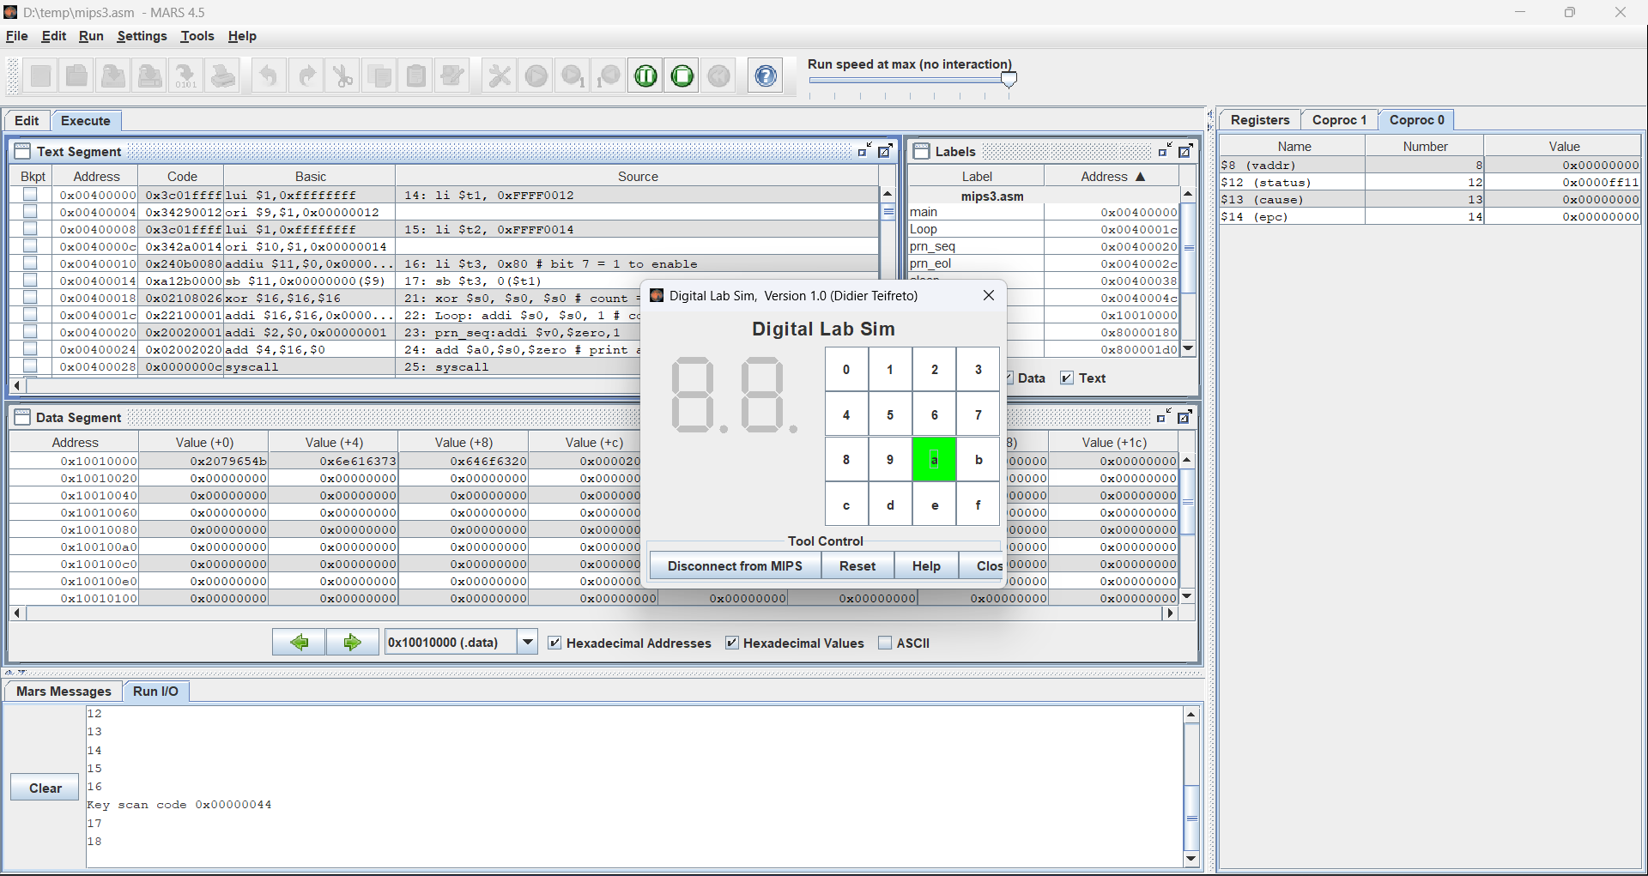
-Bấm phím d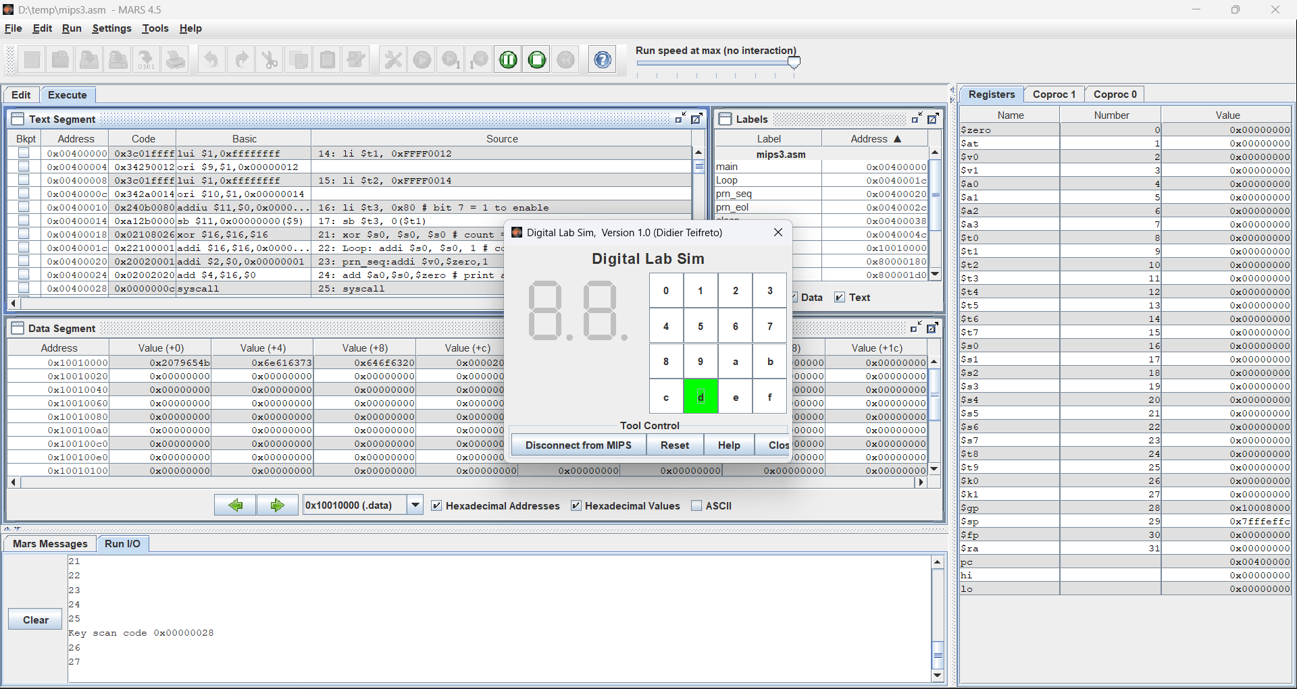
-Bấm phím c