Thực hành KTMT Lab 13
Lê Quốc Đảng
20225801
Assignment 4
- Code
.eqv IN_ADRESS_HEXA_KEYBOARD 0xFFFF0012
.eqv OUT_ADRESS_HEXA_KEYBOARD 0xFFFF0014
.eqv COUNTER 0xFFFF0013 # Time Counter
.eqv MASK_CAUSE_COUNTER 0x00000400 # Bit 10: Counter interrupt
.eqv MASK_CAUSE_KEYMATRIX 0x00000800 # Bit 11: Key matrixinterrupt
.data
msg_keypress: .asciiz "Someone has pressed a key: "
msg: .asciiz "\n"
msg_counter: .asciiz "Time inteval!\n"
#~~~~~~~~~~~~~~~~~~~~~~~~~~~~~~~~~~~~~~~~~~~~~~~~~~~~~~~~~~~~~~~~~
# MAIN Procedure
#~~~~~~~~~~~~~~~~~~~~~~~~~~~~~~~~~~~~~~~~~~~~~~~~~~~~~~~~~~~~~~~~~
.text
main:
#---------------------------------------------------------
# Enable interrupts you expect
#---------------------------------------------------------
# Enable the interrupt of Keyboard matrix 4x4 of Digital Lab Sim
li $t1, IN_ADRESS_HEXA_KEYBOARD
li $t3, 0x80 # bit 7 = 1 to enable
sb $t3, 0($t1)
# Enable the interrupt of TimeCounter of Digital Lab Sim
li $t1, COUNTER
sb $t1, 0($t1)
#---------------------------------------------------------
# Loop an print sequence numbers
#---------------------------------------------------------
Loop: nop
nop
nop
sleep: addi $v0,$zero,32 # BUG: must sleep to wait for Time Counter
li $a0,200 # sleep 300 ms
syscall
nop # WARNING: nop is mandatory here.
b Loop
end_main:
#~~~~~~~~~~~~~~~~~~~~~~~~~~~~~~~~~~~~~~~~~~~~~~~~~~~~~~~~~~~~~~~~~
# GENERAL INTERRUPT SERVED ROUTINE for all interrupts
#~~~~~~~~~~~~~~~~~~~~~~~~~~~~~~~~~~~~~~~~~~~~~~~~~~~~~~~~~~~~~~~~~
.ktext 0x80000180
IntSR: #--------------------------------------------------------
# Temporary disable interrupt
#--------------------------------------------------------
dis_int:li $t1, COUNTER # BUG: must disable with Time Counter
sb $zero, 0($t1)
# no need to disable keyboard matrix interrupt
#--------------------------------------------------------
# Processing
#--------------------------------------------------------
get_caus:mfc0 $t1, $13 # $t1 = Coproc0.cause
IsCount:li $t2, MASK_CAUSE_COUNTER# if Cause value confirm Counter..
and $at, $t1,$t2
beq $at,$t2, Counter_Intr
IsKeyMa:li $t2, MASK_CAUSE_KEYMATRIX # if Cause value confirm Key..
and $at, $t1,$t2
beq $at,$t2, Keymatrix_Intr
others: j end_process # other cases
Keymatrix_Intr: li $v0, 4 # Processing Key Matrix Interrupt
la $a0, msg_keypress
syscall
#--------------------------------------------------------
# Kiểm tra xem nút nào được bấm
li $t1, IN_ADRESS_HEXA_KEYBOARD
li $t2, OUT_ADRESS_HEXA_KEYBOARD
li $t3, 0x01 # check row 4 with key 0, 1, 2, 3
li $t4, 0x02 # check row 4 with key 4, 5, 6, 7
li $t5, 0x04 # check row 4 with key 8, 9, A, B
li $t6, 0x08 # check row 4 with key C, D, E, F
sb $t3, 0($t1) # must reassign expected row
lbu $a0, 0($t2) # read scan code of key button
bne $a0, $zero, print
sb $t4, 0($t1) # must reassign expected row
lbu $a0, 0($t2) # read scan code of key button
bne $a0, $zero, print
sb $t5, 0($t1) # must reassign expected row
lbu $a0, 0($t2) # read scan code of key button
bne $a0, $zero, print
sb $t6, 0($t1) # must reassign expected row
lbu $a0, 0($t2) # read scan code of key button
bne $a0, $zero, print
#--------------------------------------------------------
print:
li $v0, 34 # print integer (hexa)
syscall
print_n:
li $v0, 4 # Processing Counter Interrupt
la $a0, msg
syscall
#--------------------------------------------------------
# Re-enable the interrupt of Keyboard matrix 4x4 of Digital Lab Sim
li $t2, IN_ADRESS_HEXA_KEYBOARD
li $t3, 0x80 # bit 7 = 1 to enable
sb $t3, 0($t2)
#--------------------------------------------------------
j end_process
Counter_Intr: li $v0, 4 # Processing Counter Interrupt
la $a0, msg_counter
syscall
j end_process
end_process:
mtc0 $zero, $13 # Must clear cause reg
en_int: #--------------------------------------------------------
# Re-enable interrupt
#--------------------------------------------------------
li $t1, COUNTER
sb $t1, 0($t1)
#--------------------------------------------------------
# Evaluate the return address of main routine
# epc <= epc + 4
#--------------------------------------------------------
next_pc:mfc0 $at, $14 # $at <= Coproc0.$14 = Coproc0.epc
addi $at, $at, 4 # $at = $at + 4 (next instruction)
mtc0 $at, $14 # Coproc0.$14 = Coproc0.epc <= $at
return: eret # Return from exception
- Thực thi
-Khi nhảy đoạn mã cho xử lí ngắt, kiểm tra xem đó là ngắt của Counter hay Keyboard matrix 4x4.
-Nếu là của Keyboard kiểm tra xem là bấm nút nào bằng cách lần lượt gán giá trị $t1 lần lượt bằng 0x01, 0x02, 0x04, 0x08 để kiểm tra xem hàng nào được bấm. Load giá trị $t2, nếu != 0 thì in ra. Sau khi in ra thì re-able ngắt của Keyboard.

-Kết quả
Bấm nút 4
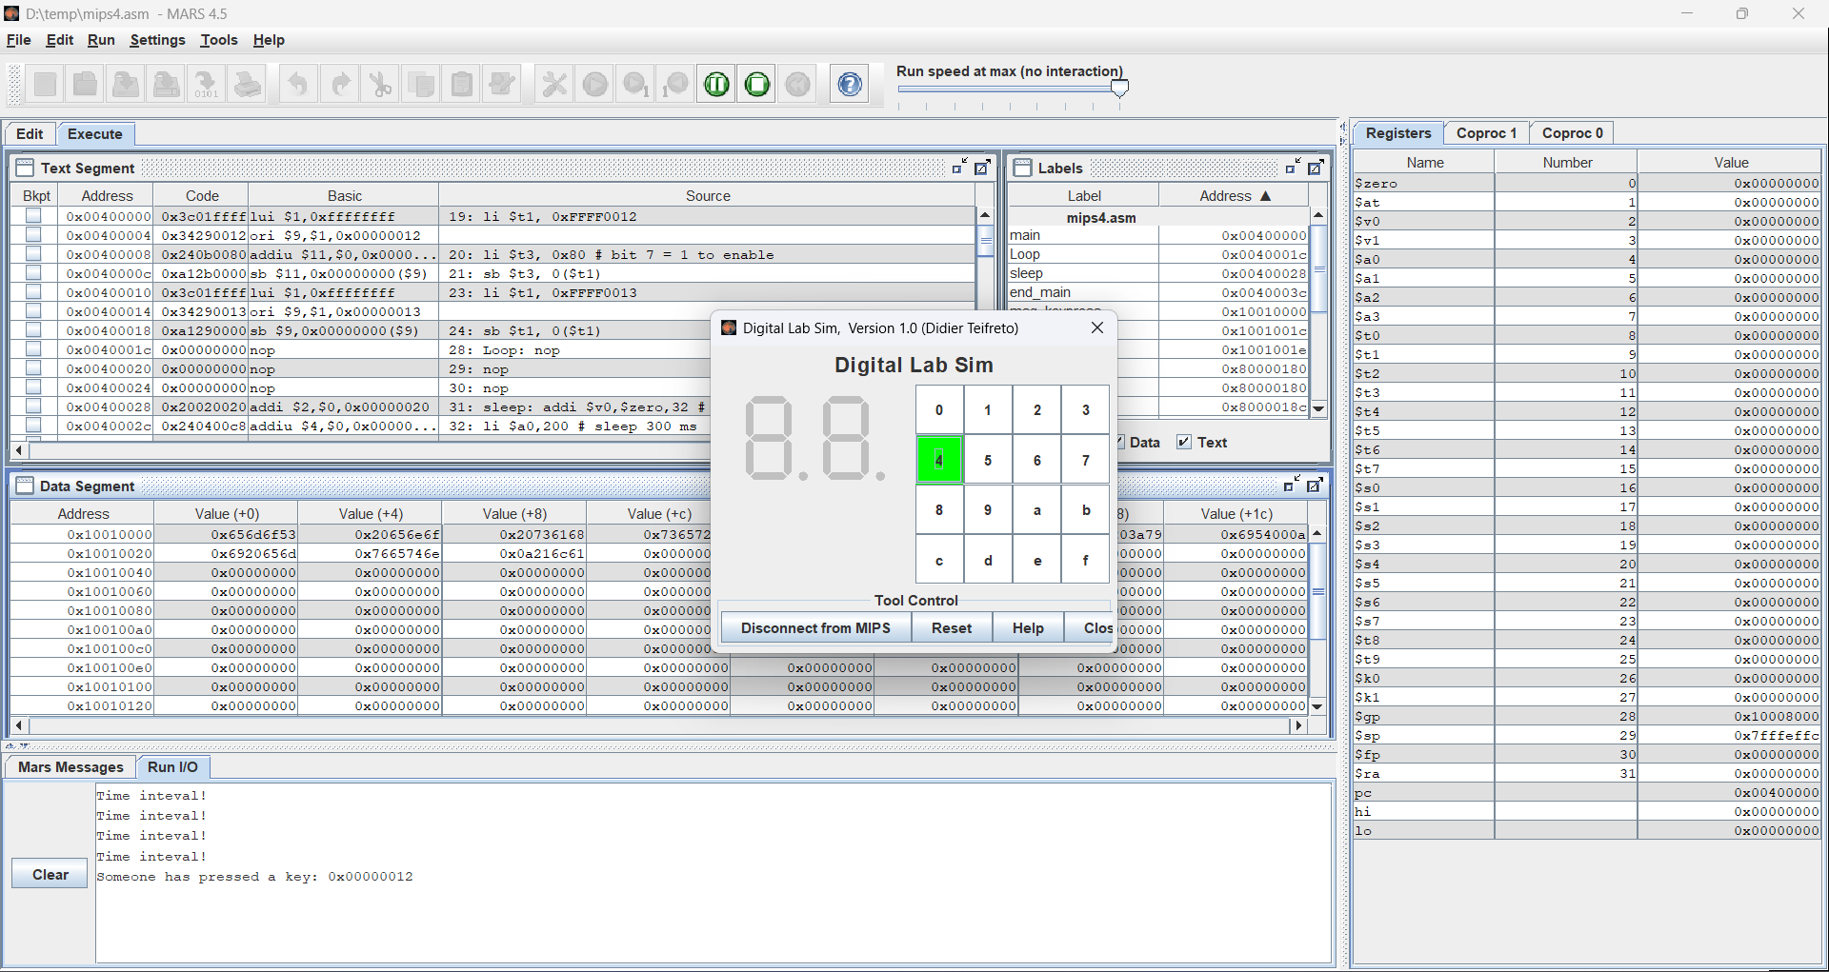
Bấm nút 9
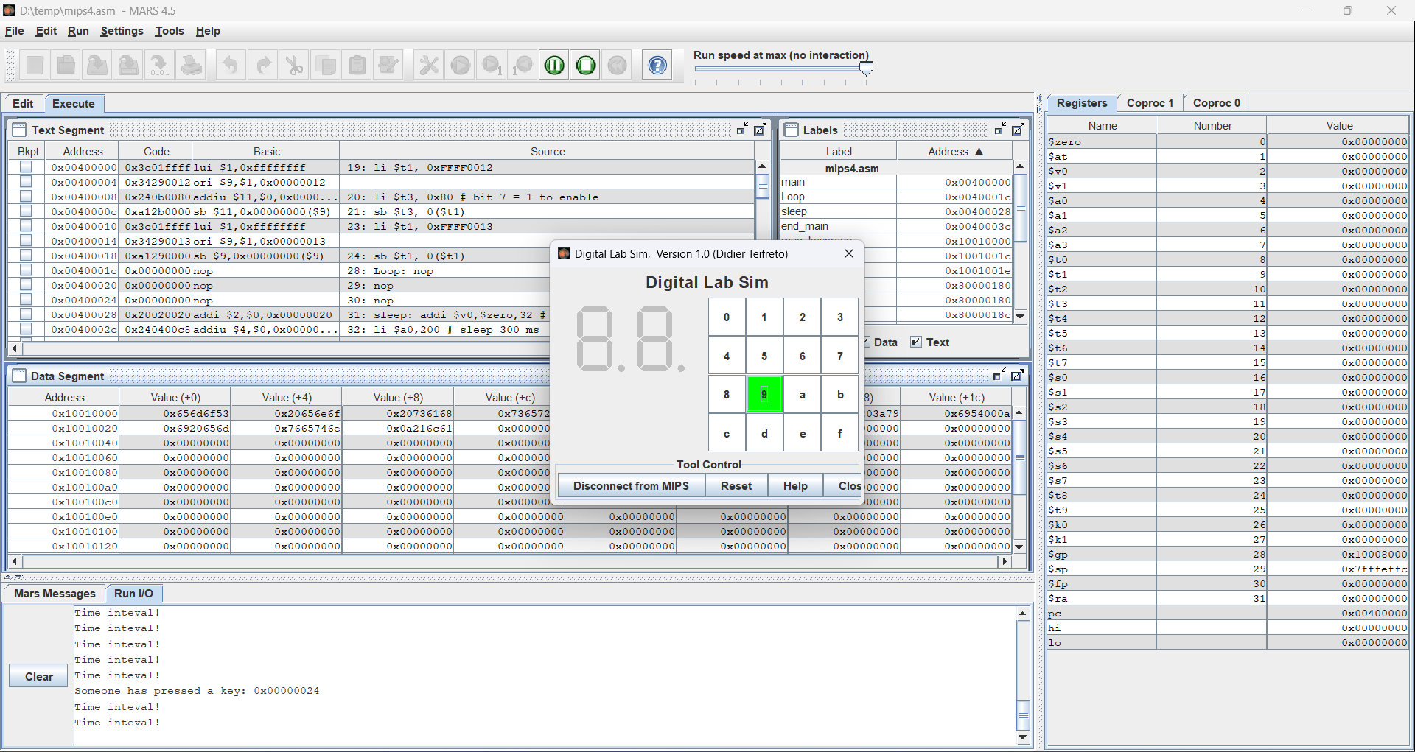

Bấm nút 6
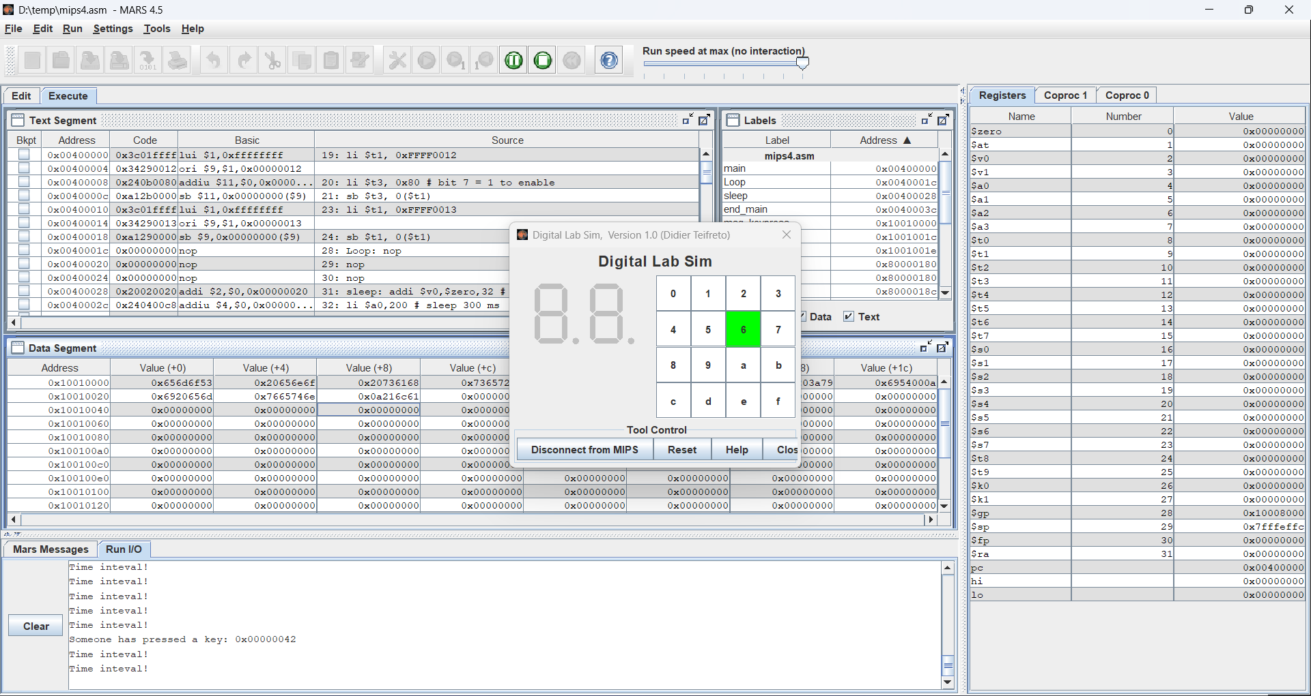
Bấm nút 1
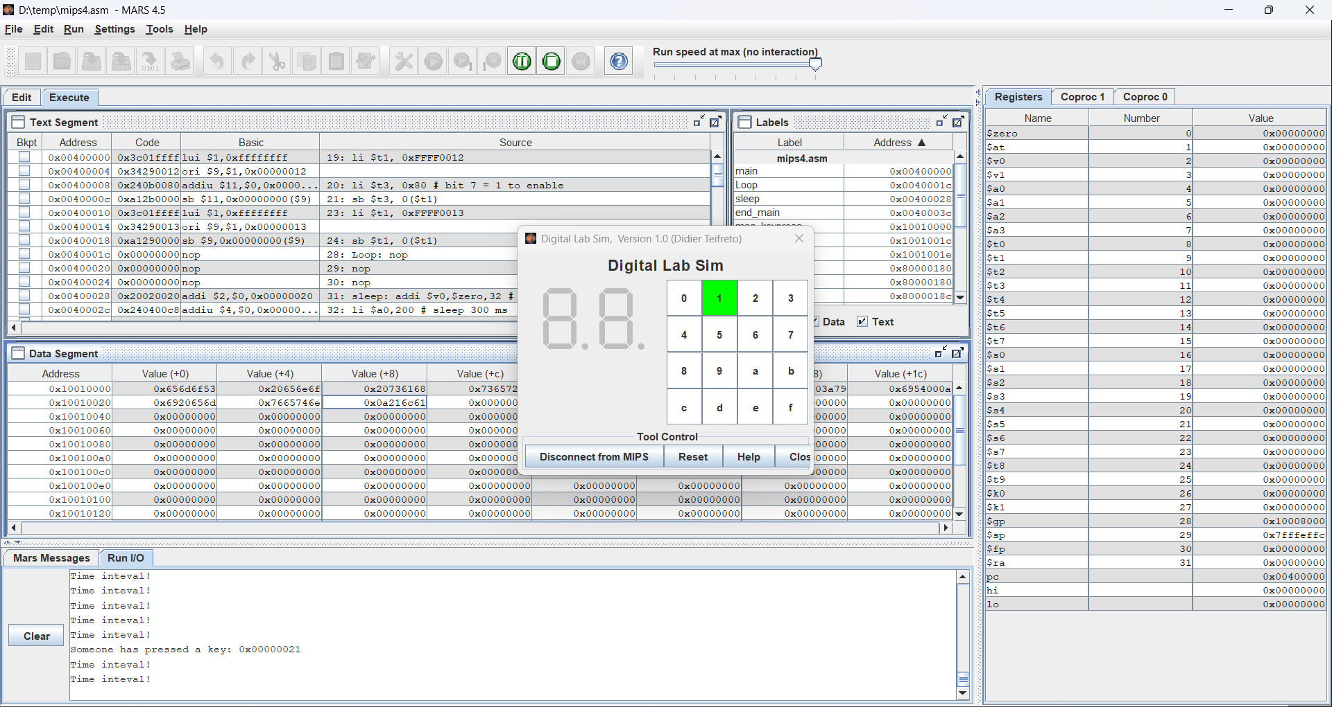

Assignment 5
- Code
.eqv KEY_CODE 0xFFFF0004 # ASCII code from keyboard, 1 byte
.eqv KEY_READY 0xFFFF0000 # =1 if has a new keycode ?
# Auto clear after lw
.eqv DISPLAY_CODE 0xFFFF000C # ASCII code to show, 1 byte
.eqv DISPLAY_READY 0xFFFF0008 # =1 if the display has already to do
# Auto clear after sw
.eqv MASK_CAUSE_KEYBOARD 0x0000034 # Keyboard Cause
.text
li $k0, KEY_CODE
li $k1, KEY_READY
li $s0, DISPLAY_CODE
li $s1, DISPLAY_READY
loop: nop
WaitForKey: lw $t1, 0($k1) # $t1 = [$k1] = KEY_READY
beq $t1, $zero, WaitForKey # if $t1 == 0 then Polling
MakeIntR: teqi $t1, 1 # if $t1 = 1 then raise an Interrupt
j loop
#---------------------------------------------------------------
# Interrupt subroutine
#---------------------------------------------------------------
.ktext 0x80000180
get_caus: mfc0 $t1, $13 # $t1 = Coproc0.cause
IsCount: li $t2, MASK_CAUSE_KEYBOARD# if Cause value confirm Keyboard..
and $at, $t1,$t2
beq $at,$t2, Counter_Keyboard
j end_process
Counter_Keyboard:
ReadKey: lw $t0, 0($k0) # $t0 = [$k0] = KEY_CODE
WaitForDis: lw $t2, 0($s1) # $t2 = [$s1] = DISPLAY_READY
beq $t2, $zero, WaitForDis # if $t2 == 0 then Polling
Encrypt: addi $t0, $t0, 0 # change input key
ShowKey: sw $t0, 0($s0) # show key
nop
end_process:
next_pc: mfc0 $at, $14 # $at <= Coproc0.$14 = Coproc0.epc
addi $at, $at, 4 # $at = $at + 4 (next instruction)
mtc0 $at, $14 # Coproc0.$14 = Coproc0.epc <= $at
return: eret # Return from exception
- Thực thi
-Chương trình thực hiện kiểm tra nếu bàn phím được bấm thì nhảy vào đoạn mã cho xử lí ngắt bằng lệnh teqi.
-Ở đoạn mã xử lí ngắt, kiểm tra xem có phải ngắt của bàn phím hay không. Nếu phải thì show key đó ra màn hình.
-Kết quả

