1. **Measurements results**

Output voltage noise and ripple in CV mode: 35 mVpp (20MHz bandwidth)

9 mVRMS (20MHz bandwidth)

Output voltage noise and ripple in CC mode: 113 mVpp (20MHz bandwidth)

28 mVRMS (20MHz bandwidth)

These are the worst values rounded up, taken from the measurements shown bellow

(ignoring values from images 26 and 30, because there the power supply stops working correctly).

I also did measurements of the output voltage at switch-on/off.

The measurements were done using Rigol DS1054 with PVP2150 probe. The power supply was being loaded with my DIY electronic load using its constant current mode (<https://github.com/Dominik-Workshop/Electronic_load>).

Measurements shown in images 9, 27-29 were done with 4 ohm resistor acting as a load.

(comparing the image 9 and image 6 we can see that the power supply acts different when loaded with a resistor or a CC load).

The image 30 shows that the oscillations in CC mode occur with higher loads, so it looks like the old problem came back (last time I checked, over a year ago, these oscillations were absent).

It can also be observed that using the switching converter to power the fan and relay coil was a bad idea, because it introduces a lot of noise on the output of the power supply

(images 18 and 19). Most of the noise on the output noise comes from this switching converter.

1. **Output voltage at switch-on**
2. Vout = 5 [V]

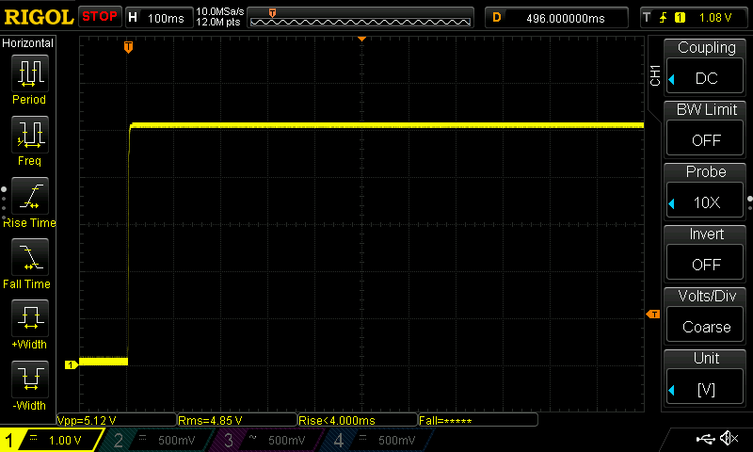 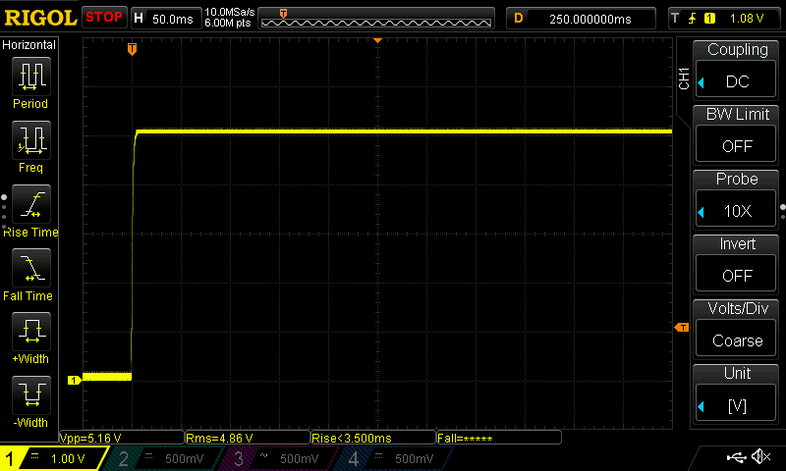

Image 1. Iout = 0 [A] Image 2. Iout = 8 [A]

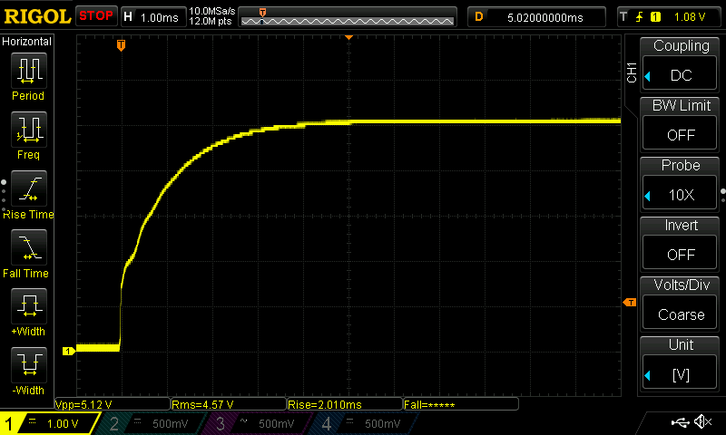 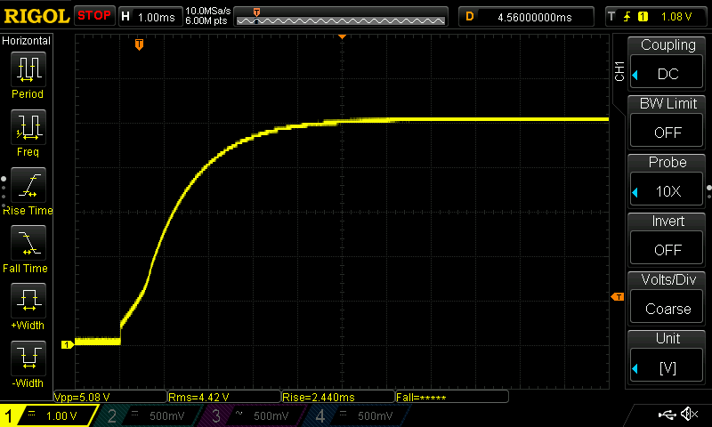

Image 3. Iout = 0 [A] zoomed in Image 4. Iout = 8 [A] zoomed in

1. Vout = 24 [V]

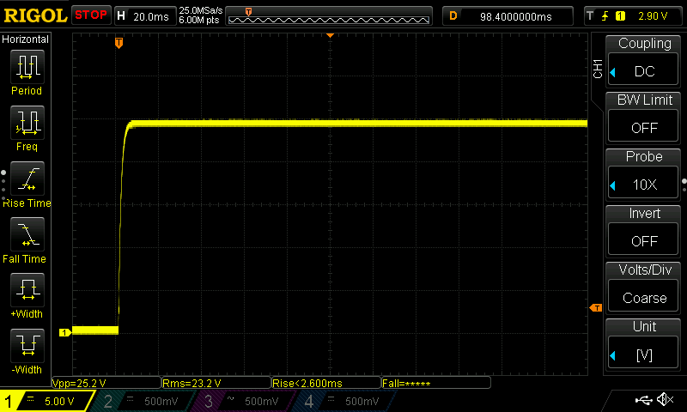 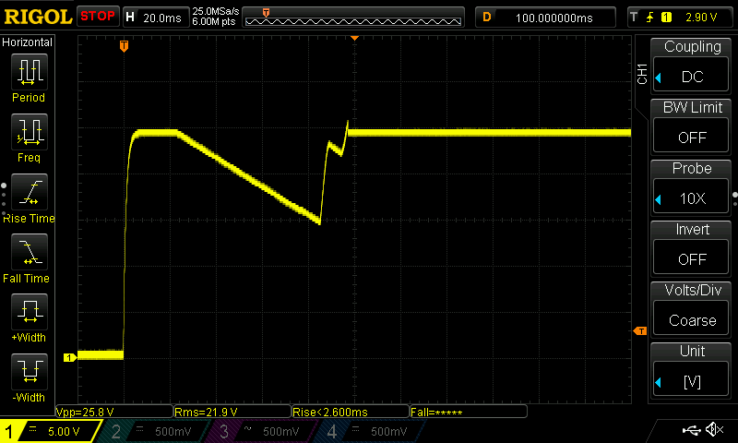

Image 5. Iout = 0 [A] Image 6. Iout = 5 [A]

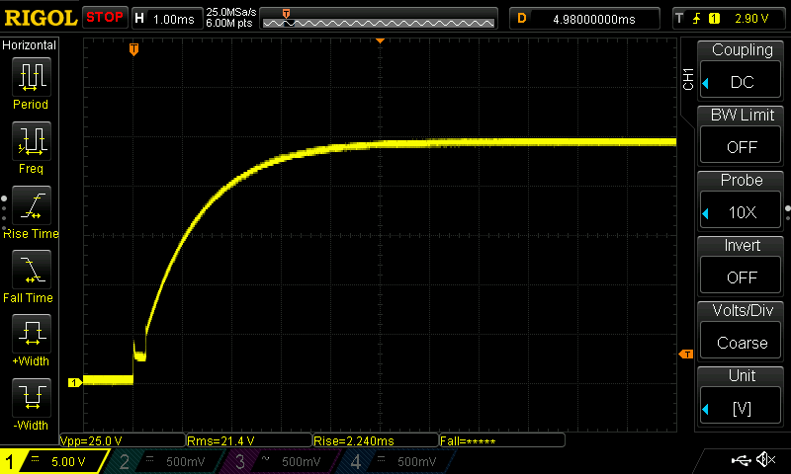 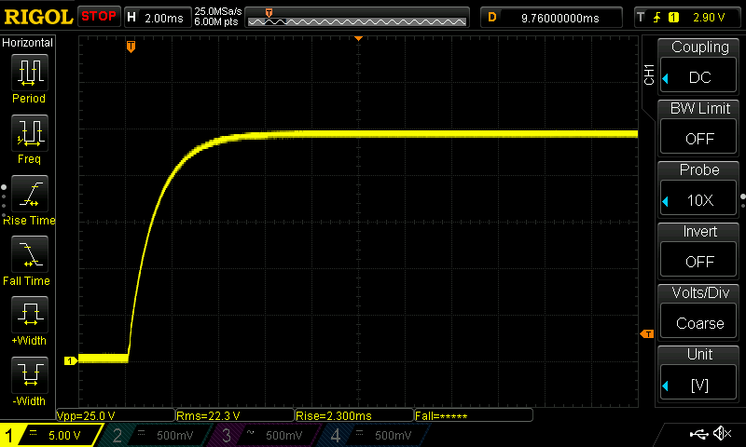

Image 7. Iout = 0 [A] zoomed in Image 8. Iout = 5 [A] zoomed in

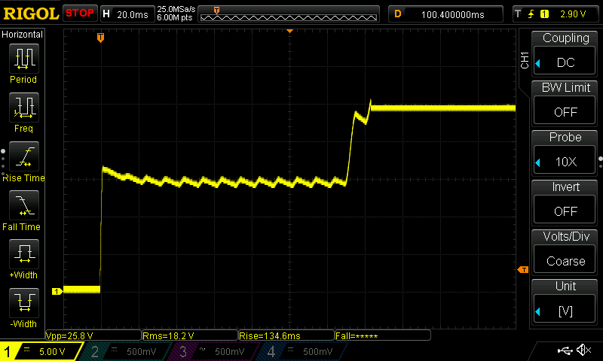

Image 9. Loaded with 4 ohm resistor

1. **Output voltage at turn off**
2. Vout = 5 [V]

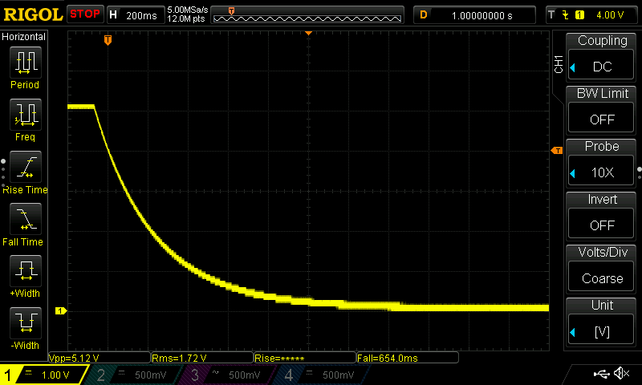 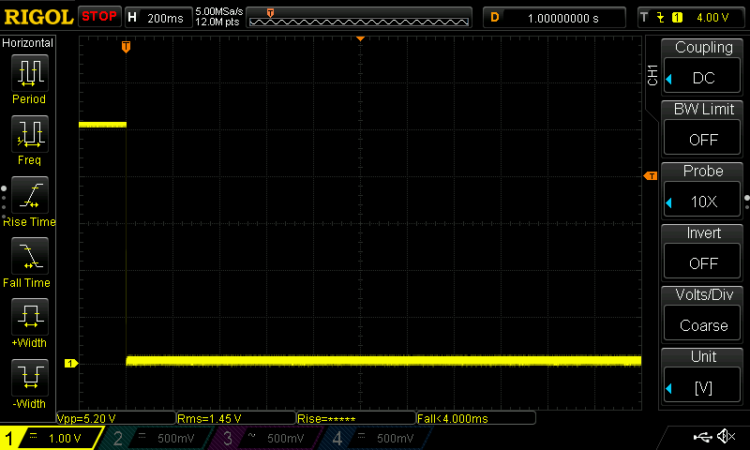

Image 10. Iout = 0 [A] Image 11. Iout = 8 [A]

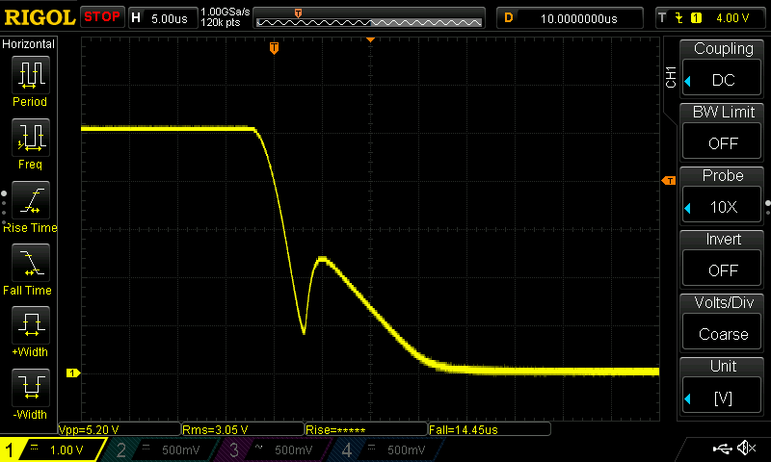

Image 12. Iout = 8 [A] zoomed in

1. Vout = 24 [V]

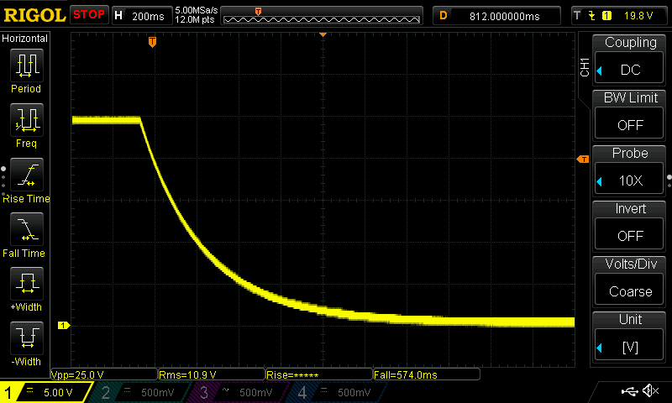 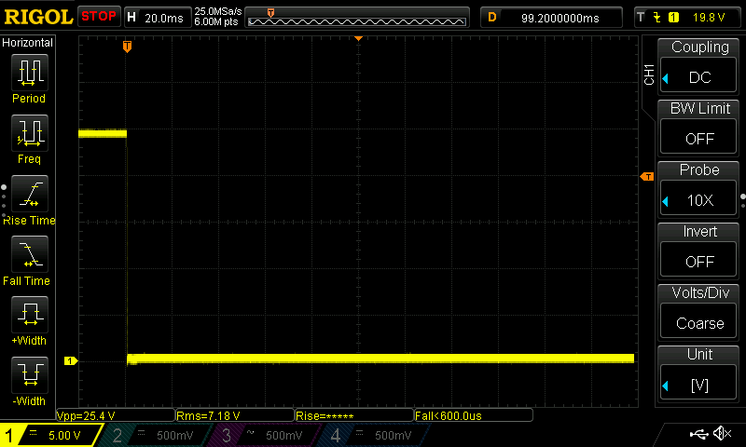

Image 13. Iout = 0 [A] Image 14. Iout = 8 [A]

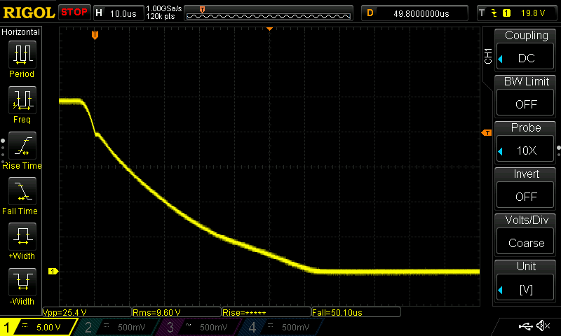

Image 15. Iout = 8 [A] zoomed in

1. **Output voltage noise and ripple in CV mode**
2. Vout = 5 [V]

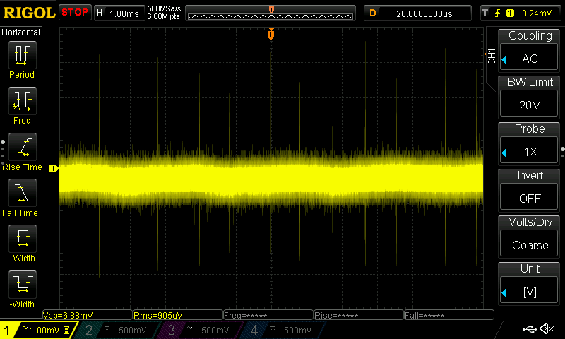 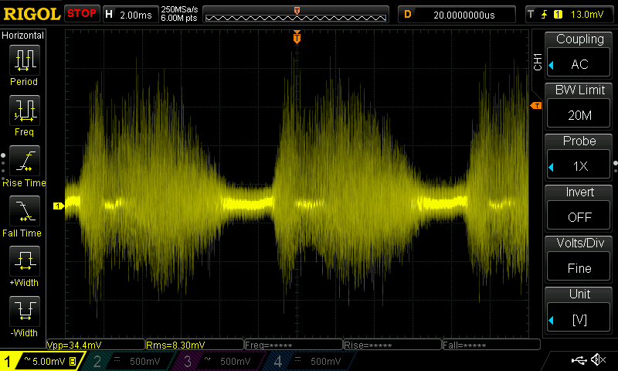

Image 16. Iout = 0 [A] Image 17. Iout = 2 [A]

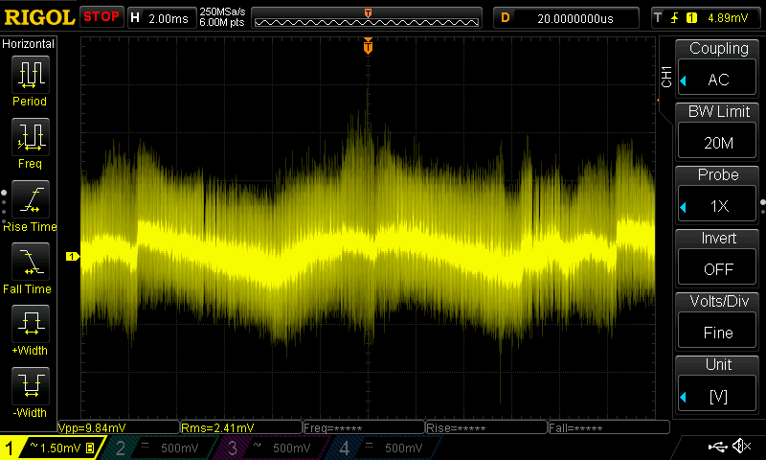 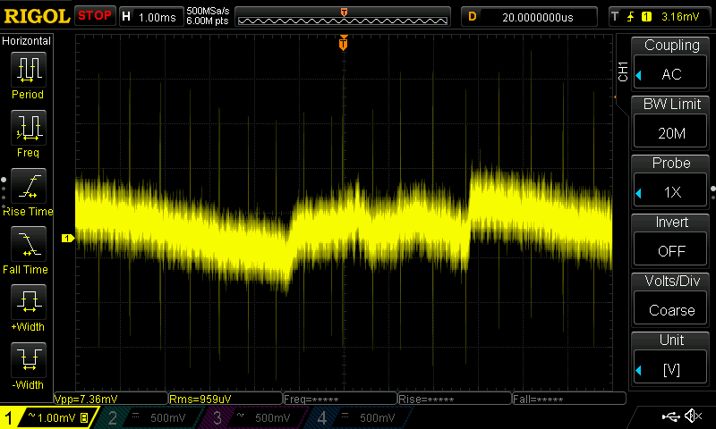

Image 18. Iout = 8 [A] Image 19. Iout = 8 [A] when cooling fans are off

1. Vout = 12 [V]

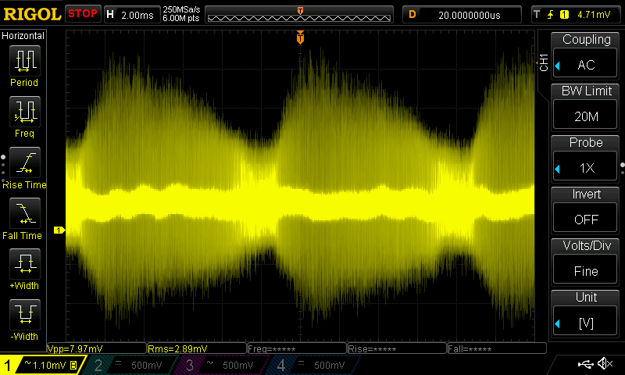 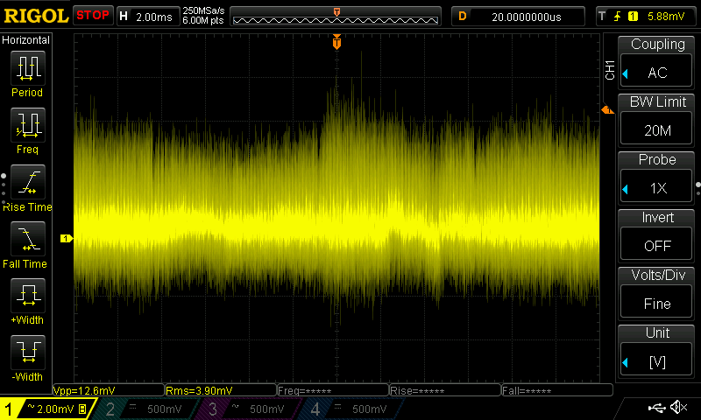

Image 20. Iout = 0 [A] Image 21. Iout = 2 [A]

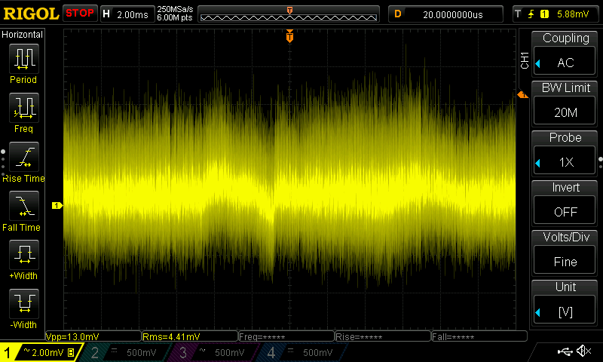

Image 22. Iout = 8 [A]

1. Vout = 24 [V]

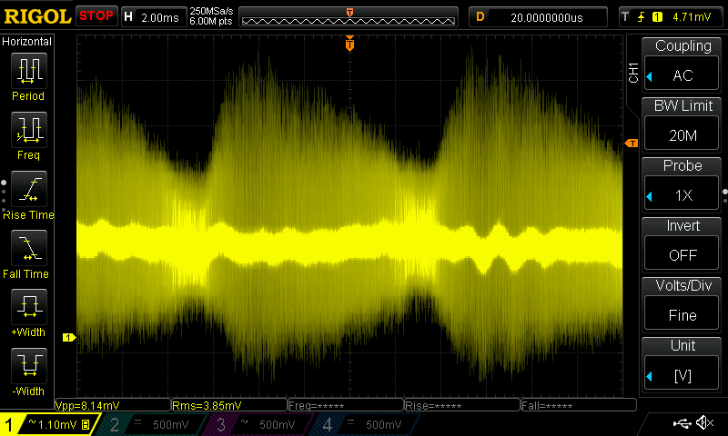 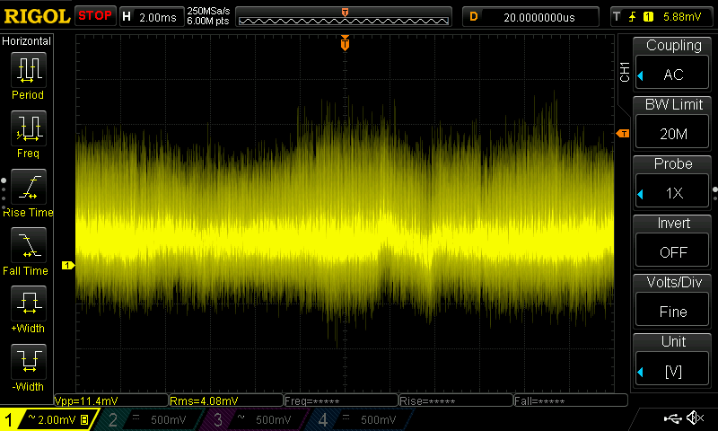

Image 23. Iout = 0 [A] Image 24. Iout = 2 [A]

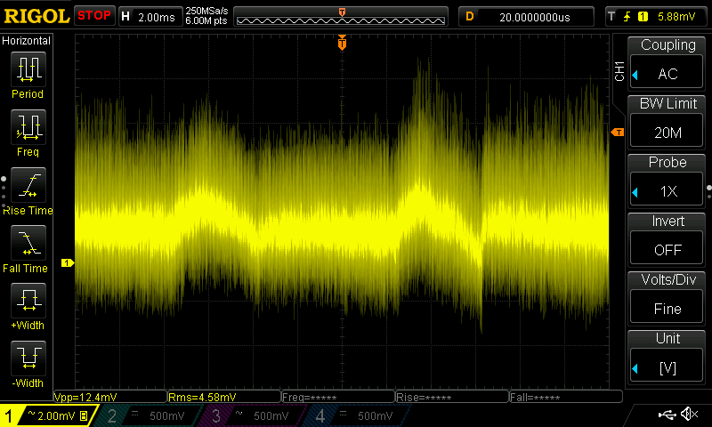

Image 25. Iout = 8 [A]

1. Vout = 25 [V]

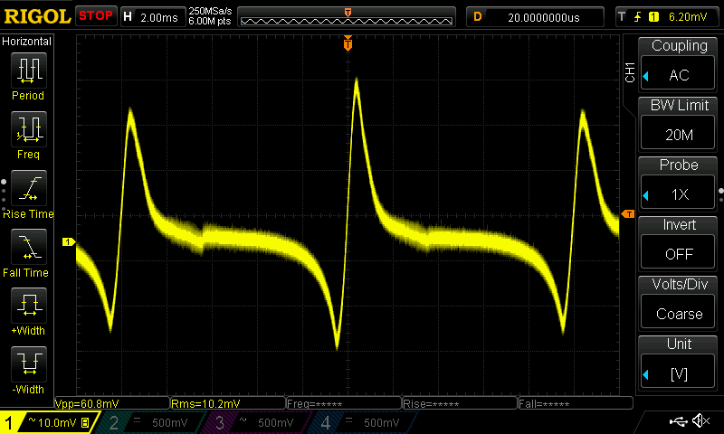

Image 26. Iout = 10 [A]

(the voltage drop on the regulator is too small

and the ripple from bridge rectifier starts showing up on the output)

1. **Output voltage noise and ripple in CC mode**

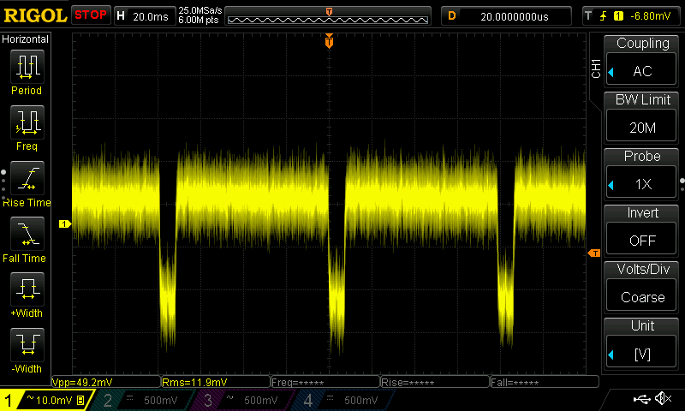 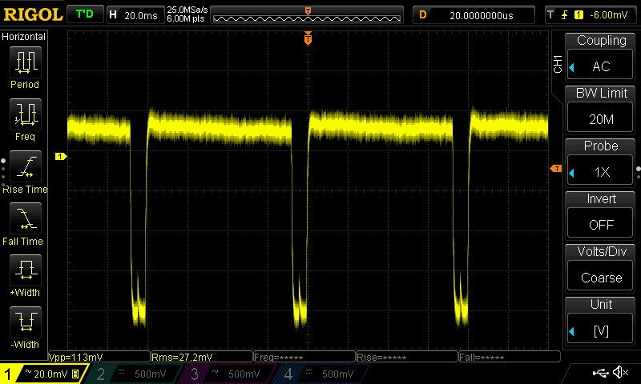

Image 27. Iout = 1 [A] (4 ohms load) Image 28. Iout = 3 [A] (4 ohms load)

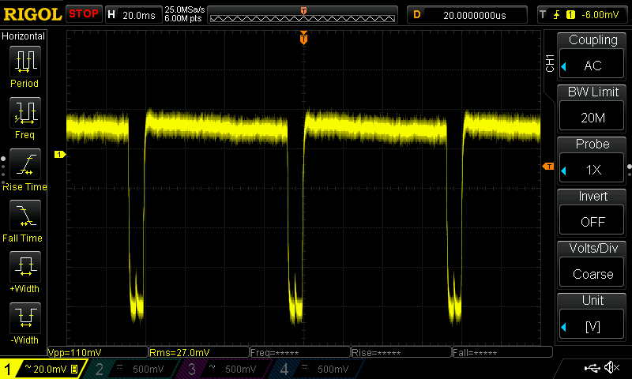 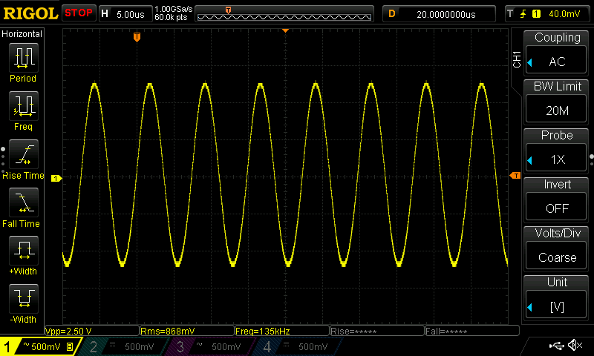

Image 29. Iout = 6 [A] (4 ohms load) Image 30. Iout = 6 [A] (shorted)