Project Name

Handcuff

On

Website: Coding Beginners | Online Programming Solutions

(http://codingbeginners.ga)

**By:**

theBeatBusters

CEC CSE - A

**Members:**

Bipul Harsh

Arjun Uppal

Amanpreet Singh

Bikramdeep Singh

**Index**

1. Introduction……………………………………………………………………………3
2. Hardware and software requirements…………………………………………………4
3. Methodology…………………………………………………………………………..5
4. Screenshots of result…………………………………………………………………..6

**Introduction:**

The project is about website named Coding Beginners that contain solutions for all coding related problems.

Site contains detail explanation of various programming languages in simple English with examples for better understanding of any concept. It is divided into three main parts which are basic, core, and algorithm. The basic part contains the basics of various programming languages which are basically a beginner’s guide, core part covers all single detail with deep explanation and in algorithm section it contains explanations for different level of problems.

Things that make this site different:

* Compatible with any screen.
* Simple design
* Easy navigation
* No ads or paid content
* Color sense that doesn’t irritate eyes

The most important part is the monthly magazine which is expected to begin on 1st march 2020. It will contain all information regarding the updates of any software, events organized by various software companies, programming related news, coding trends, algorithm problems and many more.

Sign up, feedback, complaints, and magazine subscription forms are also provided in the site, so user can get updates, share their feedback, suggestions to tell what they experience and can complain for any inconvenience.

**Language Used:**

Languages used in making this website are HTML and CSS.

**Hardware and Software Requirements:**

For hardware it can run on any device connected to internet like:

* Desktop
* Laptop
* Smart phone
* Tablet

For software you just need to install any web browser like:

* Google chrome
* Firefox Mozilla
* Internet explorer

**Methodology**

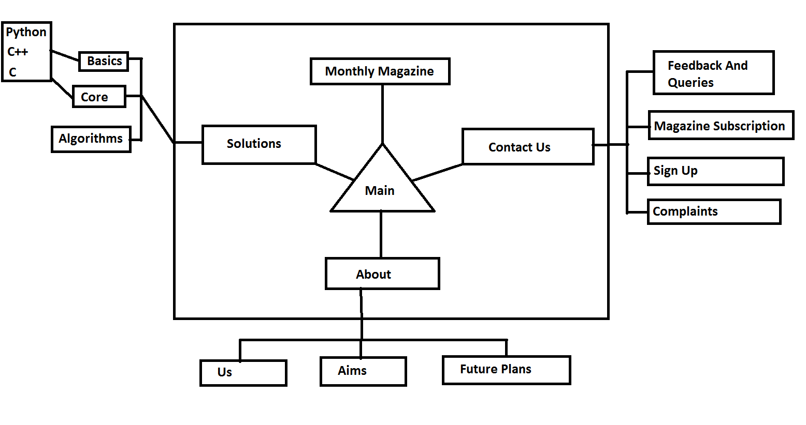

**Screenshots of Result**

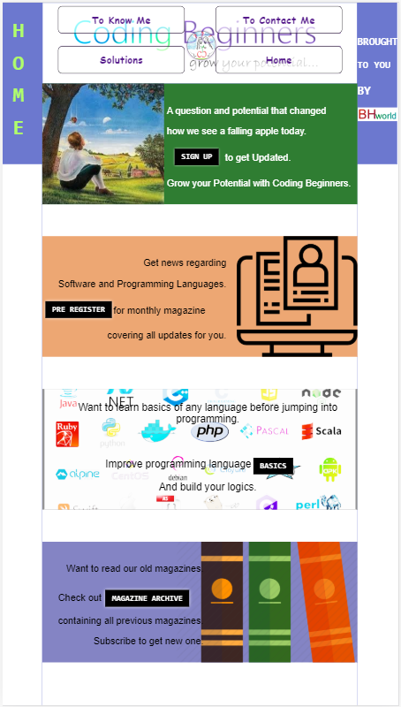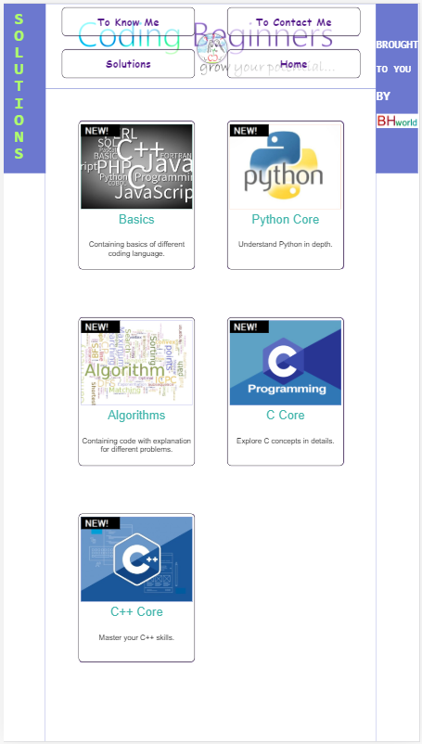

Image 1 Image 2

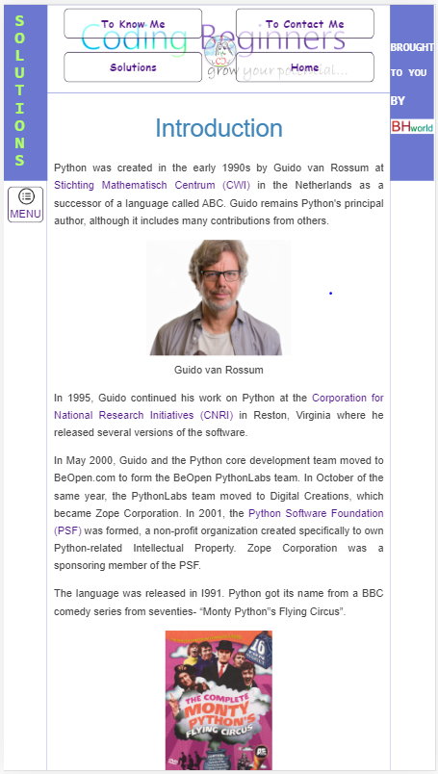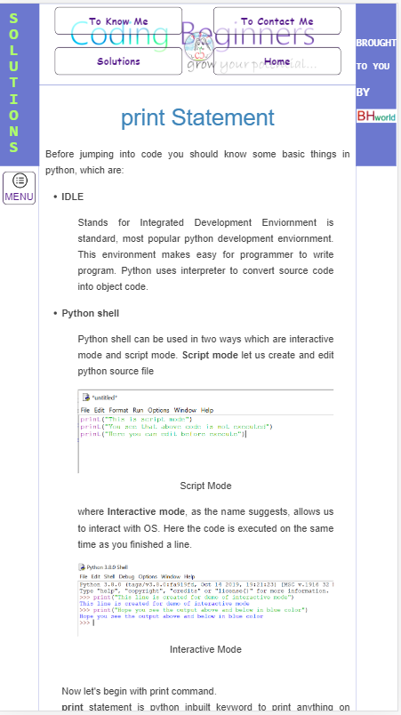

Image 3 Image 4

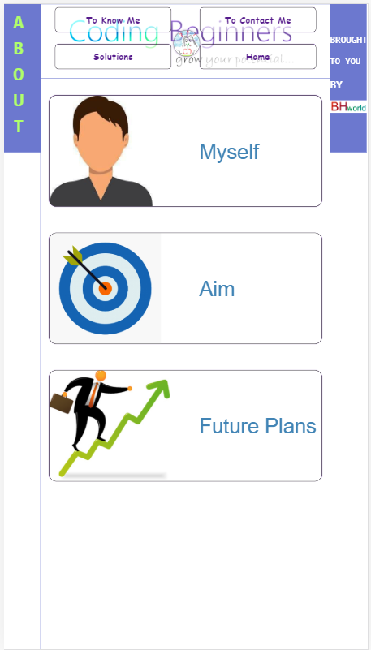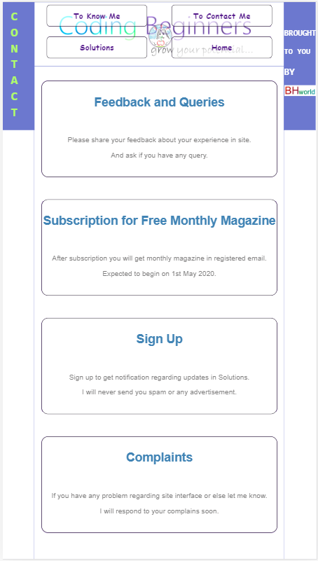

Image 5 Image 6

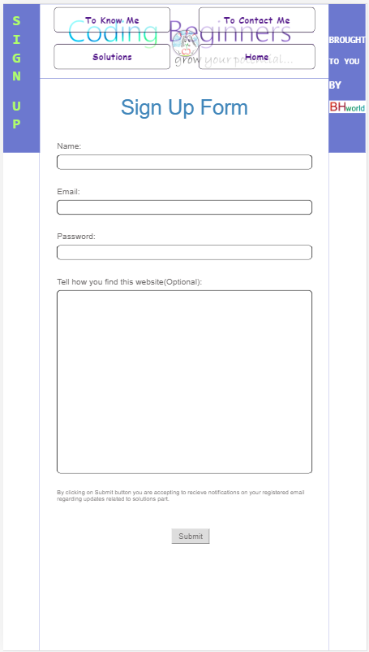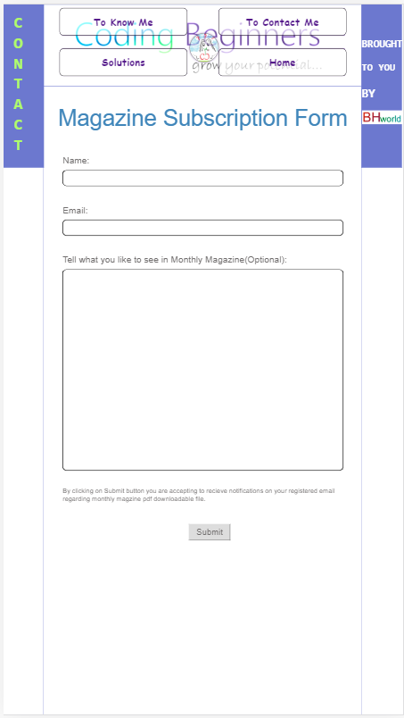

Image 7 Image 8