FTP codes:

ftp> open ftp.bits-pilani.ac.in

Connected to ftp.bits-pilani.ac.in.

220 Microsoft FTP Service

200 OPTS UTF8 command successful - UTF8 encoding now ON.

User (ftp.bits-pilani.ac.in:(none)): csis

331 Password required

Password:

230 User logged in.

Use ls,cd etc.

put filename -- stores file from local machine to remote server

get filename -- fetches file from remote to local machine

EXERCISE 2:

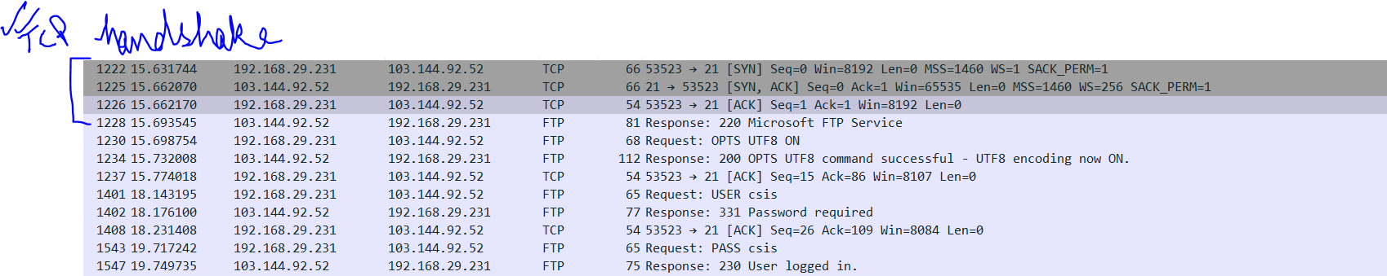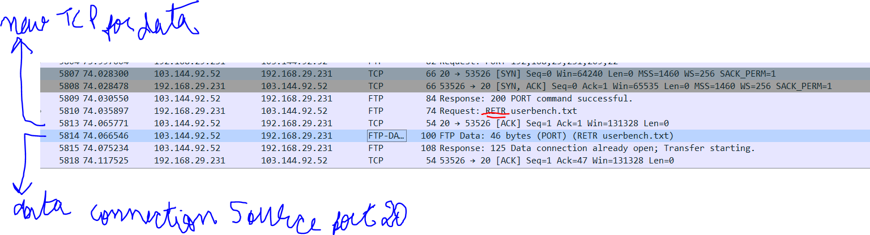

Exercise 3:

1. This command is used to provide additional information for extended features supported by the **FTP** server. For example, here it is used for setting UTF 8.

2. 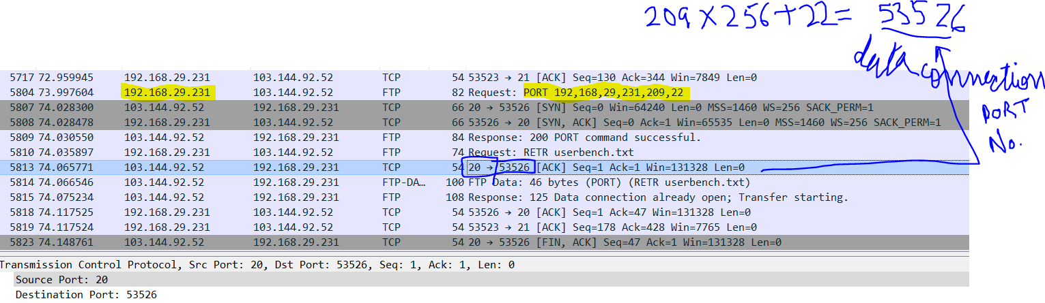

PORT used to establish data connection by sending server the host ip + port.. This info is sent on the control connection whose PORT is different from the one passed in PORT command

3. Since the response is sent back over the control port which was already open. TCP handshake for data connection completes later.

4.

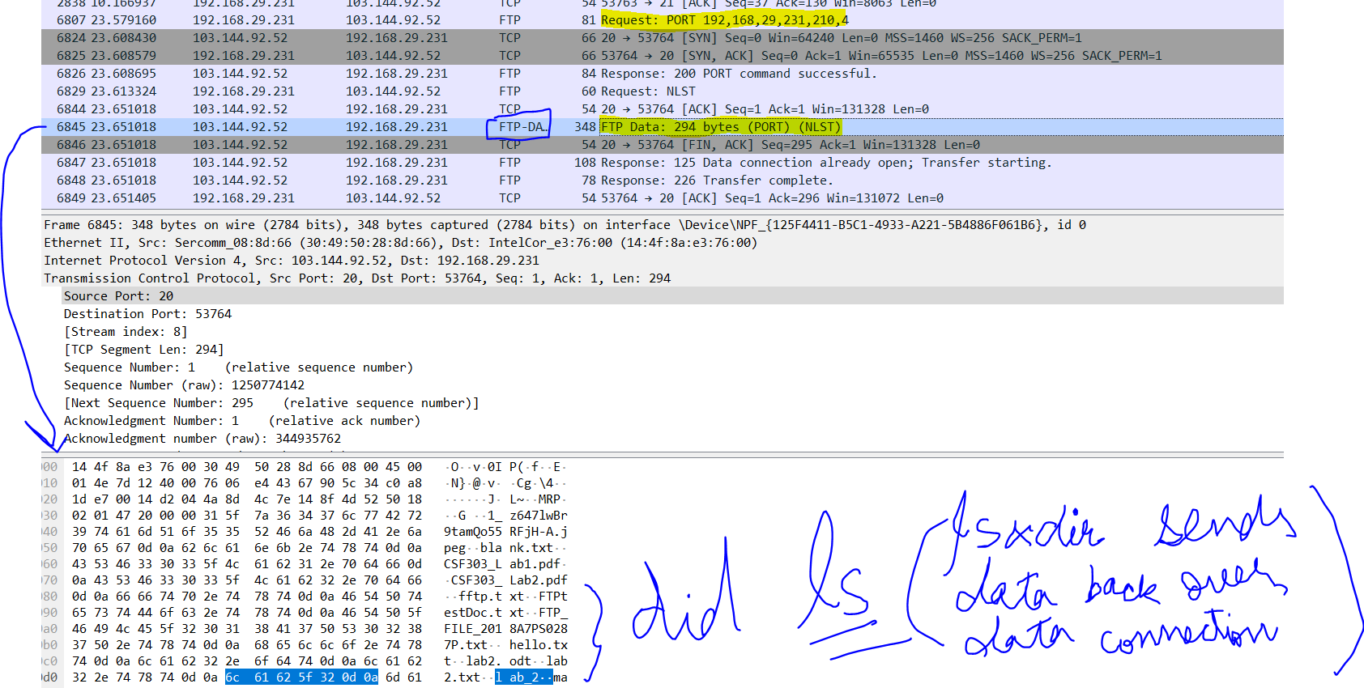

EXPERIMENT 4:

7.

1. UDP (User Datagram Protocol)

2. 0x0669 (can change) 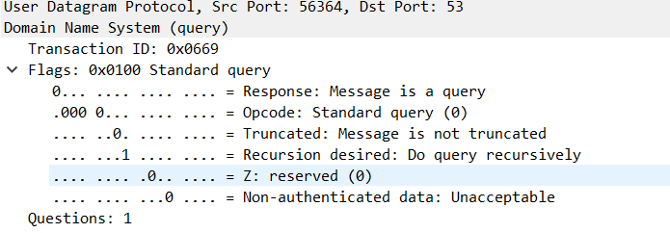

3. icms.bits-pilani.ac.in: type A, class IN ; want ip corresponding to host; AAAA



5. UDP on port 53 of DNS

Q8.

1. UDP

2. Yes

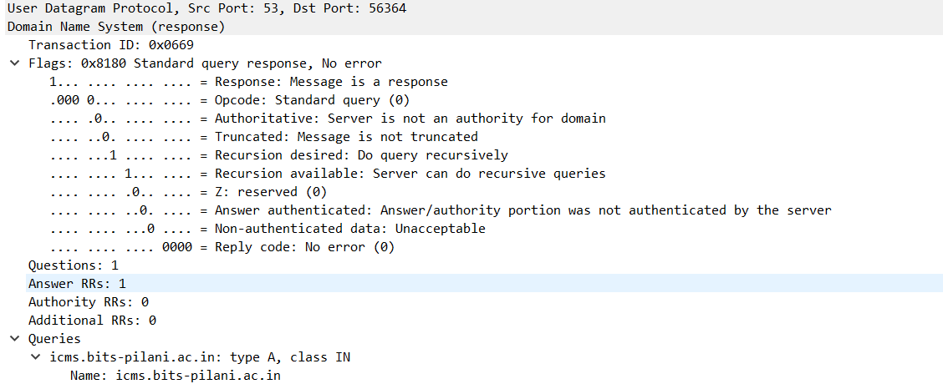

3. NO

4. NO

Lab Exercise 4:

1. UDP

2. IP pane

3. 53

6. 53

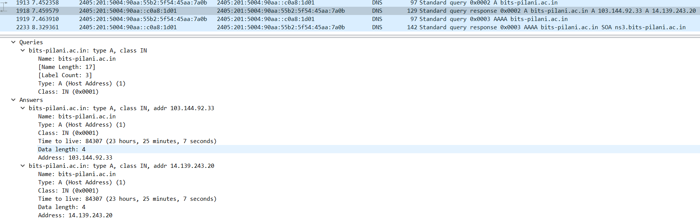

DNS query for type=NS

