**README**

Programming Language:

1. HTML (Hypertext Markup Language) -> to build the structure of the website to serve content on

2. CSS (Cascading Style Sheet) -> to design and style the User Interface

3. JavaScript -> to make the music player, add its controls and 3jS library to render a 3D world with skyboxing technique.

4. Python -> to make a server in order to run these files and handle CORS

Software Needed:

* Python 3.0+ installed
* Any Web Browser preferably Chrome or Edge with JavaScript enabled

Hardware Needed: Standard monitor and a mouse

**Note:** There may be certain lag while loading each page for the first time.

How To View the Demonstration:

* Unzip **2018A7PS0261_D3_sourceCode.zip** folder and extract the folder inside in the current directory.
* Run **simple-cors-http-server.py** file present in **2018A7PS0261_D3_sourceCode** folder. Once the executable begins it should look like the image below.

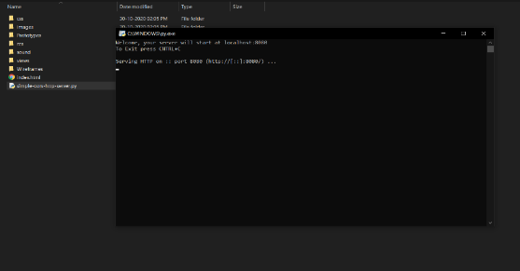

* Now open a Web Browser and visit URL: **localhost:8080/index.html**
* You will land on the page shown below, use links to navigate to different pages.

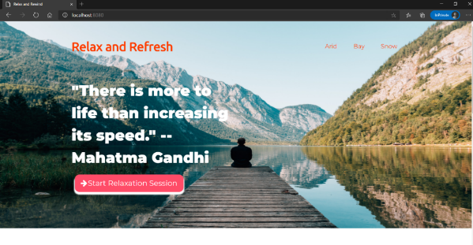

* Once you select and open a 3D world, you can navigate in a 3D sphere with your mouse (Just hold left mouse button and drag). Scroll wheel allows to zoom in and out.

A model 3D world(Bay) is shown below

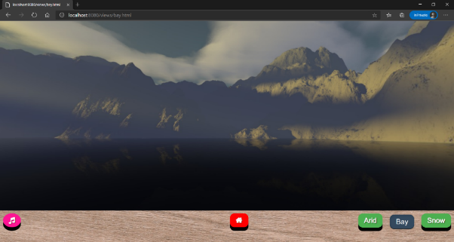

Figure . Bay 3D view

* Pink Music button on click will bring up or hide the music player, you can control music tracks by the buttons provided.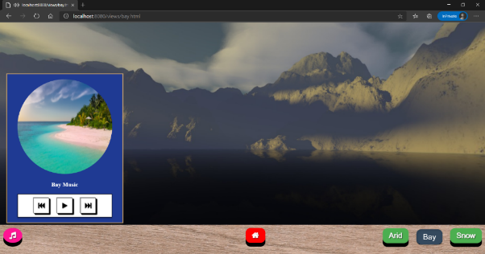music player as shown below.
* Clicking on the Red Home button will take you to the feedback page.

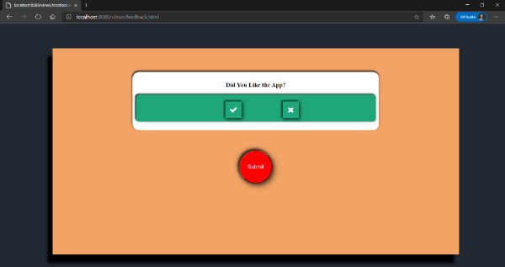

* At end close the browser and to stop the server, click on the executable window and press ctrl+C.

**In order to view the source code of the HTML or CSS files (they contain JavaScript tags at the end of each file) present in 2018A7PS0261_D3_sourceCode , 2018A7PS0261_D3_sourceCode/views, 2018A7PS0261_D3_sourceCode/css and 2018A7PS0261_D3_sourceCode/prototype folders:**

Right click and open files with notepad.